Sunday | Monday | Tuesday | Wednesday | Thursday | Friday | Saturday
 |  |  |  |  |  | 1
2 | 3 | 4  Yom Kippur Begins | 5 | 6 | 7 | 8
9  Sukkot Begins | 10  Columbus Day (US)  Indigenous Peoples’ Day  Thanksgiving Day (Canada) | 11 | 12 | 13 | 14 | 15
16 | 17  Simchat Torah Begins | 18 | 19 | 20 | 21 | 22
23 | 24  Diwali (Hindi) | 25 | 26 | 27 | 28 | 29
30 | 31  Halloween

M-OCC Activity Calendar

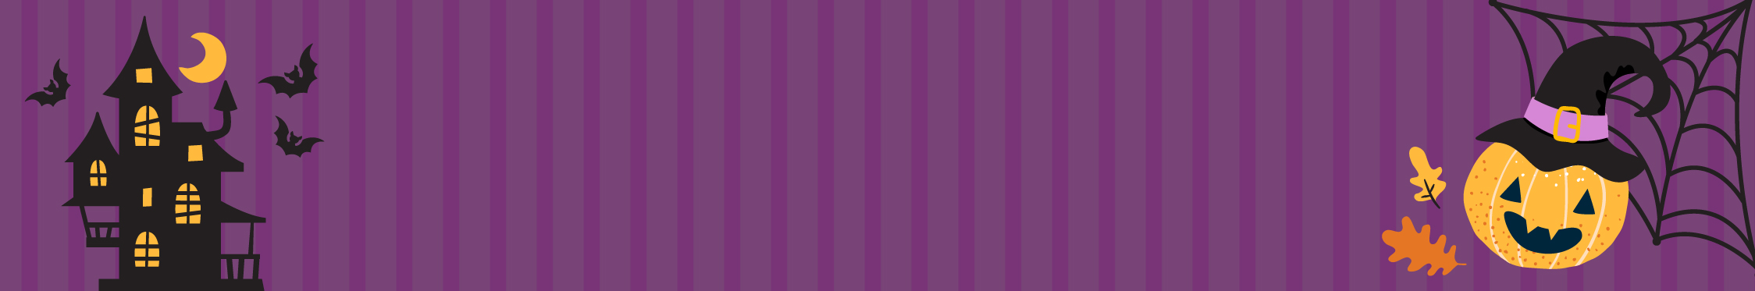
Monday – Friday

11:00 Chapel
11:15 Exercises
2:30 Coffee time
