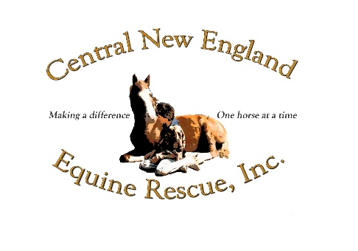  
96 New Braintree Rd. ~ West Brookfield, MA 01585  
Tel. 978-621-6717 – online @ cneer.com

Vendor Registration Form

Fall Festival at the Farm

Saturday, September 27, 2025

12pm – 4pm

First___________________ Last___________________

Address_______________________________________

City___________ State_____ Zip __________

Tel #_______________

Company_______________________________(send logo if you have one)

Goods/ Services to be sold:

Payment $25.00 Due with application to reserve space. There are a limited # of spaces. Please send a check made payable to CNEER together with the completed application to the above address. If you would prefer, you can paypal (you will need to add $5 to the total) on our website cneer.com fill out donation and mark Farm Festival or you can use Venmo -let us know and we will contact you to do so.   
(The cutoff date for applications is September 6th 2025)

If possible a basket/good or service to be donated to raffle off at the event. The raffle item can be dropped off at the farm. We ask for it prior to the event so that we can catalogue it and advertise. If not possible to drop off please take a picture of it and send it to [windybleu@gmail.com](mailto:windybleu@gmail.com) so we can post it in our advertising and bring attention to you as a vendor.

Please contact us at 413-2653270 or 978-6216717 with any questions or comments

_____________________________________________________________________________