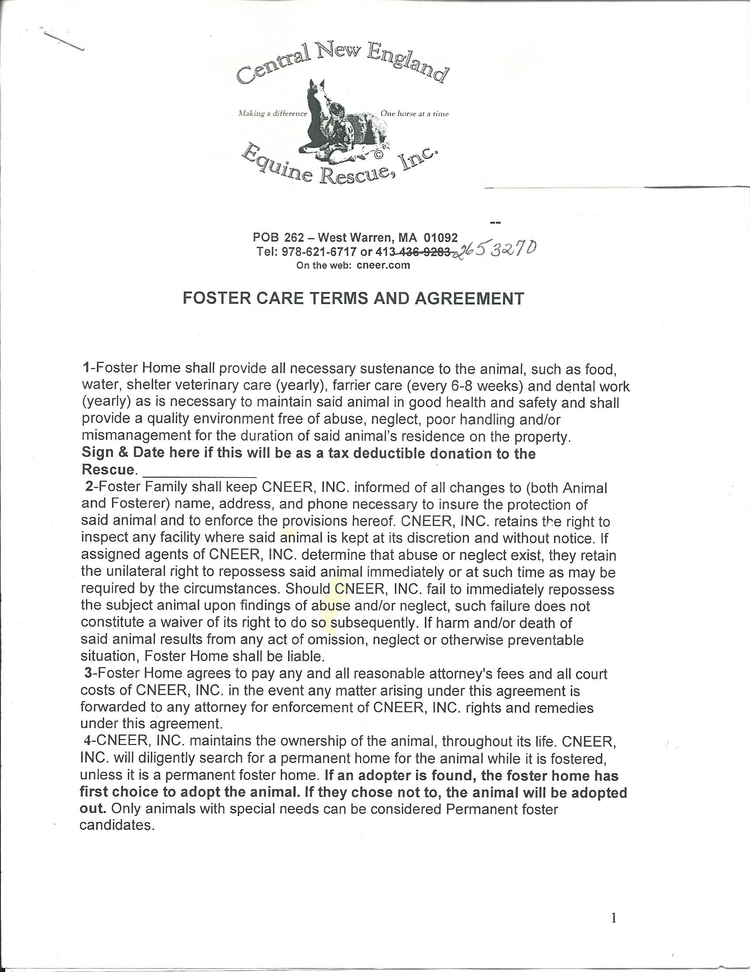

96 New Braintree Road ~ West Brookfield, MA 01585  
978-621-6717 or 413-265-3270  
On the web: cneer.com

Initial Here:_________

413-265-3270

Horse:

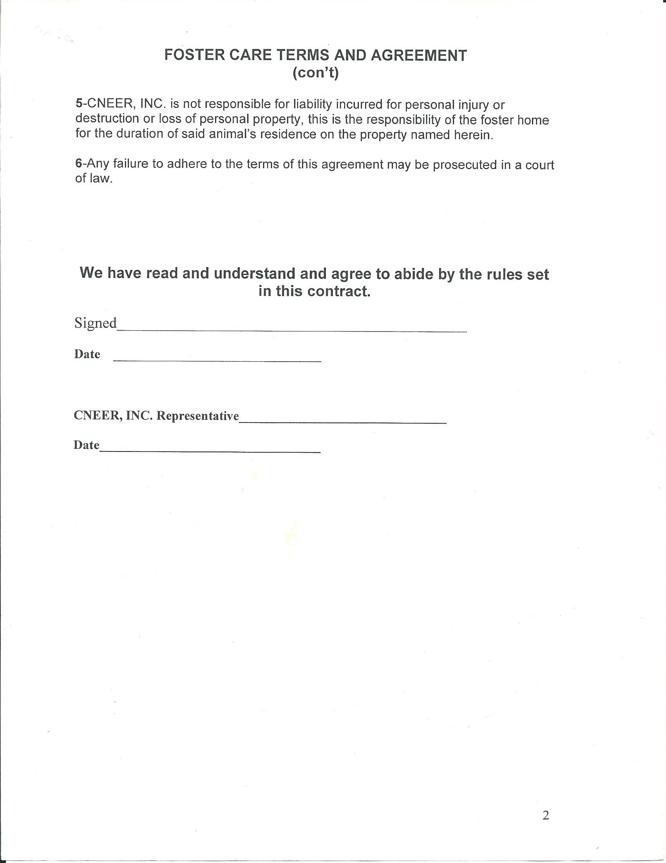

**Foster Care Address:**_____________________________________________________

**Email:_______________________________________________________**

**Tel#:________________________________________________________**

**We thank you for wanting to help us rescue and save the lives of these horses in peril. Your kindness allows us to rescue one more horse that otherwise would have no hope at all.**