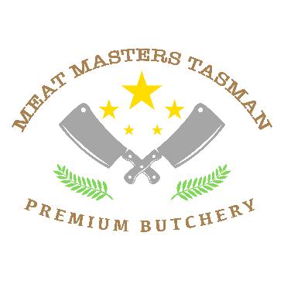

**Venison cutting List**

Backstraps Chops Steaks Mince Sausages Cappachio Biltong

Shoulder Mince Sausages Roasts

Legs Mince Sausages Roasts Biltong

Basic cutting and packing $2.50kg

Plain Sausages $5.99kg

Flavoured Sausages $6.99kg

Salami $11 per stick (approx. 1kg )

Biltong $7.99kg

Beersticks and Dry wors $8.99kg

Patties $6.99kg

****Prices exclude GSt *****

Packed for number of people