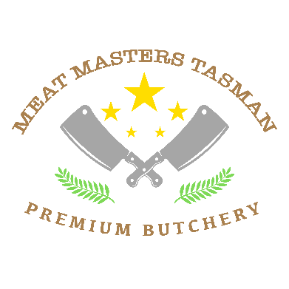
Date :
Name and Address

Killed By
LAMB CUTTING SHEETS
Basic cutting $50 per lamb – plastic bags labelled .
Vacuum packing $10 extra
Shoulder chops / Roasts
Racks / Loin chops
Leg Roasts on the bone / Deboned
Flaps
Shanks whole / deboned
Value added cuts - $10 per item
Marinated chops and roasts
Lamb Noisettes
Steaks
Diced
Mince
Sausages $7 per Kg (minimum 9kg) Animals over 30kg extra $15 Prices exclude GST
Packed for number of people
DECLARATION : I declare that I am the lawful owner of this animal , and have been for the last 30 days
SIGNED :
Date :

Total Carcass weight
Total meat kg
Total Waste Issue date 1 May 2025

