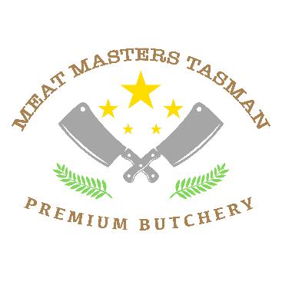

**Pork cutting list**

Head Yes No

Trotters Yes No

Bones Yes No

Shoulder Mince Ribeye steaks Sausages Rolled Roasts Bacon

Loins Chops Bacon Steaks Roasts

Hocks Smoked Plain

Legs Roasts Mince Sausages Ham on the bone Sliced Leg ham

Ham

Basic cutting and packing $2.50 per kg

Sausages Plain $5.99perkg

Flavoured Sausages $6.99 per kg

Pickled and smoked product $5 per kg

Cooked Ham on the bone $6 per kg

Cooked Sliced ham $7 per kg

Kranskies $8.00kg

Patties $6.99kg

Packed for number of people

***Prices exclude GST ****

**DECLARATION : I declare thsat I am the lawful owner of this animal and have been for at least the last 30 days**

**SIGNED**

**DATE**

Total carcasss weight on the hook

Total meat cuts returned kg Total Waste product kg

Total Sausages kg