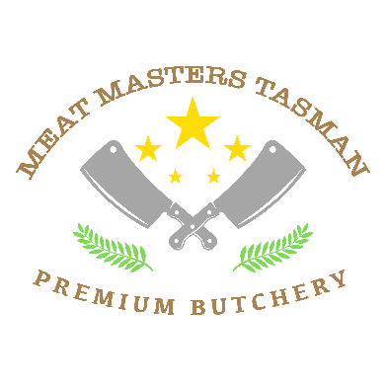

**LAMB CUTTING SHEETS**

Basic cutting $50 per lamb – plastic bags labelled .

Vacuum packing $10 extra

Chops

Racks

Roasts on the bone

Flaps

**Value added cuts -** $10

Marinated chops and roasts

Lamb Noisettes

Steaks

Diced

Mince

Sausages $7 per Kg (minimum 9kg) Prices exclude GST

Packed for number of people

**DECLARATION : I declare that I am the lawful owner of this animal , and have been for the last 30 days**

**SIGNED :**

**Date :**

Total Carcass weight

Total meat kg

Total Waste