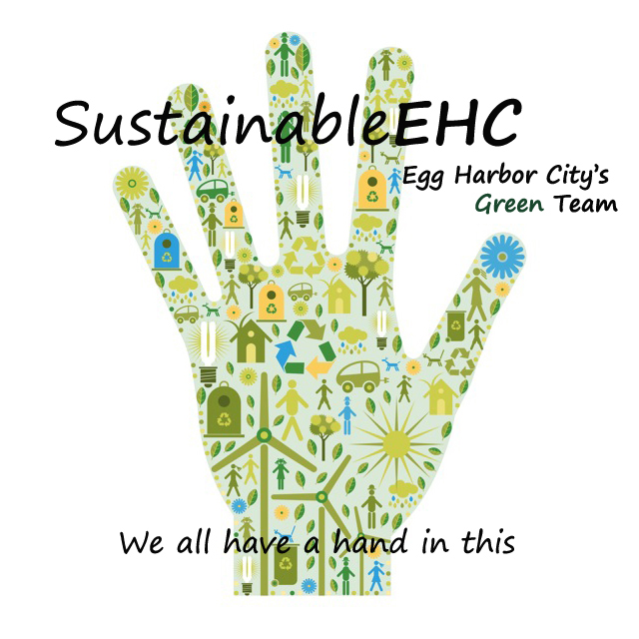
SustainableEHC
500 London Avenue
Egg Harbor City, NJ 08215

www.sustainableehc.org

Arbor Day 2026 Photo Contest

Arbor Day was founded by Nebraska journalist and politician J. Sterling Morton in celebration of nature. The first Arbor Day occurred on April 10, 1872, in Nebraska. It’s estimated that nearly one million trees were planted that day.

Today, Arbor Day is celebrated in New Jersey on the last Friday of April. Our celebration this year will be held 3-6 p.m. Friday, April 17, 2026.
“Other holidays repose upon the past;
Arbor Day proposes for the future.”
J. Sterling Morton, Founder of Arbor Day

Contest Rules

- Contest open to Egg Harbor City students and adults (amateurs only)
- Categories: Student, Adult
- Contest Theme: “The Wonder of Trees”
- Photos must feature a tree(s), preferably one(s) growing in Egg Harbor City
- Submit entry form and photos in jpg format, 10 MB or less, at www.sustainableehc.org by the deadline, Friday, April 17, 2026
- Limit one (1) submission per person
- Submit your own work not published elsewhere
- Photo must have been taken any season during the last 12 months
- No AI generated or enhanced photos permitted
- If there are people in the photo, they must not be the main focus, and you must obtain a release
- Photos will be published on the SustainableEHC website and FB page
- By submitting photos, you are granting SustainableEHC the right to publish photos in promotional materials. Credit will be provided.
- Photos will be judged anonymously based on theme, impact and composition
- Judges are professional and semi-professional photographers
- First, second, third place and honorable mention ribbons will be awarded
- Monetary Awards: First place $75, second place $50, third place $25
- Public voting for Best in Show rosette will be held at the EHC Arbor Day Celebration, 3-6 p.m. Friday, April 17, 2026, at Peace Pilgrim Park, 500-block London Ave.
- Deadline for submissions Friday, April 10, 2026



Edit 2.24.26

