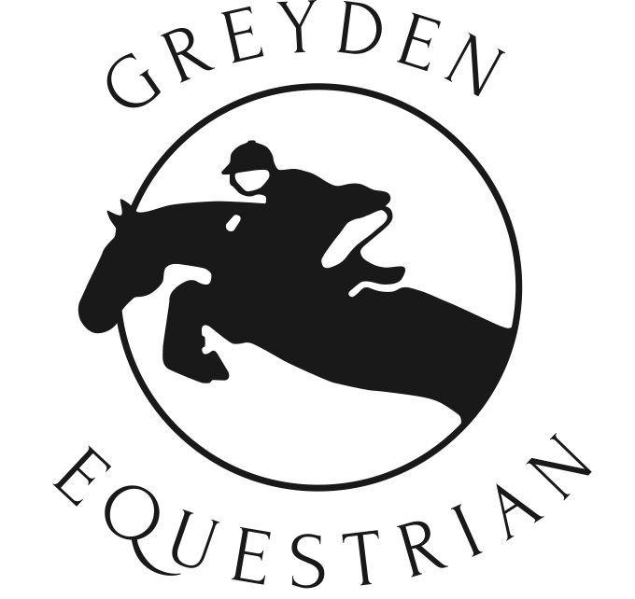

Greyden Equestrian Summer Riding Camps

# Person/Health Information Registration and Harmless Waiver

*(This form must be on file to ensure your space is reserved)*

Please print off and fill in, and return to Greyden Equestrian. We will accept a digital form for registration purposes. A hard copy signed must be on file, so please **bring with your camper the first day of camp**.

Campers must be 7 years of age as of January 1, 2025 to be able to attend camp.

# Summer 2025 Camp Dates

Check off week(s) desired. Detailed information can be found at [www.greydeneq.ca](http://www.greydeneq.ca)

* **Camp One:** Scrapbook Camp – July 7-11 ❏ **Camp Two:** Full Immersion – July 14-18 $495 + hst = $559.35 $495 + hst = $559.35
* **Camp Three:** Rider Level Boot Camp – July 21-25 ❏ **Camp Four:** Pony Pals – July 28 - Aug 1

$495* + hst = $559.35 $495 + hst = $559.35

Each Session requires full payment by **June 1st 2025**. **Payment terms are cash or cheque only, dropped off at the farm**. $50 Cancellation fee. Registration begins **March 1, 2025.** Camp three has additional fees related to Equestrian Canada Rider Level testing. See website for more information.

|  |  |  |
| --- | --- | --- |
| Camper’s name: | Age: Height:  Weight: | Would you like to order a T-Shirt ($15)? Yes / No T-Shirt size: |
| Address: | City: | Postal Code: |
| Email: | Home phone: |  |
| Cellphone: | Daytime phone: |  |
| Parents name(s): |  |  |
| Emergency contact and phone: |  |  |
| Doctor’s name and phone: |  |  |
| Health Card number: | Amount enclosed: |  |
| **Please explain any medical or behavioural information that we should know about:** |  |  |

# Harmless Waiver Parent’s signature required

I understand that riding is a risk sport. I realize that while riding or being present on the property at Greyden Equestrian, there is a possibility of a fall or injury that may cause serious bodily injury or death. I will not hold Greyden Equestrian, its owner, employees, volunteers or associates responsible for any injury or damage to any person or property.

Parent/Guardian: Date:

Signed:

# Email this form to [admin@greydeneq.ca](mailto:admin@greydeneq.ca)