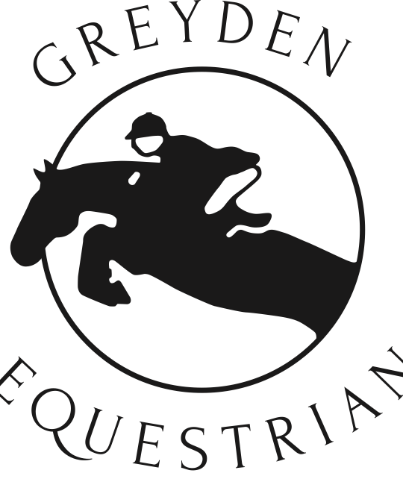

Greyden Equestrian Summer Riding Camps

Person/Health Information Registration and Harmless Waiver
(This form must be on file to ensure your space is reserved)
Please print off and fill in, and return to Greyden Equestrian. We will accept a digital form for registration purposes. A hard copy signed must be on file, so please bring with your camper the first day of camp.
Campers must be 7 years of age as of January 1, 2026 to be able to attend camp.

Summer 2026 Camp Dates
Check off week(s) desired. Detailed information can be found at www.greydeneq.ca

- Camp One: Scrapbook Camp Week 1 – July 6-10 ❏ Camp Two: Scrapbook Camp Week 2 – July 13-17 $475 + hst = $536.75 $475 + hst = $536.75
- Camp Three: Rider Level Boot Camp – July 20-24 ❏ Camp Four: Pony Pals – July 27 31
$450* + hst = $508.50 $450 + hst = $508.50

Each Session requires full payment by June 1st 2026. Payment terms are cash or cheque only, dropped off at the farm. $50 Cancellation fee. Registration begins March 1, 2026 though registrations through email may be sent in earlier. Camp three has additional fees related to Equestrian Canada Rider Level testing. See Greyden website for more information.

Camper’s name: | Age:  Height:  Weight: | Would you like to order a T-Shirt ($15)? Yes / No T-Shirt size:
Address: | City: | Postal Code:
Email: | Home phone:
Cellphone: | Daytime phone:
Parents name(s):
Emergency contact and phone:
Doctor’s name and phone:
Health Card number: | Amount enclosed:
Please explain any medical or behavioural information that we should know about:

Harmless Waiver Parent’s signature required
I understand that riding is a risk sport. I realize that while riding or being present on the property at Greyden Equestrian, there is a possibility of a fall or injury that may cause serious bodily injury or death. I will not hold Greyden Equestrian, its owner, employees, volunteers or associates responsible for any injury or damage to any person or property.

Parent/Guardian: Date:

Signed:

Email this form to admin@greydeneq.ca

