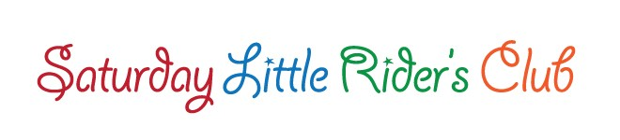

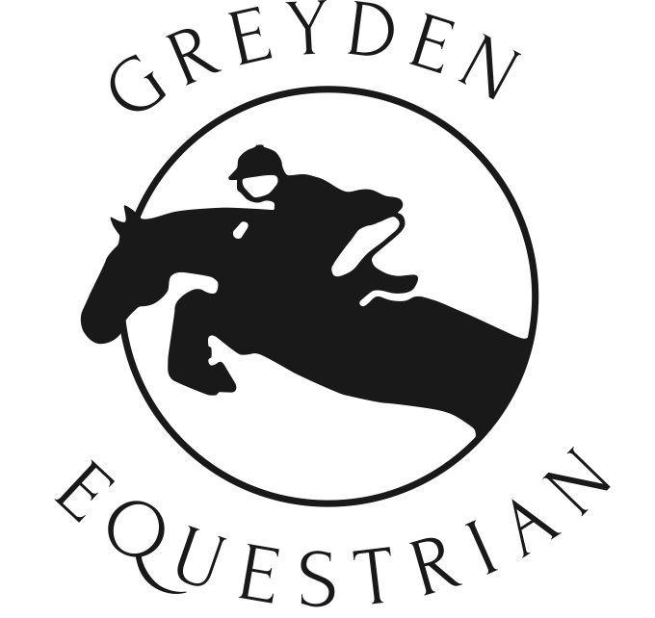Greyden Equestrian

# Person/Health Information Registration and Harmless Waiver

*(This form must be on file to ensure your space is reserved)*

Please fill out this form, print, and return to Greyden Equestrian along with Session Payment of $211.88 (**cash or cheque**). This is the only way to reserve your rider’s spot. We can not accept e-transfer. Please email this form to [admin@greydeneq.ca](mailto:admin@greydeneq.ca) and arrange your form and payment drop-off.

Your rider MUST wear pants and a shoe or boot with a heel. If they have their own riding helmet, please bring it. Otherwise, we will fit each rider to the best of our ability with the helmets we have.

# Saturday Little Rider’s Club Spring 2025

Detailed information can be found at [www.greydeneq.ca](http://www.gredenequestrian.com/)

❏ **March 22, 29, and April 5th 2025** – 9:30am to 12:30 pm $187.50 + hst = **$211.88**

The Session requires full payment upon registration.

|  |  |  |
| --- | --- | --- |
| Name: |  | Age:  Weight: Height: |
| Address: | City: | Postal Code: |
| Email: | Home phone: |  |
| Cellphone: | Daytime phone: |  |
| Parent’s name(s): |  |  |
| Emergency contact and phone: |  |  |
| Doctor’s name and phone: |  |  |
| Health Card number: | Amount enclosed: |  |

Please explain any medical or behavioural-type information that we should know about:

**Harmless Waiver** Parent’s signature required

I understand that riding and being around horses is a risk sport. I realize that while riding or while at Greyden Equestrian, there is a possibility of serious bodily injury and/or death. I will not hold Greyden Equestrian, its owner, employees or associates responsible for any injury or damage to any person or property.

Parent/Guardian: Date:

Signed: