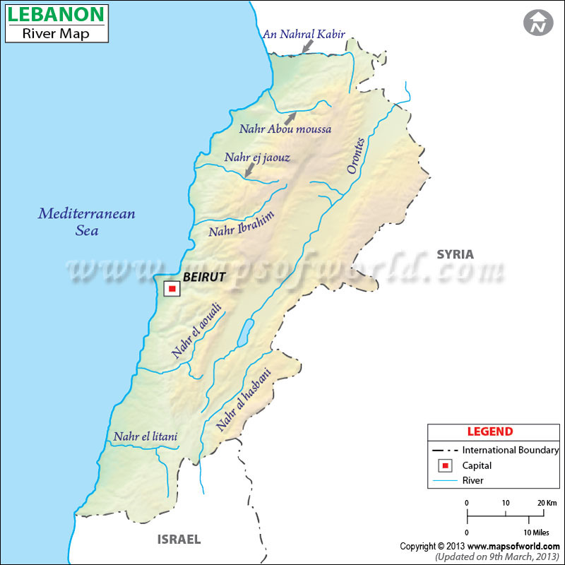

Rivers of Lebanon — Key Types and Details
Lebanon boasts around 22 non-navigable rivers, with 28 originating on the western slopes of the Lebanon Mountains and six emerging from the Beqaa Valley

Rivers from the Western Lebanon Mountains (flowing to the Mediterranean)
- Nahr al-Kabir al-Janoubi (Eleutherus)
- Ostouene River
- Nahr Ghadir
- Arqa River
- Nahr al-Bared
- Kadisha River (Nahr Abu Ali)
- Al-Jawz River
- Abraham River (Nahr Ibrahim / Adonis)
- Nahr al-Kalb (Dog River / Lycus)
- Beirut River (Magoras)
- Damour River (Damoros / Tamyrus)
- Awali River (Bostrenus / Asclepius)
- Siniq River
- Zahrani River

Rivers from the Beqaa Valley / Inland Origins
- Litani River (Qasimiyeh / Leontes)—Lebanon’s longest river flowing entirely within the country
- Asi River (Orontes)—flows north to Syria and Turkey; shared internationally
- Hasbani River (Nahal Snir)—a headwater of the Jordan River, crosses into Israel

Selected Rivers — Highlights
River | Notes
Litani River | ~174 km, crucial for irrigation, power, and water supply; originates in Beqaa, ends north of Tyre
Awali River | ~40 km long, originates in Shouf Mountains, flows near Sidon, supports hydropower via the Awali Dam
Beirut River | ~29 km, divides Beirut from eastern suburbs, flows from Mount Sannine to the Mediterranean
Abraham River | ~23 km, originates in Mount Lebanon caves, rich in mythology (Adonis), flows into the Mediterranean north of Beirut
Ghadir River | Small river south of Beirut, heavily polluted and largely used as a sewer, dries up in summer
Jaouz River | ~38 km long, picturesque but seasonal, dries in summer and affected by pollution

