**Lebanon cities**

**Beirut "the place of many springs"** 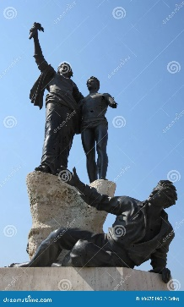

**Baalbeck “City of Baal, a god of fertility, storms, and agriculture “**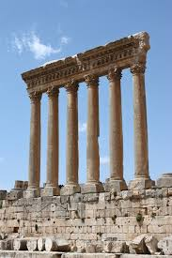

**Sidon "fishing" or "fishery."**

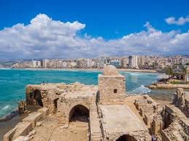

**Tyre "rock" or "fortress."**

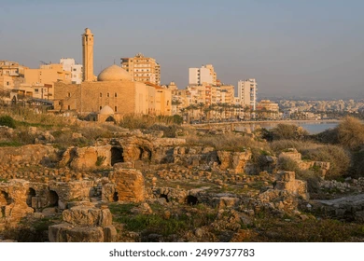

**Tripoli "three cities."**

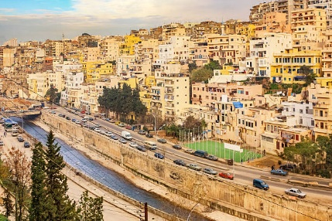

**Zahle "to slide" or "to move."**

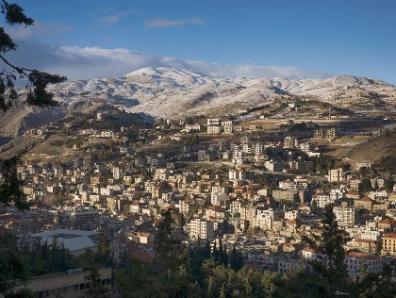

**Byblos "papyrus" or book or bible”**

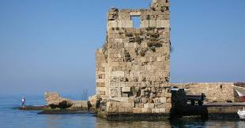

**Chouf "look" or "observe."**

