Welcome dear eclaireurs. You have a chance to know where camp d’ete is!!!
Just solve the following riddles and be ready to face the challenges :
Hint 1 :
…. - - .--. … ://-.-- --- ..- - ..- !.! -… ./…. !_!-.. “.---” -… 1 “.-.. …-“ --.. “-..”0? … ..= -..- “-..- -..- -- -.-. -“ !-! .-. “. .--- .-.. -…7.” -.—“-.-.”

Hint 2 :
War is an intense, organized, and violent conflict between states, governments, or other armed groups. It is waged using armed forces and weapons to achieve political, territorial, or strategic objectives, and typically results in devastating loss of life, displacement, and economic destruction.

Tips & Tricks :
- “” = Majuscule

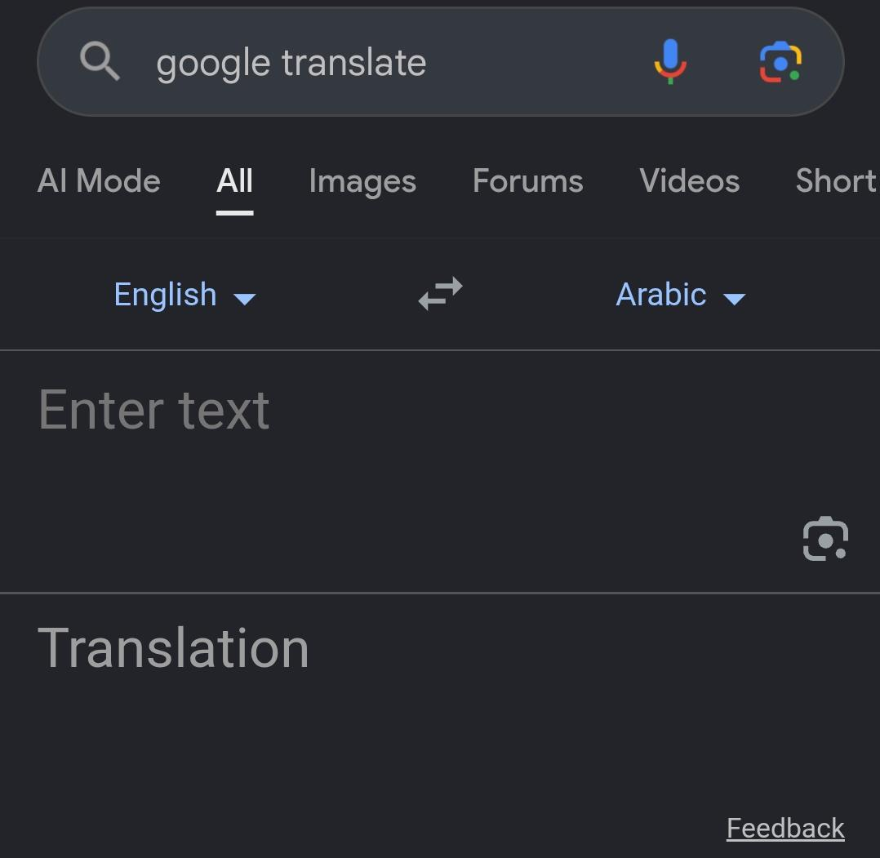

- Reverse
- !! = write it as it is

