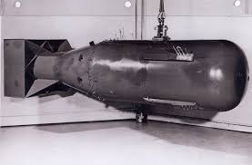 | Atomic Bomb | First deployed in 1945, this devastating weapon ended the war in the Pacific. Developed in secrecy, it reshaped global warfare and diplomacy. Its use over two cities led to mass destruction and Japan’s surrender. Today, it remains a powerful deterrent and a key focus of arms control agreements.
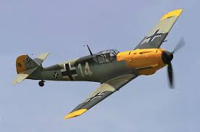 | Messerschmitt Bf 109 | Introduced in 1937, this aircraft dominated early air battles. It was crucial in the Battle of Britain and on the Eastern Front. Despite being eventually outclassed, it remained in service until the war’s end. Today, restored models appear in museums and airshows, symbolizing its once-formidable air superiority.
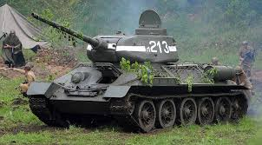 | T-34 Tank | Entering battle in 1941, this armored vehicle revolutionized warfare with its mobility and sloped armor. It was instrumental in defeating enemy forces on the Eastern Front, especially at Kursk. Its design influenced future generations of armored vehicles, and it remains a historic symbol of military innovation today.
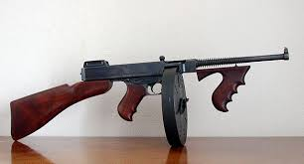 | Thompson Submachine Gun | Widely used by infantry in both Europe and the Pacific, this rapid-fire weapon proved invaluable in close combat. Its reliability made it a favorite among troops clearing enemy positions. While later replaced by lighter alternatives, it remained in use for decades and became an icon of urban warfare.
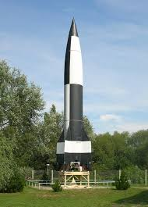 | V-2 Rocket | Launched in 1944, this long-range weapon terrorized Allied cities with supersonic speed. It was too late to change the war’s outcome but influenced Cold War missile technology. Engineers behind its development contributed to space programs, making it a crucial stepping stone in modern rocketry and space exploration.
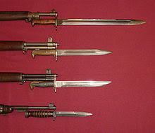 | Bayonet | A staple of infantry combat, this weapon was attached to rifles for close-quarters fighting. It was widely used in the Pacific and on the Eastern Front, where brutal hand-to-hand combat was common. Though largely replaced by modern tactics, it remains in military training as a symbol of last-resort combat readiness.

