Indice 1 – air
Hint :
Chakla :3alye w byechbe2a l hawa
Code : A7777 (A=7)

11/13/18/15/25/11 // 25/7/5/10/11/26 // 11/18 // 26/7/18/18/11/14

Indice 2 – water
Hint :
Chakla : talej
Code : ICE (I=S)

I / K / H / W / U / B

Indice 3 – fire
Hint :
Chakla : sokhne
Code : khallik healthy (H=C)

K/T/Z/W // X/J/F/X/T/S // G/F/P/J/W/D

Indice 4 – shadow
Hint
Fay l chajra l kbire
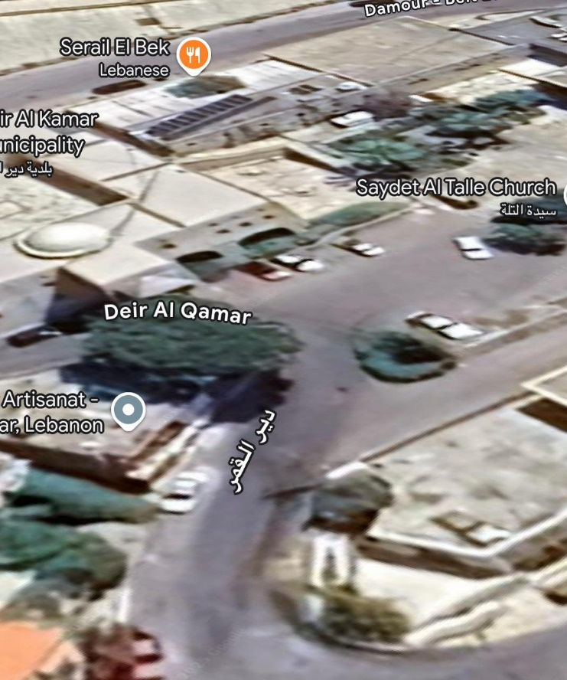
Indice 5 – earth
Hint
Les premières formes de bougies, ou plutôt de chandelles, sont très anciennes. Les Égyptiens utilisaient déjà des bougies faites de suif animal et de joncs comme mèches il y a environ 3000 ans av. J.-C.
Les Grecs et les Romains ont développé des bougies en cire d'abeille, considérées comme plus raffinées.

Destination (Greek language)
Μουσείο Κέρινων Ομοιωμάτων

Indice 6 – storm
Hint
Les générateurs de courant électrique ont deux ole distincts : Le ole positif caractérisé par son oleé permanent d’électrons ; Le ole négatif qui au contraire, se caractérise par un excès d’électrons permanents.

Destination : code generateur ( + = tat / - = tit )

+ + / + + + / + / - / - - + / - + - // - + + + / - + / - - + / + - / -

Indice 7 – nation
Here are the latest verified results from the 2025 municipal elections in Deir al-Qamar, which is part of the Chouf district in Mount Lebanon:

🗳️ Deir al-Qamar Election Outcome
- The “Deir al-Qamar United” list won the municipal council by a clear lead.
- This list was supported by the Lebanese Forces, former minister Naji Boustani, and prominent local families
- At the time of the report, only one out of the 18 ballot boxes had been counted, but “Deir al-Qamar United” was already declared the winner based on its lead

📋 Summary Table
Municipality | Winning List | Support Base | Status (first count)
Deir al-Qamar | Deir al-Qamar United | Lebanese Forces, Naji Boustani, Local Families | Unclear seats tallied (1/18 counted), significant lead reported

These first-round results indicate a clear victory for the Deir al-Qamar United list. Final official tallies across all ballots are expected to confirm this outcome. Let me know if you'd like more details on vote counts or the mukhtar elections!

Indice 8 – nomads

Nomads are people who move from place to place, instead of living in one fixed location. They usually travel to find food, water, or better living conditions, often depending on seasons or resources.

Now they are moving to a place in Deir l qamar in order to learn the French language (institute francaise )

Indice 9 – conclave
A conclave is a private or secret meeting, usually held to make an important decision.
The word is most famously used for:
- The meeting of Catholic cardinals to choose a new Pope.
- Any closed gathering of leaders, officials, or group members to discuss serious matters.
It comes from Latin "con clavis", meaning "with a key" — because the meeting is kept locked and private.

العنصر | التفاصيل
الاسم | كنيسة سيّدة الوردية الدلغانة
العهد | تأسست في ثلاثينيات القرن الـ18 وتم انتهاء بنائها عام 1760
اللوحات الفنية | أعمال فنية مهمة من القرن التاسع عشر والعشرين
الدور الاجتماعي | أول مدرسة مجانية ديمقراطية في الشرق
قيمة دينية متعددة | مكرسة من قبل جميع الطوائف في المنطقة

Indice 10 – syndicate
A syndicate is a group of people or organizations that work together for a common goal.
Depending on the context
Beit l jabal guest house could be the perfect place to host meetings and have fruitful conversations

Indice 11 – tribe (nabe3 l 7anen)
Long ago, in a time when the four tribes roamed the mountains of Lebanon in search of balance and survival, a terrible drought swept across the land. Rivers ran dry, crops withered, and even the birds flew higher in search of misty clouds. The leaders of the tribes gathered and sent their best scouts in all directions — east to the cedars, west to the sea, and south to the hills of the Shouf.
Among them was a young scout named Tariq, who believed that ancient signs always pointed the way. He followed whispers in the wind and carved trails until he reached the heart of an old village — Deir el Qamar. There, at the center of the stone-paved square, he sat to rest under the sun, near a cracked marble fountain that had not flowed in years.
But something strange caught his eye...
A small flower — fresh, green, and alive — was growing between two stones. Curious, he pressed his ear to the ground and heard it — a faint bubbling beneath the earth. Tariq called for help, and the tribes began to dig.
By sunset, they struck it.
A hidden underground spring near Deir el Qamar square burst forth, filling the old fountain again. Water flowed down the square like a blessing, and the people cheered.
From that day on, Deir el Qamar became a place of meeting, peace, and stories, where tribes returned not only for water... but to remember the scout who listened to the earth.

Indice 12 – kingdom

Fakhr al-Din II (Arabic: فخر الدين الثاني), also spelled Fakher el Dine or Fakhreddine, was a prominent historical figure in Lebanese and Middle Eastern history. He was a Druze prince and ruler of the Emirate of Mount Lebanon during the late 16th and early 17th centuries under Ottoman suzerainty. He's often remembered as a national hero in Lebanon for his efforts in uniting and developing the region.

Who Was Fakhr al-Din?
- Full Name: Fakhr al-Din ibn Maan
- Born: Around 1572
- Died: 1635 (executed by the Ottomans)
- Dynasty: Maanid Emirate (an influential Druze dynasty)
- Religion: Druze
- Title: Emir (prince) of Mount Lebanon

In honor of him, a castle in his name was built in deir l qamar

