**Maitrise**

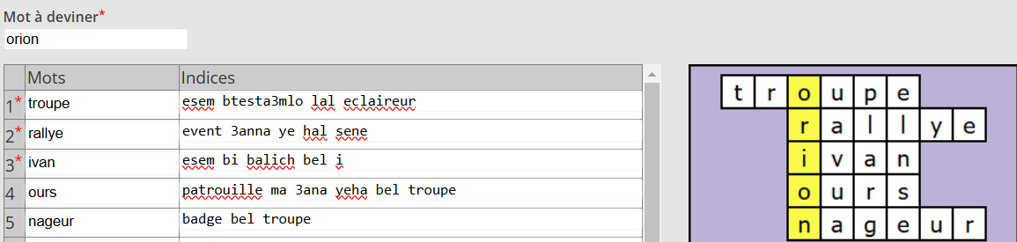

**Goelands**

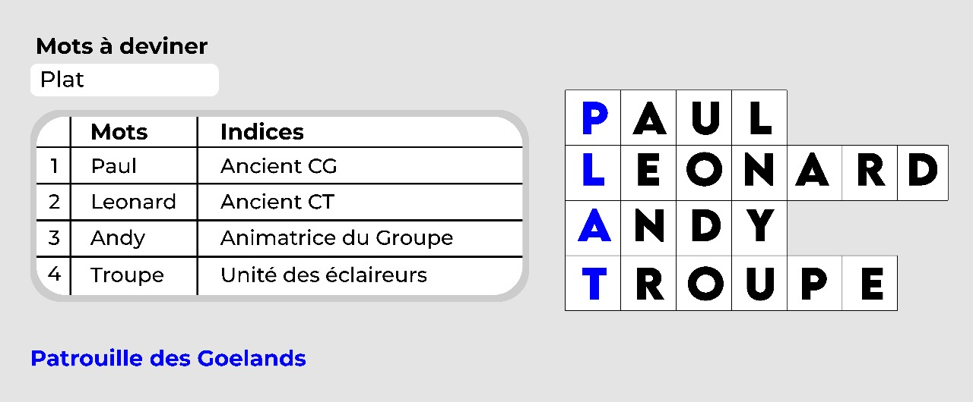

**Lions**

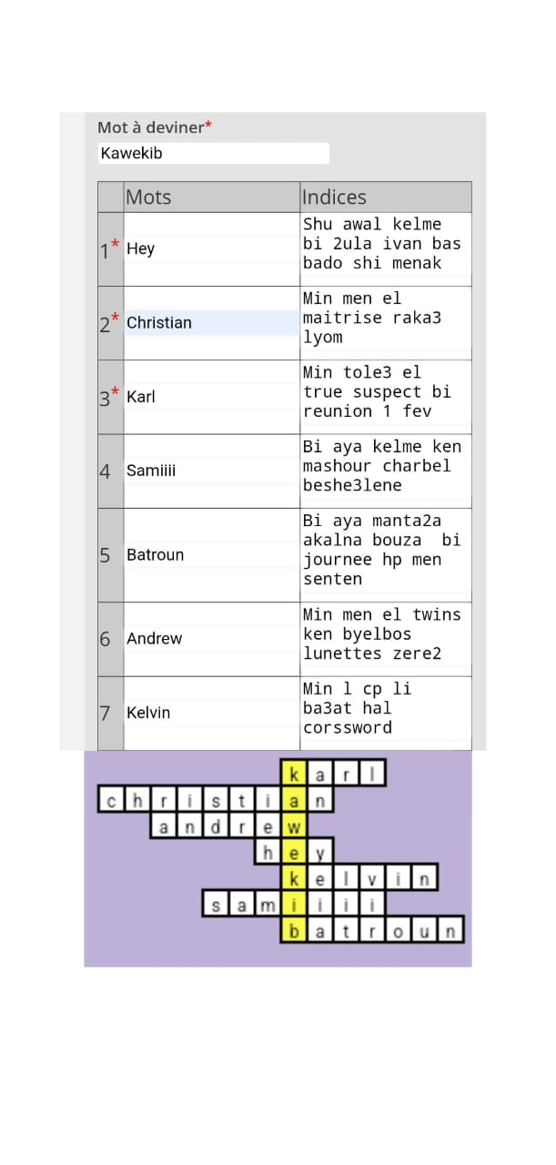

**Guepards**

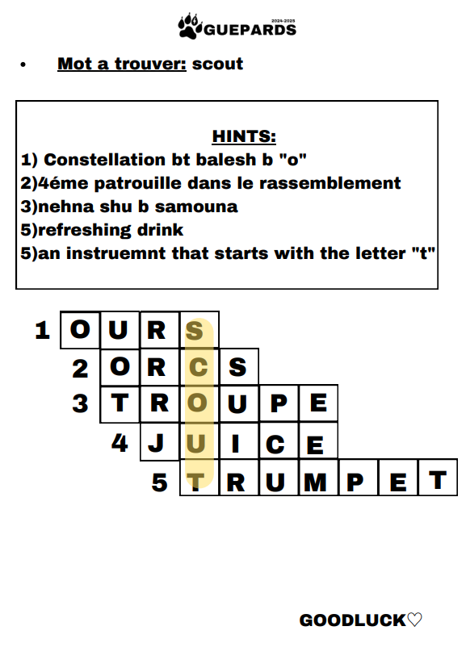

**Orcs**

**JOH𝗡NY**

**𝗢RC**

**CAB𝗘STANT**

**NAT𝗨RE**

**𝗗IMI**

**Joh N ny A muscular assistant 💪**

**O rc 4th patrouille in the Troupe Orion fellowship ⋆｡˚🫧🐋𖦹ׂ⋆｡˚**

**Cab E stant The beginning of every brelage 🪢**

**Nat U re Our Lord's creation 🌳🐌**

**D imi The newest assistant 🤫**

**Renards**

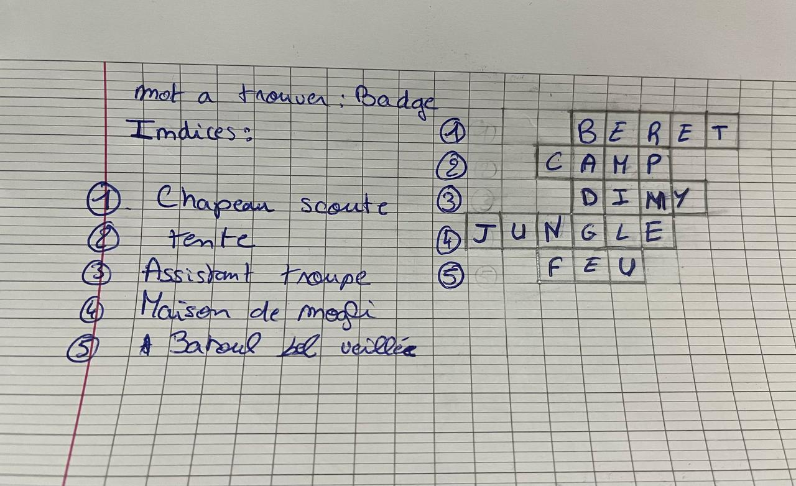

**Tauraux**

