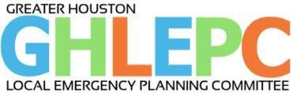
Agenda

January 27, 2021 Meeting

Logistics:
10:00AM – 12:00PM
Audio/Video Conference via Zoom

Welcome: Chair/Vice Chair

Business:

Chair/Vice Chair Report
  - December 2020 Meeting Notes (available at https://ghlepc.org/information)
  - TCEQ & Regional updates
  - Tier II Reporting
  - By-Laws Review

Treasurer Report

2020 Year in review

PIO Report
  - Release Incident(s)

Houston Fire Department Updates
- Member Reports
  - Introductions: LEPC Members and New Members

Guest Speaker: Nickea Bradley, Director, City of Houston Office of Emergency Management will provide City of Houston updates and introduction of her team. She is the City of Houston new emergency management coordinator overseeing the emergency management program including the coordination of disaster mitigation, planning, response, and recovery for the nation’s fourth largest city. She joins us from the District of Columbia’s Homeland Security and Emergency Management Agency, where she served as Bureau Chief of Long-Term Risk Reduction and State Hazard Mitigation Officer.

Next Meeting: Wednesday, March 31, 2021 via Zoom

