July 2021 |  |  |  |  |  |  |  |  | August 2021 |  |  |  |  |  |  |  |  | September 2021 |  |  |  |  |  |  |  |  | October 2021
S | M |  | T | W | T | F | S |  | S | M | T |  | W | T | F | S |  | S | M |  | T | W | T | F | S |  | S | M | T | W | T | F | S
 |  |  |  |  | 1 | 2 | 3 |  | 1 | 2 | 3 |  | 4 | 5 | 6 | 7 |  |  |  |  |  | 1 | 2 | 3 | 5 |  |  |  |  |  |  | 1 | 2
4 | 5 |  | 6 | 7 | 8 | 9 | 10 |  | 8 | 9 | 10 |  | 11 | 12 | 13 | 14 |  | 5 | 6 |  | 7 | 8 | 9 | 10 | 11 |  | 3 | 4 | 5 | 6 | 7 | 8 | 9
11 | 12 |  | 13 | 14 | 15 | 16 | 17 |  | 15 | 16 | 17 |  | 18 | 19 | 20 | 21 |  | 12 | 13 |  | 14 | 15 | 16 | 17 | 18 |  | 10 | 11 | 12 | 13 | 14 | 15 | 16
18 | 19 |  | 20 | 21 | 22 | 23 | 24 |  | 22 | 23 | 24 |  | 25 | 26 | 27 | 28 |  | 19 | 20 |  | 21 | 22 | 23 | 24 | 25 |  | 17 | 18 | 19 | 20 | 21 | 22 | 23
25 | 26 |  | 27 | 28 | 29 | 30 | 31 |  | 29 | 30 | 31 |  |  |  |  |  |  | 26 | 27 |  | 28 | 29 | 30 |  |  |  | 24 | 25 | 26 | 27 | 28 | 29 | 30
 |  |  |  |  |  |  |  |  |  |  |  |  |  |  |  |  |  |  |  |  |  |  |  |  |  |  | 31
November 2021 |  |  |  |  |  |  |  |  | December 2021 |  |  |  |  |  |  |  |  | January 2022 |  |  |  |  |  |  |  |  | February 2022
S |  | M | T | W | T | F | S |  | S | M |  | T | W | T | F | S |  | S |  | M | T | W | T | F | S |  | S | M | T | W | T | F | S
 |  | 1 | 2 | 3 | 4 | 5 | 6 |  |  |  |  |  | 1 | 2 | 3 | 4 |  |  |  |  |  |  |  |  | 1 |  |  |  | 1 | 2 | 3 | 4 | 5
7 |  | 8 | 9 | 10 | 11 | 12 | 13 |  | 5 | 6 |  | 7 | 8 | 9 | 10 | 11 |  | 2 |  | 3 | 4 | 5 | 6 | 7 | 8 |  | 6 | 7 | 8 | 9 | 10 | 11 | 12
14 |  | 15 | 16 | 17 | 18 | 19 | 20 |  | 12 | 13 |  | 14 | 15 | 16 | 17 | 18 |  | 9 |  | 10 | 11 | 12 | 13 | 14 | 15 |  | 13 | 14 | 15 | 16 | 17 | 18 | 19
21 |  | 22 | 23 | 24 | 25 | 26 | 27 |  | 19 | 20 |  | 21 | 22 | 23 | 24 | 25 |  | 16 |  | 17 | 18 | 19 | 20 | 21 | 22 |  | 20 | 21 | 22 | 23 | 24 | 25 | 26
28 |  | 29 | 30 |  |  |  |  |  | 26 | 27 |  | 28 | 29 | 30 | 31 |  |  | 23 |  | 24 | 25 | 26 | 27 | 28 | 29 |  | 27 | 28
 |  |  |  |  |  |  |  |  |  |  |  |  |  |  |  |  |  | 30 |  | 31
March 2022 |  |  |  |  |  |  |  |  | April 2022 |  |  |  |  |  |  |  |  | May 2022 |  |  |  |  |  |  |  |  | June 2022
S | M |  | T | W | T | F | S |  | S | M |  | T | W | T | F | S |  | S |  | M | T | W | T | F | S |  | S | M | T | W | T | F | S
 |  |  | 1 | 2 | 3 | 4 | 5 |  |  |  |  |  |  |  | 1 | 2 |  | 1 |  | 2 | 3 | 4 | 5 | 6 | 7 |  |  |  |  | 1 | 2 | 3 | 4
6 | 7 |  | 8 | 9 | 10 | 11 | 12 |  | 3 | 4 |  | 5 | 6 | 7 | 8 | 9 |  | 8 |  | 9 | 10 | 11 | 12 | 13 | 14 |  | 5 | 6 | 7 | 8 | 9 | 10 | 11
13 | 14 |  | 15 | 16 | 17 | 18 | 19 |  | 10 | 11 |  | 12 | 13 | 14 | 15 | 16 |  | 15 |  | 16 | 17 | 18 | 19 | 20 | 21 |  | 12 | 13 | 14 | 15 | 16 | 17 | 18
20 | 21 |  | 22 | 23 | 24 | 25 | 26 |  | 17 | 18 |  | 19 | 20 | 21 | 22 | 23 |  | 22 |  | 23 | 24 | 25 | 26 | 27 | 28 |  | 19 | 20 | 21 | 22 | 23 | 24 | 25
27 | 28 |  | 29 | 30 | 31 |  |  |  | 24 | 25 |  | 26 | 27 | 28 | 29 | 30 |  | 29 |  | 30 | 31 |  |  |  |  |  | 26 | 27 | 28 | 29 | 30
Sep 01: Parent Information Night
Sep 06: Labor Day (CLOSED)
Sep 07: Staff Development (CLOSED)
Sep 08: Open House
Sep 09: First Day of School
Sep 28: PTA Meeting (6-7pm)
Oct 08: UPK Conference Day (NO UPK)
Oct 11: UPK Conference Day (NO UPK)
Oct 18: Picture Day
Oct 19: Picture Day
Oct 20: Picture Day
Oct 29: Halloween Parade (11-11:30am)
Nov 01: Parent Teacher Conferences (JPK 1)
Nov 02: Parent Teacher Conferences (JPK 2)
Nov 03: Parent Teacher Conferences (PreK1)
Nov 04: Parent Teacher Conferences (PreK2)
Nov 11: Veterans Day (CLOSED)
Nov 25: Thanksgiving Day (CLOSED)
Nov 26: CLOSED
Dec 17: Holidays Around the World (6-7:30pm)
Dec 24: Christmas Eve (CLOSED)
Jan 08: Solutions for Families I (9-12pm)
Jan 17: Martin Luther King Day (CLOSED)
Jan 25: PTA (6-7pm)
Feb 05: Solutions for Families II (9-12 pm)
Feb 14: Valentine’s Day Party (11-12pm)
Mar 05: Solutions for Families III (9-12pm)
Mar 11: UPK Conference Day (NO UPK3
Mar 19: Family Fun Night (6-7:30pm)
Apr 09: Imagination Day (10-12pm)
Apr 26: Picture Day
Apr 26: PTA (6pm-7pm)
Apr 27: Picture Day
May 09: Parent Teacher Conferences (JPK1)
May 10: Parent Teacher Conferences (JPK2)
May 11: Parent Teacher Conferences (PreK1)
May 12: Parent Teacher Conferences (PreK2)
May 30: Memorial Day (CLOSED)
June 23: UPK 1-3 Graduation (10-10:30 am)
June 23: UPK 4&5 Graduation (11-11:30am)
June 23: UPK 6&7 Graduation (12-12:30pm)
June 23: PREK 1&2 Graduation (1-1:30pm)
June 24: Last Day of School

June 22: PreK 1&2 Graduation (1-1:30pm)

IMAGINATION CHILDCARE ACADEMY 2021-2022 SCHOOL CALENDAR

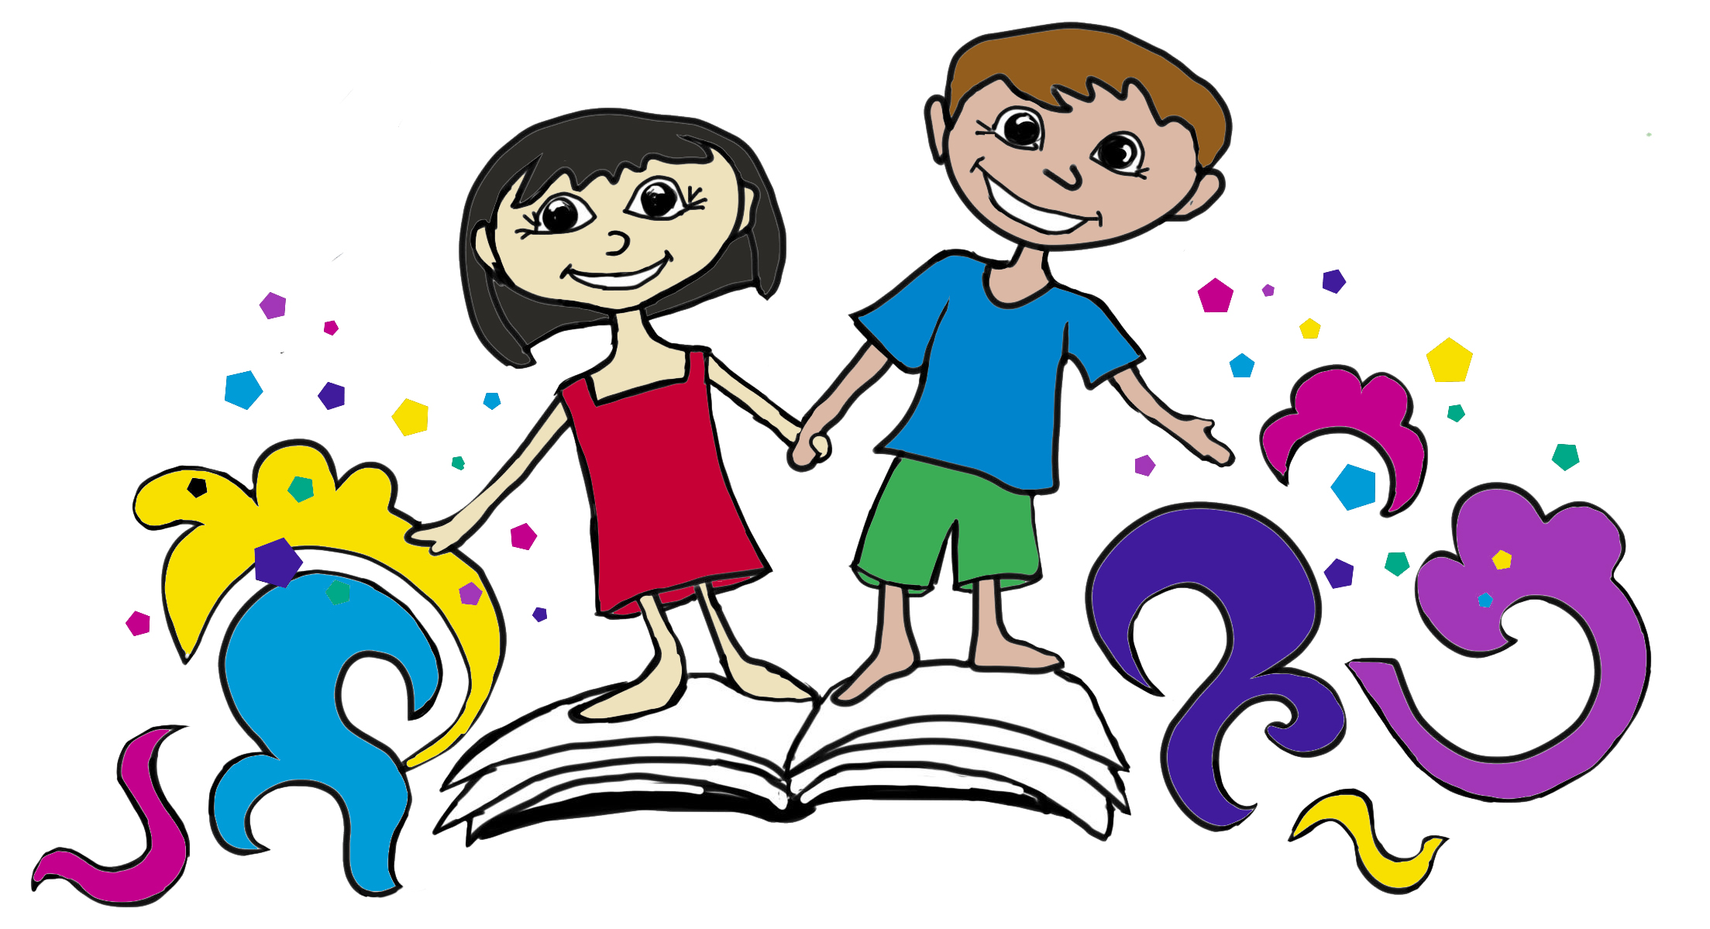

No Childcare Available

