Aug 23: Parent Information Night
Aug 31: Parent Teacher Meet & Greet
Sep 02: Open House
Sep 05: Labor Day (CLOSED)
Sep 06: First Day of School
Sep 27: PTA Meeting (6-7pm)
Oct 07: NO UPK (Childcare Available)
Oct 08: Solutions for Families I (9-12pm)
Oct 10: NO UPK (Childcare Available)
Oct 17: Picture Day
Oct 18: Picture Day
Oct 19: Picture Day
Oct 31: Halloween Parade (11-11:30am)
Nov 05: Solutions for Families II (9-12pm)
Nov 07: Parent Teacher Conferences (JPK 1)
Nov 08: Parent Teacher Conferences (JPK 2)
Nov 09: Parent Teacher Conferences (JPK3)
Nov 10: Parent Teacher Conferences (PreK)
Nov 11: Veterans Day (CLOSED)
Nov 12: Craft Fair (10am-3pm)
Nov 24: Thanksgiving Day (CLOSED)
Nov 25: CLOSED
Dec 03: Solutions for Families III (9-12pm)
Dec 05: Parent Teacher Conferences (UPK)
Dec 16: Holidays Around the World (6-7:30pm)
Dec 23: Parent Teacher Conferences (UPK)
Dec 26: Christmas-Observance (CLOSED)
Jan 02: New Year’s Day-Observance (CLOSED)
Jan 16: Martin Luther King Day (CLOSED)
Jan 24: PTA (6-7pm)
Jan 27: NO UPK (Childcare Available)
Mar 10: NO UPK (Childcare Available)
Apr 15: Imagination Day (10-12pm)
Apr 25: PTA (6pm-7pm)
May 06: Painting with a Twist (10am-12pm)
May 08: Parent Teacher Conferences (JPK1)
May 09: Parent Teacher Conferences (JPK2)
May 10: Parent Teacher Conferences (JPK3)
May 11: Parent Teacher Conferences (PreK)
May 26: NO UPK (Childcare Available)
May 29: Memorial Day (CLOSED)
June 22: UPK 1 & 2 Graduation (10-10:30 am)
June 22: UPK 3 & 4 Graduation (11-11:30am)
June 22: UPK 5 & 6 Graduation (12-12:30pm)
June 22: UPK 7 & Prek1 Graduation (1-1:30pm)
June 22: Last Day of School for UPK
June 23: Last Day of School for JPK and PreK
June 26: First Day of Summer Camp

June 22: PreK 1&2 Graduation (1-1:30pm)

IMAGINATION CHILDCARE ACADEMY 2022-2023 SCHOOL CALENDAR

July 2022 |  |  |  |  |  |  |  |  | August 2022 |  |  |  |  |  |  |  |  | September 2022 |  |  |  |  |  |  |  |  | October 2022
S | M |  | T | W | T | F | S |  | S | M | T |  | W | T | F | S |  | S | M |  | T | W | T | F | S |  | S | M | T | W | T | F | S
 |  |  |  |  |  | 1 | 2 |  |  | 1 | 2 |  | 3 | 4 | 5 | 6 |  |  |  |  |  |  | 1 | 2 | 3 |  |  |  |  |  |  |  | 1
3 | 4 |  | 5 | 6 | 7 | 8 | 9 |  | 7 | 8 | 9 |  | 10 | 11 | 12 | 13 |  | 4 | 5 |  | 6 | 7 | 8 | 9 | 10 |  | 2 | 3 | 4 | 5 | 6 | 7 | 8
10 | 11 |  | 12 | 13 | 14 | 15 | 16 |  | 14 | 15 | 16 |  | 17 | 18 | 19 | 20 |  | 11 | 12 |  | 13 | 14 | 15 | 16 | 17 |  | 9 | 10 | 11 | 12 | 13 | 14 | 15
17 | 18 |  | 19 | 20 | 21 | 22 | 23 |  | 21 | 22 | 23 |  | 24 | 25 | 26 | 27 |  | 18 | 19 |  | 20 | 21 | 22 | 23 | 24 |  | 16 | 17 | 18 | 19 | 20 | 21 | 22
24 | 25 |  | 26 | 27 | 28 | 29 | 30 |  | 28 | 29 | 30 |  | 31 |  |  |  |  | 25 | 26 |  | 27 | 28 | 29 | 30 |  |  | 23 | 24 | 25 | 26 | 27 | 28 | 29
31 |  |  |  |  |  |  |  |  |  |  |  |  |  |  |  |  |  |  |  |  |  |  |  |  |  |  | 30 | 31
November 2022 |  |  |  |  |  |  |  |  | December 2022 |  |  |  |  |  |  |  |  | January 2023 |  |  |  |  |  |  |  |  | February 2023
S |  | M | T | W | T | F | S |  | S | M |  | T | W | T | F | S |  | S |  | M | T | W | T | F | S |  | S | M | T | W | T | F | S
 |  |  | 1 | 2 | 3 | 4 | 5 |  |  |  |  |  |  | 1 | 2 | 3 |  | 1 |  | 2 | 3 | 4 | 5 | 6 | 7 |  |  |  |  | 1 | 2 | 3 | 4
6 |  | 7 | 8 | 9 | 10 | 11 | 12 |  | 4 | 5 |  | 6 | 7 | 8 | 9 | 10 |  | 8 |  | 9 | 10 | 11 | 12 | 13 | 14 |  | 5 | 6 | 7 | 8 | 9 | 10 | 11
13 |  | 14 | 15 | 16 | 17 | 18 | 19 |  | 11 | 12 |  | 13 | 14 | 15 | 16 | 17 |  | 15 |  | 16 | 17 | 18 | 19 | 20 | 21 |  | 12 | 13 | 14 | 15 | 16 | 17 | 18
20 |  | 21 | 22 | 23 | 24 | 25 | 26 |  | 18 | 19 |  | 20 | 21 | 22 | 23 | 24 |  | 22 |  | 23 | 24 | 25 | 26 | 27 | 28 |  | 19 | 20 | 21 | 22 | 23 | 24 | 25
27 |  | 28 | 29 | 30 |  |  |  |  | 25 | 26 |  | 27 | 28 | 29 | 30 | 31 |  | 29 |  | 30 | 31 |  |  |  |  |  | 26 | 27 | 28
March 2023 |  |  |  |  |  |  |  |  | April 2023 |  |  |  |  |  |  |  |  | May 2023 |  |  |  |  |  |  |  |  | June 2023
S | M |  | T | W | T | F | S |  | S | M |  | T | W | T | F | S |  | S |  | M | T | W | T | F | S |  | S | M | T | W | T | F | S
 |  |  |  | 1 | 2 | 3 | 4 |  |  |  |  |  |  |  |  | 1 |  |  |  | 1 | 2 | 3 | 4 | 5 | 6 |  |  |  |  |  | 1 | 2 | 3
5 | 6 |  | 7 | 8 | 9 | 10 | 11 |  | 2 | 3 |  | 4 | 5 | 6 | 7 | 8 |  | 7 |  | 8 | 9 | 10 | 11 | 12 | 13 |  | 4 | 5 | 6 | 7 | 8 | 9 | 10
12 | 13 |  | 14 | 15 | 16 | 17 | 18 |  | 9 | 10 |  | 11 | 12 | 13 | 14 | 15 |  | 14 |  | 15 | 16 | 17 | 18 | 19 | 20 |  | 11 | 12 | 13 | 14 | 15 | 16 | 17
19 | 20 |  | 21 | 22 | 23 | 24 | 25 |  | 16 | 17 |  | 18 | 19 | 20 | 21 | 22 |  | 21 |  | 22 | 23 | 24 | 25 | 26 | 27 |  | 18 | 19 | 20 | 21 | 22 | 23 | 24
26 | 27 |  | 28 | 29 | 303 | 31 |  |  | 23 | 24 |  | 25 | 26 | 27 | 28 | 29 |  | 28 |  | 29 | 30 | 31 |  |  |  |  | 25 | 26 | 27 | 28 | 29 | 30
 |  |  |  |  |  |  |  |  | 30

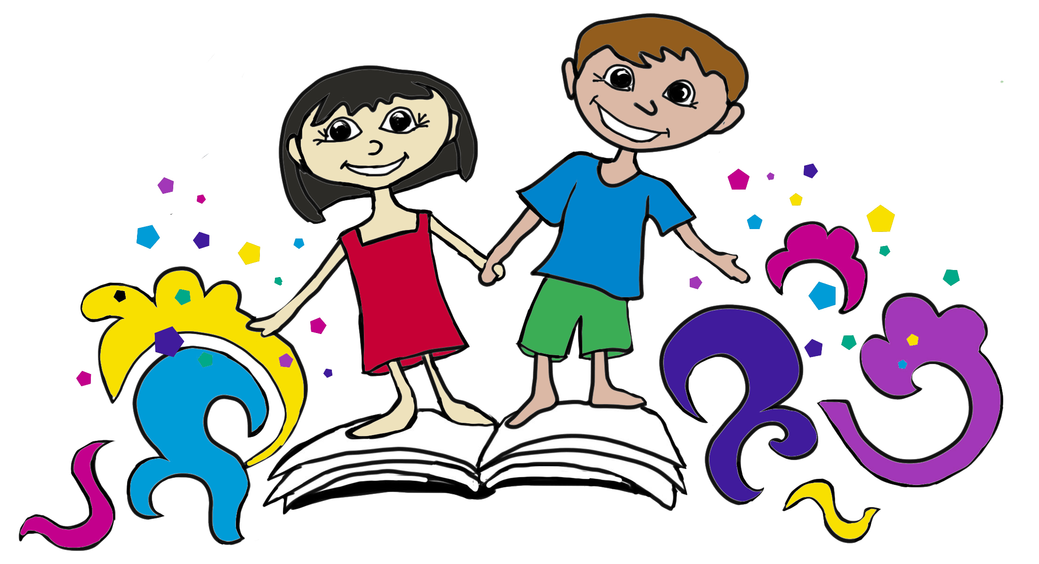

NO CHILDCARE AVAILABLE ICA is CLOSED

