**2025 Competition Team Costume List**

**I DO**- White/Gold Costume, gloves, Foot Undeez, Rhinestone Hair piece.

**Tea Time**- Multi Color Costume, leg bands, Rhinestone Bracelets, Foot Undeez, Rhinestone Hair piece.

**Titanium**- Hot Pink Dress, Rhinestone Bracelets, Foot Undeez, Rhinestone Hair piece.

**Little Mama’s**- Glitter sneakers, pants, top, Rhinestone bracelets, handkerchief. Rhinestone Hair piece.

**Elastic Heart**- Purple/Yellow Costume, Rhinestone Bracelets, Foot Undeez, Rhinestone Hair piece.

**Grease**- Black/Red Costume, Rhinestone Bracelets, Foot Undeez, Rhinestone Hair piece.

**Burlesque**- Nude Costume, Rhinestone Bracelets, Foot Undeez, Rhinestone Hair piece.

**How Will I Know**- Turquoise/Nude Costume, Rhinestone Bracelets, Foot Undeez, Rhinestone Hair piece.

**Soul Sisters**- Black/Red, Rhinestone Bracelets, Foot Undeez , Rhinestone Hair piece.

**You Make it Look Easy**- Turquoise Costume, Black Fishnets, Black Super jazz shoes, Rhinestone bracelets, Rhinestone Hair piece.

**Somebody You Loved**- Black/White Costume, Rhinestone Bracelets, Foot Undeez, Rhinestone Hair piece.

**Read All About it**- Green Costume, Rhinestone Bracelets, Foot Undeez, Rhinestone Hair piece.

**Hit the road Jack**- Multi Colored Costume, Rhinestone Bracelets, Foot Undeez, Rhinestone Hair piece.

**Independent**- pants, black top, black sneakers, Rhinestone Bracelets. Rhinestone Hair piece.

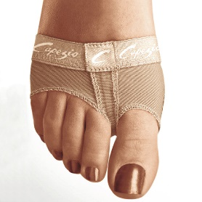Capezio Foot Undies

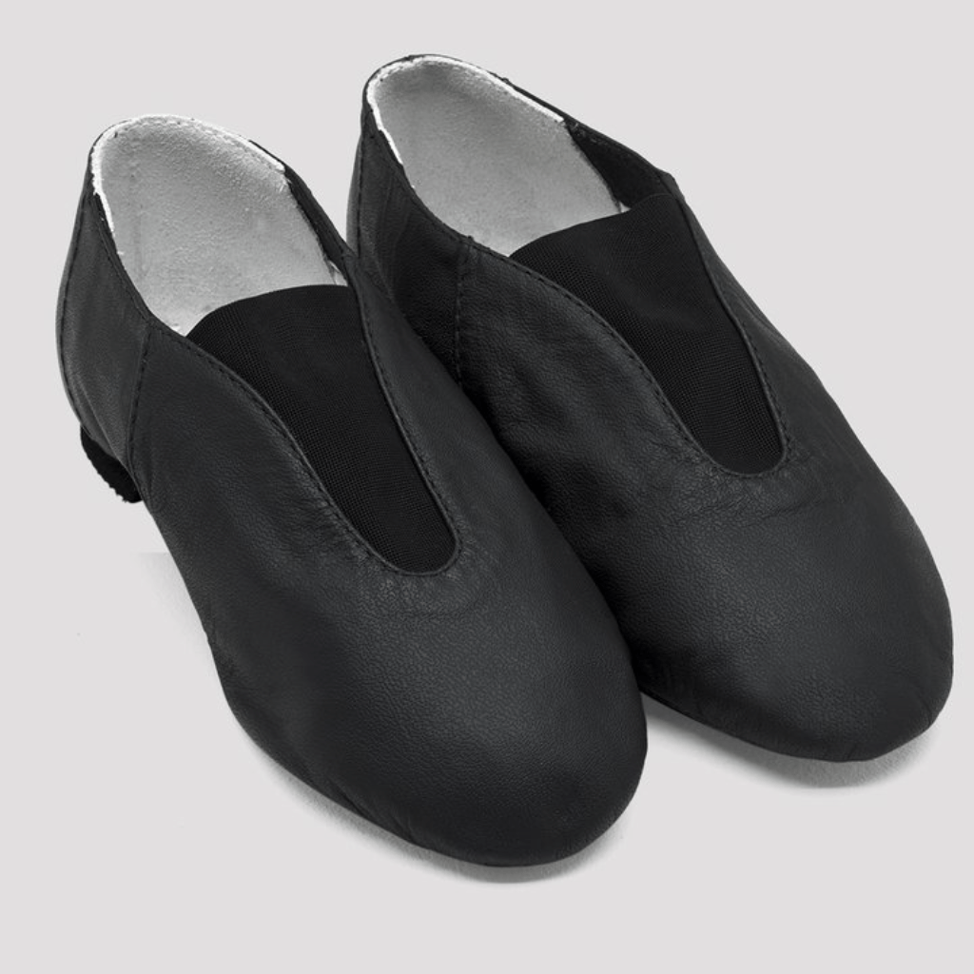 Bloch Super Jazz Black

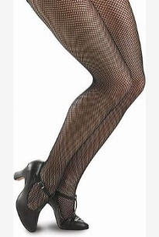 Black fishnets small squares

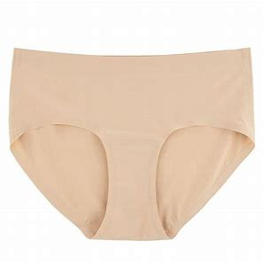nude low leg line undies

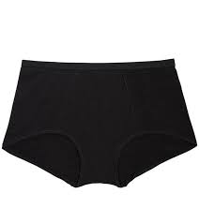Black low leg line undies

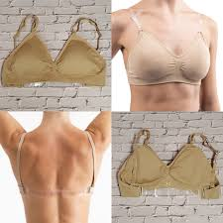 nude bra clear straps

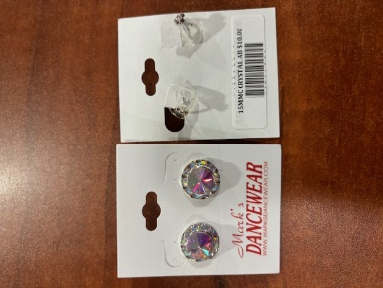 15mm AB Earrings (All Teams)

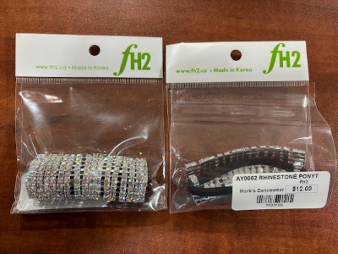 Crystal Ponytail Holder (All Teams)

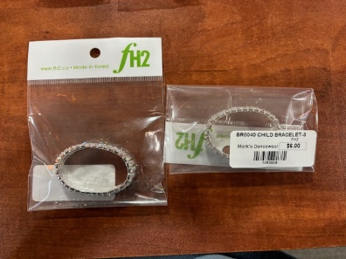 Mini/Junior Team 3 row Bracelets (Need 2)

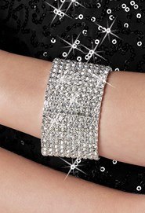 Teen Team 7 row cuff from last season (Need 2)

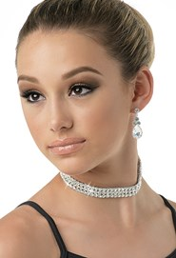 3 row AB Choker (All Teams)

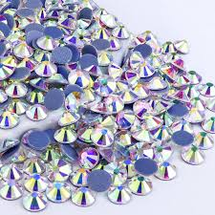 AB 30ss loose rhinestones for Face