Health Committee

The Questions of providing emergency healthcare to civilians in Israel/Palestine

**Committee: Health**

**Topic: The Question of providing emergency healthcare to**

**civilians in Israel/Palestine**

**Chair:** **Grace Gerrish and Arman Mahajan**

**Summary**

**Overview/explanation of the Topic**

-In Israel, emergency health care is provided by a well developed system. They operate a network of hospitals and emergency medical services that are able to respond to a wide range of emergencies. They are highly efficient and accessible. Additionally, Israel has national emergency medical response system that includes paramedics, emergency medical technicians and mobile intensive care units designed to rapidly respond to crises including conflict. However, the system has been put under a lot of stress. During periods of heightened violence or warfare, especially when large numbers of people are injured challenges arise. Hospitals may face difficulties in handling both civilian and military causalities’. Israeli civilians particularly in areas close to conflict zones such as Gaza border, also face the risk of attacks that could result in mass casualties further straining healthcare resources.

-In Palestine, the Palestinian Authority oversees health services in the West Bank while the Gaza strip, is governed by Hamas, a situation that creates a fragmented healthcare system with discrepancies in resource allocation, training, and infrastructure. In Gaza, the healthcare system is under immense strain. The territory has limited access to medical supplies and equipment and its healthcare facilities are also underfunded. They struggle with outdated supplies and equipment, shortages of essential medicines and a lack of healthcare professionals. The health infrastructure is frequently targeted during conflict making it even harder for healthcare workers to respond to emergencies. This is particularly evident during escalations of violence, when large numbers of civilians are injured and the healthcare system is often overwhelmed.

While the West Bank has better access to medical resources, they still face political and logistical challenges. Travel restrictions imposed by Israeli military, including checkpoints and the separation barrier can delay or prevent Palestinians from accessing necessary healthcare. Ambulance services are often delayed by these barriers particularly when urgent medical assistance is needed.

-Both Israel and Palestine face unique challenges when providing medical response during times of conflict. Emergency response in conflict zones is made difficult by the danger posed to medical workers, who are targeted or caught in crossfire. International humanitarian law, which mandates the protection of medical staff and facilities, is often violated during conflicts.

In Gaza, the ambulances face the delays or direct hits from airstrikes, making it very difficult for emergency medical teams to reach injured civilians quickly. The narrow and congested streets of Gaza complicate efforts to evacuate injured people. Furthermore, the destruction of medical infrastructure, including hospital and clinics, severely hampers the ability to provide care.

In Israel, they face the constant threat of rocket fire and other attacks from militant groups based in Gaza. Civilians in South Israel are affected by frequent rocket attacks, and the medical teams in these areas much be on constant alert. Israel has built a network of bomb shelters which also include hospitals so that they can get medical help while also being protected.

Both Israeli and Palestinian civilians face heightened risk during periods of escalated violence. The security situation can hinder the ability of healthcare providers to deliver services in a timely and efficient manner. The scarcity of medical supplies, equipment and medical personnel is a significant challenge. In Gaza, there are shortages of basic supplies like blood bags, medicines, and surgical equipment. The lack of medical experts and hospital beds often means that triage decisions must be made in extreme circumstances, and many patients are forced to go without treatment. In Israel, while resources are more plentiful, they can still face mass casualties. There are also psychological impacts on all civilians due to constant anxiety and trauma due to the threat of constant bombing and violence.

**The Origins**

-The origins of the issue of the issue of providing emergency healthcare to civilians in Israel and Palestine lie in the intersection of longstanding political, territorial and military conflicts. These have shaped the healthcare systems on both sides and continue to affect the delivery of emergency medical services. The fragmented and politicized nature of healthcare in the region, along with the constant great of violence, makes a provision if emergency care a significant and ongoing challenge.

**Why is it important?**

-The provision of emergency healthcare to civilians in Israel and Palestine is of immense importance because it directly impacts the preservation of life, the upholding of international humanitarian law, the prevention of healthcare system collapse, the reduction of psychological trauma, and the promotion of equity and justice. It is not only a medical issue but also a human rights issue. Innocent civilians should be protected as well as the ones fighting.

**Who does it affect?**

-This topic affects Israeli and Palestinian civilians, particularly vulnerable groups such as children and pregnant women, healthcare workers, humanitarian organisations, government and political leaders, refugees and displaced persons and the international community.

**Previous attempts to resolve this**

-Previous attempts to address this challenge of providing healthcare to civilians in Israel and Palestine have been multifaceted, involving both local initiatives and international intervention. One key effect has been international humanitarian organisations like the international committee of the red Cross, Médecins sans Frontières and the world health organisation, which have worked to deliver emergency medical services, set up field hospitals, and supply medical goods to the region. Local NGOs have also played a significant role in providing healthcare particularly in Gaza.

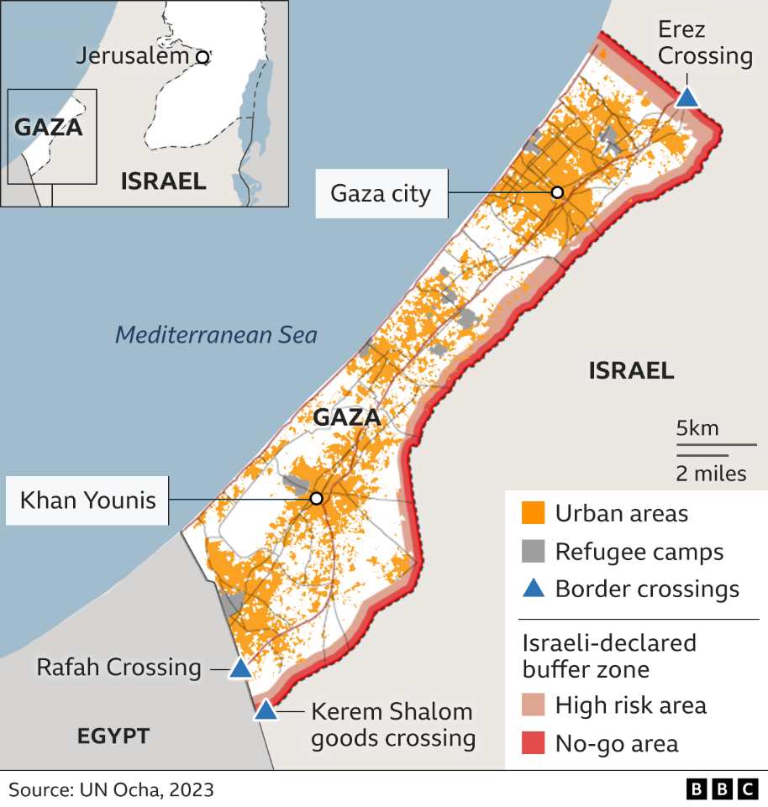

**Definition of Key Terms**

**International humanitarian law**- a set of rules that aim to limit the effects of armed conflict, ensuring the protection of non-combatants including civilians, and the provision of medical assistance. It mandates that medical facilities and personnel be protected during warfare.

**Major Countries / Organisations Involved**

Israel

Palestine

United States

red Cross

Médecins sans Frontières

the world health organisation

**(If needed) Timeline of events**

