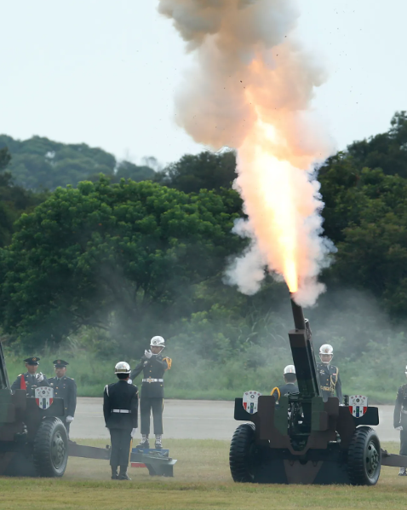

ECOFIN

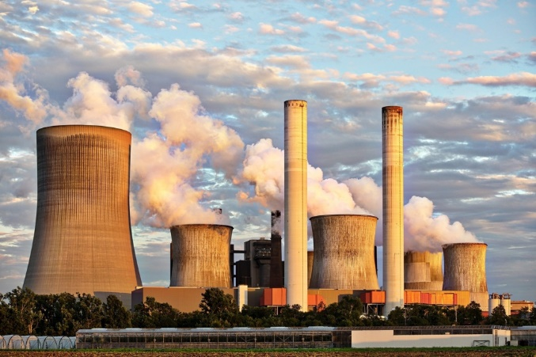

The question of over-reliance on fossil fuels within under-developed nations

Put an interesting Image here, as this is

**Committee: ECOFIN**

**Topic: The Question of over-reliance on fossil fuels within under-developed nations**

**Chairs:** **ADAORA AMBROSE AND ARLENE OLAGUNJU**

**Summary**

Over reliance on fossil fuels in underdeveloped nations creates significant economic and financial vulnerabilities. Many of these countries depend on imported oil and gas making them highly susceptible to global price fluctuations, which can lead to trade deficits, inflation, and economic instability. Additionally, heavy government subsidies for fossil fuels strain government budgets which diverts funds from the essential sectors such as healthcare and education. The maintaining of outdated energy infrastructure further limits economic growth. Furthermore, as the global economy shifts towards renewable energy, fossil fuel dependent nations risk losing foreign investment and are facing higher borrowing costs due the sustainability concerns. Without diversification, these economies remain fragile as they are constantly kept in the cycle of resource dependency.

The origins of underdeveloped nation over-reliance on fossil fuels stem from historical resource extraction during colonialism, post-independence industrialization efforts, and structural economic policies. Many of these nations inherited economies centred on exporting raw materials, including fossil fuels, while relying on imports for refined energy products. The oil shocks of the 1970s exposed their vulnerability to price fluctuations, leading to debt accumulation and financial instability. Structural adjustment programs in the 1980s and 1990s, promoted by institutions like the IMF and World Bank, prioritized economic liberalization over energy diversification, reinforcing dependence on fossil fuels. Additionally, foreign direct investment in energy infrastructure favoured fossil fuels due to lower upfront costs, while government subsidies kept energy prices artificially low, straining public finances. As the global economy shifts toward renewables, these nations now face financial barriers to transitioning, further complicating their economic stability.

Governments of underdeveloped nations have made several attempts to address the economic and financial challenges of fossil fuel dependence, often with mixed results. Some key strategies include Fuel Subsidy Reforms where countries like Nigeria, Egypt, and Pakistan have attempted to reduce or remove fuel subsidies to ease the financial burden on government budgets. While this has helped reduce deficits, it has often led to public protests due to rising fuel prices. There has also been a diversification of economies causing oil-dependent nations like Angola, Algeria, and Venezuela have launched programs to diversify their economies by investing in agriculture, manufacturing, and services. However, these efforts have faced challenges due to weak infrastructure, corruption, and global market fluctuations. Furthermore, there has been a development of International Financial Assistance and IMF Programs. Nations such as Sudan, Egypt, and Mozambique have sought financial aid from the IMF, World Bank, and other international institutions to stabilize their economies and promote energy sector reforms. These programs often include conditions to cut fossil fuel subsidies and improve fiscal management. While these attempts have shown some progress, many underdeveloped nations still struggle with financial constraints, political resistance, and infrastructure challenges, making a full transition away from fossil fuel dependence difficult.

**Definition of Key Terms**

**IMF** – International Monetary Fund is a global organization that works to achieve sustainable growth and prosperity for all its 191 member countries. It does so by supporting economic policies that promote financial stability and monetary cooperation, which are essential to increase productivity, job creation, and economic well-being. The IMF is governed by and accountable to its member countries

**Major Countries / Organisations Involved**

Here is where you briefly list the key countries involved in this issue

The over-reliance on fossil fuels affects the economics and finance of several underdeveloped nations, particularly those that either depend on fossil fuel exports for revenue or rely on imports for energy needs. Some key examples include:

1. **Nigeria**, as Africa largest oil producer, Nigeria’s economy is heavily dependent on crude oil exports, which account for over 80% of government revenue. Price fluctuations in global oil markets have led to repeated economic crises, budget deficits, and currency devaluation.
2. **Venezuela** was once one of the world’s largest oil exporters and its over-reliance on fossil fuels and economic mismanagement have led to hyperinflation, debt crises, and a collapse of public services, causing one of the worst economic downturns in modern history.
3. **Angola** is heavily dependent on oil exports and therefore suffers from economic instability when oil prices drop. Its reliance on fossil fuel revenue has led to high public debt and difficulty in diversifying the economy.
4. **Iraq**’s economy is almost entirely dependent on oil revenues, making it highly vulnerable to market fluctuations. This dependence has led to budgetary crises and difficulties in funding reconstruction and public services.
5. **Sudan and South Sudan** (in particular) relies on oil for nearly all of its export earnings. Political instability and economic mismanagement have left it struggling with debt and inflation, especially when oil revenues decline.

However, several organizations and countries play a key role in helping underdeveloped nations address their over-reliance on fossil fuels through economic and financial assistance. The most significant contributors include some International Financial Institutions such as the IMF and World Bank.

IMF that provides financial aid and policy guidance, often requiring countries to reform fossil fuel subsidies and improve economic stability (for example, the IMF has helped Egypt, Nigeria, and Pakistan implement subsidy reforms), and the World Bank that funds renewable energy projects and infrastructure development while promoting economic diversification. It has supported solar and wind projects in countries like Bangladesh and Kenya. Furthermore, developed countries such as the US, China and Germany have organizations that provide grants for clean energy projects, funded fossil fuel infrastructure or invests in renewable energy and energy efficiency projects.