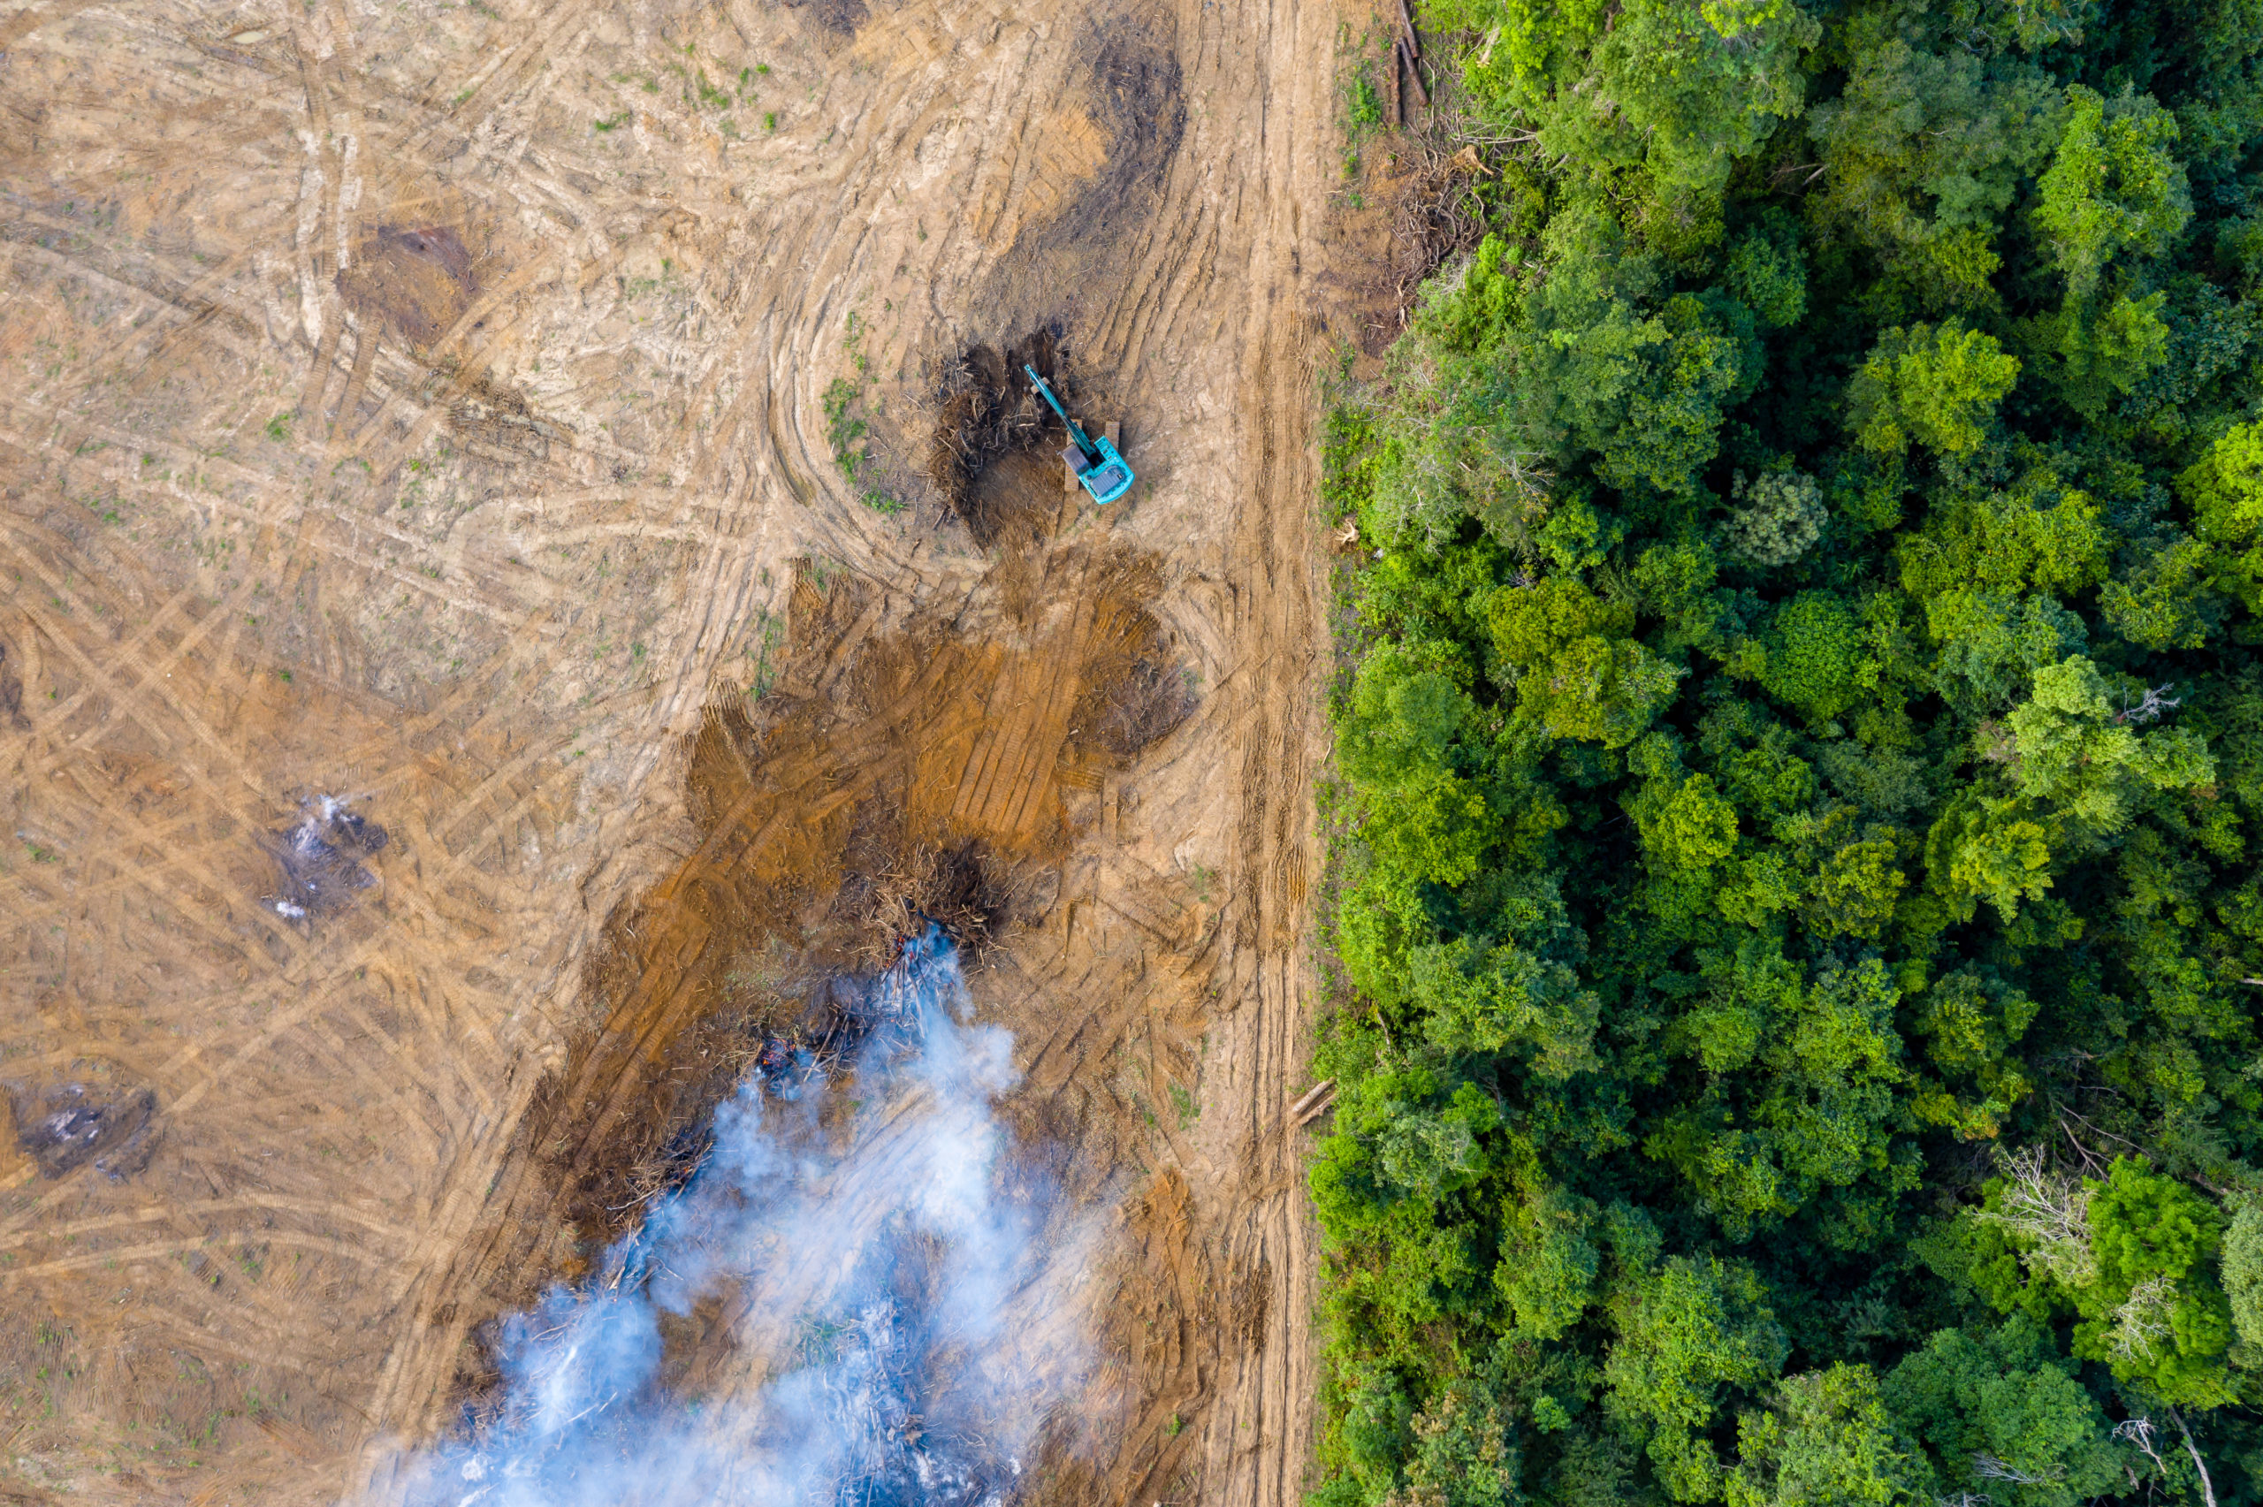

ECOFIN

The Questions of combatting illicit financial flows

**Committee: ECOFIN**

**Topic: The Question of combatting illicit financial flows**

**Chair:** **Adaora Ambrose & Arlene Olagunju**

**Summary**

**Overview and Explanation**

Illicit financial flows (IFFs) refer to the illegal movement of money or assets across borders, often linked to corruption, tax evasion, money laundering, and criminal enterprises. These flows undermine economic stability, drain public resources, and distort financial markets. The global economy faces significant threats from IFFs, which enable organized crime, weaken national economies, and erode trust in financial institutions. IFFs typically involve corrupt practices where government officials and business elites divert public funds or accept bribes, siphoning resources into foreign accounts. This undermines governance and public sector efficiency. Additionally, tax evasion and avoidance occur when corporations and wealthy individuals shift profits to low-tax jurisdictions to minimize their fiscal obligations, depriving governments of revenue needed for public services and infrastructure. Businesses also engage in trade-based manipulation, such as mis invoicing, to transfer funds illicitly across borders, which distorts trade balances and weakens domestic industries.

**Origins of the Topic**

The issue of IFFs gained global attention in the early 2000s following major financial scandals such as the 2001 Enron scandal, which exposed corporate fraud, and the 2008 global financial crisis, which highlighted weaknesses in financial regulations and banking oversight. The 2016 Panama Papers leak further revealed how offshore entities facilitated tax evasion and money laundering on a massive scale. In more recent years, the rise of digital currencies has raised concerns about their potential role in facilitating IFFs due to their pseudo-anonymity and decentralized nature.

**Importance of Combatting IFFs**

IFFs have widespread economic and financial consequences. Developing countries lose an estimated $88.6 billion annually due to IFFs, according to the UN Economic Commission for Africa. These losses hinder investments in infrastructure, healthcare, and education. Large-scale outflows of capital can cause currency depreciation, economic volatility, and reduced investor confidence, leading to long-term economic damage. Corruption and money laundering foster instability and reduce public trust in institutions, ultimately weakening political structures and democratic governance. Furthermore, IFFs disproportionately harm low-income economies by depriving them of essential development funds while benefiting tax havens and financial secrecy jurisdictions.

**Who the Issue Affects**

The effects of IFFs extend to various economic actors. Consumers face higher tax burdens and reduced public services due to revenue loss from tax evasion and corruption. Producers and businesses struggle against unfair competition from firms engaging in tax evasion or corruption, reducing economic efficiency and harming legitimate enterprises. Developing countries suffer from the loss of development funds, exacerbating poverty and economic inequality, hindering progress toward sustainable economic growth. Developed countries experience increased financial crime risks, affecting economic stability and regulatory integrity, along with weakened transparency in financial institutions. Additionally, governments and financial institutions face decreased ability to enforce tax policies and anti-money laundering regulations due to the complexities of tracking illicit funds.

**Previous Attempts to Address the Issue**

Several international initiatives have been undertaken to combat IFFs. The Financial Action Task Force (FATF), established in 1989, set global anti-money laundering (AML) standards and regulatory frameworks to monitor and prevent illicit financial transactions. The United Nations Convention Against Corruption (UNCAC), introduced in 2003, created a global legal framework to prevent and combat corruption, promoting international cooperation and asset recovery mechanisms. In 2013, the OECD launched the Base Erosion and Profit Shifting (BEPS) Project to prevent multinational corporations from shifting profits to low-tax jurisdictions, improving tax transparency and fairness. The 2016 Panama Papers investigation led to tighter regulations on offshore banking and beneficial ownership transparency, exposing widespread global tax evasion and financial secrecy practices. The European Union’s Anti-Money Laundering Directive (AMLD 5) of 2020 strengthened cryptocurrency regulations to curb illicit financial activities and enhance due diligence requirements for financial institutions. The G7 and G20 crackdowns on tax havens in 2021 enforced a global minimum corporate tax rate to reduce profit shifting and prevent tax avoidance by multinational companies. The Biden Administration’s Anti-Corruption Strategy, announced in 2021, focused on financial transparency, sanctions, and stronger regulatory enforcement.

Despite these efforts, challenges remain due to regulatory loopholes, lack of global cooperation, and emerging financial technologies that enable illicit financial flows. Strengthening transparency, enhancing enforcement mechanisms, and leveraging blockchain technology for secure financial tracking could be key steps toward mitigating IFFs in the future.

**Definition of Key Terms**

* **IFFs**: Illicit Financial Flows - Illegal movement of money or assets across borders.
* **AML**: Anti-Money Laundering - Policies and regulations aimed at preventing financial crimes.
* **FATF**: Financial Action Task Force - An international body that sets AML and counter-terrorism financing (CFT) standards.
* **UNCAC**: United Nations Convention Against Corruption - A global legal framework for preventing and combating corruption.
* **OECD**: Organization for Economic Co-operation and Development - Promotes economic policies and international tax cooperation.
* **BEPS**: Base Erosion and Profit Shifting - An initiative to prevent profit shifting by multinational corporations.
* **EU**: European Union - A political and economic union of European nations enforcing financial regulations.
* **AMLD 5**: Anti-Money Laundering Directive 5 - A European regulation aimed at curbing financial crime.
* **G7**: Group of Seven - An intergovernmental economic organization of major advanced economies.
* **G20**: Group of Twenty - A forum for international economic cooperation and policy-making.
* **UN**: United Nations - A global organization promoting international peace, security, and cooperation.
* **US**: United States - A major player in global financial regulation and enforcement.
* **FCPA**: Foreign Corrupt Practices Act - A US law that prohibits bribery of foreign officials.
* **CFT**: Counter-Terrorism Financing - Efforts to prevent funding for terrorist organizations.
* **UNODC**: United Nations Office on Drugs and Crime - A UN body focused on fighting illicit financial activities.
* **IMF**: International Monetary Fund - Provides financial support and policy guidance for economic stability.
* **CRS**: Common Reporting Standard - An OECD initiative for global tax transparency.

**Major Countries / Organisations Involved**

* **United States (US)**: Implements financial sanctions, anti-money laundering laws, and the Foreign Corrupt Practices Act (FCPA) to combat corruption and illicit transactions.
* **European Union (EU)**: Enforces AMLD 5 and other regulations to prevent money laundering, tax evasion, and terrorist financing.
* **United Nations (UN)**: Through the UN Office on Drugs and Crime (UNODC) and UNCAC, the UN promotes international cooperation and policy frameworks to fight corruption and IFFs.
* **Financial Action Task Force (FATF)**: Develops global AML and counter-terrorism financing (CFT) standards and conducts peer evaluations of member countries.
* **Organisation for Economic Co-operation and Development (OECD)**: Works on international tax cooperation and transparency through initiatives such as BEPS and the Common Reporting Standard (CRS).
* **International Monetary Fund (IMF) and World Bank**: Support capacity building, financial transparency, and policy recommendations for governments to combat IFFs.
* **G7 and G20 Nations**: Implement global tax reforms and economic policies to reduce IFFs and increase tax fairness.
* **Tax Justice Network**: Advocates for greater financial transparency, tackling tax havens, and ensuring fair taxation worldwide