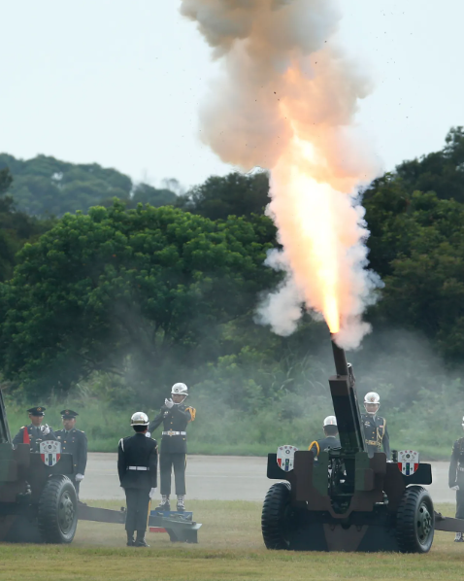

HISTORICAL COMMITTEE

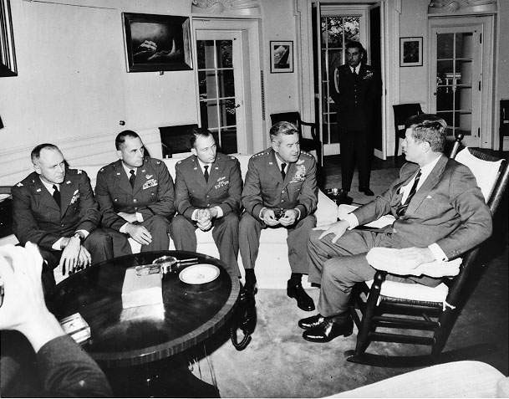

The Questions of the Cuban Missile Crisis

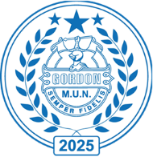**Committee: Historical Committee**

**Topic: The Question of Cuban Missile Crisis**

**Chair:** **Eloise Tindale and Aaryan Oliver**

**Summary**

The Cuban Missile Crisis (October 1962) was a 13-day confrontation between the United States and the Soviet Union over the placement of Soviet nuclear missiles in Cuba. It is considered one of the closest moments the world has come to nuclear war during the Cold War. The crisis began when U.S reconnaissance planes discovered Soviet ballistic missiles in Cuba, leading to a tense standoff between the superpowers. The crisis ended with a negotiated settlement: the Soviet Union agreed to remove its missiles from Cuba, and the United States secretly agreed to remove its missiles from Turkey whiles also publicly promising not to invade Cuba.

**The Cuban Missile Crisis was rooted in the Cold War rivalry between the U.S and the Soviet Union, but specific causes include:**

* The Cuban Revolution (1959) where Fidel Castro overthrew the US backed Batista government, leading Cuba to align with the Soviet Union. The US saw this as a threat, leading to attempts to overthrow Castro, such as the failed Bay of Pigs Invasion.
* Nuclear Arms Race where the US had placed Jupiter missiles in Turkey and Italy, capable of striking the Soviet Union, which prompted the USSR to seek a similar advantage in Cuba.
* Soviet Cuban Alliance which was a response to US hostility. The Soviet Union saw an opportunity to strengthen Cuba’s defence and challenge US dominance in the Western Hemisphere by deploying nuclear weapons.

**Previous attempts to fix the problem:**

* **The Moscow- Washington Hotline (1963):** A direct communication link between the US and Soviet Leaders was established to allows for quick communication during crises.
* **The Nuclear Test Ban Treaty (1963):** Signed by the US, USSR and UK, this treaty prohibited nuclear weapons testing in the atmosphere, outer space and underwater.
* **US - Soviet Dente (1970s):** Relations between two superpowers improved, leading to Strategic Arms Limitation Talks (SALT I AND II) to limit nuclear weapons development.

**Definition of Key Terms**

**Cold War:** A geopolitical tension between the United States and its allies and the Soviet Union and its allies from 1947 to 1991, marked by ideological conflict, nuclear arms competition and proxy wars.

**Mutually Assured Destruction (MAD):** A doctrine of military strategy in which both the US and USSR possessed enough nuclear weapons to destroy each other, discouraging direct conflict.

**Nuclear Deterrence**: The concept that the threat of using nuclear weapons prevents adversaries from attacking

**Major Countries / Organisations Involved**

Directly involved:

* United States (USA)
* Soviet Union (USSR, now Russian Federation)
* Cuba

Indirectly involved:

* Turkey
* Italy
* United Kingdom

Organisations:

* NATO
* Warsaw Pact
* OAS

