***

ECOFIN

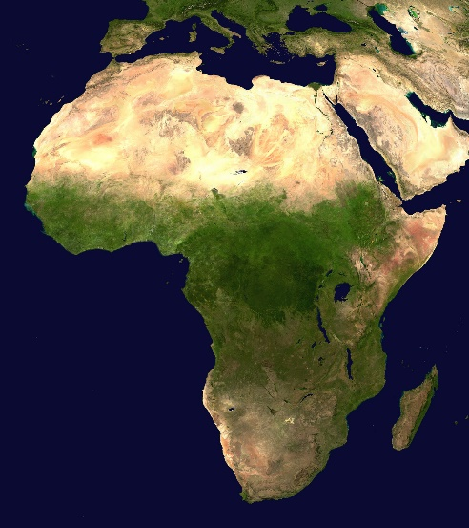

The question of the sustainable development of Africa

**Committee: ECOFIN**

**Topic: The Question of the sustainable development of Africa**

**Chair:** **ADAORA AMBROSE AND ARLENE OLAGUNJU**

**Summary**

The question of sustainable economic and financial development in Africa revolves around balancing economic growth with environmental protection, social equity, and long-term stability. Africa faces significant challenges, including poverty, limited access to quality education and healthcare, political instability, and vulnerability to climate change. To achieve sustainable development, the continent needs to harness its vast natural resources responsibly, foster innovation, improve infrastructure, and diversify its economies away from reliance on extractive industries. This requires fostering inclusive economic policies, strengthening governance, and attracting both local and international investment while ensuring that growth benefits all segments of society, addresses inequality, and preserves the environment for future generations.

The topic of sustainable economic and financial development in Africa has its origins in the post-colonial era, as many African countries faced challenges in building stable economies after gaining independence in the mid-20th century. With colonial powers leaving behind economies that were often dependent on a narrow range of exports and vulnerable to global market fluctuations, African nations struggled with poverty, debt, and underdevelopment. Over time, international organizations like the United Nations and the World Bank, along with regional bodies like the African Union, began advocating for sustainable development that integrates economic growth with environmental preservation and social equity. The issue gained urgency in the 1990s and 2000s as African nations sought to diversify their economies, address climate change impacts, reduce poverty, and achieve long-term prosperity while confronting challenges such as weak infrastructure, corruption, and limited access to capital.

The sustainable development of Africa is economically and financially important because it holds the key to unlocking long-term growth, reducing poverty, and ensuring financial stability across the continent. Economically, Africa has vast natural resources and a young, growing population, both of which present opportunities for growth—yet these opportunities often come with environmental and social challenges. Without a focus on sustainability, economic development could deplete natural resources, exacerbate inequality, or lead to environmental degradation, limiting future growth prospects. Financially, sustainable development can attract investment by demonstrating a commitment to long-term stability and resilience, which is critical for both domestic economies and international investors. It also allows African nations to diversify their economies beyond extractive industries, promoting sectors like renewable energy, agriculture, and technology, which can generate new sources of revenue and create jobs. Moreover, addressing issues like climate change and environmental degradation can help reduce future costs linked to disaster recovery and resource scarcity, making sustainability a prudent financial strategy for the continent’s future.

There have been several attempts over the decades to address the challenges hindering Africa's sustainable economic and financial development. These include the Africa Renewable Energy Initiative (AREI) launched at the COP21 climate conference which aims to scale up renewable energy in Africa to provide clean, affordable energy while also stimulating economic growth and job creation. Though it has made progress in promoting green energy projects, challenges in financing, technology, and political support remain. Furthermore, The Financing for Development Agenda adopted at the United Nations is a global initiative which includes commitments from African governments to improve tax collection, combat corruption, and encourage private investment. While it offers tools to build more resilient financial systems, it has faced challenges in implementation due to weak governance structures and a reliance on external funding. Therefore, despite these efforts, many challenges remain, including inadequate infrastructure, political instability, and external dependencies that undermine efforts to achieve comprehensive, sustainable growth of Africa.

**Definition of Key Terms**

COP21 Climate Conference – this was the 21st UN Conference of Parties led to a new international climate agreement, the Paris Agreement, which applies in every country.

Agenda 2063 – this was the January 2013 African Union Summit adopted Agenda 2063 (“The Africa We Want”) as Africa's blueprint and master plan for sustainable development and economic growth of the continent.

**Major Countries / Organisations Involved**

Several key organizations are involved in promoting the sustainable economic and financial development of Africa. These organizations work at the continental, regional, and international levels to support economic growth, environmental sustainability, poverty reduction, and financial stability. The main ones include:

1. The African Union (AU): The AU plays a central role in shaping Africa's development agenda, particularly through its Agenda 2063, which outlines the continent's vision for sustainable economic growth, regional integration, infrastructure development, and poverty reduction. It coordinates efforts across African countries to achieve common development goals.
2. The African Development Bank (AfDB) is the premier pan-African development finance institution. It provides funding for infrastructure projects, green energy initiatives, and economic development programs. It is a key player in financing sustainable development goals (SDGs) and promoting inclusive growth through investment and financial support.
3. The United Nations Economic Commission for Africa (UNECA): works to promote sustainable development across the continent by providing data, policy analysis, and technical assistance. It supports African countries in implementing the SDGs, advancing regional integration, and addressing issues such as climate change, trade, and governance.