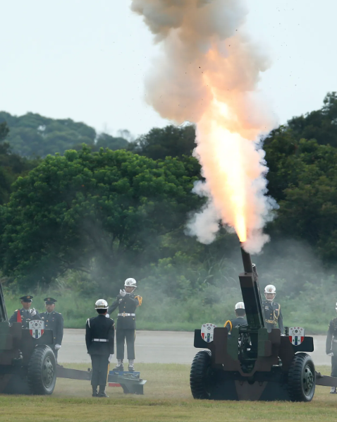

HISTORICAL COMMITTEE

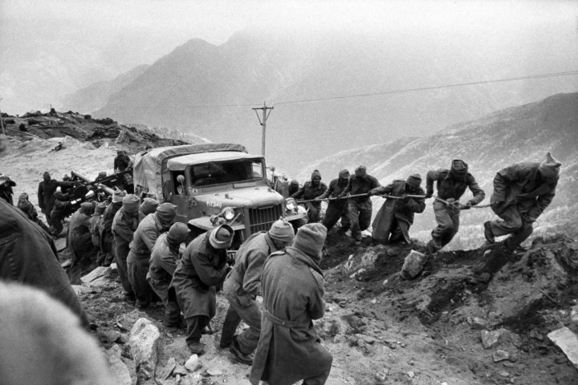

The Question of the Sino-Indian War

**Committee: HISTORICAL COMMITTEE**

**Topic: The Question of the Sino-Indian War**

**Chair:** **Eloise Tindale and Aaryan Oliver**

**Summary**

The Sino- Indian War of 1962 was a military conflict between the People’s Republic of China and India and was fought from October 20th to November 21,1962. The war was triggered by long standing border disputes between the two nations. The conflict occurred during the Cold War, with both China and India seeking to assert their regional dominance. It resulted in Chinese victory, with China occupying Aksai Chin and unilaterally declaring ceasefire. The war left a lasting impact on India-China relations, fuelling border tensions, military buildups, and diplomatic rivalries that continue today.

The Sino-Indian border dispute dates back to colonial times when the British Raj established the McMahon Line (1914) which China never recognised. After India’s independence (1947) and the formation of the PRC (1949), tensions over the border escalated.

**Key Causes of the War:**

* China built a strategic road connecting Tibet to Xinjiang, passing through Aksai Chin, an area India claimed.
* After China’s crackdown in Tibet, the Dalai Lama fled to India, worsening Sino Indian relations.
* Forward Policy (1959-62): India adopted a defensive military strategy, sending small outposts into disputed areas which China viewed as provocative
* Breakdown of Diplomatic Talks (1961-62): Failed negotiations over the border dispute escalated into military clashes.

**Previous Attempts to fix the problem:**

**1962 Ceasefire:** China declared a unilateral ceasefire and withdrew from Arunachal Pradesh but retained control over Aksai Chin

**Border Negotiations**: Both countries engaged in multiple rounds of talk between 1980-1990 but failed to reach a permanent solution

**1993 and 1996 Agreements**: China and India signed military disengagement agreements to prevent future border clashes.

**2005 and 2013 Border Agreements:** Established mechanisms for peaceful negotiations but tensions remained high

**Definition of Key Terms**

**Line of Actual Control (LAC):** The de facto border between India and China, lacking official demarcation and frequently disputed.

**McMahon Line:** The border between India and Tibet, drawn by British India in 1914 but not recognised by China

**Aksai Chin:** A disputed region in the western Himalayas, controlled by China but claimed by India as part of Ladakh.

**Major Countries / Organisations Involved**

Directly Involved:

* India
* China

Indirectly Involved:

* Pakistan
* Soviet Union (Russian Fed)
* United States

