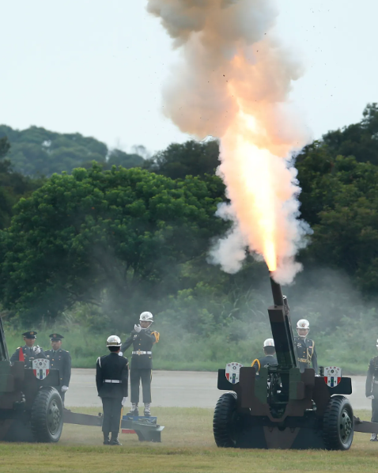

HISTORICAL COMMITTEE

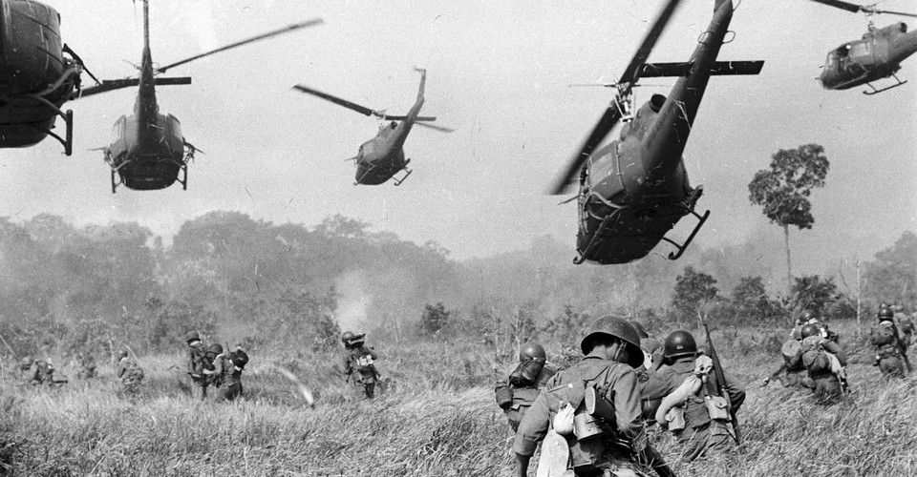

The Question of US Involvement in Vietnam

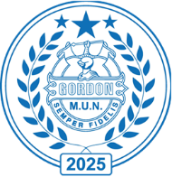**Committee: HISTORICAL COMMITTEE**

**Topic: The Question of US involvement in Vietnam**

**Chair:** **Eloise Tindale and Aaryan Oliver**

**Summary**

By 1962, the Vietnam conflict had become a critical issue in the Cold War, with the United States deepening its military, political an economic involvement in South Vietnam. While no formal US combat troops were deployed yet, thousands of military advisors, Special Forces and resources were sent to strengthen the South Vietnamese Army against the communist Viet Cong insurgency, which was supported by North Vietnam, the Soviet Union and China.

The US viewed its intervention as part of the Domino Theory, fearing that a communist takeover in Vietnam would lead to the fall of other Southeast Asian nations to communism. Meanwhile, North Vietnam and its allies framed the conflict as a nationalist struggle for unification and independence, continuing their fight against foreign influence after decades of colonial rule and war.

At this stage, the Vietnam conflict was not yet a full-scale war, but it was steadily escalating. President John F Kennedy had increased US involvement by sending more military advisors and implementing counterinsurgency measures such as the Strategic Hamlet Program to curb Viet Cong influence in rural areas. However, South Vietnam faced major challenges, including corruption, internal instability, and a vast decline in support for President Ngo Dinh Diem.

With tensions rising, the international community was increasingly concerned about whether the US would escalate its military presence, how the conflict could affect regional stability and whether diplomacy could still offer a path to peace.

**How did this problem arise:**

* **The First Indochina War and French Colonial Rule:** Vietnam was under French control until the Viet Minh, led by Ho Chi Minh, fought for independence and defeated France in 1954.
* **The Gevena Accords:** The agreement temporarily divided Vietnam at the 17th parallel, with national elections planned for 1965 to reunify the country.
* **Election Dispute and Division:** South Vietnam, with US backing, refused to hold elections, fearing a communist victory, leading to permanent division.
* **The rise of the Viet Cong:** Communist guerrillas in South Vietnam launch an insurgency against the US backed government, with support from North Vietnam.
* **US Military Involvement:** To counter the Viet Cong, the US increased military aid, sending advisors and Special Forces to train the South Vietnamese army.

**Previous attempts to address the problem:**

* **The Geneva Accords (1954):** Aimed to unify Vietnam through elections but South Vietnam, backed by the US, refused to participate.
* **SEATO Commitment (The Southeast Asia Treaty Organisation):** pledged to prevent communist expansion, leading to military and economic support for South Vietnam.
* **South Vietnamese Reforms**: Land reforms and counterinsurgency programs like the Strategic Hamlet Program failed to stop Viet Cong influence and alienated rural populations

**Definition of Key Terms**

**17th Parallel:** The line established by the 1954 Geneva Accords, dividing North and South Vietnam. It was intended as a temporary boundary until nationwide elections could be held.

**Agent Orange:** A powerful herbicide and defoliant used by US forces during the Vietnam War to eliminate forest cover and crops. Its use led to severe health issues and environmental damage.

**Domino Theory**: A Cold War – era belief that the fall of one country to communism would lead to the subsequent fall of neighbouring countries, like a row of dominoes. This theory significantly influenced US involvement in Vietnam.

**Major Countries / Organisations Involved**

* Vietnam
* Russian Fed
* China
* United States
* 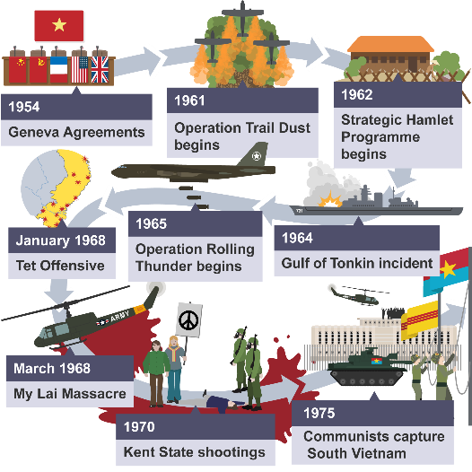South Korea

