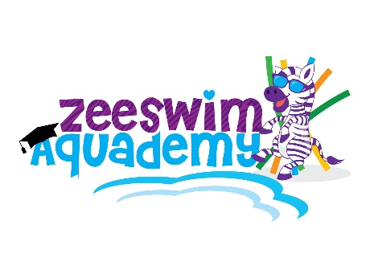
ZEESWIM AQUADEMY
COVIDSAFE PLAN – Brief Outline
PUBLIC ADVISORY ZEESWIM AQUADEMY HAS DEVELOPED A COVIDSAFE PLAN
(including but not limited to)
Amendment 15th January 2021

To ensure your safety and to honour our commitment as a COVIDSafe business we have implemented the following changes at Zeeswim Aquademy. Please find below our COVIDSafe plan in point form for your convenience.
Anyone that demonstrates any Covid/flu-like symptoms will not be allowed entry. Avoid attendance if any family members are unwell or have any symptoms or have been in declared hotspots within the last 14 days.
- Occasional visitors/carers to sign in using QR code at front gate – if your details are not already on file with Zeeswim Aquademy.
- Enter pool area no earlier than 5 minutes prior to you lesson start time.
- Social distancing – 1 adult spectator per family within the pool building (siblings exempt).
- Please use hand sanitiser before entering pool gate – dispenser is located at the top of the path on the left hand side.
- Limit personal items to bare essentials.
- Place all belongings in flexitub (chair) or pigeon holes (bench seat and change table) provided
- Bench seating area – please observe social distancing with a maximum of 2 adults to be seated.
- Limit contact with object/items – only touch essential objects/items.
- Families are requested to assist with safe hygiene procedures. Please use provided antibacterial wipes to clean surfaces first then spray antiviral spray prior to leaving.
- Beach Ready - Wrap and Go” – is preferred where possible.
- Exit pool building immediately at the end of your lesson - clothing changes are permitted if needed but are to be done with haste.
- Food - Please where possible avoid bringing food into the pool area – if you do need to provide snacks for you child while they are waiting please consider crumb free options.
- There will be a limited amount of toys available in the seating area – Families are requested to assist by please wiping and spraying toys used during your visit.
- Medical grade detergents and disinfectant is provided/used for cleaning of all surfaces and equipment between uses.
- Thorough daily cleaning of all high touch areas/surfaces with high grade medical detergents and disinfectants.
- Self-Serve Café - colds drinks and lollies will be available for purchase – please limit contact with items and use tongs provided.
For swimming lessons to continue the above must be strictly adhered to at all times. Please remember these measures are in place to keep us all healthy and safe, I appreciate your understanding and patience. Severe financial penalties for breaches of the above-mentioned Public Health Order both business owner and patron can be issued.

The plan will be regularly reviewed and updated in line with Government and Industry advice.

