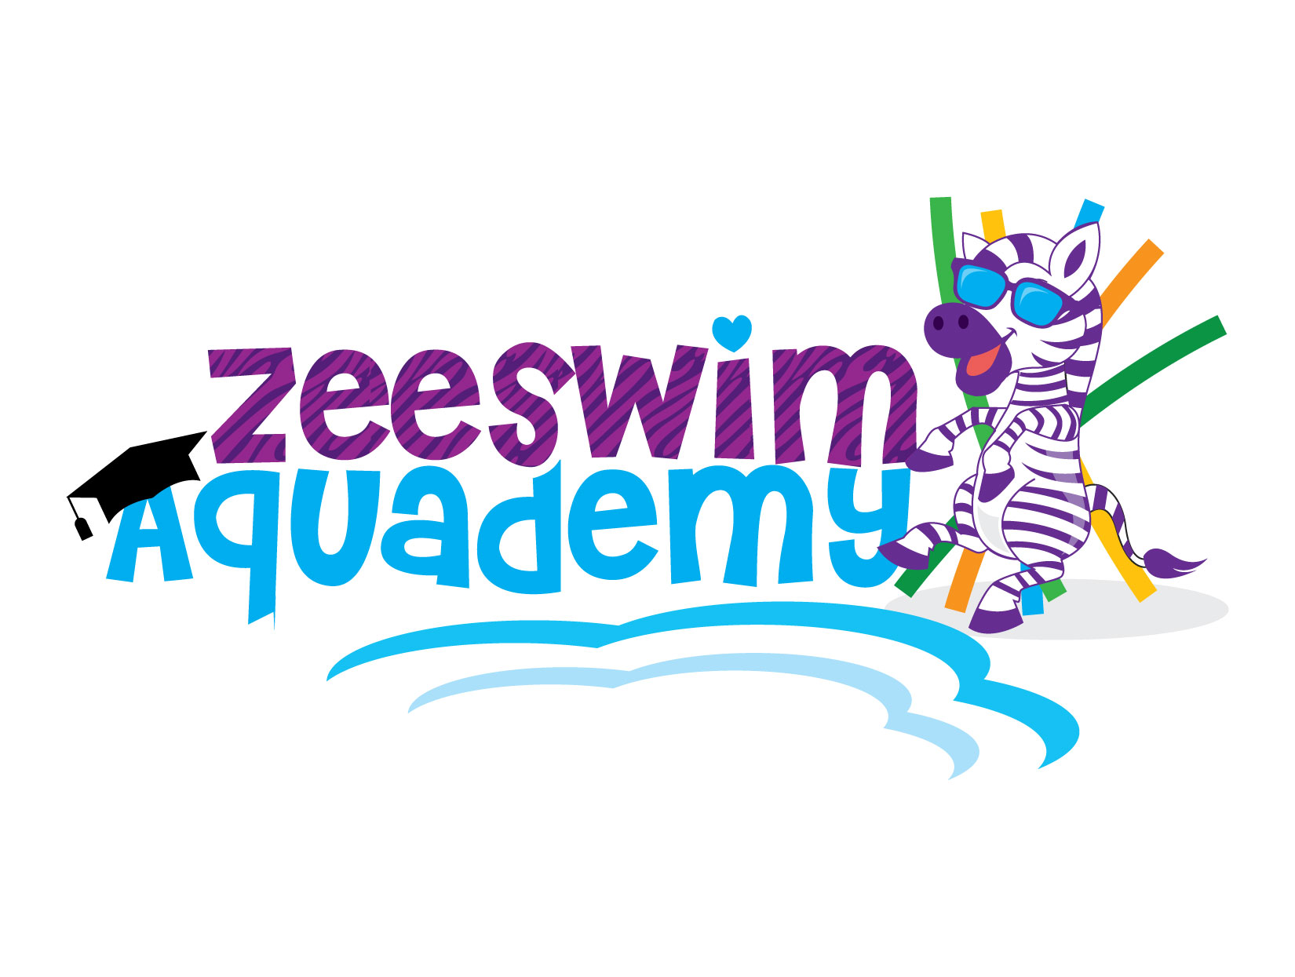

Terms and Conditions document is an important document. Please read it carefully prior commencing lessons with Zeeswim Aquademy and do not sign it unless you understand, accept and will abide by the terms and conditions at all times.
Terms and Conditions document will be reviewed and updated prior to the start of each new term.

Privacy
- Personal details you voluntarily provide us will only be used for administration related to the swim school and learn to swim. Your personal information will not be available to any third party. If a family wishes to contact another family, Zeeswim Aquademy will be happy to pass on a message but will not give out contact details unless requested to.

Enrolment and Payment
- Lessons are conducted on a term basis in accordance with NSW Department of Education school terms and are usually 10 weeks in duration but also be for the duration of 9 weeks or 11 weeks.
- Lessons are not conducted on Public Holidays and therefore not charged.
- All enrolments are perpetual (ongoing – term by term). Bookings are on a permanent basis only. You can stop lessons at any time but you must advise Zeeswim Aquademy of your intention to cancel lessons in a timely manner. No refunds or credits will be granted.
- Enrolment is not confirmed until term fees are paid in full. LESSONS MUST BE BOOKED AND PAID FOR IN ADVANCE BEFORE A SLOT IS GUARANTEED.
- A minimal ongoing fee increase will be implemented in terms 1 and 3 of each new year.
- Enrolments will be accepted at any time during the term with a pro-rata price charged for the remainder of the term.
- Swimmers will be placed in levels/classes according to their ability, then age plus other contributing factors as determined by Zeeswim Aquademy.
- Statements will be issued during week 8 of the current term for the coming term and will be due for payment within 3 weeks of the statement date.
- Lessons are to be paid for in advance. If payment is outstanding at the beginning of term you will forfeit your lesson slot.
- Term fees must be paid and receipted by Zeeswim Aquademy by 5.00pm on the advised due date. As enrolment is a reserved time slot and is secured by your term payment, non-payment means no further lessons will be provided and your child/rens time slot will be made available to families on the waiting list.
- Payments must be paid on time and any late payments must first be agreed to by Zeeswim Aquademy and a late fee of $10.00 will be added to your family account. Only one payment extension will be approved by Zeeswim Aquademy for the term, if payment is not received by the agreed due date and time, Zeeswim Aquademy will enforce a NO PAYMENT/NO SWIM policy for any lessons you attend after this date.
- If you request a change to your lesson day/time for a new term, fee payment still needs to be received by the due date even though you new lesson day/time will not be confirmed until after this date – your statement will also list your current term lesson day and time until new class details are confirmed, locked in and updated in SimplySwim.
- Zeeswim Aquademy reserves the right to refuse admittance to the swimming lesson until fees are paid in full. No make ups will be given for missed lessons due to outstanding fees.
- Payment options are bank deposit or cash.
- No refunds will be given and credits will only be issued due to extenuating circumstances at the discretion of Zeeswim Aquademy on a case by case basis.
- In the event that Zeeswim Aquademy is subject to a closure, make-up/s will be added to family accounts who are up to date with their fees, and when an individual request has been received by Zeeswim Aquademy that a family wishes to receive a make up credit. Any client with outstanding fees will not receive a make-up in this instance.
- Lessons will not be held for extended absences – options are to cancel lessons for the duration of the absence and rebook upon return or pay term fees to hold lesson (make-ups will be offered in this instance).
- Lessons are up to 30 minutes in duration.
- Zeeswim Aquademy reserves the right change or cancel classes.

Lessons scheduling
- Zeeswim Aquademy reserves the right to cancel/re-schedule classes temporarily or permanently due to absences, low enrolments or any other reason that may impact the effective operation of the swim school. You will be notified in the most timely manner possible of any changes, either by text message or email.

Make-Up Policy
- Absences can be notified via the family login on the website www.zeeswim.com.au, using the SIMPLYPORTAL APP or in writing via text message or email no later than 7.00pm on the day of your regular day/time. You will not be eligible for make-ups if no notification or if notification is received after the deadline.
- Make-up lessons are not guaranteed and options will be restricted due to availability.
- Make-ups are valid for up to 90 days from the date of the missed lesson after this time missed lesson make-ups will be forfeited.
- Make-up lessons are a privilege not provided by other child-based activities and if you are not available to attend make-up classes outside of your current class time you will forfeit them after 90 days from the date of the missed lesson.
- Make-up lessons cannot and will not be deducted from a future term fees.
- Term fees must be paid in full to receive a make-up lesson. Make-up lessons will not be available to any clients with outstanding fees regardless of notification of absence.
- It is a parent/guardian’s responsibility to book make-up lessons via the customer portal at www.zeeswim.com.au or through the SIMPLYPORTAL APP

- Make-ups can be booked via the family login on the website www.zeeswim.com.au or through the SIMPLYPORTAL APP. Make-ups can be booked up to 6 days in advance or ½ hour before make-up lesson start time.
- Make-ups can not be booked unless you are booked into a permanent class or have outstanding fees.
- When booking a make-up please take note, if you are UNABLE to attend your booked make-up for any reason you will forfeit that make-up. Make-ups CANNOT be changed or moved once they have been booked.
- It is in your child’s best interests that absences are restricted to instances of genuine illness

Health Policy (Hygiene/Illness)
- These conditions are based on the Public Health and Wellbeing Regulations 2009 (Regulation 85) and NSW Health Guidelines – Clean Pools for Healthy Swimming.
- Before entering the pool area/building please wipe your feet on mat provided.
- Make sure children use the toilet before entering the pool.
- Please shower before entering pool.
- Illness and exclusion A copy of the Minimum Period of Exclusion from Primary Schools and Children’s Services Centres for Infectious Diseases Cases and Contacts (Public Health and Wellbeing Regulations 2009) is kept on file at Zeeswim Aquademy.
- Zeeswim Aquademy reserves the right to not admit entrance or remove any child or adult into the pool/facility based on illness, open/weeping wounds or behaviour. Medical clearance my be requested to return.
- Reasons to not attend lessons are but not limited to:
Lethargy, fever/clammy skin, shivering, abnormal skin colouring (paleness/excessively red), any signs of rash or unexplained dots/hives/rings/bites like skin marks that have appeared unexpectedly, weeping sores/cut/abrasions that cannot be adequately covered or dried, infections including ear/chest/throat/nose and UTI’s, any coloured snot apart from clear – (clear is normal and fine to swim), vomiting and diarrhea.
- Stay out of the pool if you have an infection. Even when you are recovering, stay out of the water until the infection has passed. Timeframes for some common infections include:
chickenpox – after the first sign of a rash, avoid swimming for seven days
gastroenteritis (gastro) – do not swim for 14 days after recovering
Tinea corporis (athlete’s foot) – do not swim until one day after commencing treatment
- Zeeswim Aquademy reserves the right to ask for medical clearance before allowing you to return to the swim school.
- If you or your child are sick and are not permitted at daycare/kindy/school/work then you are too sick to attend swimming lessons and are not permitted to attend lessons until recovered.
- If illness is due to vomiting, the last vomit must have occurred at least 48 hours prior to attending the lesson for either child or adult attending (swimming or spectating).
- If illness is to diarrhea, the last loose stool must have occurred 14 days prior to the lesson for the child or adult to attend classes in the water and a minimum of 48 hours for spectators.
- Please advise of absence via family login at www.zeeswim.com.au or in writing by text message or email and only book a make-up once you or your child have fully recovered or have clearance to attend.

Contamination Policy/Pool Testing and Water Health
- Zeeswim Aquademy strives to always provide a safe and healthy pool. Water testing is carried out every morning prior to the commencement of lessons (all results are logged and recorded and can be view upon request).
- A water sample is taken once a term to the Coffs Harbour City Council Laboratory for testing of E.Coli, Total Plate Count and Pseudomonas Aeruginosa – results are available for inspection upon request.
- Zeeswim Aquademy is a Registered Public Pool with Coffs Harbour City Council and is therefore subject to regular Healthy and Safety inspections.
- Pool deck, toilet and change table areas are cleaned on a daily basis. Play area toys are sanitised regularly.
- In the event of an unforeseen incident which could affect the health and safety of our swim school participants we reserve the right to the close the pool. Where possible all affected classes will be contacted by either email or text message.
- In the event of faecal and/or vomit incidents within the pool itself, strict measures will be utilised to avoid possible disease transmission. The measures, as enforced by the NSW Government health standard, are:
- Evacuate and close pool (10 minutes)
- Remove contaminant and clean pool with manual vacuum (30 minutes)
- ‘Super’ chlorination of the water to treat it (13 hours)
- Water retested (10 minutes)
- Zeeswim Aquademy reserves the right to recoup/charge clients for losses up to the full amount of the total cancelled lessons (up to 2 hours after the incident for in the water incidents and up to 1 hour for on deck incidents). This will be enforced especially in cases where clients have failed to take preventive measures and follow our swim nappy policy.

Swim Nappies
- ‘no nappy – no swim’ for under 3’s – no exceptions. This also applies to any children over the age of 3 years who are not completely toilet trained.
- A firmly fitting reusable swim nappy (Zeeswim Aquademy nappy) MUST be worn to prevent accidental contamination of the pool. This is in ADDITION to any disposable swim nappy that is worn underneath (spare and loan swim nappies are available when required).
- Nappy changes are to be made at the change table provided. Soiled nappies are to be placed in disposable nappy bags (provided by Zeeswim Aquademy if you do not have your own) and disposed of in the bin provided. Wash hands thoroughly with soap.

Spectators, behaviour and Zeeswim Aquademy rules
- Clients are only permitted on the pathway leading into the fenced swim school yard. The rest of the house, patio and backyard are out of bounds.
- Family members and siblings are welcome on the pool deck to watch lessons, seating is limited and children spectating should not be running, jumping or throwing toys into the pool or you and your child will be asked to leave the pool deck.
- Children under 18 must have a parent or adult in the facility actively supervising them at all times.
- Parents are to always remain on the premises and accompany children when they are not within the fenced pool area.
- No running around the pool deck. The floor surface may be slippery.
- No diving or bombing into the pool unless under instructor supervision (pool depth 1.2 metres).
- Arriving for lessons in a punctual manner would be greatly appreciated.
- Please vacate the lesson area as soon as possible after the completion of your child’s lesson. This will ease congestion in and around the pool deck and carpark.
- Misconduct, disruptive behaviour or showing disrespect to other clients, equipment (in and out of the pool) or the facility will not be tolerated and may result in the offending party having their lessons cancelled effective immediately.
- Please do not slam the pool gate or allow children to climb or swing on the gate. These actions cause the gate to be out of alignment and therefore does not close safely – Pool gate must be latched at all times.
- Zeeswim Aquademy is a learn to swim facility only and not available for public or free swimming by siblings or parents/carers.
- Swimmers are not to enter the water until instructed to do so by their teacher.

Dress code
- Appropriate swimwear is to be worn in the water at all times
- Babies/toddlers/pre-schoolers – Zeeswim Aquademy swim nappy plus disposable swim nappy underneath a one-piece zip suit or similar.
- Girls – correctly fitting one piece plus optional rash shirt.
- Boys – Rash shirt with brief or Jammer (bike pant) style swimmer bottoms.
- Adults – appropriate swimwear plus t-shirt or rash shirt.
- Hair tied back and off the face.
- Silicone swimming cap (not compulsory but advisable).
- Goggles – Orange, Blue and Red Clownfish are not required to wear goggles. Tang Fish, Angelfish, Dart Fish and Butterfly Fish are permitted to wear goggles as and when required. Google free time is used in every lesson to ensure that swimmers are familiar with swimming without them.

Contact Details and Customer Portal/Medical Details
- Zeeswim Aquademy will use email and text messages to communicate with all families currently enrolled for lessons and it is the client’s responsibility to keep Zeeswim Aquademy informed of any changes to email address, phone number, postal and residential address.
- Facebook is also used a method of communicating the goings on at Zeeswim Aquademy.
- Our website www.zeeswim.com.au contains a family login (customer portal) option. The family login can be used to check fees, class booking, sending email notifications to Zeeswim Aquademy, entering absences and booking make-lessons.
- Please advise and update Zeeswim Aquademy on any special needs, learning disabilities or medical conditions of any children or adult swimmers.

Progression
- Students will progress through levels at their own pace, learning to swim is a long ongoing process. Please remain patient – Zeeswim Aquademy shall ensure to the best of our ability to make progress as rapid as possible.
- It’s important to remember that children are accomplishing something by maintaining their existing skills. Many younger children will regress if lessons and regular practice are not continuous or stopped for more than a couple of months.

Photographs & Media Policy + Mobile Phones
- Photos may be taken as long as permission has been received from instructor and parents/guardians of other swimmers in your child’s class.
- Zeeswim Aquademy reserves the right to use photo’s taken during Photo Week and Fun Week of swimmers at the swim school for use on our Facebook page as well as for promotional use or similar. If you do not want your child’s photo be used please advise Zeeswim Aquademy.
- DEAR PARENTS: YOU NEED TO PUT YOUR PHONE DOWN AND WATCH YOUR CHILD’S SWIMMING LESSON. Your child’s swimming lesson is for ½ an hour only, please take the time to watch them achieve their swimming goals – they really want to show off to you when they master a particular skill that they have been struggling with. Please praise and encourage them from the pool deck but please do not “teach” or “coach” them. Disciplinary communication is acceptable when required.

Carparking
Zeeswim Aquademy understands that currently carparking at the swim school is often difficult however please attempt to adhere to these guidelines as much as possible.
- One car per family at all time, no exceptions.
- There is to be no parking on the street or the median strip in front of neighbouring and surrounding properties.
- Parking on the grass is only for overflow when required. If needing to park on grassed areas please park completely within the swim school property, on the house side of the mailbox (on the lawn of Zeeswim Aquademy).
- If you are bringing grandparents, relative or friends to watch, they need to come in the same car as the child swimming and their supervising adult. This ensures adequate parking for everyone and limits the number of cars entering and exiting the property.
- If another care giver, relatives or friends are travelling from another direction/location, you will need to arrange to carpool from a pre-arranged location ie Bray Street to travel in one vehicle to our address of 12 Oxley Place.
- Zeeswim Aquademy is not be used as a changeover/pick up/drop off point for children/pets/items between multiple cars. Please arrange to do this at another location as it is strictly one car per swimming family at all times.
- No trailers, campervans, boats, caravans, or anything which is towed, no vehicles larger than an average family vehicle or additional cars under any circumstances.
- All children regardless of age are to be accompanied by a supervising adult when in the carpark area. We ask that you limit activity and noise in this area and on the path leading to the swim school.
- Courtesy is to be shown to other clients and residents at all times, including when using Oxley Place to enter and exit by adhering to the speed limit and road rules and reducing noise where possible.

Pool details and First Aid
- Pool width and depth.
Small pool – 3m x 3m and 0.6m deep.
Big pool – 10m x 4m and 1.2 approx deep.
- A first aid kit is located in bathroom above the toilet.
- In the event of a minor or major first aid incident, Parents and other persons present may be asked to provide assistance if necessary.

Zeeswim Aquademy reserves the right to update policies as required and will endeavour to have current policies available for viewing via www.zeeswim.com.au. It is the parent/caregiver’s responsibility to remain informed and up to date with Zeeswim Aquademy policies.

Name: ………………………………………………………………………………………………………………………

Signed: ……………………………………………………………………………………………………………………

Date: ………………………………………………………………………

