You are here: [Home](https://acdsinc.org/) / [Housing Resources](https://acdsinc.org/housing-resources/) / Homeless Resources

**Homeless Resources**

**Are you homeless and need shelter tonight?**

Anne Arundel County has a Coordinated Entry system and one list for all shelters in the County.

**To be screened for shelter and added to the list, please call 410-417-7260**

Please note that COVID-19 testing is required for each shelter.

**Anne Arundel County Department Of Social Services**

[7500 Ritchie Hwy., Glen Burnie](https://goo.gl/maps/2fgd6CHdDt12) or [80 West St, Annapolis](https://goo.gl/maps/vkGi2Xy8gkB2)

**The Light House – Safe Harbor Resource Center**

[(410) 263-1835](tel:(410)%20263-1835) | [10 Hudson St., Annapolis](https://goo.gl/maps/6sJvwyQxFYt)

**Arundel House of Hope – Homeless Resource & Day Center**

[514 N Crain Hwy., Glen Burnie](https://goo.gl/maps/ggDM42FjkSJ2)

Look for the blue awning.

**Are you at risk of homelessness? Will you lose your housing in the next two weeks, but do not need shelter tonight?**

Call the Systems of Care to receive one-to-one assistance and support over the telephone. Information and referral specialists are available to help callers find local resources including homelessness prevention, mental health services, food, housing, utilities, and more.

Available Monday to Friday 8:30 a.m. – 5:00 p.m. at 1-800-485-0041.

**Crisis Services Community Warmline**

If you are experiencing a crisis, the Crisis Response System at the Anne Arundel County Mental Health Agency can help. Staff intervenes with callers who are experiencing a mental health and/or substance use disorder emergency. Non-emergency calls are provided with information, support and referrals.

The Community Warmline receives calls 24 hours a day, 7 days a week at 410-768-5522.

**Domestic Violence Assistance**

If you are, or someone you know is, seeking assistance in dealing with a domestic violence situation, please contact:

**YWCA/Arden House, Domestic Violence Shelter**  
Domestic Violence Hotline: 410-222-6800  
General Information: 410-626-7800

**Homeless Resource & Day Centers**

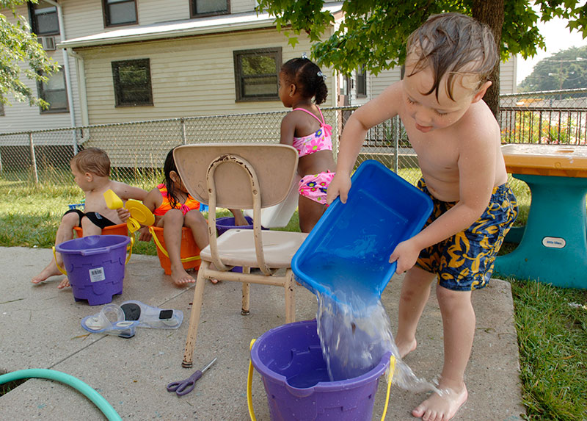

**Arundel House of Hope – Homeless Resource & Day Center –**offers a day shelter and services. Look for the Blue Awning.

514 N. Crain Hwy, Suite K  
Glen Burnie, MD 21061  
Monday-Saturday 8am – 4pm  
410-863-4888

**Safe Harbor Resource Center – The Light House –**offers laundry and shower facilities, case management, food, housing assistance, and other services.

10 Hudson St  
Annapolis, MD 21401  
Monday, Tuesday, Thursday, Friday from 9 am-2 pm  
Wednesday from 2 pm-7 pm  
410-263-1835