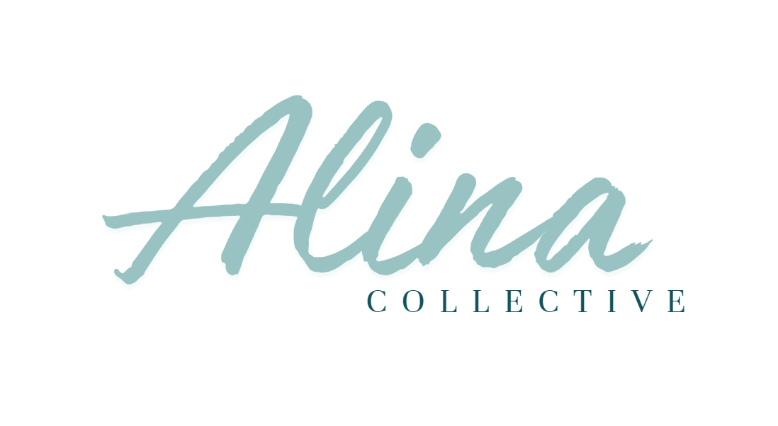

Communication, Confidentiality and Privacy Policy
- Purpose
This Policy sets out Alina Collective framework for the protection of personal privacy and confidentiality of our Clients and ensures that our Clients, their families, carers, advocates and members of the public are aware of their right to have their personal information protected and treated confidentially.
- Policy Statement
  - Alina Collective understands that Clients have a right to confidentiality and embraces the Australian Privacy Principles and the National Disability Insurance Scheme (Quality Indicators) Guidelines 2018.
  - Alina Collective recognises that confidentiality and proper communication is a fundamental component of service provision and that Clients have a right to be treated with dignity and respect.
  - Alina Collective is responsible for protecting Clients’ information from misuse, interference, loss, and from unauthorised access, modification or disclosure.
  - There may be situations where Client information is required to be disclosed by law.
  - Alina Collective shall engage employees and contractors that have the right skills, training and clearances to meet the standards prescribed by this Policy.
- Scope
  - This Policy applies to all employees, volunteers and contractors of Alina Collective and will be implemented with all Clients of Alina Collective.
  - This Policy does not apply to the collection, holding, use or disclosure of staff personal information forming Employee Records, such as health information and information about the engagement, training, disciplining, resignation, termination, terms and conditions of employment of the staff member.
- Definitions
  - Any reference to a Client also means a participant under the scheme or their nominee (family member, carer, advocate, guardian, etc.).
  - Any reference to a Person-centred Approach also includes family-centred approach when considered in relation to providing services to children.
  - Employee Records mean records kept by Alina Collective relating to the employment of a staff member.
  - Informed consent means permission an individual gives to sharing information, either implied or explicit, after they have demonstrated that they understand the purpose of the request and the likely outcomes of that consent.
  - Personal Information means information or an opinion (including information or an opinion forming part of a database), whether true or not, and whether recorded in a material form or not, about an individual whose identity is apparent, or can reasonably be ascertained, from the information or opinion.
  - Sensitive Information means information or opinions about racial or ethnic origin, political opinions, religious beliefs, philosophical beliefs, membership of a trade union, sexual preferences, criminal record, health information or genetic information.
- Communication
  - This Policy will be communicated to existing Clients on its commencement and to new Clients on the commencement of their service via a Client handout or verbally. This Policy will be made available for viewing by Clients on request.
  - This Policy will be communicated to all staff of Alina Collective on its commencement and to new staff members on the commencement of their employment in compliance with Recruitment and Induction Policy and Training and Registrations Policy.
  - This Policy shall be read in conjunction with:
      - Client Complaints, Feedback and Grievances Policy;
      - Data Breach and Response Policy;
      - Duty of Care and Incident Management Policy;
      - Individual Programs Policy;
      - Performance Management and Disciplinary Policy;
      - Recruitment and Induction Policy;
      - Training and Registrations Policy;
      - Vulnerable Persons Policy.
  - Client feedback about the practices of Alina Collective can be communicated according to the Client Complaints, Feedback and Grievances Policy.
  - Alina Collective has a dedicated Privacy Officer who may be contacted in the following ways:
      - Telephone number: 0408 067 926
      - Email: cat@alinacollective.com.au
      - Postal address: 40 Flagstaff Street Armstrong Creek VIC 3217
  - Queries and complaints regarding privacy that are unresolved by the Privacy Officer may be referred to the Office of the Victorian Information Commissioner. https://ovic.vic.gov.au/privacy/for-the-public/privacy-complaints/
  - This Policy is available in easy read and pictorial format.
Policy and Procedures
- Client Communications
  - Alina Collective understands the needs of different parties to access and view its website as a means of communication of Alina Collective with the Clients and other parties. In designing and updating the business website, Alina Collective shall have regard to the Disability Discrimination Act 1992 and make reasonable efforts to provide the information needed to allow equitable access for people with disability.
  - Alina Collective implements Individual Programs through the delivery of services in accordance with the Individual Programs Policy. In developing and implementing Individual Programs Alina Collective recognises and respects the role of the Client, their choices and decisions and the valued inputs that may be included from families, friends, carers and advocates. Furthermore, a family-centred approach to the delivery of services is central to the development of a program.
  - It is expected that all staff conduct themselves in a manner appropriate to the situation at all times. This extends to communication with other staff, Clients and other related parties.
  - Alina Collective uses a variety of means for communication with Clients:
      - Face-to-face verbal communication in person and online meetings;
      - Telephone calls;
      - Email;
      - Website;
      - Social media;
      - Pamphlets and brochures;
      - Notice boards at Alina Collective
      - Information sheets;
      - Letters and newsletters/distribution lists;
      - Employee handbooks and manuals.
  - Information published on the website and printed media i.e. brochures, information sheets, etc. shall be kept accurate and up-to-date.
- Collecting and Handling Information
  - As part of its daily operations Alina Collective collects, stores, retains, uses and discloses Client, staff and supplier information some of which will be considered confidential.
  - Alina Collective may collect information using a variety of means, including:
      - Face-to-face verbal communication;
      - Telephone calls;
      - Email;
      - Written Communication via letters, application forms, website forms and messages;
      - Business transactions;
      - Publicly available information sources (telephone directories, internet websites and social media, etc.);
      - Direct marketing databases.
  - Information collected through publicly available information sources shall not be considered confidential and shall be managed in accordance with the Australian Privacy Principles.
  - Alina Collective shall take reasonable measures to ensure the integrity of Client information; it shall be kept accurate, complete and up-to-date.
  - Alina Collective shall only use lawful means of collecting information collected directly from the Client unless the Client consents to the information being collected from another individual or entity, or Alina Collective has a lawful obligation to do so.
  - A Consent to Obtain or Release Information Form shall be completed by Clients prior to information being collected from Clients, other sources or provided to other parties. This form shall be kept on the Client’s file and will be renewed annually.
  - When collecting information from a third party without direct consent or inquiry from the Client, Alina Collective shall take reasonable steps to notify the Client of:
      - Alina Collective identity and contact details;
      - The fact that the information has been collected from a third party;
      - The lawful obligation Alina Collective has to collect this information, if any;
      - The purpose of collecting the information;
      - The expected consequences of not collecting this information;
      - Any other third party to which this information may be disclosed;
      - This Policy that outlines how and why information may be collected;
      - Whether the information is likely to be disclosed to overseas recipients and in which countries those recipients are likely to be located.
  - Alina Collective shall only collect information about the Client that is directly relevant to effective service delivery and performing Duty of Care responsibilities.
  - In some cases, Alina Collective may be unable to respond to a Client’s request or provide services without collecting information about the Client.
  - Client information received by Alina Collective without prior request shall be considered unsolicited and shall be de-identified or destroyed unless:
      - This information is publicly available and could have been collected in line with the Australian Privacy Principles; or
      - This information is contained within a Commonwealth record.
- Confidential Information
  - Confidential information may include:
      - Personal information: name, date of birth, home address, telephone number, photographs, etc.;
      - Information about medical conditions and health status;
      - Information about personal preferences;
      - Sensitive information.
  - Confidential information may be requested and retained where it is necessary to:
      - Assess a potential Client’s eligibility for a service;
      - Provide a safe and responsive service;
      - Monitor the services received;
      - Fulfil duty of care responsibilities;
      - Fulfil contract requirements to provide information to a funding (e.g. NDIS, Medicare), or auditing body (e.g. Australian Taxation Office, Accountant, External Auditor).
  - Sensitive information shall only be collected with consent and when it is reasonably necessary for delivery of Client services.
  - Alina Collective shall hold Client information only as long as it remains relevant to the delivery of services and fulfilling the Duty of Care unless other lawful obligations apply. Once it is no longer required to hold the information, Alina Collective shall take reasonable steps to destroy or de-identify it.
  - Where confidential information is disclosed it will not be to overseas recipients unless required by law or another authority or a Client has expressly requested the provision of information to an overseas recipient.
  - A Client may make a written request to access their confidential information kept by Alina Collective. Within a reasonable timeframe Alina Collective shall provide a written response containing the requested information or an explanation of the circumstances that prevent Alina Collective from disclosing it along with the details for how the Client can appeal that decision or make a complaint.
  - Any requests made to Alina Collective to release a Client’s confidential information shall be recorded and kept on the Client’s file.
- Keeping Information Confidential
Alina Collective shall keep all documents containing confidential information stored privately in a locked filing cabinet (or similar place with restricted access); digital files containing confidential information shall be protected electronically by restricting the access to only those requiring it to perform their duties.
  - To keep information confidential Alina Collective staff are required to:
      - Not discuss a Client or their treatment with another person, even in a social setting, unless the Client has provided permission to do so i.e. in the case of an advocate, family member, friend or carer;
      - Seek consent of the Client or family prior to obtaining information from any other source;
      - Ensure confidential documents are out of sight and reach in public areas;
      - Ensure Client information is not disclosed to agencies that are not involved with the Client;
      - Ensure Client names or other identifying information is not to be displayed on notice boards, whiteboards, etc. where they are open to view by another Client or member of the public;
      - Ensure photographic, video or other identifying images are not displayed or aired publicly without the prior written consent of the Client or family;
      - Destroy personal information kept on file in a secure manner once it is no longer needed;
      - Ensure that if public comments are requested, the<Manager is consulted, and confidential information is not disclosed.
  - There may be instances such as mandatory notification where confidential information must be disclosed. Alina Collective shall do so in compliance with the Vulnerable Persons Policy. These instances may include:
      - A serious or imminent threat to an individual’s life, health or safety or a potential serious threat to public health or safety;
      - Preventing, detecting, investigating, prosecuting or punishing of criminal offences and other breaches of the law that attract a penalty;
      - Preventing, detecting, investigating or remedying of seriously improper conduct or prescribed conduct;
      - Preparation or conduct of proceedings before any court or tribunal.
  - Alina Collective shall promptly investigate, remedy and document any grievance regarding actual or suspected confidentiality breaches in accordance with the Client Complaints, Feedback and Grievances Policy, Data Breach and Response Policy, and Performance Management and Disciplinary Policy.
  - Alina Collective shall amend a Client’s confidential information on request if it can be shown that the newly collected information is correct and unless:
      - It is unlawful to change the information;
      - Changing the information will pose a serious threat to the life or health of any individual;
      - The request is believed to be frivolous or vexatious.
  - Where a request for disclosure of confidential health information is made under section 16B of the Privacy Act 1988 (Cth) Alina Collective shall take all reasonable steps to de-identify the information before it is disclosed.
  - Client files shall remain confidential after service provision has stopped or on transfer/closure of the business.
- Training
  - Alina Collective shall provide information and training to all staff and management about this Policy and its application.
  - Alina Collective shall ensure that all employees, contractors, volunteers hold an appropriate level of Police Clearance such as a current National Police Clearance or Working with Children Check as regulated and required by the Training and Registrations Policy.
  - Alina Collective is committed to understanding and implementing contemporary practice frameworks and shall participate in training and workshops to this end. This may include cultural awareness training if required for the service to acknowledge and understand Aboriginal and Torres Strait Islander Culture.
- Documents
      - ALINA COLLECTIVE Consent to Obtain or Release Information Form
      - ALINA COLLECTIVE Service Agreement
- References
  - External:
      - Australian Privacy Principles;
      - Disability Discrimination Act (Cth) 1992;
      - National Disability Insurance Scheme (Protection and Disclosure of Information) Rules 2018;
      - NDIS Code of Conduct Rules;
      - NDIS (Quality Indicators) Guidelines 2018;
      - Privacy Act (Cth) 1988.
  - Internal:
      - Client Complaints, Feedback and Grievances Policy;
      - Data Breach and Response Policy;
      - Individual Programs Policy;
      - Performance Management and Disciplinary Policy;
      - Recruitment and Induction Policy;
      - Training and Registrations Policy;
      - Vulnerable Persons Policy.

- Commencement and Review
Approval and Review
Date of commencement | 31/12/2021
Version | 1.3
Approved by | Catherine Erskine
Date of review | 12/12/2023
Due for review | 31/12/2024

Review History
Date | Version | Details
10/10/2021 | 1.1 | Minor amendments
7/12/2022 | 1.2 | No updates required
12/12/2023 | 1.3 | Minor updates to internal procedures, forms and references

