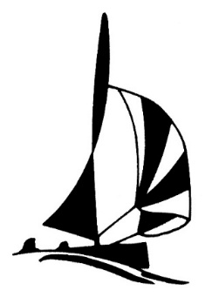

Bluff Yacht Club

Oyster Regatta 2026

Saturday 14 and Sunday 15 March 2026
Entry Form

Organising Authority:  Bluff Yacht Club  C/- PO Box 5017  Waikiwi  Invercargill | Class | Country Code on Sail | Sail Number
 | Hull Colour
 | Boat Name

Helmsperson | Crew
First Name | First Name
Surname | Surname
Yacht Club | Yacht Club
Address | Address
Email | Email
Phone | Phone

I agree to be bound by the Racing Rules of Sailing and all other rules that govern this event. I understand that yacht racing has inherent risks and dangers that are beyond the control of the organising authority. I understand that neither the organising authority and its officers, members and servants nor other persons assisting with the conduct of the regatta accept any responsibility in respect of any injury or loss to person or property that may be sustained by reason of participation in the regatta or howsoever arising in connection with the regatta. I agree to the use of my photograph(s) and other relevant information in any event publicity and in the ongoing promotion of New Zealand yachting. I agree to the Organising Authority and Yachting New Zealand holding the above information for the general administration and well-being of the sport, and for them to retain, use and disclose the information to affiliated organisations and any other persons or organisations that Yachting New Zealand believes will further the interests and objectives of Yachting New Zealand. I acknowledge my right to access to and correction of this information. The consent is given in accordance with the Privacy Act 1993.

Helmsperson’s Signature: | Crew Signature:
Parent/Guardian Signature (if sailor under 18 years old) | Parent/Guardian Signature (if sailor under 18 years old)
Date | Date

Fee Paid | Junior  $10.00 | Senior  $25.00 | Trailer Yachts  $85.00
Fee Paid | ☐ | ☐ | ☐

Office Use
Entry Fee Paid | Cash / Cheque / Eftpos | Date | Comment

