Living Christ Lutheran Church (L.C.M.S.)
Faith | Love | Outreach | Worship
726 Moon Road, Plainfield, IN 46168 (317) 839-4800 (317-450-7505 cell)
Pastor Steven D Latzke 574-261-4427
www.livingchristplainfield.com

The Baptism Our Lord
January 11, 2026

: Behold My servant, whom I uphold, My chosen, in whom My soul delights; I have put My Spirit upon Him; He will bring forth justice to the nations. Isaiah 42:1


As We Gather
Today we hear that divine promise in Isaiah 42, identifying Jesus as God’s chosen servant. From the beginning, however, we are told He is not only to be King of the Jews alone but a light to lighten the Gentiles also. The great news is that He is the Savior of and for all people, the descendants not only of Abraham but also of Adam and Noah! By repentance of sin and faith in Christ, worked by the same Spirit that marked Jesus as the chosen one at His Baptism, now all who are baptized into Christ—Jew or Gentile—are the chosen people of God. Praising and thanking God for calling and saving us, we echo the Gospel to all people in the words of the Psalm: “Praise the Lord, all nations! Extol Him, all peoples!” (Psalm 117:1).
Living Christ for Kids
Christian educational childcare for infants thru 11 years
Mrs. Kim Willis, Director 317-837-9998

Visitors, we welcome you and thank you for being with us today. May we be a blessing to you and you to us.

Please come again soon to receive with us and hear of God’s gifts of forgiveness, peace and life in the name of Jesus Christ.

Join us each Sunday at 10:30 am to hear the Word from Scripture and to share in worship of our Savior and Lord.

Pre-Service Meditation
On entering: Lord, I love the habitation of Your house and the place where Your glory dwells. In the multitude of Your tender mercies prepare my heart that I may enter Your house to worship and confess Your holy name; through Jesus Christ, my God and Lord. Amen.

Before worship: O Lord, my Creator, Redeemer, and Comforter, as I come to worship You in spirit and in truth, I humbly pray that You would open my heart to the preaching of Your Word so that I may repent of my sins, believe in Jesus Christ as my only Savior, and grow in grace and holiness. Hear me for the sake of His name. Jesus. Amen.

Each Sunday Worship 10:30 a.m. Holy Communion 1st, 3rd, 5th Sundays
Sunday Morning Bible Class continues studying Job at 9:00 am. Join us!

This week:
Adult Study Lutheranism 101 will meet this week Wednesday at 5:00 pm
Church Council – Monday 1/19 - 6:00 pm
Outreach – Tuesday 1/20 10:00 am

The Spirit-Marked Servant
PREPARATION
Opening Hymn 344 On Jordan’s Bank the Baptist’s Cry
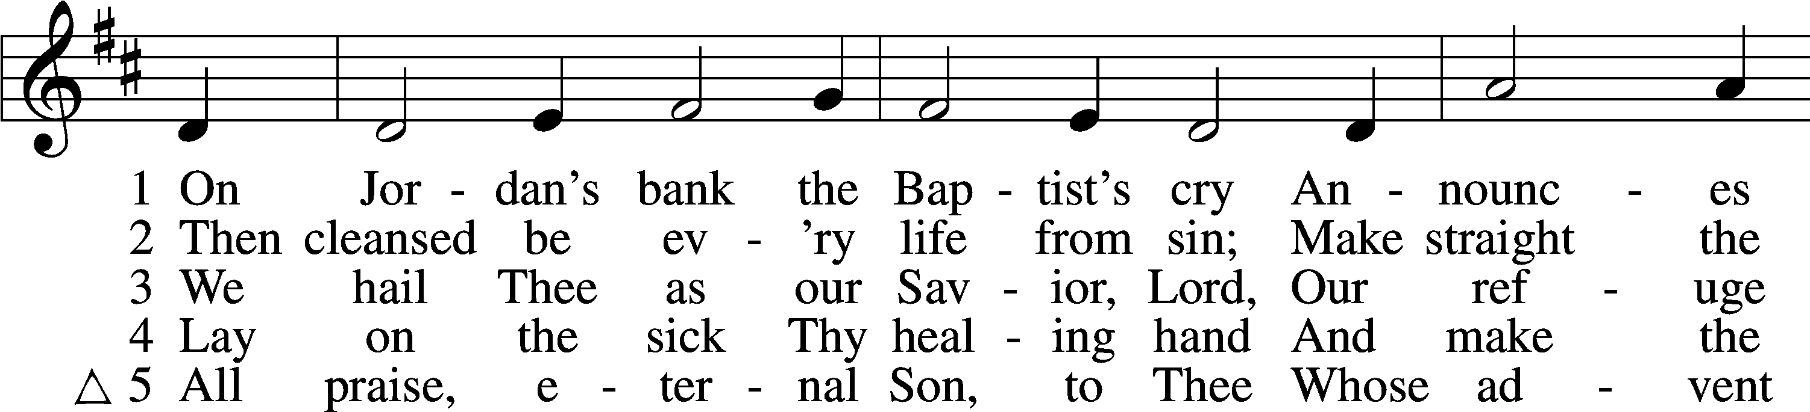
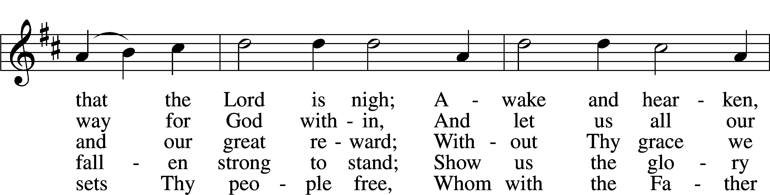
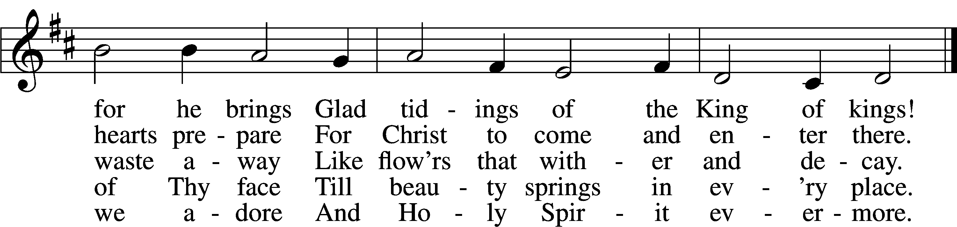
Text: Charles Coffin, 1676–1749; tr. Composite Tune: adapt. Michael Praetorius, 1571–1621
Text and tune: Public domain

Invocation
P In the name of the Father and of the T Son and of the Holy Spirit.
C Amen.

Opening Sentences Psalm 43:4; Psalm 117
P I will go to the altar of God,
C to God my exceeding joy.

P Praise the Lord, all nations! Extol Him, all peoples!
C For great is His steadfast love toward us,
and the faithfulness of the Lord endures forever. Praise the Lord!

Confession and Absolution
P Jesus Christ is God’s chosen one, who came and who comes again today to call everyone to salvation from sin and death and who makes all who are baptized in His name to be the chosen sons and daughters of God. Marked by the sacred waters of Holy Baptism, let us receive God’s assurance and promise of forgiveness.
C Almighty God, our dear Father in heaven, in Holy Baptism You have marked us with the sign of the holy cross upon our foreheads and upon our hearts to mark us as people of Your choosing to be redeemed by Christ the crucified. Open our eyes to Your light of freedom and forgiveness and to Your calling of us to be Your own chosen people of Your eternal kingdom.

P Upon this your confession, the almighty God and Father of our Lord Jesus Christ, who has given you the new birth of water and of the Spirit, has forgiven you all your sins. God strengthen you with His grace to life T everlasting.
C Amen.

WORD
Introit for Baptism of Our Lord
P Behold My servant, whom I uphold, My chosen, in whom My soul delights.

C will tell of the decree:*
The Lord said to Me, “You are my Son; today I have begotten You.
Ask of Me, and I will make the nations Your heritage,*
and the ends of the earth Your possession.
You shall break them with a rod of iron*
and dash them in pieces like a potter’s vessel.”
Now therefore, O kings, be wise;*
be warned, O rulers of the earth.
Serve the Lord with fear,*
and rejoice with trembling,
for His wrath is quickly kindled.*
Blessèd are all who take refuge in Him.
Kyrie LSB 204
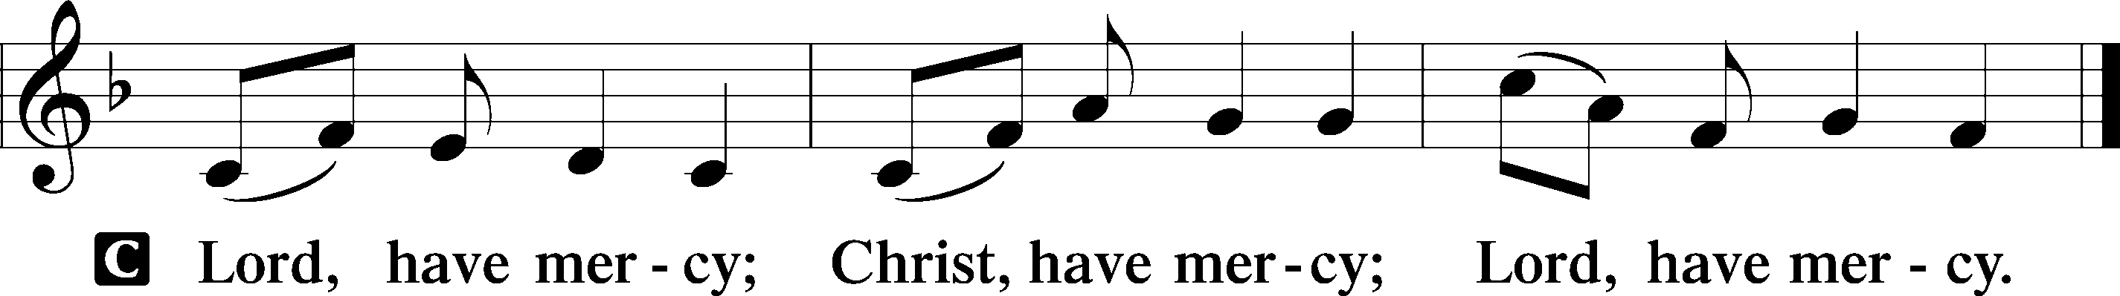
Gloria in Excelsis LSB 204
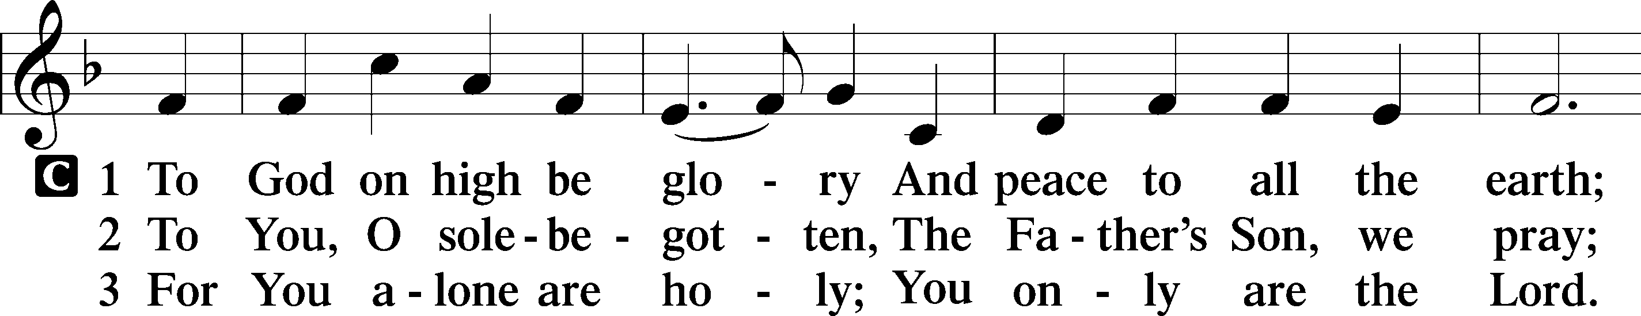
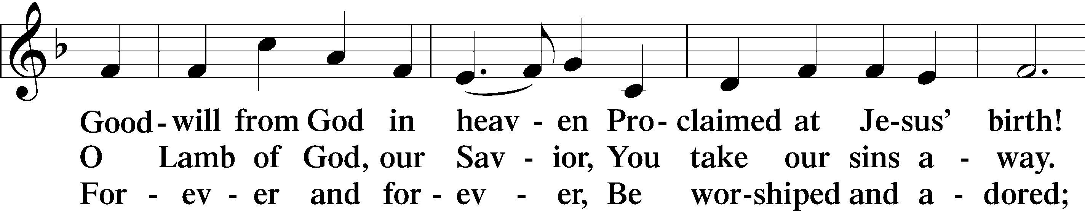
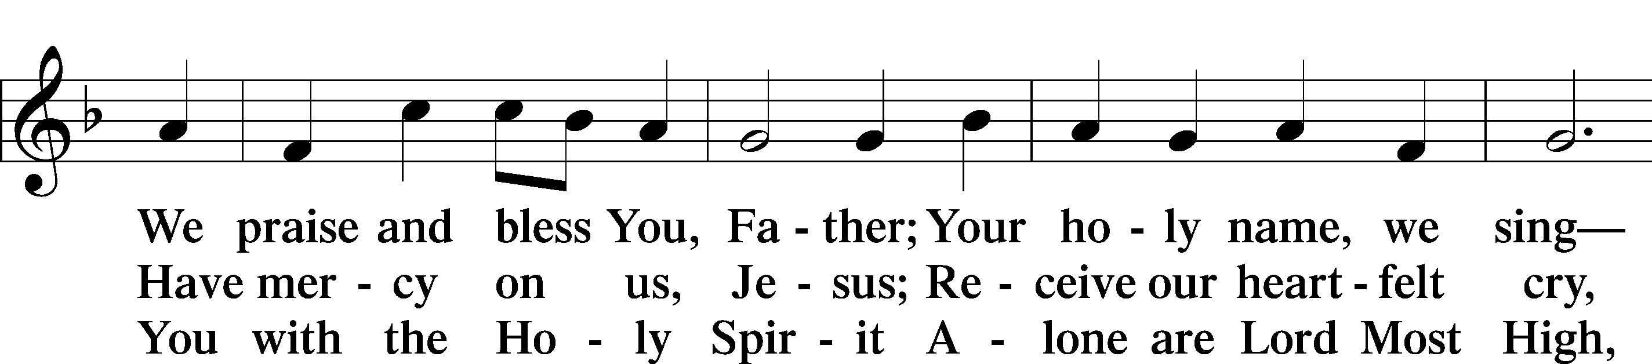
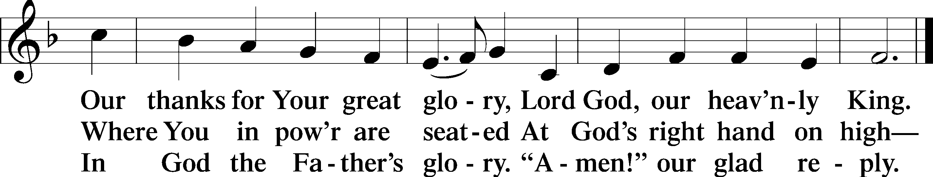
Text: Stephen P. Starke

Salutation
P The Lord be with you.
C And also with you.

Prayer of the Day
P Let us pray.
Father in heaven, at the Baptism of Jesus in the Jordan River You proclaimed Him Your beloved Son and anointed Him with the Holy Spirit. Make all who are baptized in His name faithful in their calling as Your children and inheritors with Him of everlasting life; through the same Jesus Christ, our Lord, who lives and reigns with You and the Holy Spirit, one God, now and forever.
C Amen.

Old Testament Reading Isaiah 42:1–9
(The Lord’s chosen servant)
1Behold my servant, whom I uphold,
my chosen, in whom my soul delights;
I have put my Spirit upon him;
he will bring forth justice to the nations.
2He will not cry aloud or lift up his voice,
or make it heard in the street;
3a bruised reed he will not break,
and a faintly burning wick he will not quench;
he will faithfully bring forth justice.
4He will not grow faint or be discouraged
till he has established justice in the earth;
and the coastlands wait for his law.
5Thus says God, the Lord,
who created the heavens and stretched them out,
who spread out the earth and what comes from it,
who gives breath to the people on it
and spirit to those who walk in it:
6“I am the Lord; I have called you in righteousness;
I will take you by the hand and keep you;
I will give you as a covenant for the people,
a light for the nations,
7to open the eyes that are blind,
to bring out the prisoners from the dungeon,
from the prison those who sit in darkness.
8I am the Lord; that is my name;
my glory I give to no other,
nor my praise to carved idols.
9Behold, the former things have come to pass,
and new things I now declare;
before they spring forth
I tell you of them.”

L This is the Word of the Lord.
C Thanks be to God.

Epistle Romans 6:1–11
(Dead to sin, alive to God)
1What shall we say then? Are we to continue in sin that grace may abound? 2By no means! How can we who died to sin still live in it? 3Do you not know that all of us who have been baptized into Christ Jesus were baptized into his death? 4We were buried therefore with him by baptism into death, in order that, just as Christ was raised from the dead by the glory of the Father, we too might walk in newness of life.
5For if we have been united with him in a death like his, we shall certainly be united with him in a resurrection like his. 6We know that our old self was crucified with him in order that the body of sin might be brought to nothing, so that we would no longer be enslaved to sin. 7For one who has died has been set free from sin. 8Now if we have died with Christ, we believe that we will also live with him. 9We know that Christ being raised from the dead will never die again; death no longer has dominion over him. 10For the death he died he died to sin, once for all, but the life he lives he lives to God. 11So you also must consider yourselves dead to sin and alive to God in Christ Jesus.

L This is the Word of the Lord.
C Thanks be to God.

Verse Mark 1:11b
P Alleluia.
C You are My beloved Son; with You I am well pleased.
P Alleluia.

Holy Gospel Matthew 3:13–17
P The Holy Gospel according to St. Matthew, the third chapter.
C Glory to You, O Lord.
(The Baptism of Jesus)

13Then Jesus came from Galilee to the Jordan to John, to be baptized by him. 14John would have prevented him, saying, “I need to be baptized by you, and do you come to me?” 15But Jesus answered him, “Let it be so now, for thus it is fitting for us to fulfill all righteousness.” Then he consented. 16And when Jesus was baptized, immediately he went up from the water, and behold, the heavens were opened to him, and he saw the Spirit of God descending like a dove and coming to rest on him; 17and behold, a voice from heaven said, “This is my beloved Son, with whom I am well pleased.”

P This is the Gospel of the Lord.
C Praise to You, O Christ.

Apostles’ Creed
C I believe in God, the Father Almighty,
maker of heaven and earth.

And in Jesus Christ, His only Son, our Lord,
who was conceived by the Holy Spirit,
born of the virgin Mary,
suffered under Pontius Pilate,
was crucified, died and was buried.
He descended into hell.
The third day He rose again from the dead.
He ascended into heaven
and sits at the right hand of God the Father Almighty.
From thence He will come to judge the living and the dead.

I believe in the Holy Spirit,
the holy Christian Church,
the communion of saints,
the forgiveness of sins,
the resurrection of the body,
and the life T everlasting. Amen.

Hymn of the Day 596 All Christians Who Have Been Baptized sts. 1–4
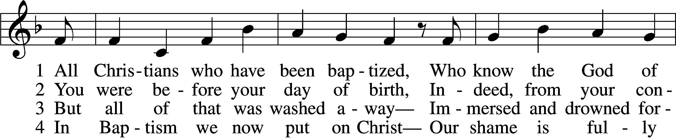
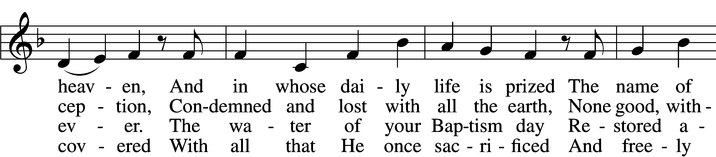
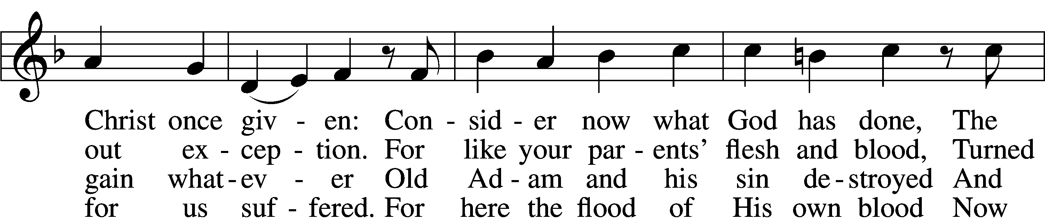
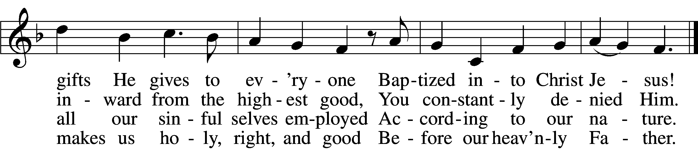
Text: Paul Gerhardt, 1607–76; tr. Jon D. Vieker, 1961 Tune: Etlich Cristlich lider, 1524, Wittenberg
Text: © 2004 Concordia Publishing House. Used by permission: LSB Hymn License no. 110018662 Tune: Public domain

Sermon DEAD TO SIN

Votum
P The peace of God, which passes all understanding, keep your hearts and minds in Christ Jesus.
C Amen.

Stand

Offering (Please place your offering in the offering plate in the back.)

Offertory Hymn 596 All Christians Who Have Been Baptized sts. 5–6
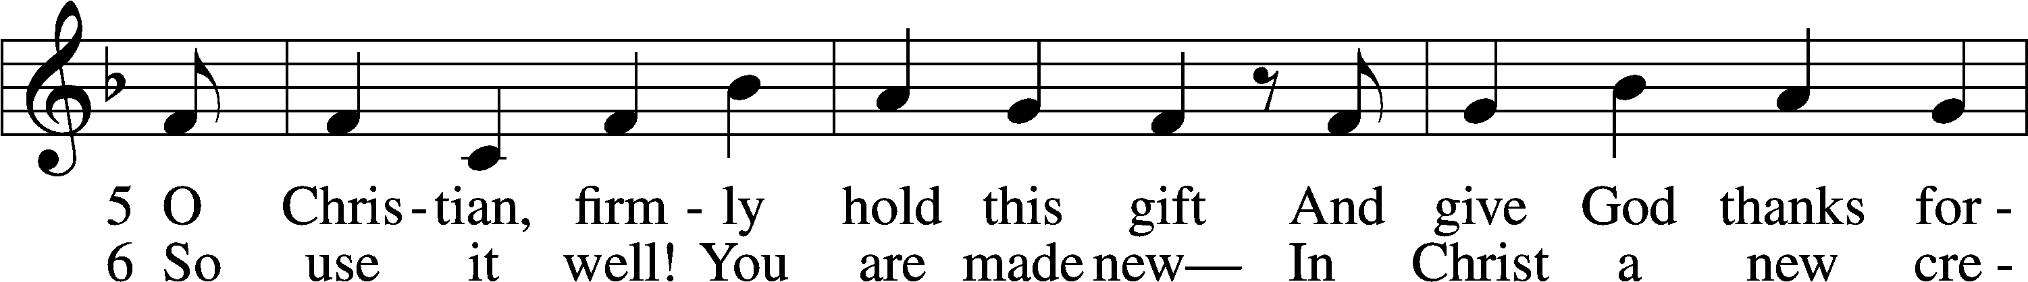
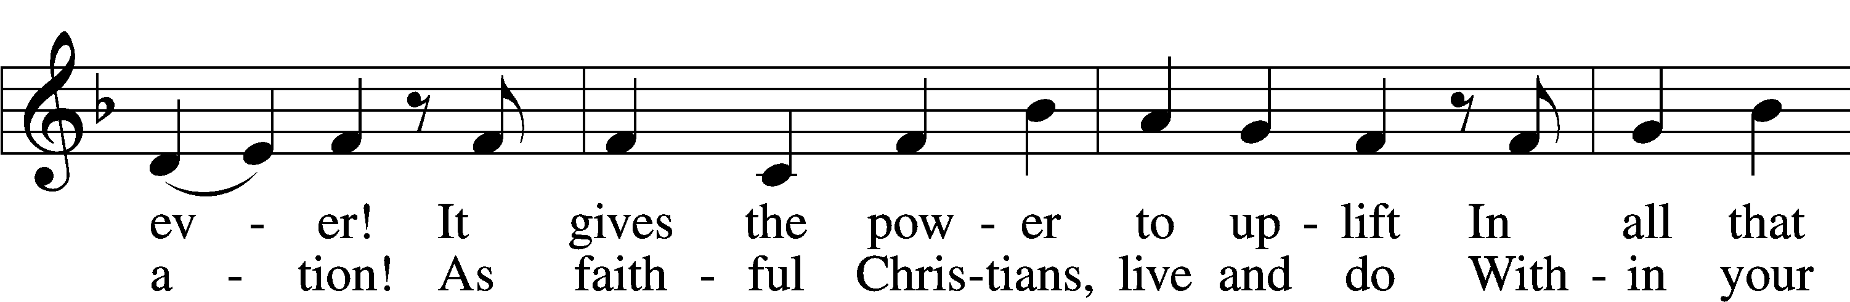
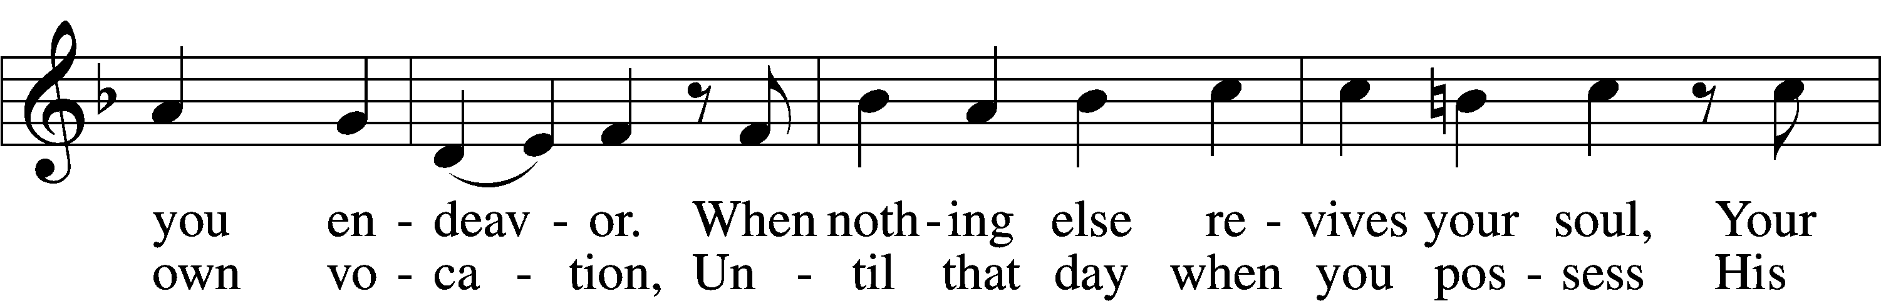
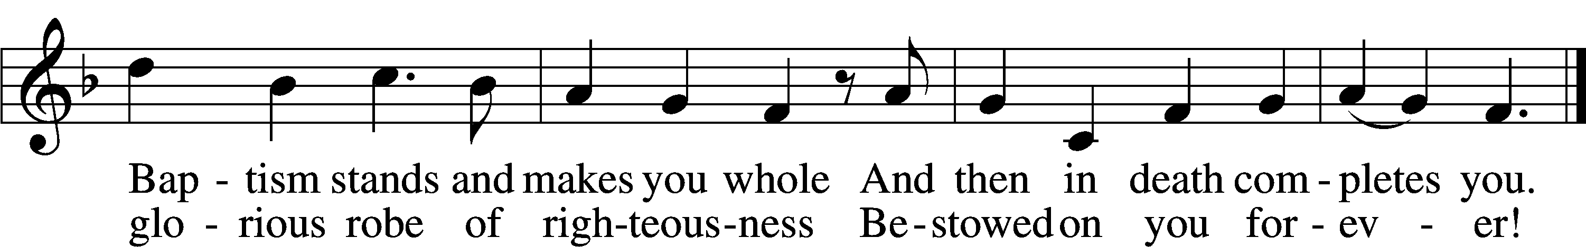
Text: Paul Gerhardt, 1607–76; tr. Jon D. Vieker, 1961 Tune: Etlich Cristlich lider, 1524, Wittenberg
Text: © 2004 Concordia Publishing House. Used by permission: LSB Hymn License no. 110018662 Tune: Public domain

Prayer of the Church
P All glory and praise to You, O God, for You have created all mankind in Your image to live in Your love and fellowship forever in Your eternal kingdom. By Your design, You have defeated the devil and the power of sin and death by the sacrifice of Your Son, our Lord Jesus Christ, and opened the kingdom of heaven to all believers. He became Your chosen one in His Baptism in the waters of the Jordan River and by Your Holy Spirit, in order that all who are baptized in His name and by the same Spirit may be restored to newness of life as Your chosen sons and daughters. Help us to extend the same invitation of Your mercy and grace to all people. Lord, in Your mercy,
C hear our prayer.

P Grant that Your church be guided in true faith and worship by faithful pastors and shepherds of Your flock, that we may sing Your praises joyfully now and in eternity. Lord, in Your mercy,
C hear our prayer.

P Help us to live with integrity as people of Your own possession, guarding us from all evil and leading us safely in the ways of Your good and gracious will. Give to all in the authority of government a desire for good order to the promotion of freedom and faithfulness to the ways of peace. Lord, in Your mercy,
C hear our prayer.

P To all who are yet enslaved by the darkness of sin and separation from You, cause the light of Your salvation to break forth that many may hear of Your deliverance and the hope of life and love by faith in the Savior and be drawn by the Spirit to Your covenant of Holy Baptism. Lord, in Your mercy,
C hear our prayer.

P Grant healing and relief to all who are sick, homebound, or in any need or distress, that they may know the power of Your love. Lord, in Your mercy,
C hear our prayer.

P We remember all the saints who have gone before us, [especially . . .]. Give us a heart of wisdom that when our last hour comes, we are granted a blessed end in the life of the world to come. Lord, in Your mercy,
C hear our prayer.

P Into Your hands, O Lord, we commend all for whom we pray, trusting in Your mercy; through Your Son, Jesus Christ, our Lord.
C Amen.

Lord’s Prayer
C Our Father who art in heaven,
hallowed be Thy name,
Thy kingdom come,
Thy will be done on earth
as it is in heaven;
give us this day our daily bread;
and forgive us our trespasses
as we forgive those
who trespass against us;
and lead us not into temptation,
but deliver us from evil.
For Thine is the kingdom
and the power and the glory
forever and ever. Amen.
Benediction
P The Lord bless you and keep you.
The Lord make His face shine on you and be gracious to you.
The Lord look upon you with favor and T give you peace.
C Amen.

537 Beautiful Savior
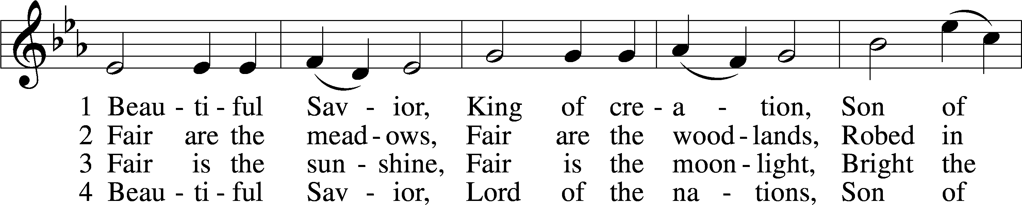
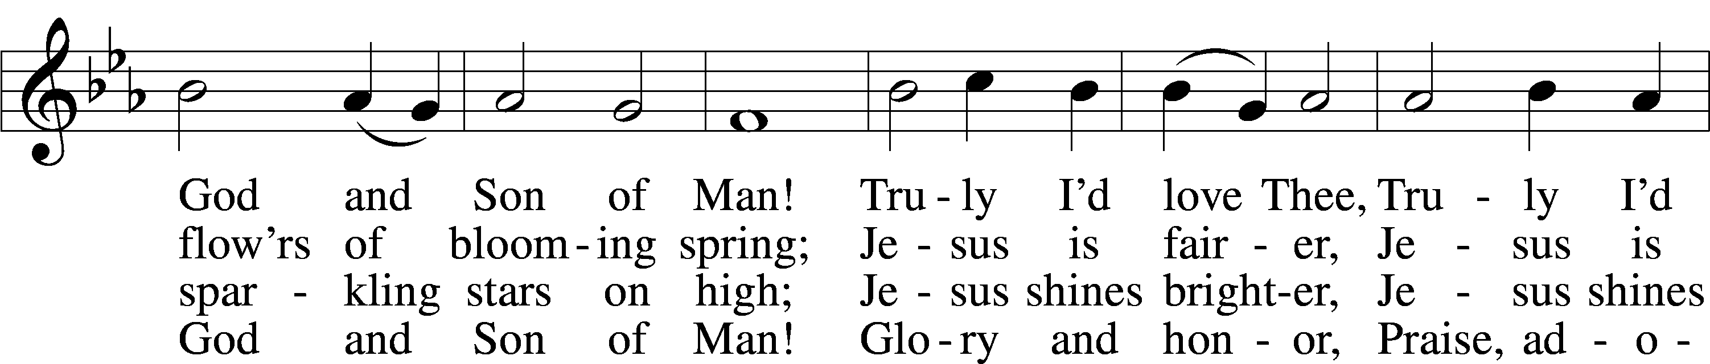
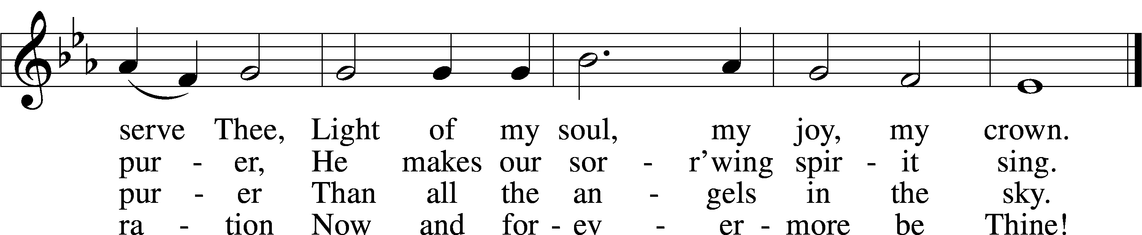
Text: Münsterisch Gesangbuch, 1677, Münster; tr. Joseph A. Seiss, 1823–1904
Tune: Silesian, 19th cent. Text and tune: Public domain

Acknowledgments
Creative Worship for the Lutheran Parish, Series A, Quarter 1.
Copyright © 2025 Concordia Publishing House. All rights reserved. Used by permission.

Acknowledgments
Unless otherwise indicated, Scripture quotations are from the ESV® Bible (The Holy Bible, English Standard Version®), copyright © 2001 by Crossway, a publishing ministry of Good News Publishers. Used by permission. All rights reserved.
Created by Lutheran Service Builder © 2026 Concordia Publishing House.

Chronological Reading Plan for Scriptures for the
January 2026. Be in the Word
 |  | 1/4 | Daniel 4-6 | 1/11 | Zechariah 8-14
 |  | 1/5 | Daniel 7-9 | 1/12 | Esther 1-5
 |  | 1/6 | Daniel 10-12 | 1/13 | Esther 6-10
 |  | 1/7 | Ezra 1-3 | 1/14 | Ezra 7-10
1/1 | Ezekiel 46-48 | 1/8 | Ezra 4-6, Psalm 137 | 1/15 | Nehemiah 1-5
1/2 | Joel 1-3 | 1/9 | Haggai 1-2 | 1/16 | Nehemiah 6-7
1/3 | Daniel 1-3 | 1/10 | Zechariah 1-7 | 1/17 | Nehemiah 8-10

1/18 | Nehemiah 11-13, Psalm 126 | 1/25 | Mark 2
1/19 | Malachi 1-4 | 1/26 | John 5
1/20 | Matthew 1, Luke 2: 1-38 | 1/27 | Matthew 12: 1-21, Mark 3, Luke 6
1/21 | Matthew 2, Luke 2: 39-52 | 1/28 | Matthew 5-7
1/22 | Matthew 3: Mark 1, Luke 3, | 1/29 | Matthew 8: 1-13, Luke 7
1/23  1/24 | Matthew 4, Luke 4-5, John 1: 15-51  John 2-4 | 1/30  1/31 | Matthew 11  Matthew 12: 22-50, Luke 11

\

