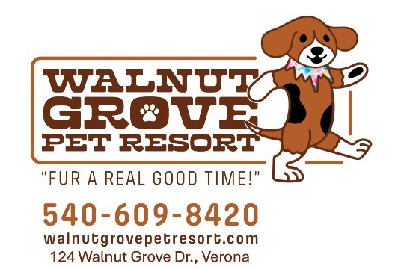

WE’RE PAWSITIVELY EXCITED TO INVITE YOU & YOUR PUP FAMILY
TO JOIN US AT OUR OPEN HOUSE!!!

Saturday, November 22
11:00 – 2:00

124 Walnut Grove Dr., Verona VA

Treats for Pups & Humans

Giveaways & Door Prizes

Meet Our Team & Tour Our New Pup “Home Away From Home”

For each person who joins us, we’ll donate a $1 to be split between the Staunton-Augusta-Waynesboro Animal Shelter & the Augusta Regional SPCA



