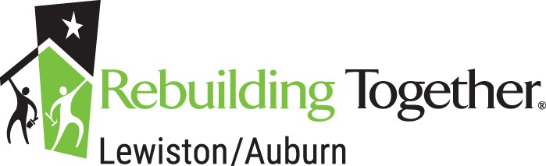
P. O. Box 7161
Lewiston, Maine 04243-7161

Rebuilding Together Lewiston/Auburn is a non-profit organization supported entirely by contributions of time, labor, material and money. We are dedicated to repairing homes of those who, due to financial hardship, age, and/or disability, cannot do the work themselves. Skilled and unskilled volunteers along with able-bodied members of the recipient’s family and friends complete the repairs at no cost to the homeowner.
Home safety is the first priority of RTLA. Volunteers provide improvements that enhance the safety and comfort of your home. Because it is primarily a one-day project, major structural repairs are not possible. Also, we need you to understand that time may prevent the volunteers from accomplishing everything that you would like to have done in your home.

To be considered for the program, please complete the enclosed application and return it to Rebuilding Together Lewiston/Auburn at the above address, or email it to rebuildingtogetherla@gmail.com . Please include a verification of income with your application.
If you have any questions about the program or if you need assistance in completing the application, please email rebuildingtogetherla@gmail.com . A member of the board will get back to you. Final site selections should be made by end of April, and all applicants will be notified by phone or in writing as to whether or not their home has been selected for our program.

Application:
Name:
Address Phone: Email:
Age of Homeowner:
How did you hear about Rebuilding Together? Do you own your home? Number of people living in your home: Do you plan to sell your home within the next 18 months?
Do you own other property? If so, what is that property used for?

Have you applied to Rebuilding Together in the past? When? Has your home received services from Rebuilding Together? When? Total family income per month:

List sources of all income (i.e. Social Security, SSI, AFDC, VA Benefits, etc.):

Is the homeowner or anyone else residing in the home disabled? No The Fair Housing Act defines disability as a physical or mental impairment that substantially limits one or more major life activities. The Supreme Court has determined that to meet this definition a person must have an impairment that prevents or severely restricts the person from doing activities that are of central
importance in most people’s daily lives. The disability must be permanent (of continual or long duration).
List the most necessary work needed in order to make you home safe, secure and weatherproof or to adapt the home to a family member’s disability. (Funds are limited and not all repairs can be made.)
Electrical Exterior Painting Interior Painting
Plumbing Wall Repairs Roof Repairs
Yard Work Floor Repair Door Repair
Ramp Installation Ramp Repair
Other (Please specify):

My signature below indicates that the information provided above is accurate and complete. I have read the information provided by Rebuilding Together Lewiston/Auburn and have a basic understanding of the program and its process. I give Rebuilding Together Lewiston/Auburn volunteers my permission to inspect my home for purposes of home selection and/or repair.

Signature of Applicant Date of Application

Rebuilding Together does not discriminate on the basis of race, color, national or ethnic origin, religion, sex, sexual orientation, marital or parental status, age, or disability.
Check here if you are a veteran

