PULSES
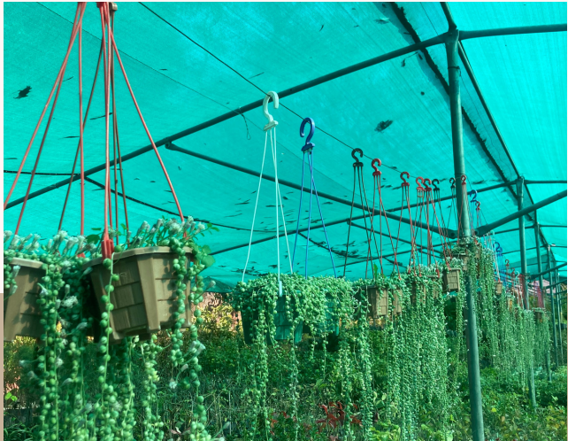
Where do Pulses Grow?
Pulses are grown in virtually every corner of the globe. They have a strong history of nourishing people around the world for centuries. Along with the early cereal grains, pulses were among the first crops cultivated as far back as 11,000 years ago. In the past three decades, global pulse production has grown rapidly. In the past ten years alone, the world has produced between 50 and 60 million tonnes of pulses each year. As of 2015, the world's biggest producers of pulses were India, Canada, Myanmar, China, Nigeria, Brazil, Australia, USA, Russia, and Tanzania. While the world's most important pulse exporters also include Argentina, France, Ethiopia, and Turkey. Overall, there were nearly 173 countries in the world that grew and exported pulses between 2010 and 2013!

Common Pulses
Pulses are the dried seeds of the legume plants. Hundreds of different varieties of pulses are grown around the globe.

Dry Beans ,Lentils, Faba Beans, Dry Peas, Chickpeas, Cowpeas, Bambara Beans, Pigeon Peas, Lupins, Vetches.

Pulses for a Healthy Diet

Help maintain a healthy body weight
Rich in protein and fiber and low in fat, pulses can help you feel fuller longer.
Reduce post-meal “crashes”
Pulses are complex carbohydrates, which take longer to break down compared with other carbohydrates (simple sugars), providing longer-lasting energy.
Reduce the risk of chronic diseases
Pulses can help with the management of blood sugar levels and diabetes because they do not cause blood sugar levels to rise as much as sugary or starchy foods that are low in fiber.
Help maintain heart health
Pulses are a heart-healthy food choice. Research has shown that eating pulses can lower blood cholesterol, reduce blood pressure and help with body weight management, which are all risk factors for heart disease.
Contribute to gut health
Pulses are a source of prebiotic fiber – the preferred food of our gut bacteria – which contributes to good gut health.

It is not a fengshui plant, and it’s also a outdoor plant.

Panda Ficus
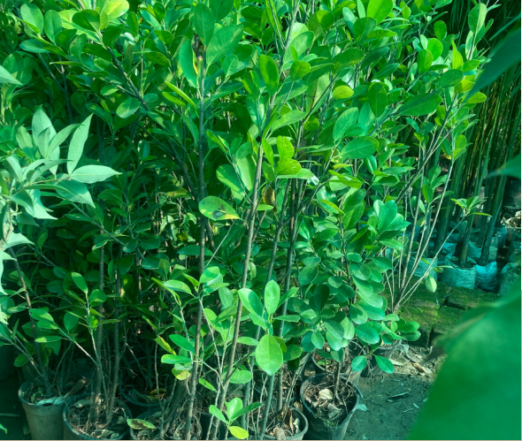

What isFicus Panda?
Ficus panda plant is the best evergreen plant. There are many varieties of this plant Which are grown as houseplants. Ficus trees can maintain their tree-like shape regardless of their size, so this makes them ideal for bonsai or for large-scale houseplants in large locations. The plant is planted to create terrace gardens, landscaping, and borderers. This plant is best used for making hedges. This plant grows very fast and well.

Caring
The care of this plant is very low and easy. After 20 to 25 days in this plant, vermicompost should be added from 100 to 200 grams per plant. And add a spoonful of Epsom salt to 5 liters of water. Which improves plant growth, and grows well. Water should be added after 2 to 3 days (as the soil dries). Water should never be poured in the afternoon. Because by pouring water in the afternoon, the water becomes hot in the sun and damages the plant due to which the plant deteriorates quickly. Therefore, water should be poured in the evening.

Ficus Panda Uses
Ornamental Use:
- Ficus trees can maintain their tree like shape regardless of their size, so this makes them ideal for bonsai or for massive houseplants in large spaces
Culinary Use:
- The common fig (Ficus carioca) is cultivated for its pear-shaped, edible fruits, which are really hollow fleshy receptacles (syconia) containing hundreds of male and female flowers
Medicinal
- The bark of the root, the root itself, and the leaves are boiled in oil and applied on wounds and bruises
- The juice of the bark (latex?) has a reputation in the Philippines for curing liver diseases
- The pounded leaves and bark are applied as a poultice in the treatment of rheumatic headaches
Type: Evergreen plant.

Care: Easily care and maintained.

Suitable: Outdoor & Shaded Area.

Make an eye catcher display in your outdoor and indoor spaces with an excellent Ficus panda plant.Ficus trees are a common plant in the home and office, mainly due to the fact that they look like a typical tree with a single trunk and a spreading canopy

Is ficus plant good for feng shui?
Ficus plants are favored in feng shui for air-purifying qualities that are said to encourage enlightenment. There are several varieties of ficus plants, all of which serve a space by filtering toxins from the air and offering an energizing boost from their vibrant foliage

Christmas Tree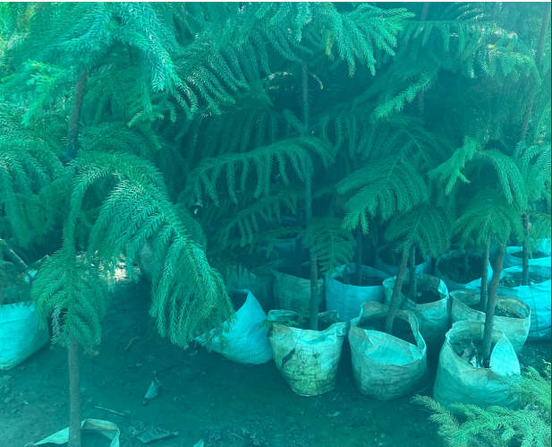

About Christmas Tree
The Cook pine, called Christmas Tree in India, is a tree native to the Cook Island, north-east of Australia in the South Pacific. The bark of the Cook pine peels off in thin paper like sheets. Can reach 60 m in natural habit. But more commonly grown as a house plant in pots. The relatively short, mostly horizontal branches are in whorls around the slender, upright to slightly leaning trunk.
This is an evergreen tree. Its long, horizontal branches are densely covered with short, soft needles that become darker as the plant ages. This is also called as star pine, triangle tree or living Christmas tree. This is slow growing plant.

Medical properties according to Ayurveda :-
Properties:-
Bitter taste, Bitter in digestion, Light, Dry, Hot, Vata-Kafa destroyer, eatable

Therapeutic Uses:-
- Diuretic
- Helps to destroy gall bladder and kidney stones
- Helps in management of joint pain
- Stops diarrhoea

Plant Protection
- Remove dead, infected or damaged plant parts and discard them away from the plants.
- For any insect attack or disease, you can use Neem oil, Eucalyptus oil or Citrus oil spray for primary treatment.

Don’ts
- Do not over water the plant especially when pot does not have drainage holes.
- keep away from the AC Vents.
- Do not apply water on plant leaves.

Initial care for 1-2 weeks after receiving plant at your location.
- Check the moisture in the soil before watering it.
- Poke your finger into the soil, if dry then apply water.
- Keep the plant in indirect light.
- Do not repot immediately after receiving it.

Special feature of Christmas Tree
Areca palm is an air purifier indoor plant.

Is Christmas tree good for Feng Shui?
A Christmas tree connects you with the living world, so it is considered a strong Wood Element symbol. In addition, the triangular shape of a Christmas tree is considered a Fire Element, even more so when it is covered with lights. Therefore, your Christmas tree is both a strong Wood and Fire enhancement.

Sugi Tree
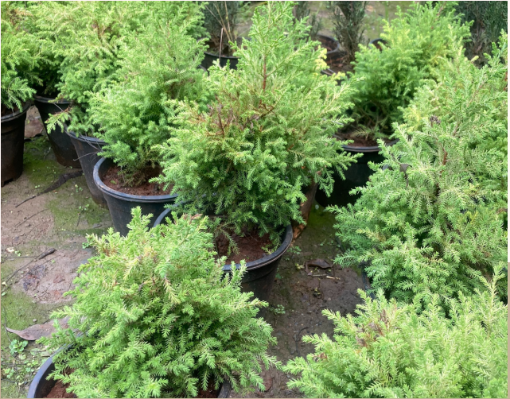
About Sugi Tree
"Sugi" redirects here. For other uses, see Sugi (disambiguation) and Cryptomeria (disambiguation).
Cryptomeria (literally "hidden parts") is a monotypic genus of conifer in the cypress family Cupressaceae, formerly belonging to the family Taxodiaceae. It includes only one species.
Cryptomeria is a very large evergreen tree, reaching up to 70 m (230 ft) tall and 4 m (13 ft) trunk diameter, with red-brown bark which peels in vertical strips. The leaves are arranged spirally,
Biology
Cryptomeria grows in forests on deep, well-drained soils subject to warm, moist conditions, and it is fast-growing under these conditions. It is intolerant of poor soils and cold, drier climates.
Cultivation

Timber: -
Cryptomeria japonica timber is extremely fragrant, weather and insect resistant, soft, and with a low density. The timber is used for the making of staves, tubs, casks, furniture and other indoor applications. Easy to saw and season, it is favored for light construction, boxes, veneers and plywood. Wood that has been buried turns dark green and is much valued. Resin from the tree containscryptopimaric.
Is Sugi tree good for feng shui?
Cast Iron Plants are considered to be auspicious in the feng shui tradition. They are believed to ward off bad luck and protect homes from negative energy.

Mechanical properties: -

In dry air conditions, the initial density of Japanese cedar timber has been determined to be about 300–420 kg/m³. It displays a Young's modulus of 8017 MPa, 753 MPa and 275 MPa in the longitudinal, radial and tangential direction in relation to the wood fibers.
Popular Ornamentals: -

Sugi are quite popular ornamentals that have been propagated in Japan for over 500 years. Currently they are also grown in North America and Europe. Because of their relatively narrow crowns, they are suitable for moderate-sized locations, although the lower branches may require removal to permit access by pedestrians and vehicles. Fortunately, the wood is relatively strong, so limb drop is a rare phenomenon on healthy trees. Once mature, Sugi possess a beautiful, reddish colored, peeling bark.

Commercial Uses: -

In addition to those traits that make them excellent ornamental species, Sugi trees yield high quality wood that has a number of commercial applications. The fragrant wood is very resistant to rot, so it is used in extensively in construction and furniture making. To satisfy the demand for the useful timber, Sugi trees are grown on large plantations in Japan.

It is not a fengshui plant, and also an indoor plant.

Philodendron Tree

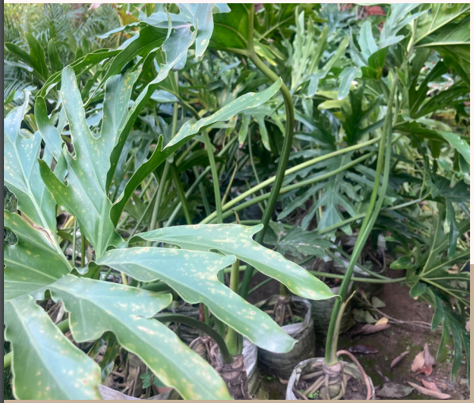

The tree philodendron (Philodendron bipinnatifidum) is a large plant that is native to the tropical regions of South America, namely Brazil, Bolivia, Argentina, and Paraguay. This tropical aroid also grows naturally in the East and Gulf coasts of the United States and is popular as a houseplant. Mainly grown for its large and unique foliage, the tree philodendron is easy to grow and adds a tropical feel to any space.

Botanical - Name - | Philodendron bipinnatifidum, Thaumatophyllum bipinnatifidum
Common - Name - | Tree philodendron, lacy tree philodendron, Philodendron selloum, horsehead philodendron
Plant Type - | Broadleaf evergreen
Mature Size - | 15 ft. tall outdoors, 10 ft. spread outdoors; 6 ft. tall indoors, 8 ft. spread indoors.

Climate
The ideal temperature for these houseplants is between 70 and 85°F, but they’ll do okay as long as nighttime temperatures don’t drop below 55°F. If you’ve accidentally left yours outside in a light frost, you may luck out. Sometimes they’ll survive overnight or for a few hours in temperatures that plummet to 36°F, but don’t press your luck.
Tree Philodendron Plant Care: Fertilizer Requirements

The Tree Philodendron does well with a well-balanced fertilizer. Grow the philodendron in a soilless potting mix, adding a balanced liquid fertilizer monthly. Even for larger trees, take care not to over-fertilize your plant as this can lead to leaf burn.

Tree Philodendron Plant Care: Interesting Facts

Ingestion of any part of the Tree Philodendron (Philodendron selloum) may cause severe discomfort. Contact with sap may cause skin irritation.
According to the American Society for the Prevention of Cruelty to Animals (ASPCA) list of poisonous houseplants, most philodendron including Tree Philodendron are poisonous to many domestic animals such as cats.

Philodendron selloum is an air purifier indoor plant.

Is Philodendron Tree fengshui?

Philodendron Green
With quick-growing vines and low-maintenance care, the classic philodendron plant makes a well-suited feng shui plant for channeling love. Its soft, heart-shaped leaves can help activate the marriage and relationships area of your space,

Chamaecyparis lawsoniana

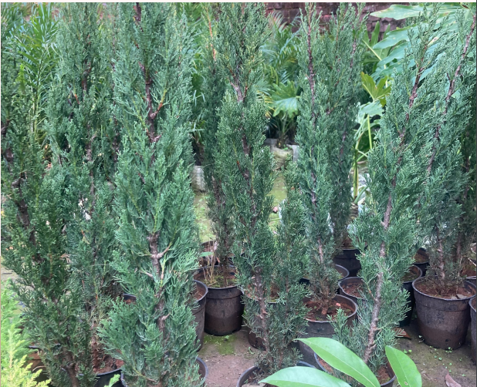
Common Name:Lawson's cypress
Type: Needled evergreen
Family: Cupressaceae
Native Range: Western North America

Chamaecyparis lawsoniana, known as Port Orford cedar or Lawson cypress, is a species of conifer in the genus Chamaecyparis, family Cupressaceae. It is native to Oregon and northwestern California, and grows from sea level up to 4,900 feet (1,500 m) in the valleys of the Klamath Mountains, often along streams.

Description: -
Port Orford cypress is a needled evergreen tree in the Cupressaceae (cypress) family. It is native to northern California and Oregon from sea level to 4900 feet. Port Orford cypress is a large tree up to 180 feet tall with ascending branches and tips that droop giving it a pendulous look.
This tree prefers moist but well-drained soils in full sun with some wind protection.
This tree is large and rarely used as an ornamental but there are over 300 cultivars available that are more useful as a specimen tree
The aromatic wood is light and strong with rot resistance and is often exported to Japan for use in coffins, shrines and temples. The straight grain of the wood make it ideal for making arrows and stringed instruments.

Wildlife Value:

Provides protection and nesting sites for wildlife. Douglas squirrels harvest Port-Orford-cedar cones and eat the seed. Mountain beavers and rabbits occasionally eat the foliage of saplings, and woodrats and porcupines eat the bark.

Genus: Chamaecyparis
Species: lawsoniana
Family: Cupressaceae
Uses (Ethnobotany): Used in making arrows and stringed instruments.
Life Cycle: Woody
Leaf Color: Blue, Green
Leaf Value To Gardener: Long-lasting

Chamaecyparis plants can be considered effective fungicides and the best plants for purifying the air.

It’s not a fengshui plant it’s also an outdoor and indoor plant.

Cycas

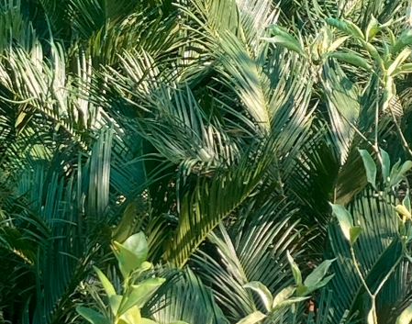

About Cycas Plant
Enjoy the tropical view at your home by growing an amazing Sago Palm.Sago Palm leaves are pinnately compound, dark green color on a thick shaggy trunk. The trunk is very low to subterranean in young plants, but lengthens above ground with age. It grows out into a feather like rosette. The basal leaflets become more like spines.

Plant Specifications
Common Name: - Sago palm, Cycas revoluta, Sotetsu, King sago, Sago cycad

Maximum Reachable Height: - Up to 6 ft (1.8 m) indoors.

Cycas Plant Special Feature
- This species is not a true palm.
Cultivation and uses

Propagation of Cycas revoluta is either by seed or clonally by removal of basal offsets. It is one of the most widely cultivated cycads, grown outdoors in warm temperate and subtropical regions, or under glass in colder areas. It grows best in sandy, well-drained soil, preferably with some organic matter. It needs good drainage or it will rot. It is fairly drought-tolerant and grows well in full sun or outdoor shade, but needs bright light when grown indoors. The leaves can bleach somewhat if moved from indoors to full sun outdoors.

Slow-growing cycads are used as ornamental conservatory plants, but some survive outdoors in temperate regions. The popular sago palm (Cycas revoluta) is grown as a houseplant and outdoor ornamental, and its leaves are widely used as ceremonial “palms” in floriculture. The pithy stems of this and other species are a source of sago, a food starch. The cardboard palm (Zamia furfuracea) and giant dioon (Dioon spinulosum) are also common ornamental species.

Is Cycas revoluta an indoor plant?
Cycas revoluta is one of the oldest household plants. It is commonly grown as a houseplant in temperate climates. Cycas revoluta can thrive both indoors and outdoors. It is ideal for growing in a container, which can be kept outside in summer. Avoid placing them in direct sunlight. When grown indoors, choose a bright east-, west- or south-facing window.

Cycas Plant is an air purifying plant that removes various xylene, toluene, and VOCs from the air to make it cleaner. Your Cycas Plant can grow up to 3-5 feet tall when grown indoors

Is Cycus plants fungshui?

This plant is considered very good in feng shui to place near the entrance and is a good asset for main door feng shui. The cycas plant is propagated by itself as in form of bulbs

Golden Juniper

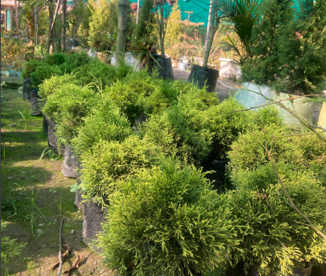
Common Name: - Chinese juniper

Type: -Needled evergreen

Family: - Cupressaceae

Juniperus chinensis, commonly called Chinese juniper, is a dioecious evergreen conifer that is native to China, Japan, Mongolia and the Himalayas. It is often seen in the wild as a conical tree to 50’ tall and 20’ wide, but also appears in much shorter shrubby or spreading forms. Foliage is dark green. Brown bark on mature stems peels in strips. Although species plants are rarely sold in commerce, a large number of cultivated varieties ranging in size from large trees to large/small shrubs to low-growing groundcovers have become popular ornamental landscape plants. Chinese juniper leaves come in two types: scale-like (adult) and awl/needle-like (juvenile). Cones (pollen and seed-bearing) appear on different plants. Male plants produce catkin-like pollen cones. Female plants produce fleshy, berry-like, whitish-blue seed cones that usually acquire violet-brown tones as they mature over two years.

Culture
Easily grown in average, medium moisture, well-drained soils in full sun. Tolerant of a wide variety of soils including clay. Intolerant of wet soils. Tolerant of some drought once established. Also tolerant of many city air pollutants.
Plant Protection
- Remove any dead, infected, or damaged parts of the plant and discard them away.
- For any disease or insect attack, you can use “Neem oil”, Eucalyptus oil, or Citrus oil spray for usual treatment.
Don'ts
- Make sure there will be no water logging in its soil, it can cause damage to the plant.
- Keep the plant away from the dark and shady place.
Golden Juniper Special Feature
It is easy to take care of because it never needs pruning to maintain its attractive shape.
Golden Juniper Uses
- The best plant to use for ornamental purposes and has medicinal value.
What makes it special:
- A beautiful plant with leaves like needles or scales.
- Low-growing ground cover or edging plant.
- It’s a low-maintenance and evergreen plant.
The botanical name of the Golden Juniper is “Juniperus Chinensis”. It has rounded shapes with narrow columns. The evergreen conifers feature leaves that can be like needles or scales, looks very beautiful.
Is juniper bonsai good luck?
It's an evergreen and has long been a symbol for protection. In folklore, it wards off evil spirits and cleanses and purifies those near it. The tree produces small cones that are used in many healing rituals. In bonsai circles, the Juniper represents one's ability to overcome all that life throws at you.
It is not an indoor plant and not a fengshui plant.

Orange Jasmine

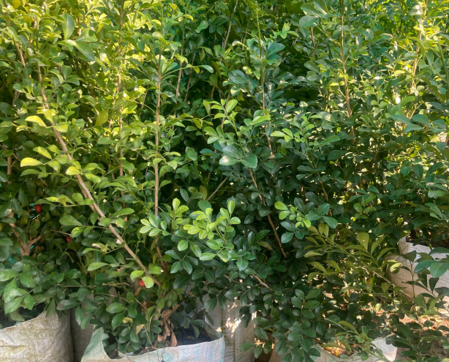
Common Name: - Orange jasmine, orange jessamine, satinwood, mock orange
Botanical Names: - Murraya paniculata, Chalcas paniculata
Family: - Rutaceae
Plant Type: - Shrub
Sun Exposure: - Full, partial
Bloom Time: - Spring, summer, fall
Flower Color: - White
Murraya paniculata, commonly known as orange jasmine, orange jessamine, China box or mock orange, is a species of shrub or small tree in the family Rutaceae and is native to South Asia, Southeast Asia and Australia. It has smooth bark, pinnate leaves with up to seven egg-shaped to elliptical leaflets, fragrant white or cream-colored flowers and oval, orange-red berries containing hairy seeds.

Distribution and habitat
Murraya paniculata grows in rainforest, often as an understory shrub in vine thickets, including behind beaches. It is native to South and Southeast Asia, China and Australasia, while the distribution area extends from Pakistan via India, Sri Lanka and southern China to Taiwan, the Philippines, where it is called kamuníng, the Ryukyus Islands and the Mariana Islands, to the south via Malaysia and Indonesia to New Guinea and parts of Australia. In Australia, it is native to the Kimberley region of Western Australia, northern parts of the Northern Territory, and parts of Queensland. The species has been naturalized in other places, sometimes becoming an invasive weed, including on many Pacific islands. In Queensland, it is regarded as different from the cultivated form Murraya paniculata 'Exotica', which is regarded as one of the most invasive plant species in southeast Queensland.
Uses
Murraya paniculata is cultivated as an ornamental tree or hedge because of its hardiness, wide range of soil tolerance (M. paniculata may grow in alkaline, clayey, sandy, acidic and loamy soils), and is suitable for larger hedges. The plant flowers throughout the year and produces small, fragrant flower clusters which attract bees, while the fruits attract small frugivorous birds.

Temperature and Humidity
As tropical plants, orange jasmine does best in humidity above 50 percent and must have temperatures above 40 degrees Fahrenheit, as they are not frost-tolerant. The plant can tolerate lower levels of humidity.

Orange jasmine plants require protection from hot, direct sunlight. Locate the plant where it receives morning sunlight and afternoon shade.
Is jasmine plant good for Feng Shui?
Jasmine is an effective Feng Shui houseplant if you want to attract and store positive romantic feelings. It helps build romance and strengthen relationships. The scent of Jasmine can also help soothe a stressed mind. Jasmine needs to stay cool with well-circulated air.

Camellia

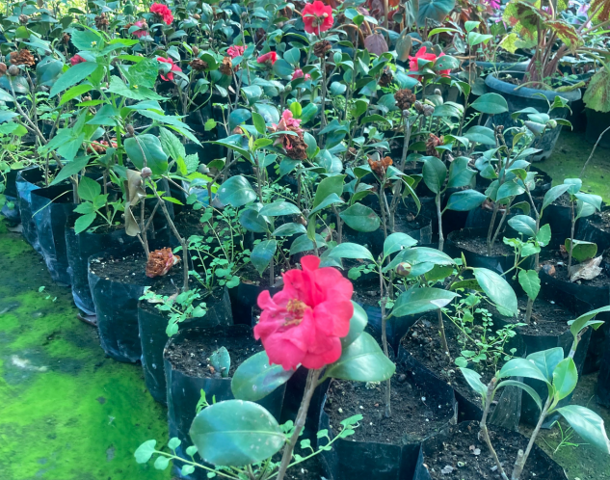

Common Name: - Camellia

Botanical Name: - Camellia spp.

Family: - Theaceae

Plant Type: - Broadleaf evergreen shrub

Soil Type: - Rich, moist but well-drained

Bloom Time: - Late fall, winter, early spring

Flower Color: - White, pink, red, yellow, or lavender

Camellia is a genus of flowering plants in the family Theaceae. They are found in tropical and subtropical areas in eastern and southern Asia, from the Himalayas east to Japan and Indonesia. There are more than 220 described species, with some controversy over the exact number, and also around 3,000 hybrids.

Of economic importance in East Asia, Southeast Asia, and the Indian subcontinent, leaves of C. sinensis are processed to create the popular beverage tea. The ornamental C. japonica, C. sasanqua and their hybrids are the source of hundreds of garden cultivars. C. oleifera produces tea seed oil, used in cooking and cosmetics.

Types of Camellia

Although camellias are indigenous to the Philippines, the genus is named for Moravian Jesuit priest Brother Josef Kamel, a botanist, pharmacist, and missionary who classified plants in the Philippines. The Camellia genus belongs to the Theaceae (tea) plant family and includes well over 100 species. But nearly all garden camellias, of which there are hundreds of different types, are cultivars developed from C. japonica (Japanese camellia) or C. sasanqua (sansaqua camellia). A third common species, C. sinensis, is normally grown for tea production, not as an ornamental plant. Additional species sometimes lend their genetics to hybrids.

Some popular garden varieties include:

'April Dawn': Reliably hardy in zone 6, this variety has white flowers streaked with pink.

'Elfin Rose': This cultivar has pale pink blooms that appear in October and November.

'Fragrant Pink': This variety has small pink flower clusters with a sweet fragrance that is especially obvious on warm winter days.

'Francis Eugene Phillips': This popular cultivar has highly ornamental fringed foliage and ruffled pink flowers.

'Yuletide': This plant features red blooms on a compact, four-foot-tall shrub.

Is Camellia plant fengshui?
Yes, Camellia flowers are considered to be auspicious in Fengshui. In Chinese culture, the Camellia flower is often associated with love, devotion, and affection. It is also believed to bring good luck and prosperity to the home or office.The color of the Camellia flower can also have specific Fengshui meanings. For example, red Camellias are believed to attract love and passion, while white Camellias are associated with purity and new beginnings.

camellias fast growing?
Generally, they grow at a medium pace for an evergreen plant, with most putting on about 4 to 8 inches a year. If your heart is set on one, select a sasanqua which will grow faster than a japonica. ‘Kanjiro’ may be a good cultivar to try—a gardener in Atlanta reported hers putting on more than 4 feet in just three years (an average of 16 inches a year). Keep in mind that growth rate varies wildly depending on zone, exposure, soil, and other conditions.
Its generally kept indoor in living room and in terrace area.
Monstera Plant 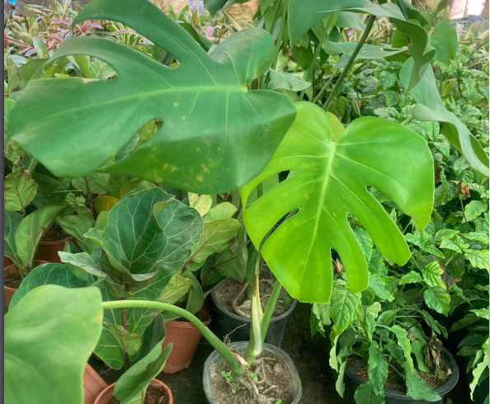
Common Names: - Split-leaf philodendron, Swiss cheese plant, window leaf
Botanical Name: - Monstera deliciosa
Family: - Araceae
Plant Type: - Climbing evergreen
Mature Size: - 3 ft. tall, 2-3 ft. spread
Sun Exposure: - Bright indirect sunlight, partial shade
Bloom Time: - Mid-summer
Flower Color: - Cream/tan

monstera, (genus Monstera), genus of nearly 50 species of flowering plants of the arum family (Araceae), native to tropical America. Several are grown as popular ornamental foliage plants. Monstera plants are generally climbing and can be terrestrial or epiphytic. They have attractive leathery leaves that are often cut into lobes.

Growth pattern
They are herbs or evergreen vines, growing to heights of 20 meters (66 ft) in trees, climbing by means of aerial roots which act as hooks over branches; these roots will also grow into the soil to help support the plant. Since the plant roots both into the soil and over trees, it is considered a hemi epiphyte.

Uses
They are commonly grown indoors as houseplants. The best-known representative of the genus, Monstera deliciosa, is also cultivated for its edible fruit which tastes like a combination of banana and pineapple.

Common Problems of Monstera
Though it's a somewhat easy-going houseplant, the Swiss cheese plant can cause a few headaches. But once you figure out the cause of why your plant looks a little sickly, it can recover well.

Monstera deliciosa easy to care for?

As a houseplant, this plant is easy to grow and maintain. Outdoors, however, you need to live in the right warm and humid environment for it to thrive.

Why do the leaves on some Monstera deliciosa plants split more than on others?

Fenestrated leaves require a lot of energy to split. The more light the plant receives, the more it will split. Less light produces smaller, less showy leaves.

Monsteras are a great choice for air purifying plants. They do take time to grow but to be rewarded for its amazing fenestrations is definitely worth it
It’s indoor, outdoor and fengshui plant also.

Firestick Plant
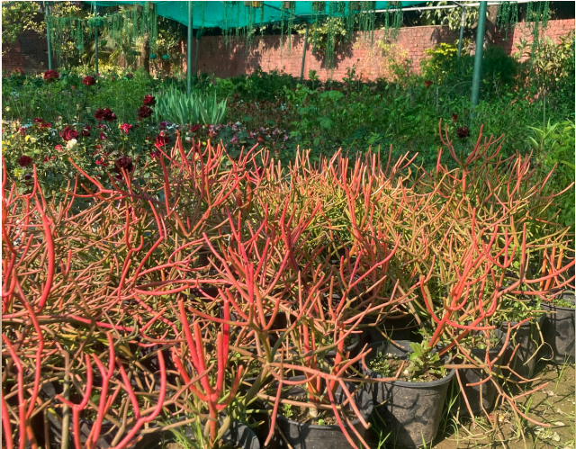
Family: Euphorbiaceae
Origin: South Africa, Arabian Peninsula and India
Common Names: Rubber-hedge euphorbia (Eng.), Kraalmelkbos (Africa.), Indian tree spurge, Firestick Cactus, Pencil Cactus, Sticks on fire, Pencil plant, Finger Tree, Naked lady, Red Pencil tree, Milk bush

Uses:
These versatile plants have many uses. They are often kept indoors as a houseplant in contemporary interior designs along with the prickly pear Opuntia cactus.
They are used as landscape plants in hot, dry climates.
When growing a pencil tree plant outdoors, the small flowers provide pollen for bees, and birds can safely eat the plant’s seeds.

Why aren’t my Firesticks turning orange?

Many people add Firesticks to the garden because of the orange/red color that the stems turn during the winter months. However, only some varieties of Euphorbia tirucalli turn orange or red (e.g., Euphorbia tirucalli ‘Sticks on Fire’). If your Euphorbia tirucalli remains green when exposed to a season of direct, summer light, you have the green type of Firestick. This is good to know because Euphorbia tirucalli matures into a tree while Euphorbia tirucalli ‘Rosea’ grows into a bush.
Euphorbia tirucalli ‘Rosea’ needs exposure to sunlight to turn orange/red. Cooler temperatures are not critical to color change.

Where can you grow Firesticks?

Firesticks make good additions to container gardens. This makes it easy to bring your Firestick plants indoors before the first frost. They can also be grown as shrubs or bushes in USDA Hardiness Zones 10 through 12.

Best Soil for Euphorbia tirucalli

Like other succulents, Firesticks need to be grown in gritty, well-draining soil. A good soil mix for Firesticks would be comprised of two parts sand, two parts potting soil and one part perlite.

Is Euphorbia tirucalli Toxic?

Like other Euphorbias, Firestick Plants contain a white, milky sap that is toxic to pets and humans. This sap irritates the skin and can cause eye damage. An article written by researchers at Kasturba Medical College reported that three patients whose eyes accidentally came into contact with the sap of Firestick Plants suffered severe eye irritation and blurring of vision for 10 to 14 days (Basak et al., 2009). These patients required medication to recover. For this reason, it is very important to wear gloves and eye protection when handling these plants.

It is also known as firestick for the bright colors it turns when in full sun. It likes bright light and moderately low moisture. It is an excellent houseplant and provides an interesting silhouette

The Fire stick plant is not a fengshui plant but it’s an outdoor and indoor both also.

Nagpur Orange
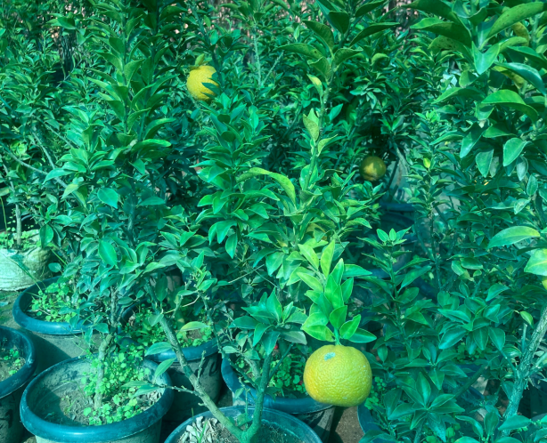
We all know that India is a land of diversities in terms of cuisine, language, culture and climatic conditions. Different areas in the country with different climatic conditions are suitable for certain types of farming. Like Shimla is good for apples, Mahabaleshwar is famous for strawberry, Allahabad is suitable for Guava cultivation, Goa is popular for Cashew nuts and Ratnagiri is renowned for Alphonso Mangoes, Nagpur is synonymous with Oranges.

History of Orange Cultivation in Nagpur

It is very interesting to roam around the beautiful orange farms which are full of trees laden with ripe oranges. But, the story how the cultivation of Nagpur orange in this region started is more interesting. It was Late Shri Raghujiraje Bhonsle who tested Nagpur orange for the first time as a kitchen garden plant during 1896 and it was a successful venture. Since then the cultivation of oranges in attained momentum year after year and now orange is one of the most remunerative potential foreign exchange earning crops in this region. Nagpur oranges are also one of the horticultural crops after mango and banana at national level.

Nagpur Oranges
Nagpur oranges, which are a variety of orange grown in Nagpur, are quite popular not only in India but also outside with its sweetness and juicy pulp. The Mandarin orange, which is also known as mandarin or mandarin is the common type of orange that is widely cultivated in Nagpur. Nagpur mandarin is the most popular fruit among all types of oranges in India due to its sweet-sour appealing taste and easy peelable quality of the rind. Some of the finest Mandarins are cultivated in Nagpur, Amravati and Wardha districts of Maharashtra. Nagpur Santra, a type of loose jacketed orange belongs to this category of Mandarins. Nagpur Santra is commonly grown in the Satpura Hills of Vidarbha region.

What Makes Nagpur Oranges So Special?
Nagpur Mandarin or NM has a unique blend of sugar and acid, which cannot be seen in any other orange types. The loose skin of Nagpur oranges makes them easily peelable. It is basically a table fruit and is not fully circular in shape. Nagpur Mandarin has deep orange colour and slices. These oranges with a peculiar aroma and unique taste make it different from other orange varieties.
Benefits

- Oranges are a good source of vitamin C and B complex. They lower cholesterol and control blood sugar level.
- Oranges contain carotenoids, which maintains good eye health and prevents constipation. Orange peels are highly nutritious, fiber-rich and edible.
- They are believed to be good for skin and nails.

Storage and Uses

- Store them in a cool, dry place away from direct sunlight. No pulpy orange canned juice can match the fresh taste of Nagpur oranges.
- Bursting with freshly picked juiciness, these are perfect to serve to kids. We also like to toss sections into fruit salads.
Is Nagpur orange fengshui?
Nagpur orange, also known as Nagpur Santra, is not traditionally considered a Fengshui plant. However, in some cultures and belief systems, oranges are considered to be symbols of good luck and prosperity, and they may be used in Fengshui practices for this reason.

Crassula Plants

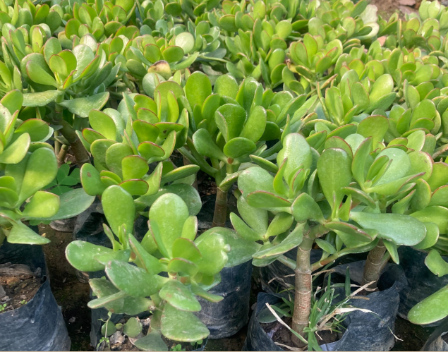

Common Names: - Jade plant, rattlesnake tail, living coral, string of buttons

Botanical Name: - Crassula spp.

Family: - Crassulaceae

Plant Type: - Perennial

Mature Size: - Varies by species

Sun Exposure: - Full, partial

Soil Type: - Moist but well-drained

Bloom Time: - Spring, summer

Flower Color: - Varies by species

Succulent plants have become so popular because they offer low maintenance and varied shapes and textures, both in gardens and indoors. Crassula is a diverse and extensive genus of succulent plants, with about 300 species total, but probably the most well-known of the group is the emerald green jade plant (Crassula ovata)—many know it as a houseplant, but outdoors in warm climates, it actually grows into a shrub.

Types of Crassula
There are so many species and cultivars of crassula to choose from that you may become a collector. In addition to the standard jade plant cultivars (Crassula ovata), here are a few others that may catch your eye:
- Crassula 'Morgan’s Beauty': This hybrid cultivar has silver leaves dusted in white, with pretty pink late spring flowers. It grows about 4 inches tall.
- Crassula erosula 'Campfire': This variety has long-branching lime leaves that turn blazing red in winter. It's a clumping plant that grows about 4 to 8 inches tall and spreads up to 3 feet wide.
- Crassula pellucida variegata: This plant exhibits a flowing mass of heart-shaped leaves variegated in pink, green, and creamy yellow.
How long can a crassula plant live?
The lifespan of succulents, including crassula plants, varies widely, from 20 years up to well over 100 years. If you take care of your crassula plant, you will enjoy it for a long, long time.
How can I identify what crassula plant I have?
Crassula plants usually have symmetrical stacking fleshy leaves. The easiest way to figure out what type of crassula plant you have is by looking at the shape and pattern of the leaves to determine exactly which one it is.

Crassula ovata, commonly known as jade plant, lucky plant, money plant or money tree, is a succulent plant with small pink or white flowers that is native to the KwaZulu-Natal and Eastern Cape provinces of South Africa, and Mozambique; it is common as a houseplant worldwide.

Is Crassula Ovate is Fengshui?

Crassula Ovate or Jade is a renowned good luck & Feng Shui money cure. It is an evergreen succulent, with jade green coin shaped leaves which activates financial luck. It also brings in health & abundance along with prosperity. Jade is a perfect gift for all.

Christmas cactus

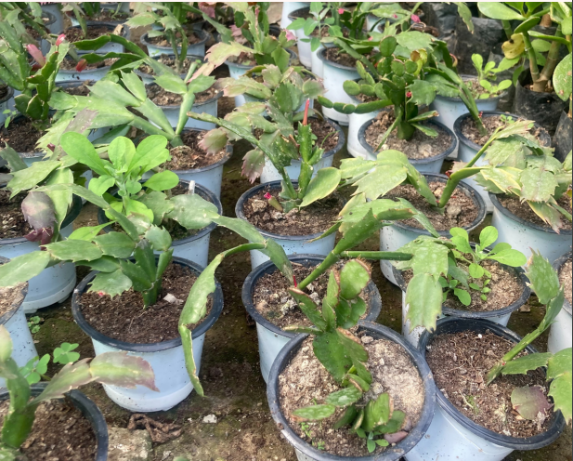

Common Name: - Christmas cactus, holiday cactus, crab cactus
Botanical Name: - Schlumbergera x buckleyi
Family: - Cactaceae
Plant Type: - Succulent, cactus, perennial
Sun Exposure: - Partial
Soil Type: - Moist, well-drained, loamy
Bloom Time: - Fall, winter
Flower Color: - Pink, red, white, purple, orange

The Christmas cactus joins Norfolk Island pine trees and poinsettias as plants beloved during the winter season. While it may seem like an unusual holiday plant, the Christmas cactus, also called holiday cactus, is flush with bold blooms, making it a welcome sight in the middle of winter. The fleshy segmented stems of the plant are flattened leaves and slightly serrated on each side. In late fall or early winter, tubular flowers bloom on the ends of each stem.

Types of Christmas Cactus
Schlumbergera x buckleyi is a hybrid plant often called by other names such as Thanksgiving, Christmas, or Easter cactus. They look alike but bloom at different times and have slight differences in the shape of their leaves.³ Because of their subtle differences, they are often mislabeled in garden centers.
- Thanksgiving cactus (Schlumbergera truncata): This plant blooms close to the end of November with showy flower colors that are either red, pink, peach, purple, orange, or white. It has very pointed and claw-shaped projections on the edges of its leaves.
- Christmas cactus (Schlumbergera russelliana): Often bred with S. truncata to form Schlumbergera x buckleyi, this species blooms close to the end of December with magenta and white flowers. It has flattened leaf segments that are rounded with a few notches around the edges.
- Easter cactus (Rhipsalidopsis gaetneri): This variety starts to reveal star-shaped flower buds in February and flowers from March through May. It has tiny bristles on the edges of its rounded leaf segments.
What is the lifespan of a Christmas cactus?
This beautiful blooming cactus can last for 20 to 30 years if it is well cared for. Note that just because it's not blooming doesn't mean it's dead and needs to be disposed of!

What should I do with a Christmas cactus after it blooms?

Don't toss your plant after the Christmas cactus blooms because it may survive for decades, blooming year after year.
Christmas Cactus is a popular, winter-flowering houseplant that makes a great addition to nearly any indoor setting.
Is Crassula Ovate is Fengshui?
Christmas cactus (Schlumbergera) is not traditionally considered a Fengshui plant. However, in Fengshui practices, plants are often used to enhance positive energy and bring balance to an environment. Christmas cactus is a popular houseplant.

Vrieseacarinata

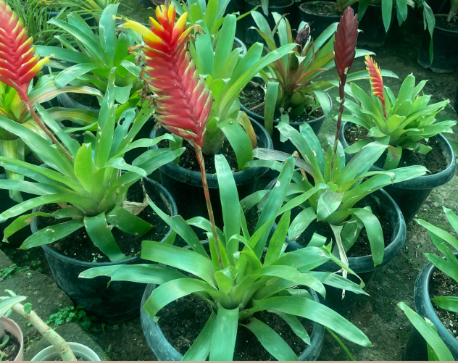
Name – Vriesea
Family – Bromeliaceae
Type – indoor plant
Height – 12 to 20 inches (30 to 50 cm)
Exposure – light but not direct light

As original, colorful and exotic as its cousins, Vriesea is simply an astounding indoor plant. Native to South America, its deep dark green foliage and beautiful orange or red blooming are truly appealing.

Description

Vriesea Carinata, commonly called flaming sword, is a bromeliad with generally lance-shaped or linear foliage 8 – 24 inches long that is green or purplish often with crossbands of dark brown. The leaves have smooth margins and may have colorful bracts at the leaf bases. The foliage is often arching, forming a funnel-shaped rosette.
The red rosette of Vriesea carinata produces a flower stalk in a lobster-claw form, with red bracts ending in yellow tips. While the leaf rosette is only 8 inches tall and equally wide, the colorful flower stalk rises to 12 inches tall, making it a bright addition to a small space.

Best spot for a Vriesea
The temperature of a house or apartment is thus ideal for growing a vriesea.An ideal location for your vriesea is in a spot where there isn’t any direct sun on the plant.
• Vriesea can’t stand the sun’s rays when they touch its leaves directly.
Good light but no direct sunlight is what’s needed.
• Absolutely avoid setting it near heat sources such as radiators, because moisture is what this tropical plant needs most.
• East or West-facing windows are thus usually the best call for your Vriesea.
• Vriesea plants fear drafty spots.

Landscape Uses
Suitable for Container, Rock Garden & Xeriscaping

How Do You Get A Flaming Sword Plant To Bloom?
Greenhouses use Ethelene gas to stimulate blooms once a pup has grown to at least three-fourths the size of the parent plant, and you can do the same by placing a piece of banana or apple peel near the base of your plant. Given plenty of bright, filtered sunlight and a rise in temperature to about 75 F (24 C), blooming should occur in six to ten weeks.

What Pests Are Vrieseas Susceptible To?
Vrieseas tend to be pretty pest-free, although like most houseplants, they are susceptible to mealy bugs and scale, which you should simply wipe away rather than using a pesticide or oil spray that will suffocate the plant. The best way to prevent bugs and fungus is to provide good ventilation and avoid over-watering.
It is not a fengshui plant and its an indoor and outdoor plant also.

Selaginella

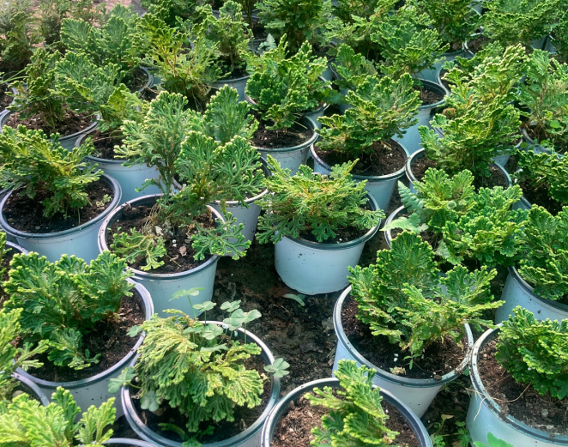
Species: Selaginella
Common Name: Trailing moss, spike moss, club moss, or arborvitae fern
Plant Type: Perennial
Native to: Northern hemisphere from Southern Africa to Asia
Maximum Size: Low-growing
Watering Requirements: Moist but not soggy
Light Requirements: Full shade
Preferred Humidity: High

Selaginella is a pteridophyte. It is also called spike moss or club moss. It is the largest and the only living genus of the family Selaginellaceae. It contains more than 800 species distributed all around the world with the highest diversity found in the tropical regions.
They are seedless vascular plants. They are mostly found in shady areas; some species are also present in seasonal dry or xerophytic conditions. They are found on tree trunks, rocks, forest floors, etc.

Vascular system
The conduction system of vascular plants includes the xylem, composed largely of tracheids (tubular cells) in the lower vascular plants and gymnosperms and vessels in angiosperms, for conduction of water and minerals; and the phloem (sieve cells) for conduction of food materials. These vascular tissues are arranged in different patterns in different plant groups and in different parts of the plant.

Cell types
Cells of the vascular system
The cells of the vascular strands in lower vascular plants are mainly tracheids, sieve cells, parenchyma, and endodermal cells. The tracheids, which comprise the xylem, or water-conducting tissue, are normally long, narrow, and attenuated at the tips. Their secondary walls display ladderlike (scalariform) thickenings. The largest tracheids are several centimeters long, but most are much smaller.

Other cells
The pith is made up of parenchyma cells as a rule, but, in some fern genera, scattered tracheid-like cells are found as well. The cells of the stems differ from those of many seed plants in lacking collenchyma (modified parenchyma cells with expanded primary walls) and true stone cells. Latex-producing cells in lower vascular plants are rare.

Structure
The main plant body is a sporophyte. It is a vascular plant and is differentiated into root, stem and leaves. Some of the important features.

Morphology
- It is an evergreen, profusely branched and delicate herb.
- Primary roots are short-lived. The adventitious roots are present at the tips of rhizophore.
- Rhizophores are leafless colourless branches that develop from the prostrate stem and grow downwards. When it reaches the soil, adventitious roots develop at the tip of rhizophores.
- Stem is green, dichotomously branched, erect or prostrate with erect branches.
- A single apical cell is generally present at the growing tip of the stem.
- Leaves are small with pointed tips. They bear scaly leaves.
- Leaves contain unbranched midrib.

What is Selaginella used for?
Selaginella is used in food, medicine, ornaments and handicrafts.
It is a fengshui and an indoor plant.

Kalanchoe

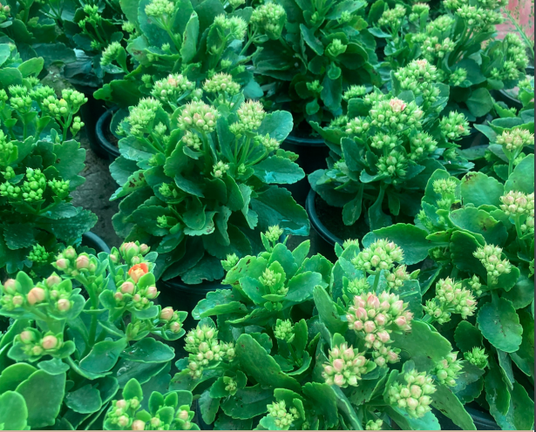
Common Name: - Kalanchoe, flaming Katy, Christmas kalanchoe
Botanical Name: - Kalanchoe blossfeldiana
Family: - Crassulaceae
Plant Type: - Perennial, succulent
Sun Exposure: - Full sun, partial shade
Soil type: - Sandy, well-drained
Bloom Time: - Varies; requires 6 weeks of 14-hour nights
Flower Color: - Yellow, red, orange, pink, white

The genus Kalanchoe includes more than 100 species of plants, but only a few are regularly seen in cultivation. The most recognizable is Kalanchoe blossfeldiana, usually known simply as kalanchoe. Native to Madagascar and closely related to the jade plant, K. blossfeldiana is a succulent perennial with scallop-shaped leaves and umbels of flower clusters that extend above the voliage. It has an especially long bloom period when compared to other succulents. Kalanchoe thrives in arid environments and is a popular, easy-to-grow houseplant. Growers are drawn to kalanchoe for its ease of care and interesting leaves, and for flowers that bloom repeatedly if the light exposure is properly controlled.

Types of Kalanchoe
Kalanchoe blossfeidiana is available in several unnamed varieties featuring different shades of yellow, red, orange, pink, and white. Planted outdoors, they normally flower in the spring, but indoor plants can be coaxed into blooming nearly year-round. There are also several related species that can make good garden plants and houseplants:
- K. manginii: This species features fleshy leaves and bears large, bell-like pendant flowers. Moist air is an essential component of its prolonged flowering. Sometimes known as chandalier plant, this species is hardy in USDA zones 9 to 11.
- K. porphyrocalyx: Also known as Pearl Bells, this species consists of slender, rectangular leaves and purple pendant flowers. It is hardy in zones 11 and 12.
- K. beharensis: This kalanchoe species is prized for its large, velvety leaves that are pale silvery green in color. Sometimes known as elephant ear kalanchoe, it is hardy in zones 9 to 11.
- K. pinnata: This kalanchoe species is characterized by fleshy green leaves and bears tiny plantlets along its margins. Often known as cathedral bells, it is hardy in zones 10 and 11.

How long can a kalanchoe live?
As is true of many slow-growing perennial succulents, Kalanchoe blossfeldiana can thrive for as long as its basic needs are met. There are many cases of century-old potted kalanchoe plants.

Do kalanchoe plants work well in mixed containers?

Kalanchoe is most often planted by itself in a container, but they also will work well in large pots planted alongside related succulents, such as aloe and jade. On a patio, they are often planted with sedums and other creeping plants.

Kalanchoe also have air purifying abilities. It helps in removal of indoor air toxins. The plant bloom consistently throughout the year in response to daylight with proper care Provide bright light or morning or evening sun to the plant.

It is a fengshui and an indoor plant.

Clerodendrum Inerme
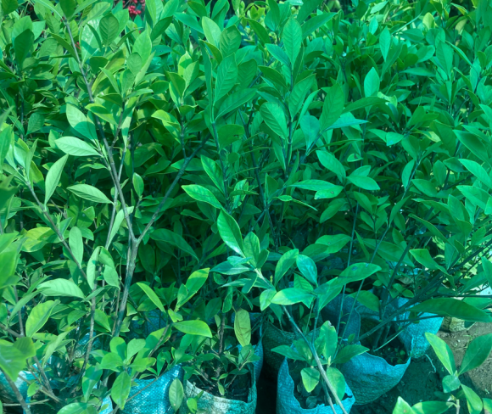
Common Name: - Abelia
Maximum Reachable Height: - Up to 5 feet
Flower Colour: - Lavender pink
Soil | Slightly acid, the moist peaty soil is ideal.
Temperature | 20 to 35 degrees C
Fertilizer | Apply any organic fertilizer.
Harvest Season | May to September
Bloom Time: - May to September

Clerodendrum. inerme is an evergreen mangrove plant, which has found a place in our gardens, is able to thrive near the ocean at the high tide mark, making it a potential weed in the coastal environment.
This erect, sprawling or climbing shrub grows to heights of up to 6 meter. The stems are woody, and smooth. The opposite, simple leaves are ovate or elliptic, usually 3-10 cm long, 1-4 cm wide, the apex obtuse to shortly acuminate, the base more or less rounded.
The margins are entire, and the petiole is from 5 mm to 2 cm long. The leaves are green, smooth, with a slightly shiny upper surface
.
- Habit: A straggling branched shrub.
- Bark: Greenish-brown, lenticillate; branches greenish-brown or purplish softly pubescent, slightly flattened for younger parts, terete in older.
- Leaves: Leaves opposite, entire, elliptic or obovate, obtuse, base acute.
- Inflorescence: Cymes

Special features:
Clerodendrum inerme Leaf is used for medicinal purpose.
Ornamental use:
Clerodendrum inerme is used in many places in landscaping, as a ground cover or a hedge plant, especially near the sea, as it tolerates the salt spray.
Medicinal use:
A wreath of the flowers may also be given to a person suffering from depression. The flowers are used to perfume coconut oil.
Parts of the plant are used in medicinal preparations; for example, Wulej is an ingredient in a baby bath preparation which is reckoned to prevent body odour in the baby in later life.

It is an outdoor and fengshui plant

Fiddle-Leaf

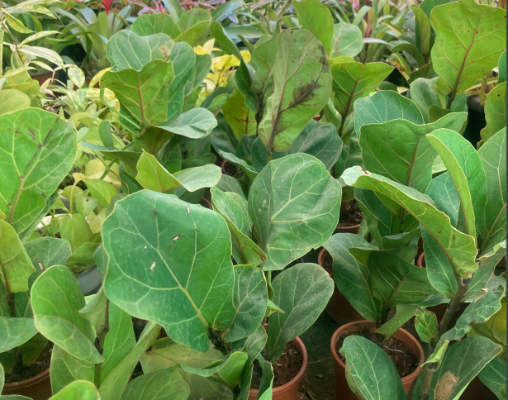

Common Name: -Fiddle-leaf fig, banjo fig

Botanical Name: -Ficus lyrata

Family: - Moraceae

Plant Type: -Broadleaf evergreen

Sun Exposure: - Part shade

Soil Type: -Loamy, medium moisture, well-draining

Bloom Time: - Rarely flowers outside of its native area

Flower Color: - Insignificant

The fiddle-leaf fig (Ficus lyrate) is a popular indoor tree featuring very large, heavily veined, and glossy violin-shaped leaves that grow upright on a sleek trunk. A fiddle-leaf fig is perfect as a focal point of a room if you can situate it in a floor-standing container where the plant is allowed to grow to at least 6 feet tall. (Most indoor specimens reach around 10 feet tall.) It's a fairly fast grower and can be potted at any point in the year if you're like most gardeners acquiring a nursery plant to keep indoors. Keep in mind this gorgeous plant is toxic to cats and dogs.

Types of Fiddle-Leaf Fig
The main species, Ficus lyrata, is the most common fiddle-leaf fig plant that gardeners grow. But there are several cultivars available as well, including:
- Ficus lyrata ‘Bambino’: This is a dwarf variety that only reaches a few feet tall.
- Ficus lyrata ‘Compacta’: This variety can reach up to 5 feet tall and features smaller, more bunched leaves than the main species.
- Ficus lyrata ‘Variegata’: This is an uncommon variety with showy leaves that are a mix of green and cream.

Common Problems With Fiddle-Leaf Fig
A fiddle-leaf fig plant can be sensitive to its environment and watering schedule, so when something is off, you can tell by the behavior of its leaves. The plant can develop spots on leaves or drop leaves, sometimes at a fast rate. Be on the lookout for the first signs of leaf distress.

Bleached Leaves
If you see light brown or bleached spots on the top of the leaves, the plant may be getting too much direct sunlight. This is called leaf sunburn or leaf scorch. In the case of a fiddle-leaf fig plant, you can prune the leaf with sharp shears and relocate your plant away from sitting near the direct and harsh rays of the sun.

Yellowing Leaves
If newer fiddle-leaf fig leaves are yellowing, it may indicate a bacterial problem. It may be too late to save the plant. But try cutting off the affected leaves and repotting the plant in fresh soil.
How fast does the fiddle-leaf fig grow?
This houseplant can grow 2 feet a year, reaching about 6 to 10 feet in height.

Will a fiddle-leaf fig grow fruit?

An indoor fiddle-leaf fig houseplant will not produce fruit.

fiddle leaf figs are air purifying plants.

It’s a popular indoor plant and also fengshui plant.

Spathiphyllum
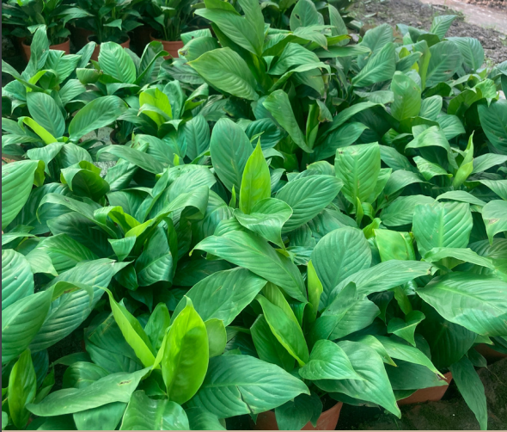
Common Name: - Peace lily, spath lily
Botanical Name: - Spathiphyllum spp.
Family: - Araceae
Plant Type: - Perennial
Sun Exposure: - Partial
Soil Type: - Moist but well-drained
Bloom Time: - Spring
Flower Color: - White, yellow
Native Area: - Central America, Asia

The peace lily is a flowering tropical plant from the Spathiphyllum genus. Outside of its hardiness zones, many people grow the peace lily indoors. There are many types of peace lilies within the genus. But in general, peace lilies have large, glossy, oval leaves. They typically bloom in the spring, though that can vary when growing them as houseplants. A healthy peace lily might bloom twice a year, resulting in several months of flowers.
When grown in the garden in the tropical and subtropical climates where they are hardy, peace lilies are normally planted in the spring while it is still cool. When you care for a peace lily indoors, they can be purchased and brought into the home at any time of year, though you will want to protect them from cold temperatures as you transport them

Types of Peace Lilies
Peace lilies have been heavily hybridized and therefore come in dozens of popular varietals. They range in size from miniature to massive and from deep green with snow-white flowers to golden-leaved beauties. Some of the popular types of peace lilies include:
- ​Spathiphyllum ’Power Petite’: A small varietal that grows to only about 15 inches.
- S. ‘Mauna Loa Supreme': A very common variety that grows to be between 3 to 4 feet tall, with leaves that are up to 9 inches wide.
- S. ‘Sensation’: The largest peace lily varietal, which reaches up to 6 feet in height with broad, 20-inch-long leaves.
- S. 'Mojo': A striking, large varietal with vibrant green leaves
- S. 'Golden Delicious': A varietal that features new growth with stunning golden-green color.
- S. 'Starlight': A varietal with narrow leaves that have wavy margins. It's also known for having multiple blooms, with as many as 20 flowers on a single plant.

How long does a peace lily last?
Though a peace lily matures between three and five years, it can live for years after that and bloom over and over again.
What do you do with a peace lily after it dies?
After the flowers die, you can snip off depreciated blooms, as they will just sap energy from the plant. Continue to care for the plant as you normally would until it blooms again.
How fast do peace lilies grow?
Peace lilies grow at a moderate pace, reaching maturity in three to five years.

Peace lily, also known as Spathiphyllum, is one of the most popular indoor plants. It brightens up the living space and also removes toxins from your house. It is one of the easiest flowering indoor plants.

It’s an indoor and fengshui plant.

Mexican snowballs

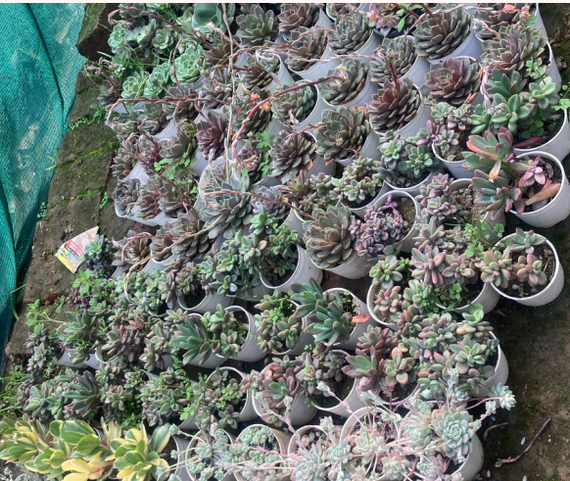

Botanical Name: - Echeveria elegans

Common Name: - Mexican Gem, Mexican Snowball, White Mexican Rose

Plant Type: - Succulent

Mature Size: - 6 to 8 inches tall, 12 inches wide

Sun Exposure: - Full sun

Soil Type: - Sandy, well-drained

Bloom Time: - Spring, summer

Flower Color: - Pink, yellow

Mexican snowballs (Echeveria elegans) are one of the most well-known and popular varieties of Echeveria succulents. Also commonly known as White Mexican Rose or Mexican Gem succulents, Mexican snowballs are characterized by thick, fleshy blue-green to silver-green leaves that grow in an attractive rosette shape. As their name suggests, these succulents are native to Mexico and can be commonly found in semi-desert habitats across the country. These gorgeous, low-maintenance succulents are popular as houseplants and garden plants and won the Award of Garden Merit from the Royal Horticultural Society.

Does Echeveria elegans need sunlight?
Absolutely! Bright sunlight is a must with this succulent. It can be indirect or direct sunlight, as long as there are at least 6 hours of it per day. In some circumstances, Echeveria elegans plants can handle partial shade if full sun isn’t possible.
How big do Echeveria elegans get?
These succulents can grow 6-8 inches tall and a foot wide. Some varieties can achieve a leaf count of up to 100!
What is Echeveria elegans used for?
Echeveria elegans plants are excellent grown outdoors in rock gardens or among a dense carpet of ground cover. These plants also grow well in containers when brought indoors. This is an ornamental plant in landscaping, though it’s sometimes used in bouquets. It’s a very popular and beloved succulent (it was even praised by the Royal Horticultural Society!).
Is Echeveria elegans a cactus?
No, but it’s very similar. Echeverias store water like cacti, are native to Mexico, and appreciate full sun to partial shade. However, Echeveria elegans is in the Crassulaceae family and only distantly related to true, native cacti.

This Echeveria is one of the most easily recognizable of its species. The light-green rosette does well indoors when given enough light.
It’s an indoor houseplant and also a fengshui plant.

