**AFRICAN DAISY**

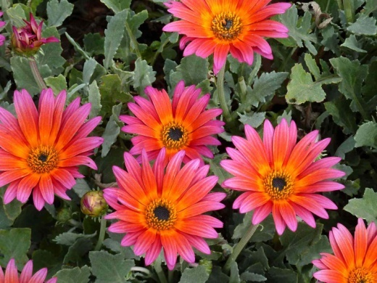

**Common name:** Daisy

**Botanical name:** Bellis perennis

**Hindi name:** Gulbahar, Gulabahaar

**Family:** Astreraceae

**What Is an African daisy?**

African daisy is the common name of Osteospermum, a genus of daisy-like flowers within the Asteraceae family. These South African native daisies are also called the South African daisy, Cape daisy, blue-eyed daisy, and daisy bush. Most African daisies in the Osteospermum genus are perennials.

**Why is the African daisy important?**

Daisies are symbols of innocence, purity, and loyal love; hence, these beautiful flowers are popularly exchanged between couples around the world.

**What season does African daisy grow?**

Blooms peak in late spring to early summer and again in late summer to early fall. Because African daisies stop blooming during hot spells, they are best grown in combination with other plants that will have visual interest in the peak of summer.

**What is the best time to plant daisies?**

Daisies can be transplanted into the garden in spring or fall. Autumn planting has the advantage of establishing root systems before flowering. Each 4-inch transplant you set out in fall will produce, at a fraction of the cost, roughly the same amount of blooms as a 1-gallon plant purchased in the spring.

While African daisies are drought tolerant, they will give you more flowers if watered well throughout the growing season. It grows best in full sun or part shade and moist, well-drained soil.

**What are the medicinal uses of daisy flower?**

People take wild daisy tea for coughs, bronchitis, disorders of the liver and kidneys, and swelling (inflammation). They also use it as a drying agent (astringent) and as a "blood purifier." Some people take homeopathic wild daisy for preventing problems during childbirth, pain and soreness, and minor bleeding.

**What is special about daisy flower?**

Daisies are actually closely related to artichokes, so they're a great source of vitamin C. Additionally, daisies also have lots of medicinal properties—they're known to slow bleeding, relieve indigestion, and soothe coughs.

**Can African daisies be kept indoors?**

Grow inside or on your balcony! Commonly known as the African daisy, the Osteospermum is the perfect plant for a balcony, cottage garden or any room in your house.

This flower is not a fungsui plant.

**GURENIAA**

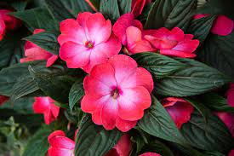

**Kingdom:**  Planate

**Clade:** Tracheophytes

**Clade:** Angiosperms

**Order:** Gunnerales

**Family:** Gunneraceae

**What is Gunneria plant?**

It is a large, clump-forming herbaceous perennial growing to 2.5 m (8 ft) tall by 4 m (13 ft) or more. The leaves of G. manicata grow to an impressive size. Leaves with diameters well in excess of 120 cm (4 ft) are commonplace, with a spread of 3 m × 3 m (10 ft × 10 ft) on a mature plant.The flowers of Gunnera species are dimerous (two sepals, two petals (or none). two stamens (or one), and two carpels. Other giant Gunnera species within the subgenus Panke are found throughout the Neotropics and Hawaii. Gunnera insignis is also known by the name "poor man's umbrella" in Costa Rica.

**What is the use of Gunnera plant?**

Gunnera tinctoria is widely used as herbal medicine for analgesic, anti-inflammatory, cardiovascular, gastrointestinal, genitor-urinary, obstetric-gynaecological, and respiratory diseases in Argentina [13]. In Sub-Saharan Africa, G. perpensa is the most popular Gunnera species.

**How do you identify a Gunnera?**

Leaf stalks are red or purplish (except on very young plants) and are covered in thin green bristles. Look at the underside of the leaf and you'll see those stiff bristles. You won't, however, see any spines on the veins. The flowering spike is erect, compact, and a rather lovely crimson.

**Can Gunnera grow in water?**

These are not aquatic plants which grow in water. They are bog plants which like their roots in rich wet bogs which remain wet all year round they happily colonise alongside lakes and streams where their gigantic umbrella-like leaves reflect splendidly in the water.

**What are the benefits of Gunnera?**

Gunnera perpensa is an ingredient in many herbal concoctions and prescriptions which have been used to induce or augment labour, postnatal medication, to treat parasitic diseases, urinary complaints, kidney problems, general body pains, sexually transmitted infections, and many other diseases.

**Is Gunnera poisonous to humans?**

Is Gunnera manicata poisonous? Gunnera manicata has no toxic effects reported.

**Medical benefits of Gunnera?**

Gunnera perpensa is an ingredient in many herbal concoctions and prescriptions which have been used to induce or augment labour, postnatal medication, to treat parasitic diseases, urinary complaints, kidney problems, general body pains, sexually transmitted infections, and many other diseases.

**Can you grow Gunnera indoors?**

You can choose to move your potted Gunnera plant indoors, but the size of the plant may not permit you and the environmental conditions indoors may hurt your plant as well. The best bet is to provide your potted Gunnera with the same type of winter protection that outdoor gunner plants receive.

It is not a fungsui plant.

**AUSTER**

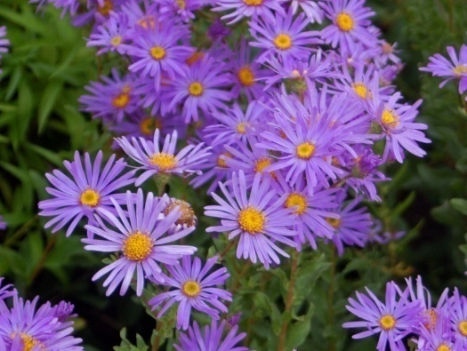

**Scientific name:**Aster

**Higher classification:**Astreae

**Rank:** Genus

**Family:**Asteraceae

**Kingdom:**Planate

**Order:** Astrales

**What is Auster plant?**

Aster is a genus of perennial flowering plants in the family Asteraceae. Its circumscription has been narrowed, and it now encompasses around 170 species, all but one of which is restricted to Eurasia; many species formerly in Aster are now in other genera of the tribe Astereae.

**What is Auster used for?**

Either dried or fresh, the flowers and leaves of the Aster plant can be eaten. However, they are most commonly used nowadays in herbal teas, fresh in salads, or used as garnish. It has several health benefits and has traditionally been used in the treatment of weak skin, pain, fevers and diarrhea (source).

**Bloom time and size of Auster?**

Asters are daisy-like flowers that bloom in late-summer and early-fall and the size is Asters grow 1 to 6 feet tall and 1 to 4 feet wide depending on the types and variety. The plants are upright and bushy with hairy or smooth leaves and daisy-like flowers.

**What are the medicinal uses for Asters?**

The New England Aster imparts medicinal properties of immense value. The stems and roots are used as poultices in relieving pain and healing wounds. The root alone is helpful in attenuating diarrhea and fever. Moreover, this nutrient-dense herb has an affinity for the respiratory system.

**What is the economic importance of Aster?**

**Economic Importance of Asteraceae**  
  
This family is an important source of food. The roots and leaves of Helianthus tuberosus and Lactuca sativa are edible. There are other species that are grown as food crops, as the nutritional value of the plant parts is remarkable.

**Why is aster important?**

Aster, being used as a 'cover crop' in farm fields, is providing habitat and late-season food for pollinators. Asters have a rich history. They are also known as the Michaelmas daisy for their tendency to bloom around the autumn equinox, which coincides with the feast of St, Michael.

**Is Aster an indoor plant?**

We would suggest that **plant Aster indoors** and then transplant them outdoors with proper spacing. The plant prefers loamy, well-draining soil. Note that the new plantings should be kept moist till the blooms cease. These are grown in 25 cm pots also.

**Is aster a** **feng shui plant?**

Apart from this, Aster flowers also represent Patience, Elegance, and Daintiness. As the September birthday flower, Asters are considered as a good luck charm too. It is said that if you gift Asters to the September-born people, it brings joy and luck in their life.

**PRIMROSE**

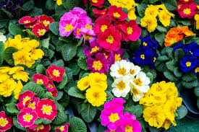

**Botany:** Primilaceae

**Places:** Primrose hill London

**Family:** Clan primerose

**Surname:** Archibald Primrose

**What is Primerose?**

Primrose is a genus of herbaceous flowering plants in the family Primulaceae. They include the primrose, a familiar wildflower of banks and verges. Other common species are P. auricula, P. veris, and P. elatior. These species and many others are valued for their ornamental flowers.

**What are primrose flowers used for?**

The mild, sweet-scented flowers can be eaten raw in vegetable or fruit salads or cooked as a vegetable. Primrose flowers can also be used in conserves, custards, mousses, tarts or other desserts and confections. The leaves make an alternative salad green and have a reportedly spicy taste with slight anise aroma.

**Where is primrose found in India?**

Himalayan White Primrose is found at altitudes of 3500-4600 m in the Himalayas, from C. Nepal to Bhutan, S.E. Tibet and Arunachal Pradesh.

**What is the health benefit of primrose?**

Evening primrose oil is known for its hormone balancing, anti-inflammatory, and antioxidant properties. It's also hailed as a tool for minimizing hair… The oil of the evening primrose contains high concentrations of a powerful anti-inflammatory ingredient called gamma-linoleic acid (GLA).

**What is the medicinal value of primrose?**

**Medicinal Uses:-**  
It helps to prevent blood clotting, dilates blood vessels, keeps the arteries subtle and reduces inflammatory auto-immune responses - making it useful in conditions such as rheumatoid arthritis. Externally the oil can be applied to dry skin, scaly and itchy skin disorders and brittle nails.

**What is the economic importance of primrose?**

Its seeds are used as raw material for production of oil extensively used in pharmaceutical industry, mainly due to its medicinal and nutritional properties.

**Can primrose be an indoor plant?**

Primroses bring a unique touch of spring indoors during the winter. Like cinerarias, primroses are considered temporary indoor plants. Enjoy them while they are blooming and beautiful, and discard them when they are done.

It is not fungshui flower.

.

**GERANIUM**

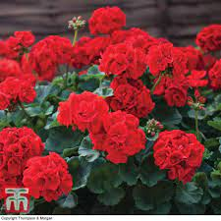

**Kingdom:** Planate

**Clade:** Tracheophytes

**Order:** Geraniales

**Family:** Geraniaceae

**Genus:** Geranuim

**What is Geranium?**

Geranium is a genus of 422 species of annual, biennial, and perennial plants that are commonly known as geraniums or cranesbills. They are found throughout the temperate regions of the world and the mountains of the tropics, but mostly in the eastern part of the Mediterranean region.

**What are geraniums called?**

Pelargonium is a genus of flowering plants that includes about 280 species of perennials, succulents, and shrubs, commonly called geraniums, pelargoniums, or storksbil.

**Where do geraniums grow best?**

The ideal location has morning sun, afternoon shade and well-draining soil. Choose a properly-sized area for your geranium flower beds. Appropriate spacing in between plants will reduce the risk of disease. Don't rush the planting season – geraniums are not cold hardy.

**Do geraniums need full sun or shade?**

For success with geraniums, you need to know what kind you have so you can choose the best spot for planting. Most annual geraniums need a spot in full sun, except for the ivy geranium, which grows best in light shade. Perennial geraniums, on the other hand, grow in either sun or shade, depending on the type.

**Which geraniums are medicinal?**

**Geranium robertianum**  
Robert geranium has medicinal properties (albeit different to those of the aromatic essential oil extracted from Pelargonium graveolens). It is used in the practice of homeopathy.

**What are the health benefits of geranium leaves?**

The most interesting health benefits of geranium include its ability to lower stress levels, reduce inflammation, relieve pain, improve kidney health, strengthen the immune system, and ease digestion. The impact of geranium on the nervous system is well known and the plant has been used in this way for generations.

**What is the commercial use of geranium?**

This plant is native to south office and used cosmetic and perfumery industries. The main ingredients of the oil are geraniol and citronellol and the pure geranium oil is almost a perfume by itself and blends very well with all other perfume

**Is indoor air fresheners Geranium flower?**

There are many houseplants that act as natural air fresheners. Among the most popular fragrant houseplants are the scented geraniums, perfume-leaved members of the genus Pelargonium.

**Are Geranium flower is fengshui?**

A geranium is a particularly good plant to help you ensure that your energy is positive because it is considered to be a symbol of wealth and abundance as well as good luck. However, the color and exact positioning of the plant is key to feng shui.

**POLY OAK**

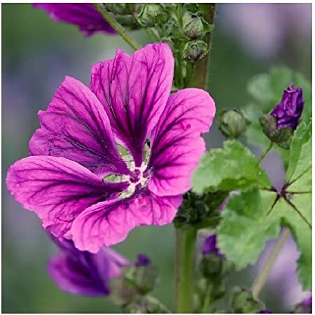

**Kingdom:** Planate

**Clade:** Tracheophytes

**Order:** Malvales

**Family:** Malvaceae

**Genus:** Malva

**Species:** M. verticillata

**What is Poly oak (Malva Verticillata)?**

Malva verticillata, also known as the Chinese mallow or cluster mallow, is a species of the mallow genus Malva in the family of Malvaceae found in East Asia from Pakistan to China. M. verticillata is an annual or biennial that grows up to 1.7 meters in high and can inhabit woodland areas of different soil types.

**What is Malva Verticillata used for?**

Malva verticillata seeds have also been used in traditional Chinese medicinal formulae as a diuretic, laxative, and galactopoietic material [8]. Despite its medicinal uses, the chemical constituents and the biological activity of the aerial parts of the M. verticillata plant are not well understood.

**How do you use Malva plant?**

People use the flower and leaf to make medicine. Mallow is used for irritation of the mouth and throat, dry cough, and bronchitis. It is also used for stomach and bladder complaints. To treat wounds, some people put mallow in a warm moist dressing (poultice) and apply it directly to the skin, or add it to bath water

**How do you grow Malva Verticillata?**

Start the seed off in trays or sow direct, thinning plants to 30cm apart. You can also sow in modules, planting out when seedlings are 5-10cm tall. Mallow will grow well in pots and containers – though, as it grows tall, make sure it's not in a windy position.

**What are the health benefits of Malva Verticillata?**

The seed is used to make medicine. People use Chinese mallow as a laxative to relieve constipation and as a diuretic to relieve water retention by increasing urine production. Chinese mallow is also used for kidney disorders and to start the flow of breast milk.

**What are the medicinal uses of Malva?**

Sylvester’s and other species of Malva. It is well-known that M. Sylvester’s can be utilized as an anti-inflammatory substance for the respiratory tract, GI tract, and the skin (11). The plant can be used topically or in a bath to treat abscesses, bruises, burns, dermatitis, swellings, and various ulcers (12, 13).

**Height of Malva Verticillata?**

 M. verticillata is an annual or biennial that grows up to 1.7 meters in high and can inhabit woodland areas of different soil types. The small, symmetrical flowers have five white, pink or red petals (0.8 cm) and 13 or more stamens. Each flower has 3 narrow epicalyx  The fruit is a dry, hairless. The leaves are simple and alternate.

It is not a fungshui flower.

**BIGUNIA**

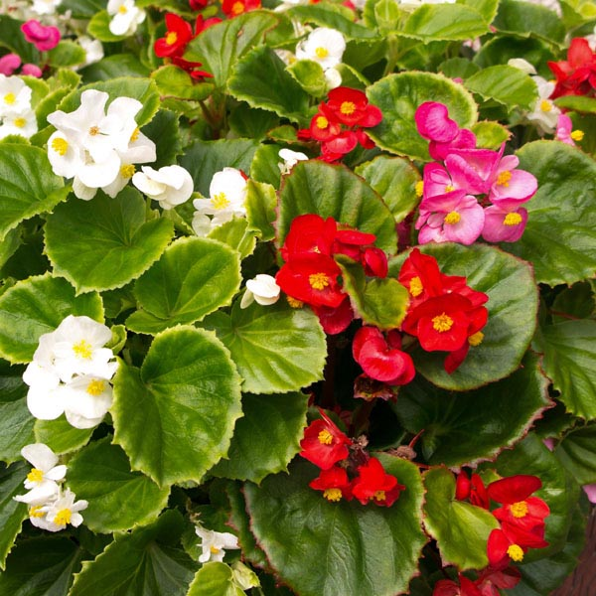

**Kingdom:** Planate

**Clade:** Tracheophytes

**Order:** Cucurbitales

**Family:** Begoniaceae

**Genus:** Begonia

**Species:** Begonia obliqua

**What is Wax Begonia?**

Wax begonia is a compact, mounded, succulent, and fibrous-rooted plant with fleshy stems and green to bronze leaves. Loose clusters of cymes in leaf axils, single or double and in various colors, bloom from spring to frost.

**What is the description of wax begonia?**

Wax begonias are often thought of as a plant for shade, but most of today's varieties grow well in full sun making this plant very versatile for gardens and landscaping. In the sun plants are shorter and develop somewhat more flowers than in the shade. Begonias bloom continuously throughout the summer and early fall.

**How big do begonia flowers grow?**

Begonia plants are typically under 1 foot tall, with loads of colorful flowers up to 4 inches wide. Begonias are generally hardy in zones 9 & 10, and in colder zones (2 - 8), they can be grown as annuals and overwintered indoors to grow year after year

**What is wax begonia used for?**

Wax begonia is one of the most popular bedding plants in landscaping. Innumerable flats of these sturdy plants are poked into the soil every spring to create lush beds of flowers. The reasons for this heavy use are obvious—they're durable, ever-blooming plants that provide sweeping color in single or double blooms.

**Is begonia good for indoor?**

Begonias are some of the most beautiful, visually interesting plants you can grow indoors. However, they can be a bit picky about light and water, though not overly delicate, making them a great intermediate-level plant project.

**Where do wax begonias grow best?**

One of the best things about wax begonias is that they grow well in sun or shade and thrive equally well in landscape beds and borders as they do containers. Most wax begonias stay a foot tall or less and bloom nonstop all spring, summer, and fall.

**What are health benefits of** **wax begonias?**

Relieves Bronchitis.

Cures Candidacies.

Heals Digestive Disorders.

**Are Geranium flower is fengshui?**

Signify multiple meanings; Good fortune, nobility, family harmony. Alternative, if place in study room, it will improve your child (girl) to grow up to have good fortune & wealth during their upbringing. Note that they may contain mild poison which causes rashes or vomiting.

**CLON**

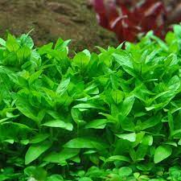

**Kingdom:** Planate

**Clade:** Tracheophytes

**Order:** Lamiales

**Family:** Acanthaceae

**Genus:** Staurogyne

**Species:** Synonyms

**What is Clon?**

Staurogyne repens is a light green compact strong plant for the aquarium foreground originating from Rio Cristalino in Brazil. It can be used as ground-covering plant or as low cushion-like bush. Forms well through trimming. It is effective for setting accents in crevices and gaps in the hardscape.

**How big does staurogyne repens grow?**

Its nearest relative in the aquaristic is Hygrophila but Staurogyne is different with its marked compact, low and bushy stature (**5-10 cm**) and small green leaves (each stem is 3.4 cm wide).

**How much light does Staurogyne repens need?**

Staurogyne repens needs medium lighting levels for around 10 hours every day, and your standard aquarium lighting system will provide that. If possible, try to avoid too much natural light, as that encourages the growth of algae.

**Is Staurogyne repens a carpeting plant?**

Staurogyne repens is a great freshwater aquarium plant choice for aquarists of all experience levels. It's a plant that is easy to care for and does a great job of adding to the aesthetic of your tank. In fact, Staurogyne repens is one of the best carpet plants outthere

**What are the economic uses of flowers?**

The Economic Impact of Flowers  
  
Flowers is also important in the pollination process, which is crucial for the continued production of food. Because of the importance of food crops, flowers have a significant economic impact. They are also sometimes used for medicinal purposes.

**Does Staurogyne repens need fertilizer**?

Staurogyne repens also requires some fertilization. A combination of a nutrient rich substrate (Tropica Plant Care Substrate or Aquarium Soil) in addition to supply of micro nutrients (Premium fertiliser) is necessary in order to maintain the fresh green colours of the leaves and constant, covering growth.

**How tall does S repens grow?**

The plant will only grow to around 2 to 4 inches tall when cultivated as a carpet, allowing plenty of swimming space above for your fish. The plant's leaves are a classical leaf shape, being oval with a broad base, tapering to a point at the end of the leaf.

**How big does Staurogyne repens get?**

Its nearest relative in the aquaristic is Hygrophila but Staurogyne is different with its marked compact, low and bushy stature (**5-10 cm**) and small green leaves (each stem is 3.4 cm wide).

It is not a fungshui flower.

**NUPIN**

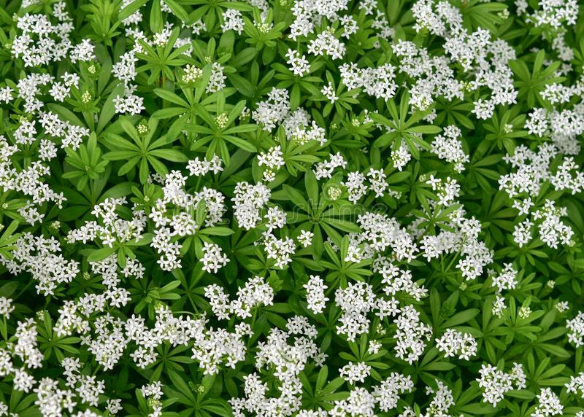

**Kingdom:** Planate

**Clade:** Tracheophytes

**Order:** Gentianales

**Family:** Rubiaceae

**Genus:** Galium

**Species:** Galium Odoratum

**What is Nupin (Woodruff)?**

Woodruff, any of various species of plants of a genus (Asperula) belonging to the madder family, Rubiaceae. The woodruff is found growing wild in woods and shady places in many countries of Europe, and its leaves are used as herbs. The genus Asperula includes annuals and perennials, usually with square stems.

**What is a woodruff used for?**

Sweet woodruff is an herb. The parts that grow above the ground are used to make medicine. People sometimes take sweet woodruff by mouth to prevent and treat lung, heart, stomach, liver, gallbladder, and urinary disorders**,** among many others.

**How do you identify a woodruff?**

Woodruff - Galium odoratum  
  
Stems square, erect with a ring of hairs at each node. Leaves elliptical in whorls of 6 to 9 edged with tiny forward pointing prickles. Flowers white, 4 to 7 mm in lax heads. Deciduous woodland and shady places.

**Uses of** **woodruff flower?**

Sweet woodruff is sometimes used to relieve nerve pain (neuralgia) and migraine; cause sweating; loosen chest congestion; and increase the flow of urine to relieve water retention. Some people apply sweet woodruff directly to the affected areas for skin diseases, wounds, vein problems, hemorrhoids, and swelling.

**How fast does sweet woodruff grow?**

If it has ideal growing conditions, sweet woodruff can easily spread out as much as 18 inches in one year.

**What is the smell of Woodruff?**

Vanilla odor

The dried leaves and flowers – said to have a grassy vanilla odor like freshly mown hay – can be used for potpourri and as a household insect repellant.

**What is the spiritual meaning of sweet woodruff?**

This association with fertility and abundance is no doubt the reason why Sweet Woodruff is said to bestow, prosperity, wealth and “make the heart merry”

**What does woodruff smell like?**

Galium odoratum is an herbaceous, mat-forming perennial native to Europe, northern Africa, and western Asia. The plant is known for its scent which is reminiscent of vanilla.

It is not a fungshui flower.

**BERBINA**

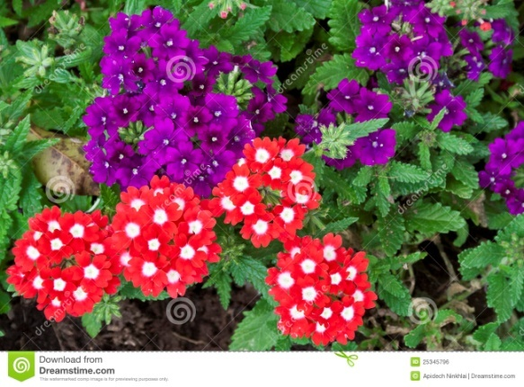

**Kingdom:** Planate

**Clade:** Tracheophytes

**Order:** Angiosperms

**Family:**  Verbenaceae

**Genus:** Verbena

**Species:** Verbena officinalis

**What is the meaning of garden verbena?**

**Meaning of verbena in English**  
  
a plant that has small colorful flowers growing in groups on its stems. There are many different types of verbena, some of which are used in perfumes, etc. or to make tea: Plants with thin stems and leaves, such as tall verbena, fit in without blocking other plants.

**What type of flower is verbena?**

Verbena, also known as vervain, is a long-blooming, heat-tolerant perennial or annual flower. Verbenas come in many colors and sizes; some grow up to 6 feet tall while other varieties are short ground covers that reach no higher than a foot. The tiny flowers are grouped into rounded clusters.

**What is verbena used for?**

Verbena is a plant. The parts that grow above ground are used to make medicine. Verbena is used for mild gum disease (gingivitis), swelling (inflammation) of the nasal cavity and sinuses (rhino sinusitis), heart conditions, depression, and other conditions, but there is no good scientific evidence to support these uses.

**Where do verbena flowers grow?**

Verbenas require a location that receives full sun throughout the day. They must have well-drained soil. They will not tolerate overcrowding with poor air circulation, shade or soil that stays overly moist. Most problems of verbenas occur in improper growing conditions.

**What season does verbena grow?**

Verbenas originated in South and North America and Europe and their flowering season is from May to October. Verbenas grow from 20cm to 2m and require sharply drained soils in full sun.

**What are the benefits of verbena leaves?**

Lemon verbena is a plant with impressive potential health benefits. Some research suggests that it may help reduce oxidative stress, protect against muscle damage, improve sleep quality, and have anti-obesity effects. However, human research remains limited at this time.

**Which verbena is medicinal?**

Verbena officinalis (common vervain) is a medicinal plant species widely distributed in the world and commonly used in folk medicine of different countries, including traditional Chinese medicine.

**Is there a verbena essential oil?**

Verbena is a classic top note in fragrances, perfectly setting off formulations that use patchouli, rose, lavender, sandalwood, neroli and bergamot. Genuine verbena essential oil is not cheap to buy, as its production takes careful manipulation of several environmental and climate-based factors..

It is not a fungshui flower.

**GAJENIA**

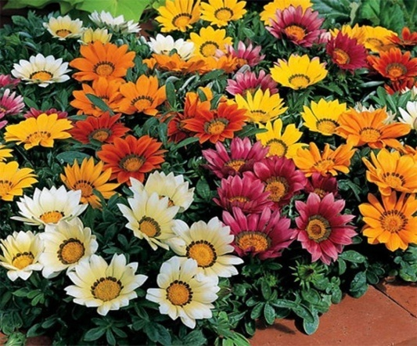

**Kingdom:** Planate

**Clade:** Tracheophytes

**Order:** Asterales

**Family:**  Asteraceae

**Genus:** Gazania

**Species:** Gazania rigens

**What is Gazania rigens?**

Gazania rigens (syn. G. splendens), sometimes called treasure flower, is a species of flowering plant in the family Asteraceae, native to coastal areas of southern Africa. It is naturalised elsewhere and is widely cultivated as an ornamental plant. Gazania rigens

**What are the uses of gazania?**

Gazania has been reported in folk medicine to prevent miscarriage and tooth ache, also it was incorporated in purgative preparations especially with aloes. Few studies have been reported to evaluate the biological effects of Gazania; which attributed antioxidant and hepatoprotective activities for G.

**Where do gazania flowers grow?**

Native to South Africa, Gazanias (Treasure Flower or African Daisy) are showy tender perennials exhibiting brightly colored daisy-like flowers, up to 4 in. wide (10 cm), over a long blooming season. Ridiculously easy to grow, they tolerate drought, heat, and seacoast conditions, and grow well in most soils.

**What season do gazania flowers grow?**

Summer season is the best season to grow Gazania (OP) seeds. The germination process will be good in this season.

**Is gazania medicinal?**

Gazania has been reported in folk medicine to prevent miscarriage and tooth ache, also it was incorporated in purgative preparations especially with aloes.

**Do gazanias need a lot of water?**

Gazanias are not fussy about soil quality and require water only once every week or two after they are established. One feeding in the spring with a slow release fertilizer should be enough. If you have a very sandy soil, you may have to water a bit more often and make a second fertilizer application in mid-summer.

**How many varieties of Gazania are there?**

The Plant List includes 100 scientific plant names of species rank for the genus Gazania. Of these 19 are accepted species names.

**What is the benefit of gazania flower?**

Gazania has been reported in folk medicine to prevent miscarriage and tooth ache, also it was incorporated in purgative preparations especially with aloes. Few studies have been reported to evaluate the biological effects of Gazania; which attributed antioxidant and hepatoprotective activities for G

It is not a fungshui flower.

**NEMESIA**

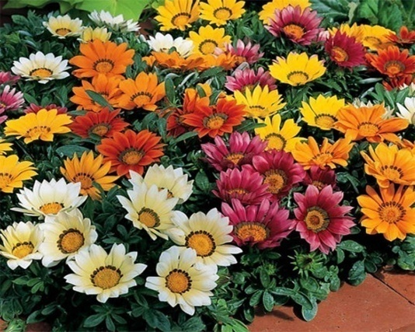

**Kingdom:** Planate

**Clade:** Tracheophytes

**Order:** Asterales

**Family:**  Asteraceae

**Genus:** Zinnia

**Species:** Chrysogonum peruvianum

**What is Zennia (Nemesia) flower?**

Zinnia is a genus of plants of the tribe Heliantheae within the family Asteraceae. They are native to scrub and dry grassland in an area stretching from the Southwestern United States to South America, with a centre of diversity in Mexico.

**What do zinnia flowers mean?**

**The Meaning of Zinnia**  
  
While zinnia has many different meanings, it is usually associated with friendship, endurance, daily remembrance, goodness, and lasting affection.

**What are zinnias good for?**

This long bloom season makes them excellent for landscape color in mixed plantings or for cutting gardens. Zinnias are one of the best annuals for attracting pollinators, especially butterflies. Interplant zinnias between rows of vegetables or as a border around vegetables to attract more pollinators to your garden.

**Where do zinnias grow best?**

Light: Zinnias grow and flower best in full sun. They can flower in part shade, especially in warmer climates with afternoon shade, but they may be more susceptible to disease and have fewer flowers. Soil: Zinnias grow best on fertile, well-drained soils high in organic matter.

**Why are zinnias so popular?**

Zinnias are a popular plant for annual gardens due to how easy they are to grow and how quickly they can grow, both from seed and as transplants. The vast range of growing habits also leads to their popularity as they can be anywhere from short and bushy to tall with a singular stalk.

**Can zinnias grow in pots?**

Zinnias are colorful additions to any flower garden – they're great for cutting, they are easy to grow and start from seed – so they make a great choice for container gardening.

**Can zinnia be an indoor plant?**

Zinnias may be started indoors or directly in the garden. If you have good conditions for growing them indoors such as plant lights, a heat mat for germination, then you can get a head start by starting them indoors.

**Can zinnias grow in hot weather?**

Zinnias tolerate full sun and hot weather very well, and, best of all, they don't attract insects. If you're not in a hurry, zinnia seeds are large and easy to handle. In our mild climate, zinnias seeds planted directly into the garden germinate quite quickly.

It is not a fungshui flower.

**MOTIMUM**

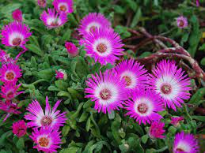

**Kingdom:** Planate

**Clade:** Tracheophytes

**Order:** Caryophyllates

**Family:**  Asteraceae

**Genus:** Cleretum

**Species:** Cleretum bellififrome

**What is Motimum (Livingstone daisy)?**

Cleretum bellififrome, commonly called Livingstone daisy, Bokbaaivygie (Afrikaans), or Buck Bay vygie, is a species of flowering plant in the family Aizoaceae, native to the Cape Peninsula in South Africa.

**How tall are Livingstone daisies?**

Plants grow up to 8 inches high and spread to 12 inches wide. The flowers close at night and on cloudy days. Growing Livingstone daisy: Livingstone daisies need full sun and sandy, well-drained soil.

**How long do Livingstone daisies take to grow?**

Keep moist. Seedlings usually appear in 14-28 days.

**Are Livingstone daisies easy to grow?**

They perform extremely well in hot and dry conditions making them perfect for rockeries, pots and containers as well as edging plants. You'll be the talk of the town with these fantastic little fellas in your garden as they put on a brilliant display that is second to none. Livingstone daisies love the sun.

**Can we grow daisy at home?**

Daisy seeds are super easy to grow on a balcony, terrace, or in the garden. The plant is best for the new gardeners and kids. Daisies have a lot of medicinal benefits, along with the usage in the cosmetic industry. Daisies prefer full sunlight and fertile soil.

**Does daisy bring good luck?**

There are many meanings assigned to the gentle daisy — including innocence, happiness, good luck and new beginnings. In Victorian times, daisies stood for loyalty and trust. There is also a story in Roman mythology of a nymph named Belies who transformed herself into a daisy to escape from unwanted attention.

**Are daisies high maintenance?**

Daisies are generally low maintenance perennials. At times they can be adversely impacted by aphids, slugs, and earwigs. As a gardener, you can combat these destructive pests by planting companion plants in the garden bed.

**What are the health benefits of daisy?**

People take wild daisy tea for coughs, bronchitis, disorders of the liver and kidneys, and swelling (inflammation). They also use it as a drying agent (astringent) and as a "blood purifier." Some people take homeopathic wild daisy for preventing problems during childbirth, pain and soreness, and minor bleeding.

**What are daisy leaves good for?**

The young flower heads or buds can be added to salads, soups or sandwiches; or the flower heads used to decorate salad dishes. The leaves can be eaten raw despite their bitter aftertaste, but are better mixed in salads or cooked and might be used as a potherb.

**SALVIA**

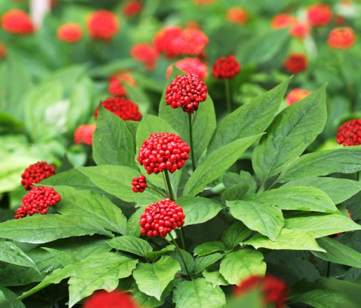

**Kingdom:** Planate

**Clade:** Tracheophytes

**Order:** Apiales

**Family:**  Araliaceae

**Genus:** Panax

**Species:** Panax Ginseng

**What is Panax Ginseng (Salvia)?**

Panax ginseng, ginseng, also known as Asian ginseng, Chinese ginseng, Japanese gingseng or Korean ginseng, is a species of plant whose root is the original source of ginseng. It is a perennial plant that grows in the mountains of East Asia.

**What is Asian ginseng good for?**

Asian ginseng is also promoted as a dietary supplement for a variety of other reasons—to improve physical stamina, concentration, and memory; stimulate immune function; slow the aging process; and relieve various other health problems, such as respiratory and cardiovascular disorders, depression, anxiety.

**Is ginseng Ayurvedic?**

Ashwagandha (Withania somnifera also known as Indian Ginseng) is a powerful herb that has been used for hundreds of years to treat a wide variety of conditions in the traditional form of Indian medicine known as Ayurveda One of the best anti-aging herbs

**Is Ginseng good for health?**

Ginseng has been used for improving overall health. It has also been used to strengthen the immune system and help fight off stress and disease. There are different types of ginseng. Asian ginseng (from Chinese and Korean sources) has been used for unclear thinking, diabetes, and male erectile dysfunction

**What is ginseng called in India?**

Withania somnifera, popularly known as Ashwagandha is widely considered as the Indian ginseng. In Ayurveda, it is classified as a rasayana (rejuvenation) and expected to promote physical and mental health, rejuvenate the body in debilitated conditions and increase longevity.

**Is a ginseng ficus an indoor plant?**

The ginseng ficus is an indoor bonsai and is not frost-hardy. It can be brought outside once temperatures are consistently above 60 F but must be kept in the sun and not allowed to dry out. Low humidity can be tolerated due to the waxy surface covering the ficus' leaves, but it will thrive in a humid environment

**Is ginseng plant lucky?**

Ginseng focus plants are easy to care for and great for not-so-green thumbs. They're considered good luck in feng shui and are one of the plants proven by NASA to purify air.

**Why do Chinese take ginseng?**

In traditional Chinese medicine (TCM), ginseng is often combined with other herbs. Today, ginseng is sometimes called an "adaptive," which is a substance that is supposed to help the body better cope with mental or physical stress.

It is not a fungshui flower.

|  |  |  |
| --- | --- | --- |
|  |  |  |

**GERENIUM**

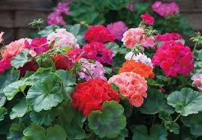

**Kingdom:** Planate

**Clade:** Tracheophytes

**Order:** Geraniales

**Family:**  Geraniales

**Genus:** Geranium

**Species:** Geranium

**What is Garden Geranium?**

Pelargonium × hortorum, commonly called zonal geranium, or garden geranium, is a nothospecies of Pelargonium most commonly used as an ornamental plant. It is a hybrid between Pelargonium zonal and Pelargonium inquinans.

**What is geranium used for?**

Geranium essential oil has been used to treat health conditions for centuries. There is scientific data indicating that it may be beneficial for a number of conditions, such as anxiety, depression, infection, and pain management. It's thought to have antibacterial, antioxidant, and anti-inflammatory properties.

**What is special about geraniums?**

Geraniums Are Drought-Tolerant  
  
These plants love bright, sunny climates and moderate to regular watering, as long as they are planted in well-draining soil. They're relatively low-maintenance plantings, and they're excellent choices for container gardening.

**Is geranium good for indoor?**

Potted geraniums (Pelargonium species) are excellent indoor plants and can be grown indoors throughout the year. They are typically available from March through June, and will flower continuously if provided with enough light in the home.

**What months do geraniums bloom?**

Geraniums are appreciated for their long blooming season that starts in spring and can last into fall. If plants are kept above 45 to 50 degrees, they may also bloom in winter to early spring.

**Are geranium is fengshui?**

A geranium is a particularly good plant to help you ensure that your energy is positive because it is considered to be a symbol of wealth and abundance as well as good luck. However, the color and exact positioning of the plant is key to feng shui.

**Do geraniums prefer pots or ground?**

Geraniums thrive in containers, so geranium care is just as easy when they are in pots. Plus, planting geraniums in pots offers the option of bringing geraniums indoors to overwinter. In general, geraniums don't mind being a little root-bound, so they don't require a ton of growing space to still look their best.

**What is the benefit of geranium leaves?**

The most interesting health benefits of geranium include its ability to lower stress levels, reduce inflammation, relieve pain, improve kidney health, strengthen the immune system, and ease digestion. The impact of geranium on the nervous system is well known and the plant has been used in this way for generations.

**BUTTON DAISY**

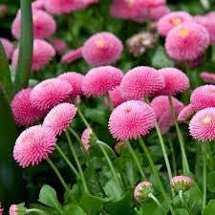

**Kingdom:** Planate

**Clade:** Tracheophytes

**Order:** Asterales

**Family:**  Asterales

**Genus:** Bellis

**Species:** Bellis Perennis

**What is Button Daisy?**

A creeping, mat-forming daisy with a compact habit, small, green, feathery leaves and small, white inflorescences borne on thin stalks.

**What is the meaning of a Daisy?**

**New beginnings**  
  
In Norse mythology, the daisy is known as the sacred flower for the goddess of love, beauty and fertility. Because of this, daisies symbolise childbirth, motherhood and new beginnings. So they're a great flower to give to welcome a new baby!

**Why is it called a daisy?**

The word “daisy” comes from the Old English dægesege, formerly dæges eage, meaning “day's eye,” because the petals of some species of daisy open at dawn and close at dusk.

**How you grow Button Daisy?**

Best suited for container gardening to prevent the cheerful blossoms.

Requires 4-6 hours of sunlight per day as daises prefer cooler tempratures.

Grows best in rich, loamy soil with good drainage.

Needs regular watering.

Attract common pests- Thrips and leaf miners.

**What is the size of a daisy?**

Its solitary flower heads are about 2.5 to 5 cm (1 to 2 inches) in diameter, and the ray flowers are white in color.

**What is the longest blooming daisy?**

**Sun Exposure: Full**  
  
Shasta daisies, black-eyed Susans, and African daisies or osteospermum have a longer bloom period, blooming at least three months. Black-eyed Susans will bloom from June to September, and Shastas will produce flowers from July to September.

**What is the benefit of daisy flower?**

People take wild daisy tea for coughs, bronchitis, disorders of the liver and kidneys, and swelling (inflammation). They also use it as a drying agent (astringent) and as a "blood purifier." Some people take homeopathic wild daisy for preventing problems during childbirth, pain and soreness, and minor bleeding.

It is not a fungshui flower.

**SENERIA**

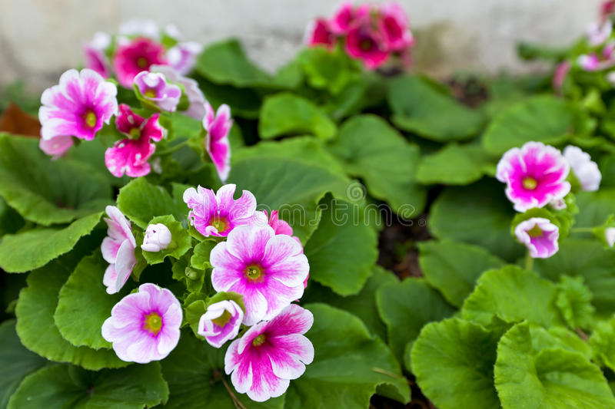

**Kingdom:** Planate

**Clade:** Tracheophytes

**Order:** Ericales

**Family:**  Pirmulaceae

**Genus:** Primula

**Species:** Primula Obconia

**What does Primula Obconica mean?**

Primula obconica is the scientific name given to what is commonly known as the Poisonous Primrose. Its name is the diminutive of the Latin primus, meaning "first" and obconica meaning inversely conical. P. obconica is included in the primrose family because it is one of the first plants to bloom in spring.

**What is Primula used for?**

According to EMA, Primula flowers and roots are used against coughs, bronchitis, and catarrhs of the respiratory tract and also to treat nervousness, headache, or rheumatism [7, 8].

**How long do Primula flowers last?**

Lasting for up to 4 weeks, each eye-catching blossom is borne on erect stems frosted with silvery-white 'farina'. The contrast of the white stems with the dark violet flowers is very beautiful. The flowers arise from a rosette of oblong, pale green, mealy leaves. Grows up to 10-12 inch.

**What month do primulas flower?**

**Primula denticulata**

It flowers from May to June and grows best in a moist, humus-rich soil in partial shade.

**Is Primula an indoor plant?**

Primulas are known as fun, colorful winter and spring plants for indoors and outdoors. Primula is also a diminutive of the word Primus and means 'first'.

**Is primrose good for the heart?**

**It may help improve heart health**  
  
According to a 2014 study on rats, EPO is anti-inflammatory and helps reduce blood cholesterol. Most people with heart disease have inflammation in the body, although it hasn't been proven that inflammation causes heart disease.

**Can evening primrose cause kidney problems?**

Some supplements can be harmful to your kidneys and should be avoided. These include creatine (not to be confused with creatinine), licorice root, barberry, yohimbe, and astragalus. Other supplements, such as bitter melon, American ginseng, feverfew, and evening primrose, contain potassium.

**Where is primrose found in India?**

Himalayan White Primrose is found at altitudes of 3500-4600 m in the Himalayas, from C. Nepal to Bhutan, S.E. Tibet and Arunachal Pradesh. Flowering: June-July. Photographed in Tawang district, Arunachal Pradesh & Tsomgo Lake, Sikkim

It is not a fungshui flower.

**LADIES PURSE**

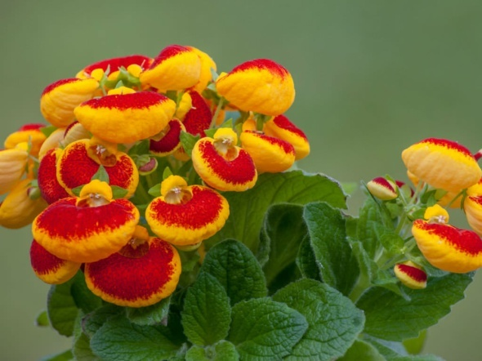

**Kingdom:** Planate

**Clade:** Tracheophytes

**Order:** Lamiales

**Family:**  Calceolariaceae

**Genus:** Calceolaria

**What is Calceolaria Herbeohybrida (Ladies Purse)?**

Calceolaria is a genus of over 300 species of herbaceous annuals, perennials, and shrubs native mainly to high altitude regions of the Patagonian Andes north to Mexico. The Herbeohybrida Group of calceolarias, commonly called pocketbook plants, are known for their showy flowers.

**What is the meaning of Calceolaria flower?**

A large genus of tropical American plants (family Scrophulariaceae) with highly irregular 2-parted showy flowers having a small upper lip and a large inflated slipper-shaped lower lip. plural -s : any garden plant of the genus Calceolaria. called also slipperwort.

**What does Calceolaria look like?**

They generally have show stopping bright yellow and orange blooms, sometimes with red spots. Calceolaria usually last for just the one season before they'll have to be replaced as they rarely rebloom. These flowers prefer a cool and not overly bright location and are mostly sold for display indoors.

**Where does Calceolaria grow?**

Calceolaria is a genus of over 300 species of herbaceous annuals, perennials, and shrubs native mainly to high altitude regions of the Patagonian Andes north to Mexico.

**Does Calceolaria bloom all summer?**

Calceolaria mexicana is an annual with typical yellow flowers that bloom all summer. Pocketbook plant related varieties: Goldcrest, Golden Bunch, and Midas are all sunshine-yellow in color. Gold crest has larger flowers than the others. Bubblegum mix has large flowers in a range of oranges.

**Is Calceolaria an indoor plant?**

Although they can sometimes be used as bedding plants, Calceolaria are usually grown in pots indoors. They prefer to be positioned in a cool room with diffused sunlight. They should be watered regularly, and their potting medium should be light and fertile

**Does Calceolaria like sun or shade?**

Grow calceolaria in full sun (at least 6 to 8 hours of direct sun) or part shade outdoors (morning shade and afternoon sun) for best blooms. Because it loves cool weather, you can move it to increasingly shaded spots as temperatures rise to help keep your plant happy longest.

**Is calceolaria an evergreen?**

Description. Evergreen with tall stems of bright yellow flowers. A classic calceolaria that is a great garden variety with evergreen foliage bright yellow flowers. With its short height it is perfect for alpine containers, alpine rock garden and border.

It is not a fungshui flower.

**CARNEMUN**

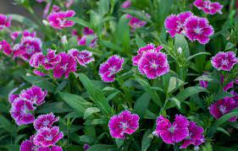

**Kingdom:** Planate

**Clade:** Tracheophytes

**Order:** Caryophyllales

**Family:**  Caryophyllaceae

**Genus:** Dianthus

**Species:**  Dianthuscaryophyllus

**What is China Pink (Carnemun)?**

Dianthus chinensis, commonly known as rainbow pink or China pink is a species of Dianthus native to northern China, Korea, Mongolia, and southeastern Russia. It is a herbaceous perennial plant growing to 30–50 cm tall.

**How do Chinese pink flowers grow?**

China pinks enjoy humus-rich and well-draining soil with a slightly gritty texture and a pH of 6.0 to 7.5. They thrive in the cool temperatures of late spring and perform best in areas with cool summers, underperforming in regions with high heat and humidity. In regions with mild summer temperatures, plant in full sun.

**What is China pink used for?**

This plant is used in Chinese herbal medicine as a bitter tonic to stimulate the digestive and urinary systems and bowels to treat cystitis, urinary stones, and constipation. It is also used externally for skin inflammations and swellings.

**Is China pink flower is fungshui?**

These are beautiful pink colored flowers widely used in the Feng Shui art. In the art of Feng Shui this flower is considered as a very good cure for love and romance. The broken love affairs are often restored with the help of these flowers.

**What are the health benefits of dianthus?**

Historically, Dianthus plants have been used for their medicinal properties, serving well in tonics to treat fevers, alleviate stomach issues and reduce chest congestion. Some species (including carnations) are a great source of essential oils and can be used to treat symptoms of stress and depression.

**How long do dianthus plants last?**

These plants will return year after year. This growth can be encouraged by regular deadheading. The flowers on the plant, however, usually only last 8 weeks.

**What months do dianthus bloom?**

Bloom time: Spring to early summer; some rebloom intermittently or continuously through summer and fall. All benefit from regular dead-heading. When to plant: Perennial types are best planted during cooler months in spring or fall.

**Can dianthus grow in pots?**

**Planting Dianthus in Pots**  
  
Dianthus works well as a container plant and can be planted in the spring and summer for a touch of romantic texture and color. They like a partial shade spot, which means three to six hours of sunlight each day. They do not do well in direct, hot sun locations.

**RENUCELUS**

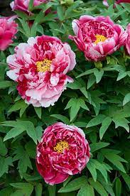

**Kingdom:** Planate

**Clade:** Tracheophytes

**Order:** Saxifragales

**Family:**  Paeoniaceae

**Genus:** Paeonia

**Species:**  PaeoniaOfficinalis

**What is the definition of a peony?**

Common peony meanings include romance, prosperity, good fortune, a happy marriage, riches, honor, and compassion — but peonies can also mean bashfulness. There are two common myths about the peony. In one, the peony is believed to be named after Paeon, the Greek physician of the gods.

**Why is it called a peony?**

Peony is the vernacular name for the section Moutan of the plant genus Paeonia, or one of the species or cultivars belonging to this section. It consists of shrubs that have perennial aerial woody stems.

**Is peony an Indian flower?**

Peony is a perennial plant native to Asia, southern Europe and western North America. Most Peonies are herbaceous plants 0.5–1.5 m tall, but some are woody shrubs up to 1.5–3 metres tall.

**What are peonies used for?**

Historically (and even through today), Peony served as primarily an herbal remedy for a variety of physical ailments, including gout, arthritis, respiratory tract infections, menstrual cramps, liver disease, seizures, nerve pain, and migraines. Today, Peony is also being used in cosmeceutical and skincare formulations.

**Are peony leaves medicinal?**

Peony is well known for its antispasmodic properties. P. officinalis was used by physiomedicalists for nervous conditions, convulsions, and epilepsy.

**Where do peonies do best?**

Peonies prefer a sunny location with well-drained soil. Good air circulation around the plant is also important. These growing conditions help peonies avoid their only serious disease problem: botrytis. Like other fungal diseases, botrytis is present in most soils.

**What time of year do peonies bloom?**

Peonies bloom between late spring and early summer, but you can plan your garden for a successive display of flowers from mid-May to late June by planting a selection of varieties.

**Is Peony flowers fengshui?**

The peony is one of the most auspicious flowers in feng shui and has come to symbolize love, prosperity, and beauty.

**AZELIA**

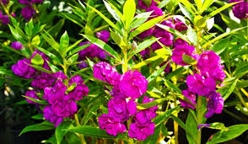

**Kingdom:** Planate

**Clade:** Tracheophytes

**Order:** Ericales

**Family:**  Balsaminaceae

**Genus:** Impatiens

**What is Impatiens Balsamina (Azelia)?**

Impatiens balsamina, commonly known as balsam, garden balsam, rose balsam, touch-me-not or spotted snapweed, is a species of plant native to India and Myanmar.

**What are Balsams used for?**

Balsams are soft, initially malleable, and therefore can be used an ointment in wound healing. Balsams consist primarily of cinnamic and benzoic acids and are therefore considered a phenolic resin [11]. The volatile fraction tends to be fragranced and is therefore used in perfumery, cosmetics, and burned as incense.

**What is the use of Impatiens balsamina?**

Medicinal ( The plant is used **to treat pains in the joints**. Leaf juice applied to warts. Mucilaginous flowers have cooling, antifungal and antibacterial properties, used to treat burns, scalds and snakebites. Powdered seeds given to women during labour to provide strength.)

**What are the characteristics of Impatiens balsamina?**

Impatiens balsamina, commonly called rose balsam or garden balsam, is an erect, sparsely-branched, tender annual that typically grows to 6-30” tall (depending on variety).

**What is Impatiens balsamina in Ayurveda?**

Impatiens balsamina Linn. (Family: Balsaminaceae) has been traditionally used for a variety of emetic, cathartic, diuretic, antimicrobial, rheumatic, pruritic and tumoural purposes as well as for the treatment of difficult labour and puerperal pain.

**Blooming time of** **Impatiens balsamina?**

They begin blooming in the late spring and persist all the way until frost in the fall. The flowers can be solid or bicolor, and sometimes they are spotted. Garden balsam is a fast-growing plant that is normally started indoors six to eight weeks before the last frost date.

**Height** **of** **Impatiens balsamina?**

It is an annual plant growing to 20–75 cm tall, with a thick, but soft stem. The leaves are spirally-arranged, 2.5–9 cm long and 1–2.5 cm broad, with a deeply toothed margin.

**How much sun does balsam need?**

**Balsam Plant Sunlight Requirements**  
  
Balsam does well with 3-4 hours of direct sunlight. However, it can also thrive in partial shade. An east or south-facing location will be best for the plant's growth. If you are growing it indoors, place it on a south-facing windowsill.

**Is Impatiens balsamina indoor or outdoor?**

They can overwinter outdoors in tropical and subtropicalareas and can be cultivated as annuals in other regions. When winter comes, you can move potted garden balsam indoors. Garden balsam (Impatiens balsamina) is a true annual herbaceous plant.

It is not a fungshui flower.

**CHERRYSO PLANT**

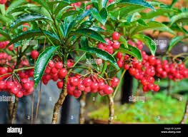

**Kingdom:** Planate

**Clade:** Tracheophytes

**Order:** Ericales

**Family:**  Primulaceae

**Genus:** Ardisa

**Species:**  ArdisaCrenata

**What is Ardisia crenata?**

Ardisia crenata, commonly known as coralberry, is a compact evergreen shrub that is native to forest understories from Japan to Southeast Asia and northern India. It typically grows to 4-5' tall and as wide.

**What are the uses of ardisia?**

Traditional medicinal uses attributed to Ardisia include alleviation of liver cancer, swelling, rheumatism, earache, cough, fever, diarrhea, broken bones, dysmenorrhea, respiratory tract infections, traumatic injuries, inflammation, pain, snake and insect bites, birth complications and to improve general blood.

**Is ardisia fruit edible?**

Its flowers are insect-pollinated. The fruits are probably eaten by birds. It can be propagated by seed, stem cuttings and leaf cuttings. Food (Fruit & Vegetable: The reportedly sweet and small fruits are edible.

**What are ardisia leaves?**

The Ardisia leaves provide a soft layer for animals to burrow and cover their secret hideout. Most reptiles and amphibians forage the forest floor in search of food and water. The top layer covers the actual substrate underneath to facilitate its moisture retention and prevent the soil from drying out.

**Is ardisia a house plant?**

Ardisia humilus is a showy houseplant that displays a shrubby habit, shiny dark leathery green leaves, and pink flower clusters followed by bright red berries. Well suited to indoor conditions. Shoebutton Plant grows best in a well-drained soil with regular watering. Adapted to a wide range of indoor conditions.

**What is the common name for ardisia plant?**

**Coral berry**

Common names include coral ardisia, coral berry, Christmas berry, hen's eyes, scratch throat, Australian holly, coral bush and spiceberry.

**Can you eat Ardisia crenata?**

Lastly there is the Ardisia crenata, which is not listed as toxic but some think it is potentially toxic. It is suspected of killing cattle in 2001 and 2007 in Florida. I ate the flesh off one seed and had no problem. It kind of tasted like a raw pea, but had the texture of a cooked bean.

**Is Ardisia crenata indoor or outdoor?**

This plant is evergreen in most climates that stay above 50 degrees. And throughout the spring and summer, some types provide bright, stunning flowers. While considered invasive in some areas, the ardisia can be a phenomenal indoor plant. And it's an easy grower, heightening its popularity indoors.

It is not a fungshui flower.