Hello Puppy Families,
Time is getting close to bring your Fur baby home. I know a lot of you have been asking about how to transport and care for your new babies, So I wanted to pass this information on!
Jane Messano Lindquist (Puppy Culture Owner) is offering a free course that is very informative and helpful for brining your new family member home.
If you are interested in learning about how to help your puppy be the best they can be, then go to the Madcap University website: With Open Arms and a Level Head: How to Bring a Puppy Into Your Life – Madcap University and register for the course. It Is FREE and very informative.
Here are a few pictures of the in-home setup we have used in the past for a new puppy:
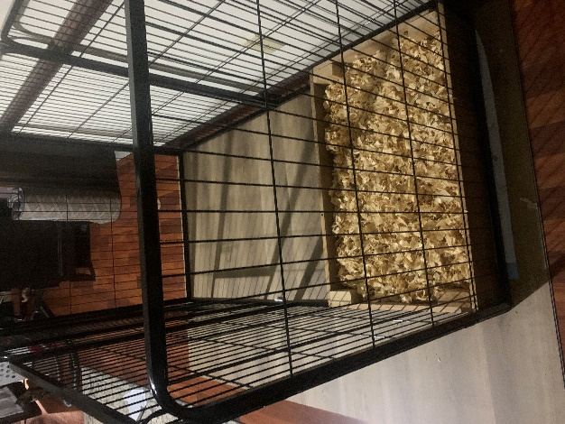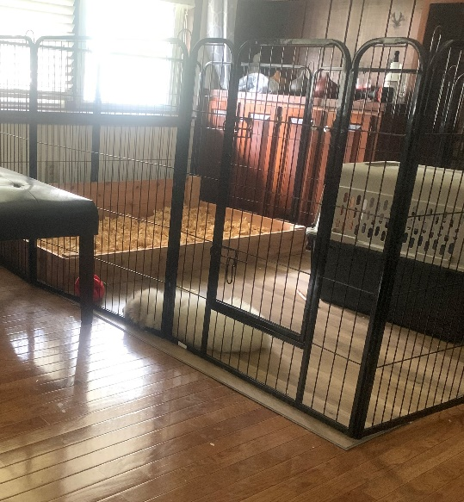
The first picture is the bedroom set up, the second is the Living Room set up!
If you are getting a puppy as a livestock guardian, then a stall in the barn or an outside secure enclosures will be needed.
Some things you need to know about your Great Pyrenees Puppy

Your Puppy was born on February 26, 2022. They have been dewormed with pyrantel pamoate and will be dewormed with Safeguard (fenbendazole) with the last dose given 4/15/22.The vet is has been out to the farm for their wellness check, and they have been cleared by her and are ready for their new homes. The puppies have NOT received any vaccines to date. We raise our puppies and dogs as naturally as possible and feel that families should decide when and what vaccines to give to their pets. You can get some good well researched information from Dogs Naturally Magazine website, here is a link about vaccinations: https://www.dogsnaturallymagazine.com/which-dog-vaccines-are-necessary/
And here is a link to their blog site which you can do a search and covers many topics: https://www.dogsnaturallymagazine.com/blog/

POTTY HABITS
The Puppies have been mostly going to the bathroom either outside, on the grass, on a puppy pad or in a designated potty area filled with grass pellets found at Tractor Supply. Puppies cannot hold it all night, so be sure to give them a place to void during the nighttime. I suggest offering them a pen area and place a crate (with the door open) inside the pen area along with a potty area, using pellets, shavings or pee pads inside the pen area so they can be successful in keeping their crate clean. For farm dogs a stall will also be a great area for your puppy and offer them a comfy den area with the door open to sleep in inside the stall. Sometimes the extra stress of travelling, a new home and environment can upset their tummies. You can offer them a little canned pumpkin (NOT PIE FILLING) to help with loose stools if it occurs.

FEEDING YOUR PUPPY:
The current food they are eating is 4 Health with Wholesome Grains Large Breed Puppy food, which is AAFCO approved for Large Breed Puppies. We also give them Raw egg yolks, Fermented raw goats milk and raw goats milk when available. Puppies are fed dry kibble approximately 3/4 cup each feeding and fed 3 times a day. If you use the “puppy puppy puppy” call, they will come running to eat. The amount of food to feed varies by the brand of food you are feeding. 4 Health with Wholesome Grains Large Breed Puppy food (found at Tractor Supply) recommends feeding 20 Lb. 2–4-month-old puppy 2 2/3 cups total per day. This amount will increase as they get older and bigger. Please follow recommended guidelines from the food you will be feeding as well as what your vet recommends. I add fermented goats’ milk and water to help moisten the food, but they will eat dry kibble as well. I am sending you home with some of the dry food they are currently eating. If you decide to switch to another food, make sure you give them a high-quality LARGE BREED PUPPY food. You will want to change them over to the new feed slowly. At first feed 75% 4 Health Puppy Food to 25% new Feed (1-2 days) Then mix 50/50 for 1/-2 days) Then 25/75 for a few days more until you are feeding 100% new food.
Feeding a large breed puppy food is important so your puppy does not grow too quickly which could cause problems, such as hip dysplasia or elbow dysplasia. According to Pet MD scientific studies show that rapid growth of the long bones in puppies is a risk factor for developing joint and bone conditions. Rapid bone growth can be caused by two methods: overfeeding and calcium supplementation. Puppies allowed to free-feed or those fed liberal meal portions that exceed their daily caloric needs risk rapid bone growth. Please consult your vet on feeding recommendations. Great Pyrenees finish growing at around 18 months.
Also, some of you have been asking what I use for training treats. I like to use Ziwi Peak Air-Dried Mackerel & Lamb Dog Food. It is very nutritious, and they LOVE it! Downside is you must order it online. Chewy and Amazon carry it. I also use cut up chicken, beef, or pork at times too.
Transporting New Pup Home
What I have done in the past is have a crate in the back seat with the door open and sit next to the puppy. That way they can go in the crate or come out on my lap if they are scared. It is also a good idea to bring them something to chew on to help distract them. This should only be done if you have someone to sit with them, otherwise I recommend you bring them a crate to secure them in to keep them safe.
We find the puppies spend most of the time in the crate with something good to chew but come out here and there when needed. If you have a long drive, you can get some adaptil calming spray, or an adaptil infused collar, to help keep them calm. You can get these from Amazon.
Something like this: Amazon.com : Adaptil JR. Calm On-The-Go-Collar for Puppies | Constant Calming and Comfort Everywhere | Reduce Separation Anxiety and Fear of Loud Noises | Stop Crying at Night : Pet Supplies
Or this: Amazon.com : ADAPTIL Spray 60 mL – Calms & Comforts Dogs During Travel, Veterinary Visits and Stressful Events - The Original D.A.P. Dog Appeasing Pheromone Spray (60mL Spray, 1-Pack) : Pet Supplies
Here are a couple of pictures of how we transported one of our puppies:
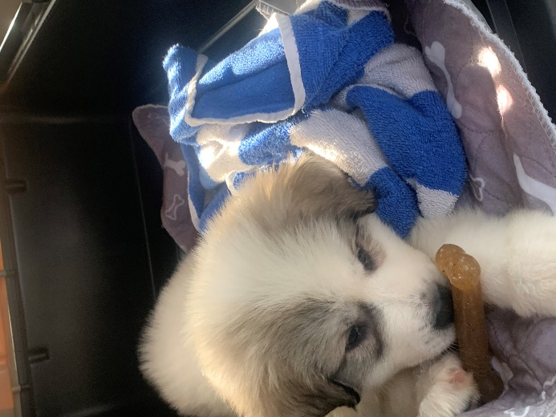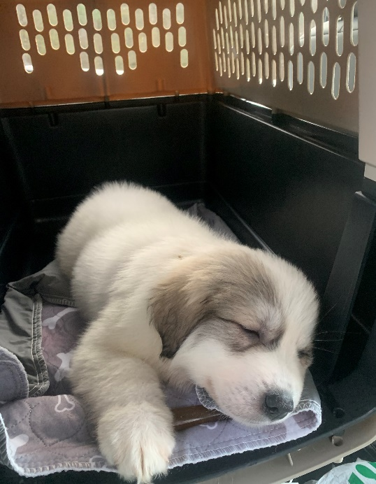
Feel free to contact me if you have any question!
Kindest Regards,
Debbie

©2022 Ivy Hill Acres Farm

