Psychological Evaluation Preparation & Referral Guide

Purpose of This Guide
This guide provides a comprehensive overview of how to prepare for a psychological evaluation with SATTC, including required referral elements, record collection processes, and strategies to improve efficiency and accuracy.
A psychological evaluation is a multi-informant, data-driven assessment process that integrates clinical interviews, standardized testing, and records across systems to clarify diagnoses, rule out alternative explanations, and guide treatment, service, and system-level decision-making.

Minimum Requirements for Referral
1. Client Demographic Information (REQUIRED): Full name, caregiver name, date of birth, current diagnosis, Insurance Name, Policy #, and Member/RIN Number, guardian status, email address, phone number, and mailing address.
2. Release of Information between referral agency and SATTC (REQUIRED)
3. Clear Referral Questions (REQUIRED)
4. Most recently completed IM+CANS, IM+CATS, or intake assessment (WHEN AVAILABLE)
The SATTC referral form is not required but is available on the homepage at http://stressandtrauma.org
Email to help@stressandtrauma.org
Fax to 618-216-9993

Evaluation Process Flow
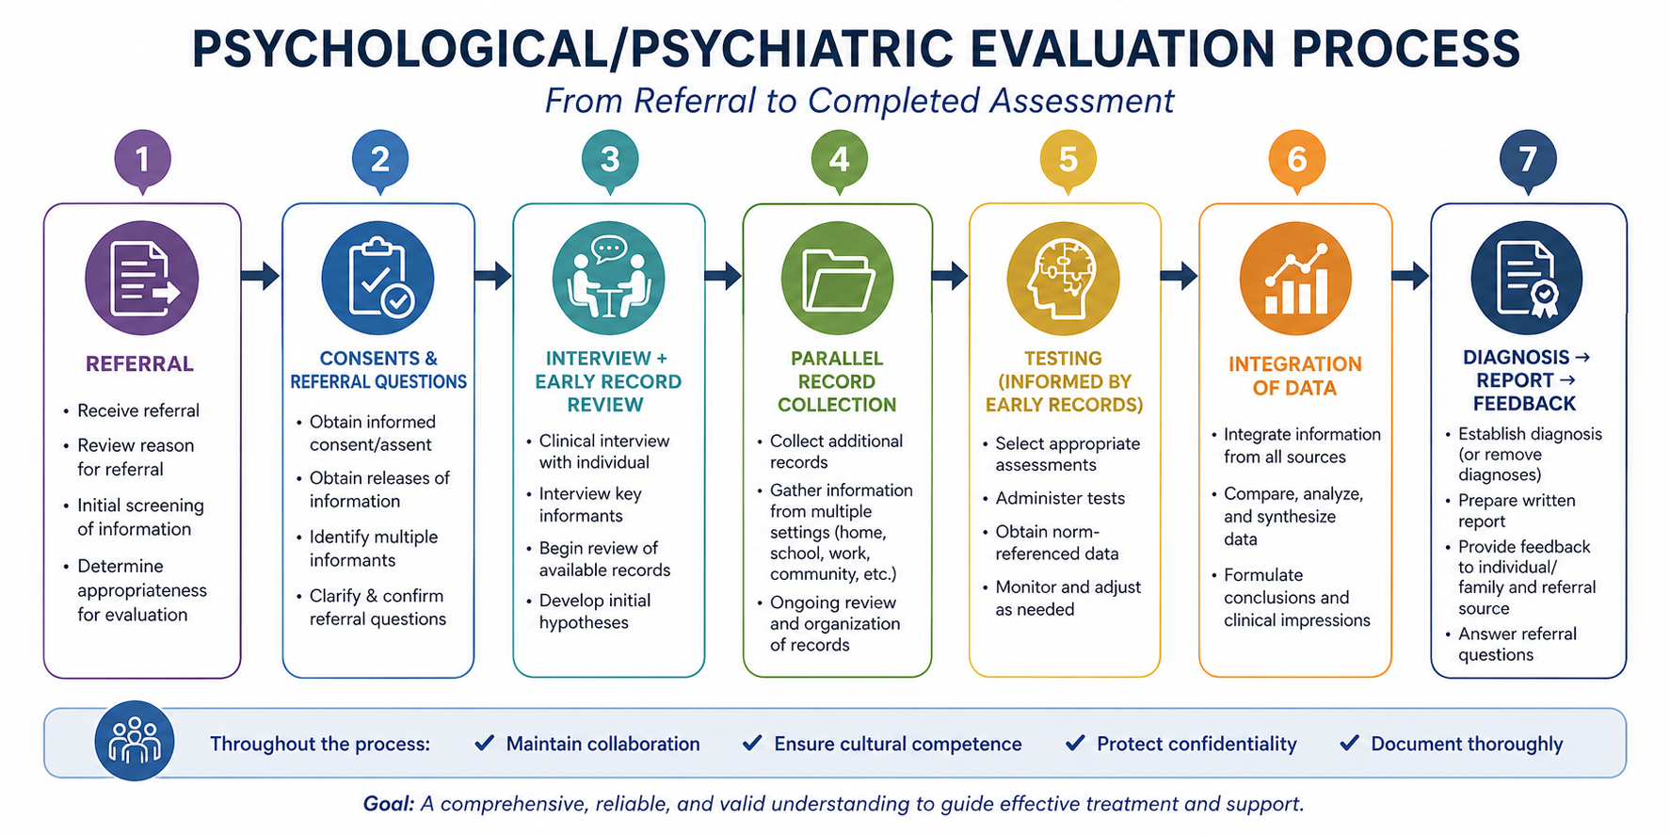

Example Evaluation Activities of a Standard Psychological Evaluation
- Clinical Interview – Multiple informants
- Norm referenced Adaptive and/or IQ Test for functioning
- Norm referenced rating scales – Multiple informants
- Diagnostic rating scales – Multiple informants
- Observations (structured or unstructured; multiple environments)
- Review and summary of records
- Situational tasks or work products
- Diagnosis and differential diagnosis (removal of diagnoses as appropriate
- Treatment or Services Recommendations
- Answers referral questions that can be answered

Norm-Referenced Testing
Norm-referenced testing compares an individual’s performance to a representative peer group. According to the American Psychological Association (APA), these tests allow interpretation of results relative to others of similar age or characteristics. Results include standard scores, percentiles, and standard deviations to determine deviation from the average.
Benefits include increased objectivity, improved diagnostic accuracy, consideration for typical vs atypical development, and stronger confidence in decision-making.

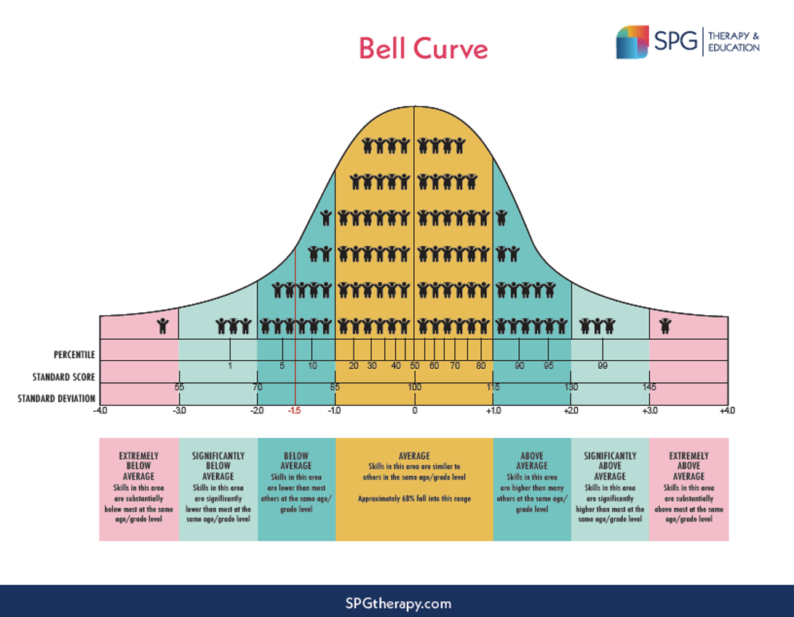

Multiple Informants & Perspectives
Multiple perspectives are required in a psychological evaluation to understand the complexities of any individual’s mental health needs and diagnoses. Using multiple informants increases the validity of the results, improves objectivity by decreasing individual biases, and provides a more full picture of the complex sides of an individual.
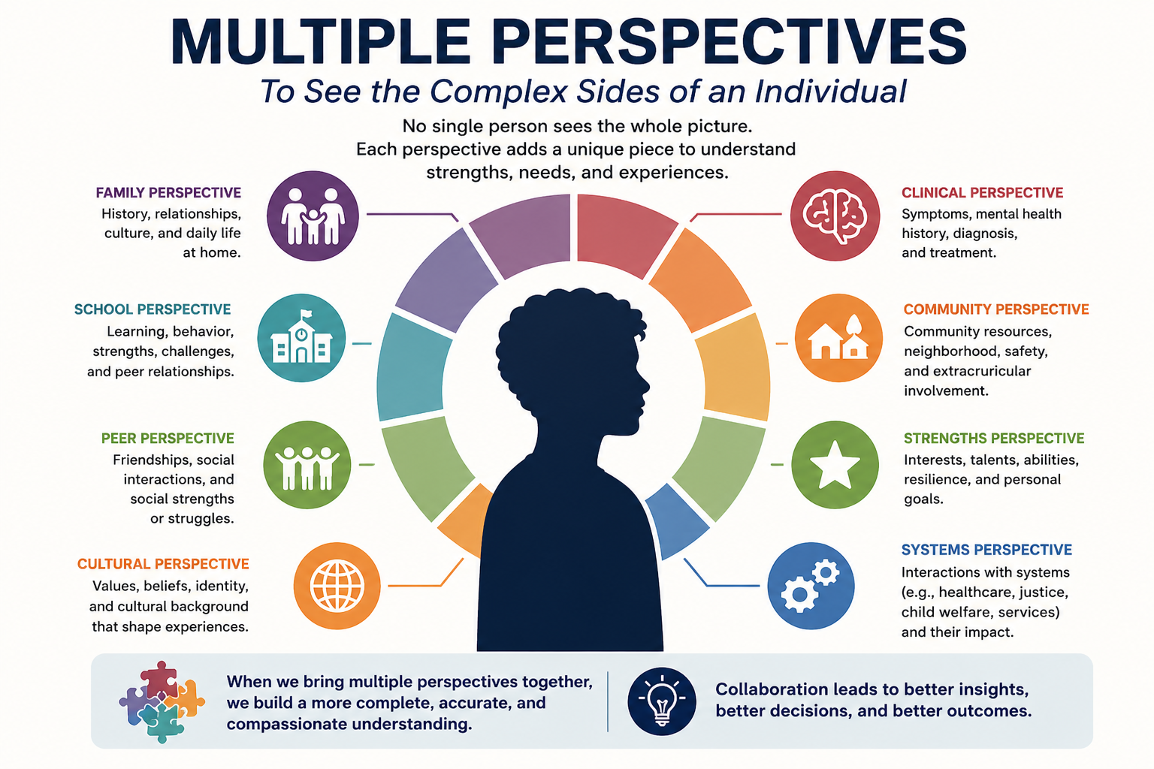

Psychological Evaluations can take 4-8 weeks to complete a final report and feedback session to the client/family.
- The amount of time needed varies based on lots of factors including the availability of records, attendance of appointments, and timely submission of completed rating scales and tests.

Referral agents often ask what can we do to speed up this process.
- Here are a list of strategies to increase the efficiency and decrease completion time:
- Compile records created by the referral agent (intake assessments, service plans, etc) and share all records that have been shared by other agencies (see list of Common Records Needed)
- Work with the family to search and find reports and records from key activities or agencies to bring to the initial meeting
- Obtain releases of information from agencies associated with the list of common documents below. If possible, collect records from multiple agencies to share with SATTC for evaluation purposes.
- Records held that were created by or shared with the referral agency can be shared with a single Release of Information.
- SATTC Release of Information can be found here: https://img1.wsimg.com/blobby/go/0945c099-6201-4d5f-8d3e-ce9d69261f44/downloads/e01b5c6c-9c6f-4476-b9b8-ecb4ee357f15/SATTC%20consent%20to%20Treat%20and%20Limits%20to%20Confident.pdf?ver=1777496362052
- After the initial referral, the family will receive a welcome message to their email address from TherapyNotes – SATTC’s Electronic Health Records. Encouraging and coaching the family to complete the opening paperwork, consent forms, and other forms over the portal prior to the initial meeting will allow the examiner to start testing immediately.
- Have the family complete SATTC Consent for Treatment in addition to releases of information:
- SATTC Consent for Treatment can be found here:
https://img1.wsimg.com/blobby/go/0945c099-6201-4d5f-8d3e-ce9d69261f44/downloads/e01b5c6c-9c6f-4476-b9b8-ecb4ee357f15/SATTC%20consent%20to%20Treat%20and%20Limits%20to%20Confident.pdf?ver=1777506814713

Common Records Needed (Expanded Detail)
- Most recent IM+CANS
- IM+CATS or detailed crisis descriptions (2 years + lifetime)
- Psychiatric hospitalization summaries (LOS, diagnosis, meds, crisis plan)
- Residential treatment summaries (LOS, diagnosis, meds, crisis plan)
- Full IEP document
- Crisis Management Plan
- Outpatient mental health summaries (frequency, attendance, compliance)
- Psychiatric service summaries (medication, labs, compliance)
- Medical/developmental records
- Provider prognosis/opinion
- DCFS reports
- Family system records if relevant

Benefits of Psychological Evaluations
- Comprehensive evaluation that can rule out and confirm Behavioral Health Diagnoses.
- Increased validity, reliability, and confidence in diagnoses
- Methodology that decreases bias
- Use of Psychometrically valid tools
- Use of norm referenced results
- Recommendations based on complex testing results
- System accepted results

