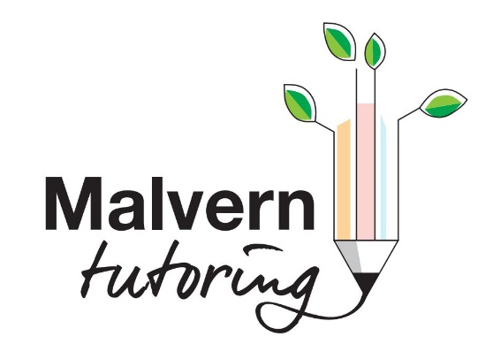

Malvern Tutoring receive, collect and store any information you enter on our website or provide us in any other way.

We may use software tools to measure and collect session information, including page response times, length of visits to certain pages, page interaction information, and methods used to browse away from the page.

We also collect personally identifiable information (including name, email, password, communications); payment details (including credit card information), comments, feedback, product reviews, recommendations, and personal profile.

When you make contact on our website, as part of the process, we collect personal information you give us such as your name, address and email address. Your personal information will be used for the specific reasons stated above only.

We collect such Non-personal and Personal Information for the following purposes:
- To provide and operate the services we deliver;
- To provide our pupils with ongoing assistance and support;
- To be able to contact visitors to our website with personalised services.
- To comply with any applicable laws and regulations.

We may contact you to notify you about tutorial sessions, to resolve a dispute, to collect fees or monies owed, to poll your opinions or questionnaires, or as otherwise necessary to contact you to enforce our User Agreement, applicable national laws, and any agreement we may have with you. For these purposes we may contact you via email, telephone, text messages, and postal mail.

If you don’t want us to process your data anymore:
Send an email to: katie@malverntutoring.co.uk
Send us a letter to: Katherine Neale, 3 Walnut Crescent, Malvern WR14 4AX

We reserve the right to modify this privacy policy at any time, so please review it frequently.
Changes and clarifications will take effect immediately upon their posting on the website. If we make material changes to this policy, we will notify you here that it has been updated, so that you are aware of what information we collect, how we use it, and under what circumstances, if any, we use and/or disclose it.

If you would like to: access, correct, amend or delete any personal information we have about you, you are invited to:
Send an email to: katie@malverntutoring.co.uk
Send us a letter t: Katherine Neale, 3 Walnut Crescent, Malvern WR14 4AX

