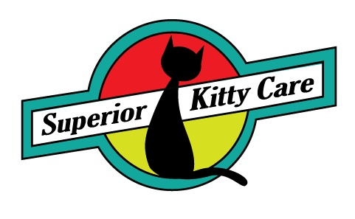

Client Survey Form

Thank you for taking the time to complete this form. We work hard to take the best possible care of your pets. Any feedback is appreciated!!

Were you happy with our service _____Yes ______ No

What did you appreciate the most about our service?

What could we have done better?

Would you use our services again? _____ Yes ______ No

Would you recommend our services to others _____ Yes _____ No

May we use you as a reference? _____ Yes _____ No

May we use photos of your pet(s) in our advertising/website? _____ Yes _____ No

Additional Comments:

