Isshiki Thyroplasty Type II : An invaluable option for the Management of Adductor Spasmodic Dysphonia in a 27 year old non responsive to Series of Botox treatment.

**Celso V. Ureta, MD**

**Leighnette L. Geronimo, MD**

**ABSTRACT**

**Objectives:**

* To present first successful local report of patient diagnosed with Spasmodic Dysphonia who underwent Isshiki Thyroplasty Type II.
* To discuss the clinical manifestation, surgical management and post operative outcome of patient with spasmodic dysphonia using Isshiki Thyroplasty type II

**Methods:**

Study Design: Case Report

Setting: Tertiary Hospital

Patient: One

**Results:**

A 27-year-old, male preacher sought consult in our institution due to dysphonia characterized as shaky with involuntary phonatory breaks associated with sensation of strangulation and exhaustion after speaking long phrases. Patient consulted an ENT specialist wherein he was managed as a case of spasmodic dysphonia and underwent repeated botulinum toxin injection which provided temporary relief of symptoms of spasmodic dysphonia. Due to persistence of dysphonia, patient sought consult in our institution. History, ENT and neurological physical examination were normal and consistent with Spasmodic dysphonia. Patient underwent Isshiki Thyroplasty Type II under local anesthesia. Intraoperatively, patient immediately noted improvement of his voice and continuous until his last follow-up 5 months ago.

Conclusion

In our experience we suggest that patient with Spasmodic Dysphonia who have series of botulinum toxin injection may be candidate for Thyroplasty Type II. It is a simple procedure that the surgeon only needs to know precisely the anatomy. At the same time, the procedure also shows good potential to help diminish the strained strangled voice of patient permanently and significantly in patients with Spasmodic Dysphonia. We believe that Isshiki Thyroplasty Type II is a viable option to treat patient in the Philippines.

Keywords: adductor spasmodic dysphonia, Isshiki Thyroplasty Type II, botulinum toxin

**DEFINITION OF TERMS:**

**Thyroplasty** – phonosurgical technique designed to improve the voice by altering the thyroid cartilage of the larynx, which houses the vocal cords in order to change the position or the length of the vocal cords.9

**Voice Handicap Index** – measures the influence of voice problems on a patient's quality of life.

**Praat Voice Analysis** – open-software tool for the analysis of speech.

**THAP – 1** – gene that provides instructions for making a protein that is a transcription factor, which means that it binds to specific regions of DNA and regulates the activity of other genes.

**INTRODUCTION**

Effective verbal communication skills are very essential for public speakers like preachers/minister, considering that voice is the primary tool of the trade. Therefore, impairment of the voice can have a devastating consequences in one's ability to fully participate in the society since it may greatly limit their daily activities and their potential effectiveness in disseminating information and messages to his audience. The loss of the power of speech may lead to frustration, despair and loss of opportunity to pursue a vocation.

According to World Health Organization (WHO) International Classification Functioning, Disability and Health (ICF) and Philippine’s National Council on Disability Affairs, chronic voice disorders such as spasmodic dysphonia (SD) is classified as a disability, which refers to disability as an umbrella term covering impairments, activity limitations, and participation restrictions.

In 1871, Traube initially described spasmodic dysphonia as a form of “nervous hoarseness”. It is a rare disorder, occurring in roughly one to four people per 100,000 people. The first signs of spasmodic dysphonia are found most often in people between 30 and 50 years of age2. It can cause problems ranging from trouble saying a word or two to being not able to talk at all. Spasmodic dysphonia is a chronic condition that continues throughout a person's life2.

Patient with spasmodic dysphonia will seek consult due to strained-strangled voice. It is important to illicit a good history in order to come up with a diagnosis of spasmodic dysphonia since this is clinical. Management of spasmodic dysphonia is directed at the relief of vocal spasm. Patient may be managed medically with botulinum toxin injections however it requires repeated injections every after 3 to 4 months due to its temporary effect. A new locally available surgical management with Isshiki Type II Thyroplasty would offer a more immediate and more permanent result compared to medical and botox injection4.

OBJECTIVES:

The aim of this study is to present first successful local report of patient diagnosed with Spasmodic Dysphonia who underwent Isshiki Thyroplasty Type II and to discuss the clinical manifestation, surgical management and post operative outcome of patient with spasmodic dysphonia using Isshiki Thyroplasty type II.

**CASE PRESENTATION**

A 27-year-old male, preacher from Quezon City who came in our institution with a chief complaint of strained-strangled voice. Four years prior to consult, patient noted a change in his quality of voice, which he described as a break when speaking which he noticed at the end of the day. Six months after, patient noticed progression and had difficulty in speaking and felt uneasy when talking with his peers and in public which affected his study. He sought consult with an ENT specialist and was diagnosed with Spasmodic Dysphonia.

Patient underwent repeated Botulinum toxin injection, three times with five months’ interval which provided temporarily relief of symptoms. However, due to persistence of symptoms and patient’s frustrations he opted to seek second opinion and sought consult in our institution and advised surgery. On complete otolaryngologic including neurological examination done by an ENT revealed normal results. Flexible endoscopic laryngeal examination revealed an overlapping of true vocal cords upon adduction. Patient’s voice was evaluated using the Filipino Voice handicap and Praat Voice analysis pre-operatively.

Patient underwent Isshiki Thyroplasty Type II and intraoperatively, patient noticed improvement in his voice and describe it as less strangulated. Patient tolerated well the proceudre and improves symptomatically on the 1st post operative day. One day post-operatively, patient’s voice handicap index improved to minimal amount of handicap and revealed more sonorant and harmonic voice and there is less sensation of strangulation and tension during phonation on PRAAT. Repeat video laryngeal endoscopy showed normal findings on 7th post-op day. Patient came in for follow-up on 1st month post-op with no episodes of strained strangled voice and difficulty in initiation of speech.

**RESULT**

Isshiki Thyroplasty Type II is done in a 27-year-old spasmodic dysphonia patient who previously underwent series of botulinum toxin. No complications occurred post-operatively. Reduced strained strangled voice reported 1 day post-operatively. Evaluation of patient’s symptoms outcome using Voice Handicap Index and PRAAT shows more sonorant and harmonic voice and there is less sensation of strangulation and tension during phonation postoperatively.

**DISCUSSION**

Spasmodic dysphonia is a neurologic disorder that is characterized by uncontrolled contractions of laryngeal muscles. Usually when an individual with spasmodic dysphonia attempts to speak it results in force adduction of the vocal folds, causing a strained, strangled-sounding voice5. It is considered a form of focal dystonia, a neurological disorder that affects muscle tone in one part of the body.

According to Grillone, the adductor type which is the most common form affects 80% of persons with SD. It is characterized by spasms that causes the vocal folds to continuously close together and stiffen. Stress often makes the muscle spasms more severe. The spasms are usually absent and the voice sounds normal while laughing, crying, or shouting. In this case, our patient presented with symptoms of adductor spasmodic dysphonia. He describes his voice as a break during speaking and characterized by strain strangled voice and with difficulty in initiating phonation. His voice worsened when stressed and sounds normal during laughing, crying or shouting.

The cause of spasmodic dysphonia is unknown. Altman stated that at one time, spasmodic dysphonia was thought to be a psychiatric disorder. However, researchers currently believed that spasmodic dysphonia is due to a dysfunction in the basal ganglia of the brain.6 The basal ganglia control the involuntary movements in the body, including the involuntary movements of the vocal cords. In this patient, the neurological examination is normal and the involuntary movement affects only the vocal cords.

Usually, the voice disruptions gradually increase over several months then become consistent and remain chronic without further progression3. Similarly, in this patient, the voice production becomes progressively physically effortful, that he feels uneasy talking with peers and affected his studying. In fact, he became desperate that he may not be able to pursue his vocation.

The diagnosis of spasmodic dysphonia is based on clinical evaluation by a multidisciplinary team of healthcare providers. This team include, an otolaryngologist who examines the vocal cords and their movements, a neurologist who rules out other neurological diseases that may cause spasmodic dysphonia and a speech-language pathologist who evaluates voice production and voice quality. In this patient, the history, physical examination and laryngeal endoscopy findings are normal except for laryngeal endoscopy findings shows overlapping of true vocal cords on adduction. This finding in this patient maybe due to spastic adduction of true vocal cords on phonation. Furthermore, the neurological examination in this case, is normal.

The voice measurements using Praat voice analysis evaluates voice acoustic parameters such as jitter, shimmer, harmonics to noise ratio and fundamental frequency7. In this case, Praat voice analysis shows less sonorant and harmonic voice and there is sensation of strangulation and tension during phonation (See Table 1). Moreover, voice handicap index shows moderate voice handicap (See Table 2). This patient who is an aspiring preacher has become desperate that he may not be able to finish his schooling. The botulinum toxin injection has provided temporary relief that he seeks further treatment option that may have permanent relief. In fact, the voice disability of SD is recognized by the WHO International Classification Functioning, Disability and Health and Philippine’s National Council on Disability Affairs.

The treatment for spasmodic dysphonia focuses on improving symptoms of the disease. Most of the previous effective treatments have in fact aimed at relieving the tight closure of the glottis on phonation, including recurrent nerve section, electrical stimulation of the recurrent laryngeal nerve and currently the most popular treatment – botulinum toxin injection. Botox injection is not definitive treatment for spasmodic dysphonia but it helps reduce symptoms of the patient. The toxin weakens the laryngeal muscles by blocking the nerve impulse to the muscle and generally improve the voice. The beneficial effect of botulinum toxin is temporary, patients experience a suboptimal voice awaiting the full therapeutic effect and a decrease in therapeutic effect after approximately 5 to 8 weeks.8 As a result, patients require repeated botulinum toxin injections over time to sustain the therapeutic beneficial effect. This patient underwent initially botulinum toxin injection for 3 sessions with interval of 3-5 months with noted improvement of his voice. However, he still complains that there is still difficulty with voice production despite the botulinum injection. The temporary relief of botulinum injection and repetitive botulinum toxin injection made the patient look for other option with lasting improvement.

The current surgical management for Spasmodic Dysphonia includes laryngeal nerve sectioning, thyroarytenoid myectomy and Isshiki Thyroplasty Type 2. According to Sanuki, among these surgical management options, Isshiki Thyroplasty Type 2 which is well known and currently being frequently used as a surgical treatment in Japan, proved to be very effective for SD patients. This type of technique innovated by Isshiki, a Japanese otolaryngologist, provides a long term relief of symptoms of spasmodic dysphonia. The principle of surgery is to release the tightness of the vocal cords during adduction by separating the outside part of the thyroid cartilage and creating a more relaxed anterior glottal gap (See Figure 3). There are several advantages using the Type II Thyroplasty technique for treating adductor spasmodic dysphonia9. First, the effect is stable and any vocal improvement is sustained without recurrence of dystonia, in contrast to the requirement for repeated injection of botulinum toxin. Second, intraoperative adjustment is possible, so as to allow the patient to aid us in eliminating the subjective difficulty they have during phonation and helping to acquire what that patient feels to be the optimal voice. Third, there is no direct surgical intervention into the vocal folds, obviating the risk of inevitable scarring and possible deterioration of the voice. Fourth, there is no iatrogenic disability created such as vocal cord paralysis. Finally, the procedure is done under local anesthesia, it is reversible and re-adjustable. Present local literature shows no local report of Isshiki Type II Thyroplasty for spasmodic dysphonia in the Philippines.

Our patient underwent Isshiki Thyroplasty Type II under local anesthesia (Figure 3). Postoperatively there is relieve of the symptoms of adductor spasmodic dysphonia and significantly provides a long-term definitive therapy for patients suffering with Spasmodic Dysphonia and improves the quality of life and voice symptoms of patient.8

On the first post operative day, the VHI of the patient’s dysphonia significantly improved from moderate (VHI score 49) to minimal voice handicap (VHI Score 41). Post operatively, the Praat voice analysis shows improvement in voice measurement. There is a more sonorant and harmonic voice and there is less sensation of strangulation and tension during phonation (Table 2). Furthermore, after surgery, the patient reports continue improvement in his voice and flexible endoscopic laryngeal examination shows normal findings. One-month post operative evaluation of patient’s voice shows marked improvement on its voice acoustic parameters such as jitter, shimmer, harmonics to noise ratio and fundamental frequency (See table 1 and 2).

In our experience we suggest that patient with Spasmodic Dysphonia who have series of botulinum toxin injection may be candidate for Thyroplasty Type II. It is a simple procedure that the surgeon only needs to know precisely the anatomy. At the same time, the procedure also shows good potential to help diminish the strained strangled voice of patient permanently and significantly in patients with Spasmodic Dysphonia. We believe that Isshiki Thyroplasty Type II is a viable option to treat patient in the Philippines.

**CONCLUSION:**

We presented a first successful local report of patient diagnosed with spasmodic dysphonia who underwent Isshiki Thyroplasty Type II after series of botulinum toxin injection. Patient with Spasmodic Dysphonia usually presents with progressive strained-strangled voice and experience breaks when speaking, temporarily relieve with Botulinum injection. ENT and neurological examination are normal and VHI show moderate disability. Isshiki Thyroplasty Type II gives permanent relief of symptoms immediately and continuously improve after surgery until last follow-up.

**INDEX**

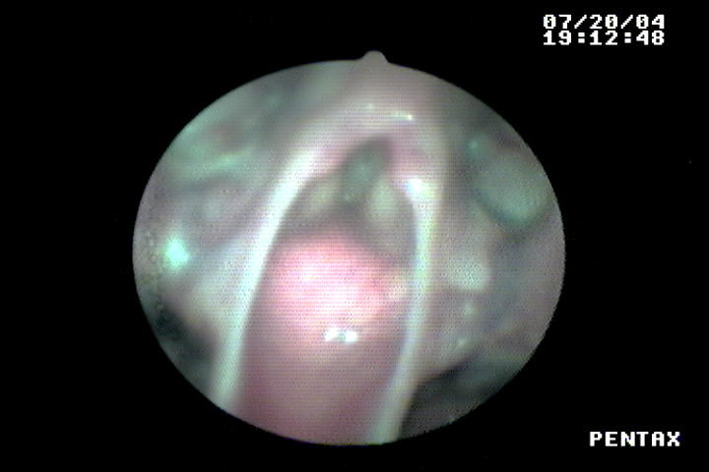

**Fig. 1. Flexible laryngoscopy of patient pre-operative: There is over closure of true vocal cords on phonation.**

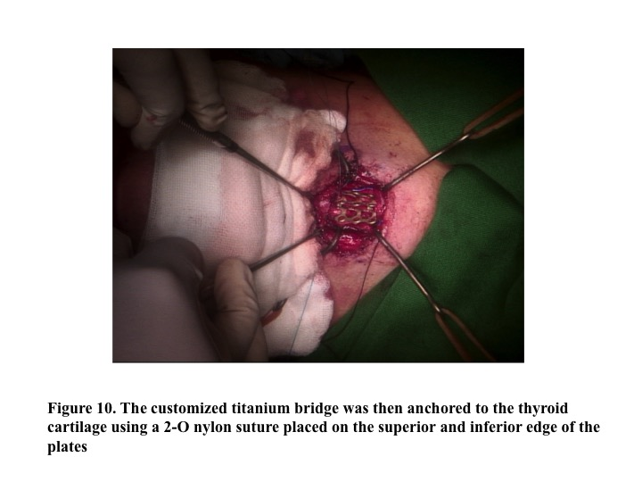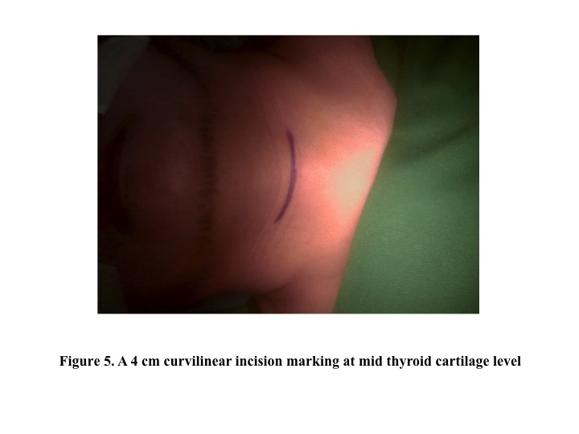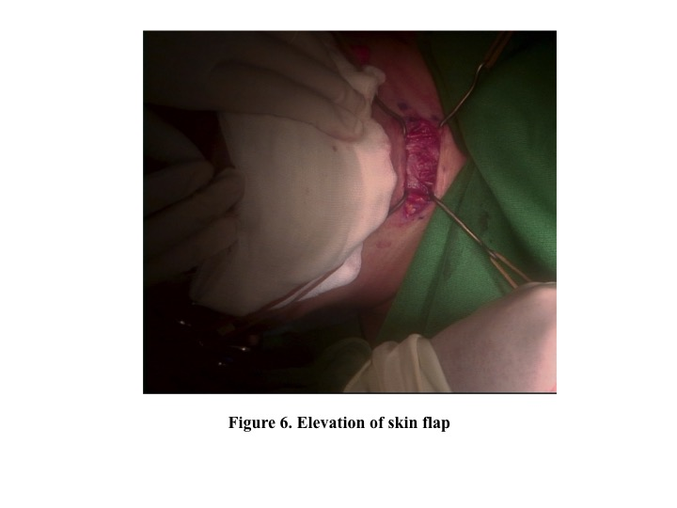

**B**

**A**

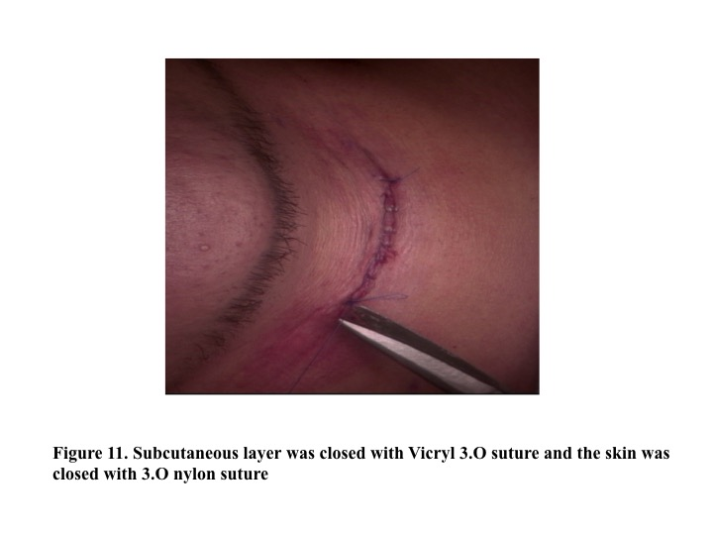

**D**

**C**

**Fig.2. Surgical Technnique of Isshiki Thyroplasty Type II. A- Patient placed in supine position with neck hyperextended. A 4cm curvilinear incision marking at mid thyroid cartilage level. B. Elevation of skin flap. C.Titanium mesh plates carefully folded, placed and anchored to the thyroid cartilage using a 2-0 nylon suture placed on the superior and inferior edge of the plates. D. Subcutaneous layer was closed with Vicryl 3-0 suture and skin was closed with 3-0 nylon suture.**

|  |  |  |  |  |
| --- | --- | --- | --- | --- |
|  | PITCH | JITTER | SHIMMER | Noise-to-harmonic ratio |
| Pre-Operatively | 386.490 Hz | 9.34% | 17.649% | 0.683737 |
| 24 hrs Post- Operatively | 192.491 Hz | 1.997% | 9.908% | 0.204224 |
| 1 month Post –Operatively | 175.356 Hz | 1.567% | 6.907% | 0.198202 |

**Table 1. Praat Voice Analysis, Pre-operatively and Post-operatively.**

|  |  |  |
| --- | --- | --- |
|  | VHI Score | Interpretation |
| Pre – operatively | 49 | Moderate amount of handicap |
| 24 hrs Post - operatively | 15 | Minimal amount of handicap |
| 1 month Post – Operatively | 11 | Minimal amount of handicap |

**Table 2. Voice Handicap Index Score**

**REFERENCES:**

1. Adler, Charles et.al. Female predominance in spasmodic dysphonia. Journal of Neurology, Neurosurgery and Psychiatry. Vol 63. Issue 5. Department of Neurology. Department of Otolaryngology. Scottsdale,AZ,USA. 2000.
2. Blitzer. Cummings Otolaryngology Head and Neck Surgery, 6th edition
3. Brin MF, Blitzer A, Stewart C. Laryngeal dystonia (spasmodic dysphonia): observations of 901 patients and treatment with botulinum toxin. Adv Neurol. 1998;78:237–252.
4. Guimaraes, I. A Ciencia e Arte da Voz Humana. Escola Superior de Saude de Alcoitao, 2007
5. Hyodo M. Nationwide survey of spasmodic dysphonia in Japan. Japan Journal of Logopedics and Phoniartrics. 2016
6. Ludlow CL, Nauton RF, Sedory SE, Schultz GM, Hallett M (1988) Effects of botulinum toxin injections on speech in adductor spasmodic dysphonia. *Neurol* 38:1220–1225.
7. Isetti, Derek, Spasmodic Dysphonia and the Americans with Disabilities Act, National Spasmodic Dysphonia Association. 016 May;30(3):293-300.
8. Isshiki. Thyroplasty for adductor spasmodic dysphonia: further experiences. Laryngoscope. 1983; 93:1-8
9. Isshiki, Nobuhiko, Sanuki, Tetsuji. Surgical tips for type II thyroplasty for adductor spasmodic dysphonia: modified technique after reviewing unsatisfactory cases. Acta Oto-Laryngologica, 2010; 130: 275-280
10. Mendelsohn AH, Berke GS. Surgery or botulinum toxin for adductor spasmodic dysphonia: a comparative study. Ann OtolRhinol Laryngol. 2012;121:231-238.
11. Richard A.L. Macdonell , Rhonda Holmes , Motor Speech and Swallowing Disorders. [Neurology and Clinical Neuroscience](https://www.sciencedirect.com/science/book/9780323033541), 2007
12. Sanuki T, Yumoto E Long-term evaluation of Type 2 thyroplasty with titanium bridges for Adductor Spasmodic Dysphonia. American Otolaryngology-Head and Neck Surgery. 2017
13. Sanuki. Overall Evaluation of Effectiveness of Type II Thyroplasty for Adductor Spasmodic dysphonia. Laryngoscope*.* 2009
14. Schweinfurth JM, Billante M, Courey MS. Risk factors and demographics in patients with spasmodic dysphonia. Laryngoscope*.* 2002 Feb. 112(2):220-3