LO’L District

Chapter Treasurer Manual

Barbershop Harmony Society Chapter Leadership & Education 110 7th Avenue N
Nashville, TN 37203-3704 United States of America
www.barbershop.org | chapters@barbershop.org P: 800.876.7464

Stock. 4078 | © 2018 Barbershop Harmony Society

Revised & Updated by LO’L - 2024

Table of Contents
If viewing electronically, each item in the Table of Contents is a “click-able” link that will automatically bring the viewer to that section of the BHS Chapter Treasurer manual.

Society Vision, Mission, Purposes, Core Values, & Pillars 7
The Chapter Treasurer 8
What the Chapter Treasurer does 8
Chapter Treasurer Sample Schedule of Responsibilities 8
Upon Election to Office 8
December 9
January 9
February 9
March 9
April 10
May 10
June 10
July, August & September 10
October 10
November 11
December 11
Collaboration with the Chapter Secretary 11
General Accounting Practices 12
General Principles 12
Document All Expenditures 12
Submit Financial Reports 12
Maintain the Chapter’s Bank Account 12
Basic Banking Transactions 12
Check Signature Procedure 12
Pre-Numbered Checks & Receipts 12
Issue Receipts 12
Make Deposits 12
Expense Vouchers 12
Unbudgeted Items 13
Monthly Payments 13
Monthly Statements 13
Direct Dues Billing Plan 13
Types of Payments 13
Payment on Receipt 13
Payment for Society Merchandise 14
Interaction with Chapter Committees 14
Finance Committee 14
Financial Review Committee 14
Chapter Show Committee(s) 14
Pay-As-You-Sing Committee 14
Chapter Charter Suspension or Revocation 14
Late Bill Payments 14
Late Filing of a Copy of the Chapter’s IRS 990 or CRA Required Forms 14
Late Filing of Annual Financial Review 15
BHS Chapter Accounting System 15
Purpose 15
Chart of Accounts 15
Instructions 15
Sample Forms 15
BHS Chapter Chart of Accounts 16
Cash Accounts 16
Receipt Accounts 17
Disbursement Accounts 19
Using the Chapter Chart of Accounts 22
Recording Transactions 23
Balance Sheet 23
Recording Receipts and Disbursements 23
How to Record Forms 1 & 2 23
How to Summarize Transaction on Form 3 and 4 25
Example Reports 25
Donations to U.S. Chapters: Social Funds vs. Operating Funds 25
Fiscal Planning, Budgets, Financial Review & Accountability 26
The Philosophy of Budget and its Preparation 26
What is a budget? 26
A Finance Committee 26
Developing an Annual Budget 26
Research Past Financial Activity 26
Analyze the Research 27
Determine Budget Items 27
Income 27
Expenses 27
Accountability 28
Quarterly Reviews 28
Closing the Chapter Books 28
Chapter Financial Review Guidelines 28
Financial Review Committee 28
Financial Review Form 28
The Law - Tax Status & Filings (For Canadian Chapters) 29
Tax Status 29
Social vs. Operating Funds 29
Annual FInancial Review 29
SOCAN Licensing 29
Canadian Chapter Reporting Responsibility 30
Dues remittances 30
Exchange Rates 30
Sing Canada Harmony 30
The Law - Tax Status & Filings (For U.S. Chapters) 31
Four Tests of Exemption 31
History of the Society’s Federal Income Tax Exemptions 31
Purpose of Exemptions 32
Educational Purposes: Legitimate Chapter Expense 33
Meeting Place Costs 33
Technical Assistance to Members 33
Public Appearances 33
Administrative Expenses 34
Staging Expenses, Shows and Concerts 34
Public Education 34
Non-Educational Expenses 35
Out-of-Pocket Expenses 35
Charitable Purposes 35
Harmony Foundation 36
Reserve Funds 36
Non-Acceptable Activities 36
No net income to Members 36
Chapter Dues 37
Legislation Influence 37
Political Campaigns & Advertisements 38
Personal Income Tax Deductions 39
Out-of-Pocket Expenses 40
Contribution of Services Not Deductible 40
Travel Expenses 40
Non-Deductibles 40
Partial Reimbursement 41
Apply the law to the facts: Specific Cases 41
Chapter Officers 41
Chapter Board of Directors 41
Chorus Directors 41
Chapter, District and Society Officials 41
Chapter Members 42
Reporting Contributions 42
Show Tickets/Contributions 43
Show Program Advertisements 43
Trips 43
IRS Exemption 43
Who needs to file? 44
Identification Numbers 44
Which forms do you file? 45
How to receive IRS Forms 45
Form 1099-MISC and 1096 46
Guidelines for Satisfying Public Disclosure Requirements 47
Request/Response 47
Application for Tax Exemption 47
Annual Information Return 48
Permitted Changes 48
Exemption to Disclosure Agreements 48
Penalties 48
Frequently Utilized Forms, References, & Resources for Chapter Treasurers 50
BHS Contact for Chapter Leadership & Education 50
Appendix A. Example General Accounting Practices 51
- Sample Records of Investments, Assets, Insurance 51
- Sample Numbered Receipts 52
- Sample Deposit Receipts 53
- Sample Pre-Numbered Checks 54
- Sample Expense Voucher/Report 55
- Sample BHS Chapter Statement 56
- Sample Direct Dues Payout Report 57
Appendix B. Example Chapter Accounting System & Reporting 58
- Sample Chart of Accounts 58
- Sample Use of Chart of Accounts 59
- Sample “FORM 1” Report 60
- Sample “FORM 2” Report 61
- Sample “FORM 3” Report 62
- Sample “FORM 4” Report 63
- Sample “FORM 5” Report 64
- Sample “FORM 6” Report 65
- Sample Transaction Report 66
- Sample General Event Comparison Report 67
- Sample Event to Event Comparison Report 68
Appendix C. Fiscal Planning & Budget 69
- Sample Budget 69
- Records Retention Schedule 70
- Example Financial Review Report 71
Appendix D. Charitable Donation Receipts 72
- Sample Receipt for Donation less than $250 72
- Sample Receipt for Donation more than $250 72
Appendix E. United States Chapters: Income Tax Exemptions & IRS Audits 73
- Society IRS Determination Letter 73
- IRS is Conducting an Audit Article 74
- Quartet Fees and Expenses Memo 76
Appendix F. Canadian Chapters: Example Checklist for Treasurers 77
Annually 77
As needed 77
- Canadian and U.S. Exchange Rate 78

The Chapter Treasurer

What the Chapter Treasurer does
The treasurer holds the chapter funds in trust. It is his responsibility to keep accurate financial records and to offer sound financial advice to the chapter board. The treasurer should be organized, detail-minded and have a rudimentary knowledge of bookkeeping practices.

The treasurer must keep up-to-date records, in clearly understandable form, of all income and expenditures. He should collaborate with the chapter secretary, officers and chapter committee members in the collection of all money. In addition, he should indicate on his records, under various classifications, who, what, where, when, why and how money is used.

The main duties of the treasurer are to:
- Function as an active, voting, chapter board member
- Prepare, in conjunction with the president & the other officers, an anticipated chapter income and expense budget for the year.
- Keep an accurate set of financial records.
- Pay all bills promptly on receipt of billing from the Society office, district or other businesses.
- Prepare monthly reports of cash receipts and disbursements.
- Prepare and file on behalf of the chapter governmental, regulatory and tax returns and forms.
- Present financial records to the chapter financial review committee for annual review as required by the Society.
- Submit treasurer's report to chapter board, usually at each board meeting (or as requested).
- Offer advice and make recommendations to the board regarding financial matters.
- Perform such other financial assistance to the chapter as required.
- Attend the District Leadership Academy
- Work closely with the secretary to collect chapter dues (Canadian chapters only.)

This manual provides an outline of various chapter treasurer tasks and contains copies of frequently used forms and documents for reference.

Chapter Treasurer Sample Schedule of Responsibilities
A sample schedule of responsibilities for chapter treasurers can be found in the “BHS Business of Barbershop Guide” found on the LO’L District web site LO'L District Document Center. Here is a more detailed list:

Upon Election to Office
- Familiarize yourself with the Chapter Treasurer Manual and any resources available on the Society online Document Center.
- Meet with the current treasurer to review the status of the books and estimate the chapter’s year end financial position.
- Plan to attend the District Leadership Academy.

December
- Meet with the chapter president-elect. Review goals and program estimate costs desired by newly elected officers.
- Schedule a meeting with the chapter president-elect to prepare the annual budget.
- Review the past two years' records to find costs of comparable items to be included in the budget.
- Obtain the necessary papers to handle all banking for chapter (signature cards, corporation resolutions, etc.).Your present treasurer or banker will help with these details.
- Meet with the secretary-elect to coordinate handling of chapter purchases. Sometimes it will be necessary to modify the initial goals of a new administration or incorporate fundraising shows and activities to prepare a realistic annual budget.

January
- Submit budget to board for any modifications and approval.
- Though not required, it is recommended that your chapter board read into minutes of the first board meeting of the year, the names of persons authorized to handle money for chapter (ticket chairmen, show chair, etc.). If there are non-members handling funds, these individuals should be officially appointed by the board of directors and placed into the minutes.
- Remind the chapter president to appoint a financial review committee to review previous year's books.
- Pay the invoices as reflected on the chapter's monthly Society statement and all other outstanding bills by month's end.
- Complete monthly financial report forms.
- If any individual, quartet, group, etc. received $600 or more from the chapter during the previous year, ensure that a 1099-MISC is filed with the recipient and the IRS by no later than January 31. (For U.S. Chapter Only)
- Also, File Forms IRS 1096 (together with IRS Copies of Forms 1099-MISC) with the IRS
by the end of the month. (For U.S. Chapters Only)

February
- Complete any required monthly financial reporting.
- Pay the invoices as reflected on the chapter's monthly Society statement by month's end.
- Ensure that chapter is prepared to file with the IRS or CRA (if required) for the prior year.
- If your chapter has a chapter bulletin or even if it doesn’t, prepare a notice to the chapter concerning any tax treatment of personal expenses related to being a member of the Society. If there are further questions, consult your District Treasurer or contact the Society.

March
- Complete any required monthly financial reporting.
- Pay the invoices as reflected on the chapter's monthly Society statement by month's end.
- Review previously filed forms with the IRS or CRA to prepare for filing.

April
- Complete any required monthly financial reporting.
- Pay the invoices as reflected on the chapter's monthly Society statement by month's end.
- Review budget for current year with chapter board, noting any variation of anticipated expenses and revenue.

May
- Complete any required monthly financial reporting.
- Pay the invoices as reflected on the chapter's monthly Society statement by month's end.
- File IRS Form 990-N or Form 990-EZ with the IRS by May 15th. (For U.S. Chapters Only)
  - After submission to the IRS, ensure that your BHS Chapter Member Center Profile is up-to-date.
- File any CRA Forms required by your local province. (For Canadian Chapters Only)
  - After submission to the CRA, ensure that your BHS Chapter Member Center Profile is up-to-date. If your chapter is not required to file with the CRA or local province, ensure that your BHS Chapter Member Center Profile is
up-to-date, stating exactly that.
- Submit any necessary information for the Chapter Financial Review to the Financial Review Committee to complete the required Annual Chapter Review. For more information about the Chapter Financial Review Process, view the Guide for Financial Reviews: BHS Chapter & District User Guide on the Society online Document Center.
  - After completion of the Chapter Financial Review and is reviewed by the Chapter Board, ensure that your BHS Chapter Member Center Profile is up-to-date

June
- Complete any required monthly financial reporting.
- Pay the invoices as reflected on the chapter's monthly Society statement by month's end.

July, August & September
- Complete any required monthly financial reporting.
- Pay the invoices as reflected on the chapter's monthly Society statement by month's end.
- Take the opportunity to review the current financial condition of your chapter, along with the forecasted budget. Adjustments may need to be made, ensure that you submit a report to your Chapter Board.

October
- Complete any required monthly financial reporting.
- Pay the invoices as reflected on the chapter's monthly Society statement by month's end.
- Review budget for current year with the chapter board in preparation for the new budget for the following year.
- Respond to the nominating committee whether you will stand for re-election as treasurer. If not, begin to prepare for an orderly transition to a new treasurer.

November
- Complete any required monthly financial reporting.
- Pay the invoices as reflected on the chapter's monthly Society statement by month's end.

December
- Assist the treasurer-elect as outlined at the beginning of this schedule.
- Complete any required monthly financial reporting.
- Pay the invoices as reflected on the chapter's monthly Society statement by month's end.

Collaboration with the Chapter Secretary
Because the chapter treasurer works closely with the chapter secretary, let's look at his duties, to see where they overlap. The secretary is responsible for all the paperwork related to the operation of the chapter. His efforts keep the chapter organized and current in correspondence and report filing. While his work is not on display at every chapter meeting, a chapter will feel the effects of a poor secretary just as much as of a poor music director or other officer.

The chapter secretary:
- Is an active, voting, chapter board member
- Maintains accurate membership records, including submission of new member applications and ensuring through Member Center that all member information is current and accurate.
- Reports new chapter officers & leaders by updating their chapter Member Center profile. Once updated, this information is then supplied to the district and society officers.
- Reports chapter filings, in cooperation with Chapter Treasurer in chapter Member Center profile.
- Takes all meeting minutes, including any special or non-scheduled board meetings and annual chapter meetings at which election of officers takes place, etc.
- Files for show clearances [BMI/SESAC (for U.S. Chapters) or SOCAN (for Canada) Forms] with the district secretary as needed.
- U.S. Chapters submit ASCAP forms annually to the Society Offices.
- When needed, orders chapter supplies.
- Reports to the Society offices when a member of their chapter passes away, by emailing or calling Society HQ.
- Maintains chapter legal files including:
  - Standard Chapter Bylaws
  - Chapter rules & regulations (if necessary)
  - Original Chapter License & Charter
  - Copies of Insurance Certificates
  - Copies of Internal Revenue Service (IRS) or Canadian Revenue Agency (CRA) filings
  - State or Provincial incorporation documents.
- Attends the District Leadership Academy

General Accounting Practices

General Principles

Document All Expenditures
The treasurer documents all expenditures with an expense voucher and includes backup receipts and invoices. Expense vouchers should have an approval signature authorizing payment. Specific actions should have authorization from the board of directors.
Expenditures should always be in the form of bank checks. However, when necessary, the treasurer obtains receipts for all cash transactions.

Submit Financial Reports
The treasurer submits complete financial reports at each chapter board of directors meeting and at other times as called for by the president or board. Reports must include financial status compared to budget and explain how the chapter has used the money. The secretary retains a copy of the reports for the minutes.

Maintain the Chapter’s Bank Account
Typically, a chapter has a checking and savings account with its local bank. The treasurer should:
- Reconcile bank statements, both checking and savings accounts, promptly and efficiently on a monthly basis.
- Retain all bank statements and canceled checks for verification and financial review purposes.

Basic Banking Transactions

Check Signature Procedure
The chapter must update all appropriate documents when a new treasurer takes office. A new officer or change in a chapter bank account may require a resolution by the chapter board to approve the individuals who can sign checks.

The chapter's bank will assist with the proper documents. The treasurer should examine the chapter's policy concerning the number of signatures required on checks — one signature is convenient, but two signatures provide a safeguard.

Pre-Numbered Checks & Receipts
When issuing checks or receipts, the treasurer should use only pre-numbered checks and receipts.

Issue Receipts
The treasurer should issue a receipt for all money received.

Make Deposits
The treasurer should promptly deposit all monies.

Expense Vouchers
The treasurer attaches receipts and invoices to the chapter expense voucher when making payments. If the treasurer does not have a receipt or invoice from a member for reimbursements of miscellaneous expense items, he must explain these items on the expense voucher. The treasurer must record the check number and the date of the check on the expense voucher.

Unbudgeted Items
If the treasurer has an item that is not covered in the budget, or he feels uncomfortable about an expense, he should obtain approval from the chapter board of directors or another chapter officer before he disburses the funds.

Monthly Payments

Monthly Statements
The Society issues monthly statements directly to the chapter treasurer. A summary of all chapter invoices and related payments appears on the statement. The statement shows the balance due. If there are no monies due, a statement will not be sent.

Direct Dues Billing Plan
All chapters are on the Direct Dues Billing Plan.

U.S. members pay the Society office directly for their Society, district and chapter dues. The Society remits the district and chapter dues on a quarterly basis.

Canadian chapters collect their own chapter dues directly from their members. Canadian members may remit their Society and district dues directly to the Society office in Canadian funds, using the exchange rate that is established each quarter. The local Canadian chapter may also collect all of the renewal money from members and forward payment to the Society.

Special dues prepayment plans are available for both Canadian and U.S. members.

Types of Payments

Payment on Receipt
Although the chapter's payment must reach the Society office by month's end, the treasurer should establish a policy to pay bills immediately upon receipt. If the chapter secretary has obtained board approval as he orders materials or if the expenditure is for a properly budgeted chapter expense, the monthly statement will need no further action by the chapter board.

All other Society charges (i.e. Insurance) do not require board action. This practice will avoid misunderstandings concerning the statement and reduce the chances of chapter suspension for not paying the bill. The treasurer should pay all bills from other vendors upon receipt.

Society statements are issued quarterly; a detailed invoice is included for new charges. When the Society receives the chapter payment, it is applied to the outstanding invoice. If the payment is received during the month following the statement, the payment will be recorded and these invoices will not appear on the next monthly statement. Confusion can occur if the payment is not received by the Society prior to issuing the next statement; the prior invoices will be listed on the statement as well as any new invoices. The new invoices will have an invoice included, but there will not be an invoice included for charges made the prior month.

Payment for Society Merchandise
The Society no longer offers a chapter ‘line of credit’ for purchasing merchandise or other materials from the Harmony Marketplace. If a chapter would like to purchase from the Society Harmony Marketplace (i.e. manuals, merchandise, music, learning tracks, etc.) an individual should purchase (with pre-approval) and be reimbursed by the chapter. Chapter Treasurer’s may also make purchases utilizing the chapter credit/debit card, if pre-approved, and budgeted.

Interaction with Chapter Committees

Finance Committee
Because the chapter board is far more familiar with the overall operation of the chapter than any other group of individuals in the chapter, it is good practice to have the chapter board serve as the finance committee. Some larger chapters, have a separate finance committee to advise the chapter board of directors about financial matters. The chapter board has the final say on all financial matters concerning the chapter.

Financial Review Committee
The treasurer is not a member nor should be a member of the Financial Review Committee, but is responsible for providing any necessary documents or documentation related to their work.

Chapter Show Committee(s)
The treasurer works closely with the show committee(s) to help it establish a show budget and ensure that it stays within budget. The treasurer should also ensure that any money handlers are prepared and trained adequately to perform the expected responsibilities with the Chapter Show Chair.

Pay-As-You-Sing Committee
This usually is a one-person committee who collects membership dues on the installment plan. They should be able to urge members to participate without becoming a nuisance. They should announce as often as possible that they will accept any regular payment (through the chapter, not the Society office) toward the member's dues.

Chapter Charter Suspension or Revocation
As a chapter of the Barbershop Harmony Society, there are applicable policies in regards to Chapter Licensure, Chartering, Suspension & Revocation. A chapter could be suspended or revoked for chapter noncompliance.

The Society can suspend a chapter for the following reasons:

Late Bill Payments
The Society will suspend a chapter if it does not receive a statement remittance by month's end of the month the statement was received. When a chapter is suspended, all general privileges are denied and the chapter chorus is prohibited from participating in contests.

Late Filing of a Copy of the Chapter’s IRS 990 or CRA Required Forms
The chapter must update their BHS Chapter Member Center Profile with a copy of the chapter's annual IRS Form 990, 990EZ or 990-N tax return or required CRA Filings (if applicable) by May 15th each year (for IRS forms) and June 15 (for CRA forms)

Late Filing of Annual Financial Review
The chapter must update their BHS Chapter Member Center Profile with a copy of the chapter's annual financial review by June 30th each year.

There are other criteria and indicators for chapter suspension/revocation, that are not always in direct control of the chapter. [i.e. the minimum number of chapter members to remain an active chartered chapter, is eight (8)]

If concerted efforts by the Society office, assisted by district officers, fail to rectify the situation(s) within a general time frame of sixty (60) days from the suspension date, the Society office will automatically begin steps to revoke the chapter charter. It will transfer all current members to the Frank H. Thorne Chapter-at-Large for the remainder of each individual's membership year unless a member requests transfer to another chapter.

Even though the Society gives chapters advance warning of a suspension by including special notices with past due statements, it may suspend chapters frequently.

The main reasons for chapter non-compliance are generally:
- The chapter secretary or treasurer became inactive
- The chapter did not report the new officers to the Society office (i.e. where to send chapter notices or statements/bills to)
- The chapter did not report the treasurer's new address. (i.e. where to send chapter notices or statements/bills to)
- The treasurer did not understand the billing procedure.
- The treasurer sent the check too late to be received on time

In addition to paying bills on time, the best way to avoid suspension is to report any changes to the Society office immediately, by updating your BHS Chapter Member Center Profile.

BHS Chapter Accounting System

Purpose
The Society has developed a bookkeeping system for its chapters that conforms to the requirements of our organization’s relationship to Section 501(c)(3) of the Internal Revenue Code.

All (U.S. & Canadian) chapters should follow the methods detailed in this section of the treasurer's manual. Licensed chapters also must keep financial records. Quicken and Excel starter files are available to download from the Society Web site. The cash basis of accounting is used. As cash is received or expended, a record is made. No other entries are necessary

Chart of Accounts
The accounts as shown are the recommended accounts to use. The proper use of each account is explained. More detail in an account may be achieved by using suffix letters, e.g., A-B-C, etc.

Instructions
Instructions in the use of the recordkeeping forms are illustrated, with step-by-step procedures set out in sample forms.

Sample Forms
- Form 1 - Cash Receipts
- Form 2 - Cash Disbursements
- Form 3 - Summary of Gross receipts and summary of receipts, disbursements and cash balances.

- Form 4 - Summary of Disbursements
- Form 5 - Pay as You Sing Member’s Record
- Form 6 - General Utility Form [Auxiliary data which is not required (invested funds, insurance policies, fixed assets, etc.)]

BHS Chapter Chart of Accounts

Cash Accounts

Account | Name | Use and Purpose
100 | Operating Fund | All earned receipts, monies that come to the chapter through its stated purposes (show receipts, performance fees, fundraising activity and donations), must be put into Cash Account 100 from the various Receipts Accounts (310, 320,  340 and 350).  Account 100 operating funds are restricted funds and are only used for recognized chapter expenses. They may not be used for parties, regular meeting refreshments, payment of members' dues or used in any way that would benefit any member. [Required by IRS regulations for 501(c)(3) corporations.]  Receipts Accounts 310, 320, 340 and 350 add to this account  Expenditure Accounts 401, 411, 412, 413, 421, 422, 432  through 438, 440 through 450, 470, and 471 subtract from it.  All receipts from members (chapter portion of dues, collections from members for refreshments or parties) may be used without restrictions and should be kept in Account  360. It may be desirable or necessary to transfer funds from Cash Account 360 to Cash Account 100, but under no circumstances may funds be transferred to Cash Account 360 (or any extension of it) from Cash Account 100
220 | Pay-As-You-Sing | A trust fund held for the members’ dues. Balance is total partial dues payments received to date less the fully paid dues. The total of all members records on Form 5 should agree with this cash balance at all times.  Receipts Account 220 adds to, or subtracts from, the balance of this account. Refund and payment of these dues through Expenditure Account 220 will subtract from the balance.

360 | Social Activities & Chapter Dues | Social activities and chapter dues. All 360 funds are unrestricted funds.  Receipts Accounts 300, 360, (and 360A, B, C, D etc.) add to this account. Expenditures recorded in Account 460 subtract from this account. Please refer to Receipts account 360 below.

    - Receipt Accounts
All revenue accounts are used to record gross receipts undiminished by any expense, cost or expenditure (except for corrections). Note: All revenue accounts are used to record gross receipts undiminished by any expense, cost or expenditure, except for corrections of errors.

Account | Name | Use and Purpose
220 | Pay-As-You-Sing | Collections from members for Society, district and chapter dues. See accounting instructions for detailed handling.  Adds to Cash Account 220
300 | Chapter Dues | Chapter dues that are a formal part of the dues structure. See also Account 360. The funds are not restricted as to how they may be used.  Adds to Cash Account 360
310 | Gross Receipts from Shows | Receipts from chapter annual show or shows: Ticket sales, Advertising receipts.  Do not deduct expenses from these receipts. All expenses are to be entered in the proper expense accounts. See accounts 360 and 460 relating to cast parties or similar social events held in connection with the show.  This account may be subdivided to separate two shows, advertising receipts, etc., by adding suffix letters, e.g., 310A, B, C, D, etc.  Adds to Cash Account 100
320 | Performance Fees | Receipts from package shows and performances (do not include charitable contributions includable in Receipt Account 340). If there are expenses in connection with these activities, they must be entered in the proper expense accounts and not used to reduce these receipts.  Adds to Cash Account 100

330 | Singing Valentines | Receipts from Singing Valentines program. If there are expenses in connection with these activities, they must be entered in the proper expense accounts and not used to reduce these receipts.  Adds to Cash Account 100

    - Receipt Accounts (Continued)

Account | Name | Use and Purpose
340 | Charitable Contributions Received from  Non-Members | Any donation made to the chapter as a charitable gift;  It has been traditional in the Society to forward all such receipts to a charity, either through Harmony Foundation or as otherwise decided by the chapter board of directors.  Contributions from sponsors/grants, etc., may be used for chapter operations.  Adds to Cash Account 100
350 | Other Revenues- Earned from the Public  May be “non-related” income for tax purposes | Receipts from all public activities (bake sales, raffles, cabaret nights, afterglows, rummage sales, candy sales, etc.)  Enter bank interest and investment income here as well as proceeds of bank loans.  This account may be divided to separate various activities by adding suffix letters, e.g., 350A, B, C, D etc.  Adds to Cash Account 100
360 | Other Revenues- From Members Only | Cast party charge, attended solely by chapter members, their wives, or significant others.  Collections to finance social activities attended solely by chapter members, their wives, or significant others.  Contributions from members.  Fundraising projects conducted solely among the chapter members.  These are the only funds (along with chapter dues) that are unrestricted as to use. All other receipts may be used only for the purposes stated in the chapter bylaws and may not in any way be used to benefit any chapter member.  This account may be divided to separate various activities by adding suffix letters. Examples might be 360A cast party, 360B barberpole collections, etc. Adds to Cash Account 360

    - Disbursement Accounts

Account | Name | Use and Purpose
220 | Pay-As-You-Sing | Payment to the Society office for members' renewal dues on the Pay-As-You-Sing payment plan and refunds to members who do not wish to renew their memberships are charged to this account. (See instructions under Receipts Account 220 Above)  Subtracts from Cash Account 220

All 400 Accounts subtract from Cash Account 100 except for Account 460, which subtracts from Cash Account 360. Also, all 400 accounts may be expanded by adding suffixes. For instance, if your chapter holds two shows during a year in addition to the annual show, use accounts 440A through 449A for the second event to keep it separate from the first.

Account | Name | Use and Purpose
401 | Meeting Place | Charge rent, utilities (not telephone), upkeep (cleaning expense and/or supplies), and any other costs relative to having a place for chapter meetings.
411 | Chorus Director’s Fees | Charge payments to chorus directors, including Society and district dues paid for them by the chapter.  If such fees total $600 or more to any individual in a calendar year, IRS forms 1096 and 1099 must be filed. See the tax section for details. For U.S. Chapters Only
412 | Contributions to District Chorus & Quartet Fund | Contributions or assessments paid by the chapter for district chorus and/or quartet funds.
413 | Costs of Attending Schools, Clinics, & Seminars | Include registration fees, transportation, meals and lodging for such things as Leadership Academy, Harmony University, Chorus Director's schools, district schools, and coaching expenses. Charge only the necessary expenses incident for the purpose sent. (See Account 438 below)
420 | Singing Valentines | Costs incurred to run a Singing Valentines program.
421 | Travel & Expense - Participation in Shows and Contests | Charge travel, meals, lodging, registration and entrance fees of any participant. Charge only the necessary expenses incident for the purpose sent. (See Account 438 below)
422 | Uniform Expenses | Include all costs of purchasing, cleaning, repairing and altering chapter-owned uniforms.
432 | Office Supplies and Expense | Include expenditures for stationery, postage, telephone, reproductions, software expense or bookkeeping help and all similar expenses.

    - Disbursement Accounts (Continued)

Account | Name | Use and Purpose
433 | Publications, Bulletins and Directories | This account is for the regular and general publications of the chapter. Use Account 444 for expenses in connection with the show.
434 | Purchase of Music | Includes costs of special arrangements or original music as well as music purchased from the Society office.
435 | Program Expense for Regular Meetings | Includes cost of supplies used for badges, name stickers for visitors, guest registers, and special programming supplies
436 | Insurance | Include any special insurance policies carried by the chapter as well as the annual bonding and liability policy carried through the Society office.
437 | Public Relations Expense | Charge for all public relations expenses including newspaper ads, Auditions for Admission kits, Introducing BHS pamphlets, etc. Do not include show publicity, Use Account 447.
438 | Travel and Expense - Delegates to District Meetings | Charge all transportation, meals, lodging and registration fees necessary to accomplish the purposes for which attendance is required. Do not include meals, lodging or fees, for instance, for the delegate to attend other convention events. If the chapter pays for these additional expenses for the delegate to enjoy himself, they should be charged to Account 460. Refer to Account 413 and 421 above.

Accounts 440—449 relate to chapter shows and hosted conventions

Account | Name | Use and Purpose
440 | Miscellaneous Show Expense | Charge any show expense not covered by other show account numbers.
441 | Auditorium Rentals | Charge auditorium rent and deposit expense.
442 | Scenery and Props | Charge show props and scenery expense. Use this account for any special show costumes.
443 | Lighting & House Help | Charge lighting expense and any other auditorium expense such as stagehands, ushers, security, etc.
444 | Programs & Tickets | Charge printing expense for show program and tickets. Use suffixes A, B, C, D, etc. to separate program printing expense from ticket printing expense.

    - Disbursement Accounts (Continued)

Account | Name | Use and Purpose
445 | Transportation of Chorus and Quartets | Charge expenses for transporting local chorus members to the show site and other valid chorus member expenses.  Charge expenses for local chapter quartets.
446 | Fees and Expense - Out of Chapter Quartet and Chorus Talent | Charge talent fees, travel expenses, meal and lodging expenses for out-of-chapter quartet and chorus talent.  If talent fees and unsubstantiated expenses total $600 or more to any quartet - whether paid to individuals or as a unit in a calendar year, IRS Forms 1099 and 1096 must be filed.  See the tax section for details. For U.S. Chapters Only
447 | Publicity Expense | Charge all publicity expenses associated with chapter shows including printing cost of publicity material.
448 | ASCAP, BMI/SESAC, or  SOCAN Fees | Charge for annual show ASCAP, BMI/SESAC or SOCAN license obtained from the district secretary. See chapter secretary manual for more details.
449 | City and State Taxes | Charge city and state taxes including admission tax, if applicable.
450 | Charitable Contributions | Charge all charitable contributions to Harmony Foundation (the Society’s charitable mission) and local charities. Also see the explanation for Receipt Account 340.
460 | Social Activities | Charge all costs related to personal services to members where the public is not involved: show parties, gifts, delegate's extra expense not necessary for attendance at district meeting or school or seminar, payment of any member's Society or district dues (when given as an honorarium for service rendered or life membership presentation), wives' expenses to attend any function and all similar expenses.  Expenditures under this classification may not exceed receipts added to Cash Account 360. Subtracts from Cash Account 360
470 | Miscellaneous Expense | Charge for all public activities undertaken to support chapter operations (e.g. bake sales, rummage sales, etc.) where the public is involved. Record purchases of items not classified in other accounts.
471 | Show Afterglow | Charge show afterglow expenses if the public is invited to attend.

Using the Chapter Chart of Accounts
It is recommended that only the account numbers as detailed on the previous pages be used. Collections from members for uniforms (or other projects such as travel to a convention) should go through Receipts Account 360 so the treasurer will have complete freedom of use of such funds. For purposes of separation, the treasurer may use 360, 360A, 360B, 360C and 360D, etc. All 360 Receipt Accounts are added to Cash Account 360. Expenditures of these funds for uniforms will be charged to account 422, which reduces Cash Account 100. A cash transfer from the 360 Cash Account to the 100 Cash Account may be in order. You may find it appropriate to transfer the funds as you receive them rather than when you spend them. The choice is yours.

The following chart will help you visualize how some accounts affect others:

Receipts Account | Transfers to | Cash Account | Transfers from | Expenditures Account
220 | → | 220 | ← | 220
300  360 | → | 360 | ← | 460
310  320  340  350 | → | 100 | ← | 401 thru 450  470  471

To correct errors, you may make cash transfers from any cash account to any other. However, document the reasons to explain your action.

In the absence of error, you may make only these transfers:

 | From Any Account To Another |  | From Any Account To Another
Unrestricted Funds | 360 | →  NOTE: ONE WAY ONLY | 100 | Restricted Funds
 | ↕ |  | ↕
 | 360A |  | 100A
 | ↕ |  | ↕
 | 360B |  | 100C
 | ↕ |  | ↕
 | 360C |  | 100D

Recording Transactions
Following are examples of typical receipts and disbursements transactions

Balance Sheet
Use the January forms and the fund balances shown in column 5, Form 3. This is a statement of the cash balance condition at December 31 of the previous year for the chapter:

BALANCE SHEET

ASSETS

December 31, 2XXX

Cash $ 3,089.53

LIABILITIES
Pay-As-You-Sing $ 97.00

Total Liabilities $ 97.00

100 Operating Fund $ 879.43
100-A Uniform Fund $ 2,000.00
360 Social Activities $113.10

Total Fund Balances $ 2,992.53

Total Liabilities & Fund Balances $ 3,089.53

Recording Receipts and Disbursements
There are two steps to the accounting process:
- Record receipts and disbursements as they happen during the month (Forms 1 & 2 or software equivalent).
- Summarize these transactions into year-to-date reporting (Forms 3 & 4).

How to Record Forms 1 & 2
(Refer to the examples at the end of this manual)
        - On Forms 1 & 2, the totals of columns 5 through 11 must equal the total in column 4.
        - February Cash Receipts Form 1:
          - Notice the method shown to transfer cash from Cash Account 360 to Cash Account 100. All cash fund transfers (100 & 360 funds) appear on Form 1 only.

          - The refund of ad sales to Bill Gower is handled as a negative receipt. The return of a cash receipt is handled as a negative receipt, which is actually a reduction in income. This method results in an accurate record of actual income for an activity.
          - This chapter's policy is to transfer all interest income into a Uniform Fund Account 100A. Interest is received in account 350, which automatically adds to Cash Account 100. To include the interest in the Uniform Fund Account 100A, a transfer from Cash Account 100 into Cash Account 100A must be made.
          - Negative receipts are actually cash disbursements. An adjustment to the bank deposit must be made.
The total bank deposit is actually $5 more than shown on Form 1.
        - February Cash Disbursements Form 2
          - Head Mann refund of delegate expense and Anytown High School return of security deposit are negative disbursements. Refunds of cash disbursements are handled as negative disbursements which are actually reductions in expenses. This method results in an accurate record of actual expense for an activity.
          - The refund of prepaid dues to Bill Gower is handled as a regular disbursement. This money was collected as a Pay-As-You-Sing collection and is being returned to Bill Gower. Also, the treasurer records this transaction on the Pay-As-You-Sing Form.
          - Negative disbursements are actually cash receipts and an adjustment to the bank deposit must be made. The total bank deposit must include any negative disbursements recorded on Form 2.
        - Form 5 is used to record all transactions for Pay-As-You-Sing partial dues collections. One column may be used as a total column. If many members use this service, the treasurer will require several sheets. Note that he should total each member's account every month and the grand total must agree with the total amount in the summary portion of Form 3. (Line 14, Column 8). Members may also participate in the EZDues program.
        - Interest added to a savings account is shown as a Cash Receipt in account
350. The treasurer must obtain such data at each year end before closing the records for the year. If the savings are kept in a separate cash account (e.g., 100A), make a cash transfer from Cash Account 100 to Cash Account 100A for the amount of the interest.
        - Some chapters maintain a separate set of records to record all transactions relating to the Annual Show until all money is in and expenses paid. At that time, the treasurer can transfer the gross receipts and gross expenditures to the chapter records in summary form (one entry for receipts and one entry for expenditures). If a chapter uses this method, the treasurer must carefully review the show financial records.

How to Summarize Transaction on Form 3 and 4
        - Column totals on Forms 1 and 2 are transferred to Forms 3 and 4 as shown. The data in Column 11 must be summarized by account number before transfer.
        - Note that all Forms 1, 2, 3 and 4 have source and destination guide posts to assure proper transfers and postings.
        - Total cash receipts are the same on Form 1, Column 4, as on Form 3, Line 10, Column 1 and Line 23, Column 6. Total Cash Disbursements are the same on Form 2, Column 4, as on Form 4, Line 33, and Column 1 and on Form 3, Line
11, Column 1, and Line 3, Column 7.
        - Year-to-date figures for Column 2 on Forms 3 and 4 come from Column 3 on the previous month's report (except January).

Example Reports
Refer to the end of this manual, showing the example filled out Forms 1-6 for January and February. Following these pages are examples of the reports generated by Quicken, designed to match, as closely as possible, the reports shown by forms 1-6.

Quicken starter files, are available on the Society online Document Center. When you have downloaded the Quicken file (and other support files), just open it with Quicken, and you will be ready to start entering your financial data and generating reports.

Donations to U.S. Chapters: Social Funds vs. Operating Funds
Because of the Society’s tax exempt status, treasurers of chapters must be clear on what income can be used for the operating fund (restricted) and what can be used for the social fund (unrestricted). If the money, including grants, comes from non-member sources, it can only be used for the operating fund. None of it may be used for social funds nor benefit any member. So, money earned through performances, bake sales, etc., or that comes in as a gift from a nonmember, cannot be used for social funds.

However, there is one exception to this: If a nonmember makes a contribution and also states in writing that they will not take a deduction for the gift on their personal income tax return, then that money can be used in a non restricted sense (i.e., for social funds). If the statement from the contributor is not specific, then you must assume the worst, and use the money for operational purposes only. If the statement is verbal only, then write a letter to the donor, state that you intend to use the money for non-deductible purposes and weave in the fact that the donation is not deductible to the donor. Express your sincere thanks—and keep a copy the letter with your tax records.

Any money that comes in from a member can go in social funds, as long as the member doesn't claim it as a deduction on their personal tax return.

Fiscal Planning, Budgets, Financial Review & Accountability

The Philosophy of Budget and its Preparation
A chapter is a business. It should, as part of its organizational structure, adopt a proven financial practice of developing a budget. A budget is the financial guideline for a year or more of chapter operations. Without it, a chapter has no financial sense of direction.

What is a budget?
A budget is a plan which categorizes the various elements of expected income and proposed expenditures. Preferably, the treasurer should design a budget so that the expected total income exceeds the anticipated total expenditures. This difference can be referred to as "unallocated income" and is really a cushion to facilitate the handling of unexpected operating expenses.

A budget is of very little value unless a concerted effort is made to work within it. Obviously, when a budget is approved, it becomes a sort of "financial bible." It is a guideline set up by the chapter for its proposed financial plans. When submitting regular reports, the chapter treasurer should make comparisons to the budget for informational purposes. The chapter board of directors should carefully analyze and compare the total income or expenditures to date with the annual budget.

A Finance Committee
Some larger chapters have a finance committee that works with the president and treasurer to determine the financial needs of the chapter and aids in formulating the annual budget. In most chapters, the president and treasurer construct a budget with input from other officers and committee chairmen. The board of directors approves the final budget.

Developing an Annual Budget

Research Past Financial Activity
To develop a realistic budget, the treasurer should research the chapter's financial history and prepare a spreadsheet showing:
- The previous two years' actual income by account numbers.
- A comparison of the previous year's actual income to the budgeted income.
- Projected income for the new year for each account using the actual historical data gathered (be conservative).
- A listing of the previous two years' actual expenses by account numbers.
- A comparison of the previous year's actual expenses to the budgeted expense.
- A projection of expenses for the new year for each account using the actual historical data gathered, known fixed expenses and any planned special activities. Select a reasonable inflation factor to increase each budgeted expenditure.

- A summary of the budgeted income and expenses; plan for a surplus of income over expenses; revise projections until there is an income surplus, or at least a balanced budget.
- An allocation of any surplus for a purpose (i.e., unexpected operating expenses, uniforms, competition fund).

The treasurer-elect should discuss the preceding year's chapter finances with the current board to understand the reasoning that went into their projections

Analyze the Research
The chapter president-elect should establish a general plan of direction for the upcoming year. He and the treasurer-elect should perform the analysis together to establish a solid base for a budget in conjunction with the president-elect's plan. The two should ask for additional assistance from the other chapter officers, the show chairman and other committee chairmen. They should arrange a meeting with these men to gain insight into the chapter's financial structure.

With this information, the president-elect, the treasurer-elect and the finance committee members (if the chapter has a committee) can prepare a proposed budget for the incoming board of directors.

Determine Budget Items
The treasurer should determine the various budget items on the basis of expected or proposed activities for the upcoming year. In general, a basic budget should detail two areas:

Income
- Chapter dues from all members
- Chapter Shows
- Performance fees
- Charitable donations made to the chapter
- Other revenue earned from the public (Singing Valentines, rummage sales, etc.) List each separately.
- Revenue from chapter social activities. List each separately.

Expenses
- Sending chapter officers to the District Leadership Academy
- Sending music director(s) to schools

Expenses (Continued)
- Sending chapter director(s) to district house of delegates meeting(s)
- Postage, stationery, telephone and other supplies
- Publishing chapter bulletins and other internal communications
- Costs of maintaining a chapter Web site
- Annual show
- Insurance
- Chapter social activities. List each separately.
- Miscellaneous operational expenses where the public is involved. List each separately.
- Miscellaneous printing
- Music purchases

Expenses (Continued)
- Rent of meeting or rehearsal facilities
- Publicity
- Charity
- Music director's fee
- Chapter equipment and property
- Special entertainment at meetings
- Uniform replacement
- Chorus travel
- Unclassified
- Percentage budgeted to reserve fund (not to exceed one year's operating requirements)

The chapter ledger sheets will serve as a guide for planning your next year's budget. Once the treasurer prepares the proposed budget, he presents it to the chapter board. The board, acting as the finance committee, should study and adopt it with the understanding that the budget is a guideline within which they hope to conduct the financial operations of the chapter.

Accountability

Quarterly Reviews
A budget, which is merely numbers on paper, has no meaning if it is not used as a guide to compare income to expenditures. A quarterly review of the budget by the chapter board should become standard operating procedure. The chapter president and treasurer should review the accounts to see which areas need tightening and which income areas need to be addressed, and then present their findings to the board.

Closing the Chapter Books
The treasurer can officially close the books on a successful year as chapter treasurer if:
- The chapter budget adopted for the past year was reasonable and served as a financial guide.
- He submitted financial reports to the chapter board each month in an effort to keep the board of directors financially informed.
- The financial review committee reviewed the recorded receipts and disbursements and completed both the annual reconciliation of receipts and disbursements and summary of funds account.
- The treasurer submitted the chapter annual financial review with accompanying reconciliation of bank accounts and summary of funds to the Society, submitted a copy of the chapter's IRS Form 990 or CRA Forms, and successfully reported as such in their BHS Chapter eBiz Profile.
- The treasurer provides the above forms and reports to the Chapter Secretary to file with the chapter legal files.

Chapter Financial Review Guidelines
The Society requires that every BHS Chapter (licensed or chartered) performs an annual financial review. For more information about the Chapter Financial Review Process, view the Guide for Financial Reviews: BHS Chapter & District User Guide on the Society online Document Center.

Financial Review Committee
The chapter president must appoint a financial review committee (one or more members) and chapter officers or board members for the year in review should not be a part of the financial review committee. The chapter should conduct its financial review in January, as soon as all financial data is available. If a new treasurer takes office in mid-year, it is recommended that a financial review be performed.

Financial Review Form
The financial review committee prepares a financial review report (see Society online Document Center for form to complete). The committee should note in the report any transfer of funds which may occur during the year due to a change in chapter treasurer. Also, the report may include comments such as recognition of good work, constructive suggestions, etc. The chapter does not need an independent auditor to do this report. A past treasurer or anyone with accounting experience may prepare the report.
- The Law - Tax Status & Filings (For Canadian Chapters)
Chapters in Canada belong to Districts based on their geographic location. The following districts have Canadian Chapters within it:

- Ontario District
- Northeastern District
- Pioneer District

Tax Status
- Land O’Lakes District
- Evergreen District

For questions around your chapter's tax or charitable status, check with your local province or the CRA. If you need additional assistance, contact your district treasurer or secretary.

Social vs. Operating Funds
The distinctions between Social (unrestricted) and Operating (restricted) funds (see Section 3. accounts 100 and 360) are slightly less rigid in Canada compared to requirements for U.S. chapters.

However, the concept does still apply, with each province having slightly different wording; e.g., from Manitoba: “Any profits made must not be used by the individuals involved for their own personal financial gain.” Canadian chapters are encouraged to follow the guidance in Section 3. of this manual.

Annual Financial Review
Canadian chapters are subject to the same requirement as all other Society chapters, and must arrange for an annual financial review and send that review by June 30 of the following year by uploading it to their Society Member Center profile.

SOCAN/Entandem Show Clarances
The Society of Composers, Authors and Music Publishers of Canada (SOCAN) is a Canadian performance rights organization that represents the performing rights of more than 135,000 songwriters, composers and music publishers.

Canadian chapters are responsible to applicable SOCAN show licensing for performances by the chapter. The definition of a performance is identified in Tariff Number 4 published in the Canada Gazette. This Tariff is updated annually. In some cases the SOCAN fee may be paid by the facility in which the performance is conducted, and then charged back to the chapter as a renter of the facility. Please be aware that as a non-profit organization, the chapter is eligible for a rebate of the Goods and Services Tax (GST) charged.

There is a new form to use for SOCAN reporting. Please use the most up-to-date SOCAN/Entandem Report Form. Payment is also be sent to Entandem on behalf of SOCAN. Entandem prefers that payment and reporting is done electronically. Please retire any earlier report versions for SOCAN. Please contact your district (or assignee) for local assistance. Do not send reports or payments to BHS.

Canadian Chapter Reporting Responsibility
Copies of Section 1. of the SOCAN/Entandem Show License Application should be submitted to your District Secretary for approval of the show dates being requested prior to the performance. Within 30 days of the event, the chapter secretary must complete and submit the remaining sections of the SOCAN/Entandem Report Form to the SOCAN/Entandem office, with a copy to the Society office. Along with the license form, the chapter secretary must send a check (payable to Entandem), or contact Entandem for credit card, for the applicable fee (in Canadian dollars) and a completed SOCAN/Entandem Report Form. The chapter secretary should request song information from outside performers well in advance, to ensure obtaining accurate information on a timely basis for this report.

For more information, consult the Chapter Secretary manual.

Dues remittances
Canadian members may send payment for Society and district dues directly to the Society office in Canadian or U.S. dollars. An easier procedure to pay dues is through the Society Member Center website, and clicking on the “Pay Now” button next to a member’s ID# on your chapter roster to renew using a credit card.

Exchange Rates
Canadian chapters are able to pay for merchandise purchases and other charges from the Society in Canadian or U.S. dollars. The Society establishes the exchange rate quarterly to reflect the U.S. dollar equivalent. The current rate can be found on the Society website: www.barbershop.org/membership-documents

Sing Canada Harmony
The Sing Canada Harmony Scholarship Fund, also legally known as Sing Canada Harmony or Sing Canada, was established in 2000; Incorporated in 2007 and registered as a Canadian Charity in 2008. Sing Canada is a charity registered with the CRA, Registration Number 85470 3014 RR0001. Sing Canada Harmony is an official charity of the Barbershop Harmony Society in Canada, and allows Canadians to receive the benefit of an income tax deduction for donations that support barbershop activities as well as youth festivals, music scholarships and education programs related to music.

The Ontario District, as a registered Canadian charity, also supports its Harmonize for Speech service project, for which donations from members and the general public are tax deductible. Some Canadian chapters also support other service projects, such as local hospitals, universities, research, endowments or specific events. The appropriateness of contributions by Canadian chapters, or the deductibility by Canadian members for donations to these other projects, depends on the charity status of the project. However, contributions made to a chapter that is not a registered charity that will be passed on to a registered charity in the chapter’s name are not eligible for a personal charitable contribution tax deduction by members of that chapter.

- The Law - Tax Status & Filings (For U.S. Chapters)
In the United States, the Internal Revenue Service (IRS) has ruled that chapters of BHS are "educational and charitable" and qualified to receive tax exemption under Section 501(c)(3) of the Internal Revenue Code, as long as the chapter continues to meet the requirements of the group exemption.

This section deals with the Society's exemption from payment of income taxes as provided for under Section 501(c)(3) of the Internal Revenue Code.

Included appendices of this manual is a copy of a Letter from Internal Revenue Service.

Four Tests of Exemption
In order to be exempt under Section 501(c)(3), the IRS requires that an organization meet four tests:
- It must be organized and operated exclusively for one or more of the specified purposes.
- Its net income must not inure in whole or in part to the benefit of private shareholders or individuals.
- It must not by any substantial part of its activities attempt to influence legislation by propaganda or otherwise.
- It must not participate, or intervene, in any political campaign on behalf of any candidate for public office.

History of the Society’s Federal Income Tax Exemptions
From 1952 to 1965, the Internal Revenue Service held the chapters and districts of the Society exempt from federal income tax as social clubs: "Clubs organized and operated exclusively for pleasure, recreation and other non-profitable purposes" under Sec. 501(c)(97) of the Internal Revenue Code.

In 1964, the IRS informed the Society that organizations operating with this exemption must receive all of their income from dues, and it was aware that most Society chapters received substantial portions of their income from profit made from shows and other public appearances. They depended heavily on this income for financing chapter activities.

From the standpoint of both financial and public relations advantages, it is very desirable for chapters to be exempt from federal income tax. Since the IRS made it clear that classification as social clubs would not be allowed much longer to chapters wishing to finance activities from profit, conferences were initiated to investigate the possibility that chapters and districts might receive a different exemption as "corporations organized and operated exclusively for charitable ... not inured to the benefit of any private shareholder or individual" under Section 501(c)(3) of the Internal Revenue Code. This same exemption had been granted to the Society several years earlier. The increasing activities and charitable projects, including the Institute of Logopedics (now known as Heartspring), have pointed toward this classification.

After lengthy negotiation, the IRS advised Society attorneys that, if certain steps were taken, chapters and districts also might be classified as "charitable and educational organizations" and exempt from tax. With this classification, qualifying groups are allowed to continue financing their activities with profit made from shows and other activities so long as they used this income in line with the Society's professed aims and purposes.

In June 1965, the Society Board of Directors decided that qualification under this different exemption was highly desirable and should be sought. They made changes in the Society Bylaws, the Standard Chapter Bylaws and the Standard District Constitution to meet the IRS requirements, allowing chapters and districts to qualify for exemption from federal income tax under Section 501(c)(3). In particular, they adopted new language in the "Aims and Purposes" sections of those governing documents, making it perfectly clear that our chapters and districts, like the Society, are organized to operate as "charitable and educational organizations."

In addition, the Society Board directed Society attorneys to amend the Society's Articles of Incorporation, and it was agreed to inform chapters and districts that their articles of incorporation should be amended to conform to the IRS requirements for this class of exempt organizations.

On August 18, 1965, the Society's executive director, at the direction of the Society Board, notified all chapters and districts of the procedure to follow in amending their bylaws and articles of incorporation (charters). (In certain states the term "charter" is used in place of "articles of incorporation.") At that time, chapters and districts were given the option of making these changes or operating as business corporations. But, in 1966, the Society Board adopted a policy that required all chapters and districts to organize and operate as "charitable and educational" organizations. The option no longer exists. If chapters and districts did not make these changes and operate in conformity with them, they could no longer continue as Society units.

Purpose of Exemptions
The Internal Revenue Code expressly provides as a requisite for exemption under Section 501(c)(3) that a chapter must be "organized and operated exclusively for one or more of the specified purposes."

The most important purposes of a Society chapter as stated in the Society Bylaws and the standard chapter bylaws are:
- To perpetuate the old American institution, the barbershop quartet.
- To promote and encourage vocal harmony and good fellowship among its members.
- To encourage and promote the education of its members and the public in music appreciation.
- To promote public appreciation of barbershop harmony.
- To initiate, promote and participate in charitable projects and to establish and maintain music scholarships and charitable foundations.
- To initiate and maintain a broad program of musical education, particularly in the field of vocal harmony and the allied arts.

From the standpoint of this tax-exempt classification, IRS is most interested in these specific areas:
- Education of its members and the public in the field of barbershop harmony • Initiation and promotion of charitable projects
- The statements in its articles of incorporation and bylaws
- The actual objects motivating the organization and its subsequent conduct. The actual operation of the chapter will be the significant test.

In judging whether a chapter is "organized and operated exclusively" for one or more of the specified purposes, IRS will look to: Chapters that want to qualify for tax exemption under Section 501(c)(3) must operate strictly in accordance with the purposes stated in these documents. Each case will be judged on its own merits.

Educational Purposes: Legitimate Chapter Expense
What constitutes "education of our members and the public in the field of barbershop harmony?" IRS regulations state that an educational organization is one designed primarily for the "improvement or development of the capabilities of the individual." Under exceptional circumstances, it may also be one of whose primary purpose is the "instruction of the public." Educational organizations may not distribute controversial or partisan propaganda, but it is not expected that the IRS will ever characterize our staunchly partisan support to the virtues of the barbershop quartet as violations of this principle.

Obviously, the main part of a chapter's activity is directed toward improving and developing the capability of the individual to sing barbershop harmony. Related chapter expenditures may include:

Meeting Place Costs
- Rent
- Utilities
- Cost of constructing a meeting place (if the building's primary use is as a chapter meeting place), plus interest on any loan for this purpose

Technical Assistance to Members
- Chorus director's fee or salary
- Expenses incurred during participation in clinics, seminars, etc.
- Contributions to district chorus or quartet funds or district assessment fee
- Musical training and coaching

Public Appearances
Includes contests, shows and other public appearances, and attendance at inter-chapter, area and district meetings which are not social, but directed toward singing more proficiently, specifically:
- Expenses connected with travel; bus or other transportation
- Cost of uniforms, provided uniforms remain chapter property
- Lodging (where appearance requires overnight stay)

If chorus members are not making an appearance, but are purely on the scene as observers, then travel and lodging costs are not educational in character and should not be paid out of profit made from chapter shows or public appearances. An example of this situation is a convention at which the chorus members are not competing.

Administrative Expenses
Expenses that make the chapter operate more efficiently and are directed toward the Society's aims and purposes, specifically:
- Training of officers and music director(s)
- Office supplies (stationery, postage)
- Telephone
- Publication of a chapter bulletin and other printed announcements
- Purchase of music or learning media
- Supplies for chapter use which are purchased from the Society
- Programming expenses for regular meetings
- Premiums for chapter insurance
- Publication of chapter directory
- Public relations expense
- Supplies for chapter historian
- Expenses for delegate to attend district meetings
- Clerical assistance for chapter officers
- Refreshments for prospective members at regular chapter meetings

Staging Expenses, Shows and Concerts
- Rental of auditorium
- Scenery and properties (construction costs, rentals, fees to consultants and technicians)
- Lighting (fees to technicians, rental of special lights, fees to auditoriums)
- Printing of program, tickets, leaflets
- Transportation of chapter chorus and quartets to show location
- Fees and expense payments to out-of-chapter quartets
- Publicity expenditures (newspaper, radio and TV advertising, other similar expenses)
- ASCAP, BMI/SESAC or SOCAN fees
- City and state taxes, if required

Public Education
The IRS will accept public singing of any type directed toward "education of the public" in the area of barbershop singing and music appreciation. However, it is most interested in appearances made without charge and in appearances of a community character in which the charge is minimal. It may be argued that appearances of a purely commercial variety (e.g., singing for clubs, conventions, banquets, etc., where the singing is offered purely for its entertainment value) have educational value. Regarding barbershop performances, there is educational character when the charge is free or minimal, and when the performers stress the Society, its aims and purposes, its history, and its music and how it is sung.

Any chapter may place emphasis on the special characteristics of barbershop music and may "educate" its audience by preparing a program feature which explains the Society, its music, and how it is sung. The chorus or one or more of the chapter's quartets may present this feature.

Non-Educational Expenses
The following chapter expenditures are not directed toward improving and developing the capabilities of the individual:
- Refreshments for members at regular chapter meetings
- Refreshments for wives on Ladies' Nights
- Expenditures incurred in connection with chapter banquets, picnics, parties and social occasions not directly connected with chapter's singing activities
- Gifts for officers and other members

These expenditures are not prohibited, but the chapter must pay this out of income received from sources other than chapter profits (social or non-restricted funds); preferably chapter dues.

Out-of-Pocket Expenses
Some chapters pay members for their out-of-pocket expenses incurred on behalf of a chapter with subsequent contribution back to the chapter's "social fund." The chapter should do this only if:
- The treasurer pays individuals and payment back to the chapter is by check, and the treasurer retains all canceled checks in the chapter files for complete documentation.
- The treasurer gives individuals written notice that they must report such receipts as income for federal income tax purposes.
- The treasurer must clearly establish the intent of the chapter and the individuals in question, and both must be capable of providing proof at anytime.

Charitable Purposes
The income tax regulations define charitable organizations as "organizations for the relief of poverty, distress or other conditions of similar public concern." Charity is defined as "a gift, act or service for the benefit of an indefinite number of persons. The essential element of a charitable institution is that exclusively public, rather than private, interests are served."

The treasurer should always enter contributions of cash in the chapter treasurer's books of account and include the amount contributed, the name and address of recipient, and (if there is any doubt) a statement describing the nature and activities of the recipient.

Harmony Foundation
HARMONY FOUNDATION INTERNATIONAL, Inc. (the "Foundation") is a nonstock, nonprofit charitable trust corporation organized in 1959, and existing under the laws of the state of Wisconsin. The purpose of the Foundation is to promote the use of Society's resources in support of charitable and educational institutions, community services and civic projects, consistent with the purposes of the Society. The Foundation raises, manages and disburses funds generated by or through the resources of the Society, its districts, chapters, members and supporters. The Foundation is responsible for endowment, planned giving and annual fund-raising programs, and for fund raising programs supporting the Society's educational and charitable mission, programs and other special projects.

The Foundation is a tax-exempt organization, qualified under Section 501(c)(3) of the U.S. Internal Revenue Code, and contributions to the Foundation are deductible by donors for income tax purposes, pursuant to Section 170 of the U.S. Internal Revenue Code.

The Vision Statement of the Foundation is:

Harmony Foundation International, Inc. is to be a leading philanthropic force dedicated to perpetuating the barbershop harmony art form for present and future generations to enjoy.

Harmony Foundation believes that singing improves lives. The Foundation’s mission is to support and share the gift of singing as an extraordinary means of making lives more enjoyable, satisfying and meaningful. This is done through funding music education for students in High School and College in order to develop and advance their love and ability for singing. The Foundation fosters a culture of philanthropy in society to carry out comprehensive development programs, and to secure its future through endowment.

Reserve Funds
The chapter should avoid accumulations of large money reserves. It is wise to limit reserves to equal the operating budget for one year. One way to hold to this rule is to make charitable contributions to worthy community enterprises and Harmony Foundation. The chapter may also demonstrate charity by reserving a section of the auditorium, whenever staging a show, for a group of handicapped individuals, students, with transportation underwritten or provided by the chapter. The community will admire the chapter for this measure of charity.

Non-Acceptable Activities

No net income to Members
The Internal Revenue Code expressly provides as a requisite for exemption under Section 501(c)(3) that "net income must not inure in whole or in part to the benefit of private shareholders or individuals." This is a test, independent of other tests, operative regardless of the fact that the purpose of the organization is charitable, educational or otherwise. By the words "private shareholder or individual," IRS means individuals who have a personal and private interest in the activities of the organization. In the case of the Society and its chapters, it means our members.

Earnings may not inure to the members, or a group of the members, or a single member, through the distribution of money, or commodities or valuable services.
- Thus, the declaration of a "dividend" from cash reserves of the chapter, whereby the entire membership of the chapter receives money without regard to its use in accordance with the aims and purposes of the Society, clearly would constitute inurement to these members.
- The distribution of gifts to all or selected members, without regard to the Society's aims and purposes, would constitute such a prohibited inurement.
- Finally, the furnishing of refreshments, or a chapter dinner either stag or with women, or the presentation of entertainment having no relationship to barbershop quartet singing, would constitute such an inurement.

Expenditures falling within any of these three classes may not be made from the chapter's net earnings, i.e., the profit made from chapter shows or public appearances. Yet, it is clear that the presentation of gifts to deserving members and valuable services to all members might be in the best interest of the chapter.

Chapter Dues
Expenditures dealing with "dividends" from cash reserves, distribution of gifts to members or furnishing of refreshments must be made from income received from dues or assessments paid by members. The Society does not dictate what a chapter's dues shall be, but it strongly recommends that such dues be sufficient to "support" all members. Every chapter should know the costs that do not have any connection with barbershop singing.

Example: Chapter X has 100 members who pay dues of $10.00 per year. It costs the chapter $25.00 per member annually to provide a free ladies' night, free chapter officers' installation dinner, free golf party, free beach party, etc. The $15.00 differential is paid by the chapter out of its treasury into which its $2,000.00 show profit has gone. This means that the chapter member is paying only 40% of the cost of providing these non-barbershop services.

In this case, $1,500.00 per year is inuring to the benefit of "private shareholders or individuals." In the view of IRS, this would be grounds for disqualifying the chapter from exempt status.

Each chapter should constantly survey this "support" figure if it wishes to retain its exempt status. A comparison of Receipts Account 360 with Expenditures Account 460 and Cash Balance Account 360 will provide a control on this type of expenditure.

Legislation Influence
The Internal Revenue Code also states for exemption under Section 501(c)(3) that the chapter "must not by any substantial part of its activities attempt to influence legislation by propaganda or otherwise." For the Society's purposes, the key word in this provision is "substantial." Few chapters have attempted or will wish to attempt to influence legislation by propaganda, and it is doubtful that any of them will make this kind of endeavor a "substantial" part of their activities.

The term "propaganda" has been defined as "any planned or concerted attempt to influence public opinion." According to IRS regulations, the fact that an organization has a particular viewpoint, or takes a particular position, will not of itself operate to deny the exemption. If the individual listening to or reading this presentation has sufficient facts to form independent opinions or conclusions, then the presentation is "education" and not "propaganda."

This would seem important in the few cases where the Society and its chapters have attempted to influence legislation. On the silver anniversary of the Society's organization, chapters successfully persuaded members of Congress to enact a resolution calling for the President of the United States to commemorate the occasion. A full exposition of the facts was presented. As long as this occurs, there will be no danger of loss of the exemption under this prohibitory provision.

Political Campaigns & Advertisements
The Internal Revenue Code states for exemption under Section 501(c)(3)that the chapter "must not participate or intervene in any political campaign on behalf of any candidate for public office." As a charitable and educational organization, appearances, paid or non-paid, by Society quartets and choruses at political functions in support of a candidate, or candidates, for elective public office are prohibited.

In order to be exempt as a "charitable and educational" organization, an organization must be a "corporation." Under the general definition section of the Internal Revenue Code, the term "corporation" includes "associations."

Here is an official response from the Society Governance & Bylaws Committee, then referenced as Society Laws and Regulations (L&R) Committee regarding participation in political activities and advertisements by barbershop chapters.

“Chapters may not accept political advertisements in their show programs or other publications. Organizations (such as the Society) which are tax exempt under Section 501(c)(3)of the Internal Revenue Code are specifically prohibited by IRS laws, rules and regulations from engaging, in any substantial manner, in activities for carrying on propaganda, or attempting to influence legislation, or participating in any political campaign. (The Society's chapters, districts and other officially recognized subordinate units are included under the Society's exemption by virtue of a ‘blanket exemption’ ruling issued by the IRS to the Society.) Many state laws applicable to nonprofit organizations have similar—and in some cases more restrictive—provisions.

“Paragraph 7e of the Society Statements of Policy specifically prohibits paid or unpaid appearances (performances) at political functions in support of a candidate. It is our opinion that including political advertising in a show program is a similar activity, in that it may give the appearance of an endorsement of the candidate, and (even if it is identified as a paid political advertisement) it may be deemed to be ‘participating’ in a political campaign. L&R is of the opinion, however, that a chapter may accept an ad from someone who happens to be a political candidate, using

his/her name, but with no reference to any political contest—just like an ad (or ‘best wishes,’ ‘compliments of...,’ etc.) from any non-candidate.

“In addition, Canon 8 of the Society's Code of Ethics prohibits ‘the introduction of political, religious or other similar controversial issues into the affairs of the Society. ’It might be argued that the mere inclusion of a political ad in a show program does not ‘introduce political issues into the affairs of the Society’—particularly if the opportunity was open to all candidates—but L&R believes that Canon 8 also supports its position on show program ads—particularly in light of the tax exemption limitations.

“By contrast (and for your information), L&R has given its opinion that a chapter chorus (or quartet) may make an appearance at the opening ceremony for a political convention to sing the National Anthem (as a paid or unpaid civic activity), and/or to provide entertainment as paid performers (being careful not to include any material which could be considered to be partisan). We cautioned the chapter that its members (in uniform or otherwise identified as chapter/chorus members) should also enter and leave the hall as a unit, avoiding any appearance of being participants in the official convention activity—other than as performers/entertainers. In this case, L&R believes the activity is permitted, so long as there is no suggestion of ‘endorsement’ of candidate(s), party, or issue(s), and no favoritism is shown.

“One final related caution: As previously noted, organizations (such as the Society, its chapters, districts and other subordinate units) holding an exemption under Section 501(c)(3)of the IRS Code are also generally prohibited from engaging, in any substantial manner, in activities for carrying on propaganda, or attempting to influence legislation. For that reason, great care should be taken to avoid any activities such as participating as an identifiable group in letter writing campaigns, circulation of petitions, or other activities which might be considered to be lobbying in favor of, or in opposition to legislation, or otherwise to fall within that prohibition.”

Personal Income Tax Deductions
Section 170(a) of the Internal Revenue Code allows as a deduction any "charitable contribution" where payment is made within the taxable year. Such contributions are allowable only if verified or capable of verification. Contributions are "charitable contributions" if they are made to corporations, among others, which have been declared by the IRS to be exempt from federal income tax under Section 501(c)(3)of the Internal Revenue Code. The Society, its districts and chapters fall in this category.

The Income Tax Regulations (Section 1.170-2) provide that, in general, a deduction is allowable only for charitable contributions actually paid during the taxable year, regardless of when pledged and regardless of the method used by the taxpayer in keeping his books and records. It is important that a true and accurate record, with all possible receipts and vouchers, be kept if a taxpayer intends to claim a charitable contribution as a deduction.

Out-of-Pocket Expenses
According to the IRS, contributions to the Society, its districts and chapters, are deductible for the individual taxpayer, and that non-reimbursed out-of-pocket expense incurred in rendering service to any of these units fall in this category. Also, a portion of amounts paid for sponsors' or patrons' tickets is recognized as a deductible contribution.

Contribution of Services Not Deductible
There are no deductions allowed for contribution of services. However, unreimbursed expenditures made as services to an organization, contributions to which are deductible, may constitute a deductible contribution. The regulations specifically provide, for example, that the cost of a uniform without general utility which is required to be worn when performing donated services for such an organization is deductible.

Similarly, the regulations hold that out of-pocket transportation expenses necessarily incurred in rendering donated services for such an organization are deductible. Also, reasonable expenditures for meals and lodging reasonably incurred while away from home in the course of rendering donated services are deductible

Travel Expenses
Another provision of the Income Tax Regulations (Section 1.162.2) defines travel expenses as travel fares, meals and lodging, and expenses incident to travel. Only traveling expenses, as are reasonable and necessary in the discharge of the taxpayer's duty in the Society, district or chapter, and directly attributable to his duty, may be deducted.

If the taxpayer travels to a destination where he engages in both Society and personal activities, travel, meals and lodging may only be deducted if there is no significant element of personal pleasure, recreation or vacation in the trip. The traveling expense to and from such a destination is deductible only if the trip is related primarily to the taxpayer's Society duties. If his activities are not primarily Society in nature while at his destination, the travel expenses are not deductible. Whether his activities are primarily personal or primarily Society depends on the facts in each case. The actual amount of time spent in each type of activity is an important factor in making this determination.

Non-Deductibles
Activities in which a Barbershopper engages solely as the result of membership in the Society are not "duties," in the IRS sense of this word. Expenses incurred in traveling to and from any barbershop affiliated education schools which he attends not as an official, but as a general Barbershopper, or in traveling to and from shows or conventions in which he is solely a spectator, are not charitable contributions and are not deductible.
Remember—to be deductible as a non-reimbursed expenditure, the expense must occur "incident to the rendition of a service" to the Society, a district or a chapter. A Barbershopper is not rendering a service when, as an individual, he sits in the audience at a contest or show or sits in a classroom at a Society school. If he sits in such a meeting as an elected or appointed official, however, his expenses become deductible (if non-reimbursed), for he is now rendering a service.

As in so many other tax situations, the intent of the taxpayer becomes of great importance. If he attends a meeting primarily to serve his chapter, district, or Society as the result of being elected or appointed, he falls in one category. If he attends primarily for his own enjoyment, he falls in another category.

Partial Reimbursement
In many cases, a chapter, district or Society official is reimbursed for part, but not all, of his expenditures while rendering service in his official capacity. Under certain conditions he may deduct (as a charitable contribution) the excess over what he is reimbursed in this case.

If he is reimbursed, the official should keep a careful record of these payments. If he wishes to do so, he may report them as income, showing his total expense and showing the excess of actual expense over reimbursed expense as a deduction. If he prefers, however, he may use the income information only if required to do so during an audit by the IRS. In this case, the "income" in the form of reimbursement from his chapter, district or Society will now show on this tax return. He should show, as deduction, the expenses toward his duties as an official which are over and above the reimbursed amount.

The official must be very careful in documenting all expenses which he claims as a deduction. It is always possible for a taxpayer to be involved in an IRS audit.

Apply the law to the facts: Specific Cases
A Barbershopper may deduct as a charitable contribution any non-reimbursed expenditure for expenses incurred in carrying out an official duty. Such duties may arise out of having been elected to office or appointed as a chapter, district or Society official. They may arise from singing in a quartet or chorus in a public appearance if his services are donated.

Based on IRS regulations and relevant laws, the following expenses (incident to the discharge of duty for the chapter, district, or Society and not reimbursed to the chapter, district, or Society officer incurring them) are considered charitable contributions and deductible items provided they are fully documented and evidence of their nature is retained by the official:

Chapter Officers
- Travel to and from chapter meetings

Chapter Board of Directors
- Travel to and from chapter board meetings

Chorus Directors
- Travel to and from district chorus directors' workshops and craft workshops and Society music education schools
- Travel to and from chapter meetings

Chapter, District and Society Officials
- Telephone
- Stationery
- Postage

- Other supplies incident to the discharge of the official duty
- Travel, meals, lodging and other reasonable and necessary expense incurred when away from home while attending the following:
  - Meetings of official bodies, such as Society Board, district board, district house of delegates
  - Leadership Academy
  - Administrative and music education schools
  - Contest and judging workshops
  - Tuition or enrollment fees at Leadership Academies, education schools, or contest and judging sessions

Chapter Members
- Out-of-pocket expenditures for uniforms and performances
- Travel, meals, lodging to contest where no significant element of personal pleasure was derived
- Travel to performances where services were donated
  - In computing cost of automobile travel, refer to the IRS informational packet for current and accurate mileage allowances or list actual cost of gas and oil. If travel is by public transportation, use the actual cost of fare.

Reporting Contributions
In completing a Personal Income Tax Form 1040, the total amount claimed as a deduction should be entered in "Itemized Deductions," under the classification "Contributions, other than cash." Your "contribution" has been made by virtue of your electing not to claim these expenditures for reimbursement by a Society chapter. Therefore, your contribution has been "other than cash."

You should attach to your personal income tax return a sheet, headed "Contributions other than cash." It should begin with a statement that you have incurred expenses, incident to performance of your duty as a chapter, district or Society officer or official, for which you have not been reimbursed. Give the full name and address of the Society unit for which the services have been performed, and state that this unit is exempt from federal income tax under Section 501(c)(3) of the Internal Revenue Code. The statements in this paragraph are all very important and are required by law.

In a second paragraph, you should show the general classifications of expenditures into which the total deduction figure on your return breaks down, giving the dollar amount for each classification. Appropriate general classifications include:
- Travel
- Lodging
- Meals away from home
- Tuition at Society training sessions
- Supplies
- Telephone
- Other expenditures

Show Tickets/Contributions
Many chapters sell more than one type of ticket for their shows. They sell a standard or regular ticket, in which the price is based only on admission; the value of the seat for the purpose of seeing the show.

They also sell a sponsor's or patron's ticket which includes an additional charge intended by the seller and the buyer as a gift or contribution to the chapter. A regular ticket may sell for $10.00, while a patron's ticket entitling the buyer to a seat in the same location may sell for $20.00.

The Internal Revenue Service has noted that patrons or sponsors who buy tickets to functions given by tax exempt organizations are not always advised correctly. They sometimes are told the entire amount of their patron's or sponsor's ticket is deductible as a contribution. This is not correct. Only the amount over and above the price charged for an equivalent regular ticket is deductible. This is the amount of their contribution, whether they actually occupy the seat or not. Using the example above, $10.00 would be the amount of the deduction.

The IRS ruling is that where a fundraising activity is designed to solicit payment intended to be in part a gift and in part the purchase price of admission or other participation in an event, separate amounts should be stated in the invitation, and clearly indicated on any ticket or other evidence of payment furnished to the contributor.

Show Program Advertisements
Chapters sometimes sell advertisements in their show programs, scaling these charges to the size of the ad and, perhaps, to the location in the program where the ad appears. The merchant who buys such an ad may regard his expenditure, for tax purposes, as a cost of doing business.

The individual or company who does not identify himself or his business in the ad, but simply notes that the space is purchased with the "compliments of a friend," does not have the privilege of deducting this as a business expense. However, recent IRS rulings have made it clear that this person, or this company, has made a charitable contribution.

Trips
Keep these factors in mind when considering whether to claim an expenditure as a deduction on your personal income tax return:
- To qualify as "on duty" you must have been elected or appointed as an officer or official of your chapter, your district or your Society.
- The expenditures must have been made incident to performance of your duty as an official.
- If performance of your duty involves a trip away from home, your activity at your destination must be "primarily Society" in nature before you may claim travel expenses as a deduction.
- All expenditures claimed as deductions must be fully documented and verifiable.

IRS Exemption
All U.S. chapters enjoy an exemption from the payment of income tax under Section 501(c)(3) of the Internal Revenue Code as nonprofit, charitable, educational organizations.

The basis for this classification is that none of the chapter's "earned money" is used for the individual benefit of any member. Earned money can be best defined as profits from any fundraising activity involving other than chapter members. Any money that comes from the public is restricted in its use.

Chapter dues and other collections direct from the members are unrestricted and available for the "fun" things. You may not use earned money for:
- Entertainment of members and/or wives
- Gifts and awards for members
- Refreshments for regular chapter meetings
- Society and district dues for chapter members as awards or honorariums (note that payment of dues for the chorus director is to be treated as part of his pay and may be paid from earnings)

The treasurer should inform the board of directors of the basic facts regarding the exemption, so that the chapter's program of activity, which is proposed to be supported by "earned monies," does not violate the exemption.

Who needs to file?
U.S. chapters must file annual IRS information returns. The treasurer furnishes information to the IRS on Form 990, Form 990EZ or Form 990-N and, possibly, an additional Schedule A (990), Schedule B (990) and Form 990T. These forms must be filed with the IRS no later than May 15 of the year following the year for which the report is being filed.

On any forms filed with the Society office, IRS, or any bank accounts, the treasurer must use the official chapter name. This is the name on the chapter's charter, not the chorus name.

Identification Numbers
All U.S. chapters must have an IRS identification number [also called an Employer Identification number (EIN), even if your chapter has no employees]. Each IRS form requires the IRS identification number be used to identify the chapter filing the form.

Chapters that do not have an identification number must file for it on U.S. Treasury Department Internal Revenue Service Form SS4, which may be obtained from the local post office, IRS Office or IRS Web site.

Which forms do you file?
In March of each year, the Society initiates a letter to all U.S. chapters reminding them of their obligation to file a Form 990 or variant with the IRS, and detailing the procedures for the chapter treasurer to follow.

Chapters that are permitted to submit tax Form 990-N, please note that it can only be filed electronically through the IRS Web site.

Chapters that have gross receipts of more than $50,000 are required to submit tax Form 990EZ and Schedule A (Form 990) or tax Form 990 and Schedule A (Form 990), depending on the information in the table below. Form 990T is required if the chapter has $1,000 or more of unrelated income.

The Society requires chapters to file a copy of their IRS returns with the Society through their Chapter Member Center profile, upon penalty of revocation of the chapter license or charter.

Chapter Gross Receipts | File these forms with the IRS | Provide to the Society
$0 - $49,999 | Form 990-N (electronic filing only) | File a Copy with the Society through Chapter Online Member Center Profile
$50,000 - $199,999  And total assets under $500,000 | Form 990EZ, Schedule A and Schedule T (if unrelated income is  more than $1,000) | File a Copy with the Society through Chapter Online Member Center Profile
$200,000 and over, or total assets over $500,000 | Form 990, Schedule A and Schedule T (if unrelated income is  more than $1,000) | File a Copy with the Society through Chapter Online Member Center Profile

Treasurers must meet the filing date for these returns. Every tax-exempt organization must file the necessary forms. The IRS is authorized to charge a penalty for noncompliance for every day the return is late, not to exceed the lesser of $10,000.00 or 5% of gross receipts for the year.

How to receive IRS Forms
The IRS no longer automatically sends blank forms to chapters that have filed Form 990s in previous years. If filed electronically, you may receive an email notification.

All forms can be found on the IRS website: www.irs.gov

In the past, some individuals have had problems with the IRS in getting their contributions to the Society, district or chapter allowed as a charitable contribution deduction. The problem arose when the taxpayers were called in for audit of their individual tax return and the examining agent was unable to locate our organization in the printed version of IRS publication Cumulative Internal Revenue Code — Publication 78. That information is now available online at www.irs.gov/ by searching for “Publication 78” on the IRS home page.

Form 1099-MISC and 1096
Form 1099-MISC serves the same purpose for the U.S. chapter as does Form W2 for an employer. It identifies the recipient as a "contractor" performing a service for the chapter. The chapter is not required to withhold Social Security or income tax funds. Whether or not the recipient adds his income from the chapter to his personal tax return is of no concern to the chapter. But he will be made aware, for his own protection, that the chapter is required to file Form 1096 and 1099-MISC because a copy of the 1099-MISC must be sent to him on or before January 31. Note: IRS Forms 1096 and 1099 cannot be downloaded.
They must be requested by mail, or the chapter could use an online 1099 service to fulfill this requirement.

Regardless of the amount paid to a chorus director or guest quartet, a revenue ruling states a chapter must withhold 30% of the payment if a tax reporting number is not provided. The tax reporting number can be a Social Security number or an Employer Identification Number (EIN). When no tax reporting number is provided, the chapter is obligated to withhold 30% of the payment to the chorus director or guest quartet. That 30% needs to be paid to a bank or other recognized depository by the chapter. Contact the Society office concerning the specific procedure. At the end of the year, the chapter will be required to file both a 1099 and 1096 in accordance with federal regulations.

Forms 1096 and 1099-MISC also require that the recipient's Social Security number be entered when filing such reports. The instructions for preparation of Forms 1096 and
1099-MISC refer to penalties which may be imposed for noncompliance of the requirement for the installation of the chapter identification number and the recipient's tax identification number. The amount of such penalty is not specified.

Forms 1096 (together with the IRS copies of the 1099-MISC forms you prepared) are required to be sent (postmarked) by January 31 of the year following the year for which the report is being filed. Again, the reporting form is furnished by IRS and may be received from IRS, the Society office, or from both sources. Instructions for preparation accompany both forms.

The basic purpose of Form 1096 is to provide IRS with information regarding the chapter's expenditure of "earned monies" and to identify the person or persons to whom the monies were paid.

Guidelines for Satisfying Public Disclosure Requirements
The Society and its districts, chapters and officially recognized subsidiaries have been recognized as tax exempt organizations under §501(c)(3) of the US Internal Revenue Code. A Group Exemption Letter (the "Exemption Letter") has been issued to the Society by the IRS. Annually, the Society submits to the IRS a list or directory of its districts, chapters and officially recognized subsidiaries which are covered by the Exemption Letter (the "Group Exemption List").

IRS rules and regulations [26 U.S.C.S.§6104(d) and 26 C.F.R.§301.6104(d)] require the Society's districts, chapters and officially recognized subsidiaries to furnish to the public, upon request, copies of certain information (detailed below) relating to their tax-exempt status.

These Guidelines are specifically designed for use only by the Society's districts, chapters and officially recognized subsidiaries. The IRS rules and regulations contain additional requirements which would apply to other tax-exempt organizations, including Society registered quartets (if tax exempt).

For further information or guidance, contact the BHS Chief Financial Officer at the Society headquarters. Requests for information as to the Society's tax-exempt status should also be directed to Society headquarters for response.

Request/Response
The request must be made in person or in writing
- If the request is made in person, the copies must be provided immediately.
- If the request is made in writing, the copies must be provided within 30 days

Application for Tax Exemption
While the IRS regulations generally provide that in response to a request, a tax-exempt organization must furnish copies of its application for tax exemption and any supporting documents filed with the IRS, the Society's districts, chapters and officially recognized subsidiaries are exempt from that requirement because the Society's exemption was granted prior to July 15, 1987, and the Society annually submits the Group Exemption List to the IRS.

If a member of the public requests a copy of the application for tax exemption for any Society district, chapter or officially recognized subsidiary, the response should state that the tax exemption was granted prior to July 15, 1987, under a group exemption for the Society and its subordinate organizations, and a copy of the Exemption Letter and of the page from the current Society Group Exemption List on which the responding Society district, chapter or recognized subsidiary is listed must be furnished with the response.

The Exemption Letter may be copied from the Society online Document Center or by contacting the Society Headquarters.

Annual Information Return
Annual Information Returns must be made available for a period of three years beginning on the date the return is required to be filed or is actually filed (whichever is later). Annual Information Returns must be furnished only if specifically requested. If a request is made in general terms, however, the Annual Information Returns should be furnished. It is not required that more information be furnished than is requested, but if in doubt, furnish the returns.

The Annual Information Return which is required to be furnished INCLUDES the following:
- The exact copy of the return filed
- Forms 990, 990EZ or 990-N, as well as all schedules and attachments filed with the IRS.
- Any amended return filed with the IRS after the date the original return is filed.

The Annual Information Return DOES NOT INCLUDE the following:
- Form 990T
- Exempt Organization Business Income Tax return

Any parts of any return that identify the names and addresses of contributors are not required to be disclosed.

Permitted Changes
Reasonable charges may be made only for reproduction and postage, as follows:
- Reproduction charge not to exceed $1.00 for the first page and $0.15 for each additional page
- Actual postage costs

The requester should be required to pre-pay the charges. Consent must be obtained from the requester before charging more than $20.00 for the copies and postage. If no copies are requested (or if a requester does not wish to pay reproduction and postage charges), a requester must be permitted to inspect the documents in person, without charge.

Exemption to Disclosure Agreements
There is no obligation to provide copies of the documents if the IRS determines that the request is part of a harassment campaign and that compliance with the request is not in the public interest. Circumstances that may indicate a harassment campaign include: (i) a sudden increase in the number of requests; (ii) an extraordinary number of requests made through form letters or similarly worded correspondence; and (iii) requests that contain language hostile to the organization.

To obtain a determination that a request is part of a harassment campaign, application must be made to the IRS within 10 business days after the organization first suspends compliance with the request. In the event any Society district, chapter or officially recognized subsidiary believes that it is being subjected to a harassment campaign, it should immediately contact the Society Chief Financial Officer for guidance as to the specific procedures which must be followed.

Penalties
Penalties for failure to comply with these disclosure requirements are:
- $20 per day for each day the organization fails to furnish the Exemption Letter and the Group Exemption List page.
- $20 per day for each day the organization fails to furnish any Annual Information Return (maximum penalty - $10,000).
- $5000 for each willful violation of the requirements.

Failure to comply with the requirements may result in severe penalties. Responses must be made promptly. Written records of each request should be carefully maintained, including the date each request is received and the date each response is made, and all correspondence.

Frequently Utilized Forms, References, & Resources for
Chapter Treasurers
Each item below is a “click-able” link that will automatically bring you to the resource. If viewing the printed version, visit www.barbershop.org/resources/document-center to access the materials.

- LO’L Business of Barbershop: Chapter Business Guide At-A-Glance
An at-a-glance Chapter Business Guide for BHS Chapter Presidents, Secretaries, and Treasurers.
- A Guide for Financial Reviews: BHS Chapter & District User Guide
An annual financial review is required and a key safeguard for your group. This is a simple guide for Chapters & Districts in what they need to know about conducting an annual financial review.
- A Guide for Robert’s Rules of Order for Small Boards: BHS Chapter & District User Guide
A user guide for Chapters & Districts who may want to utilize ‘Robert's Rules of Order for Small Boards’
- BHS Standard Chapter Bylaws
Each Chapter Secretary should ensure that they have the most up-to-date copy of the Standard Chapter Bylaws.
- FAQ’s & Filing Tutorial with the IRS (For U.S. Chapters)
All BHS U.S. chapters must report to the IRS by May 15th, each year. Failure to file can result in financial penalties or loss of nonprofit status (or both). Loss of nonprofit status would cause all receipts to become taxable and any donations to the chapter ineligible as a charitable donation.
- Filing With the CRA & Treasurer Responsibility Checklist (For Canadian Chapters)
All Canadian Chapters that are organized as not-for-profit corporations, are tax exempt. It is crucial that Chapter Treasurers and Secretaries work collaboratively to keep the chapter fully compliant with all applicable laws, regulations, rules and guidelines.
- Chapter Financial Review Form
Required annually for all BHS Chapters, a reviewer or reviewers submit to your chapter board of directors for review. As a reminder, this is NOT an audit. Reviewers can be members of your chapter or not, but should not be your chapter treasurer or a member of the board of directors.

BHS Contact for Chapter Leadership & Education
For all comments, concerns or further questions about this guide or resources, please feel free to contact the BHS Chapter Leadership & Education Team at chapters@barbershop.org or call 1.800.876.7464. You can also contact the BHS Customer Service Team at customerservice@barbershop.org or by calling 1.800.876.7464.

BHS Chapter Treasurer Appendices

Appendix A. Example General Accounting Practices

Sample Records of Investments, Assets, Insurance
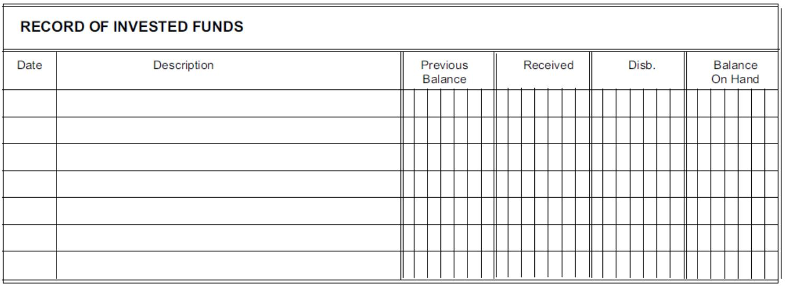
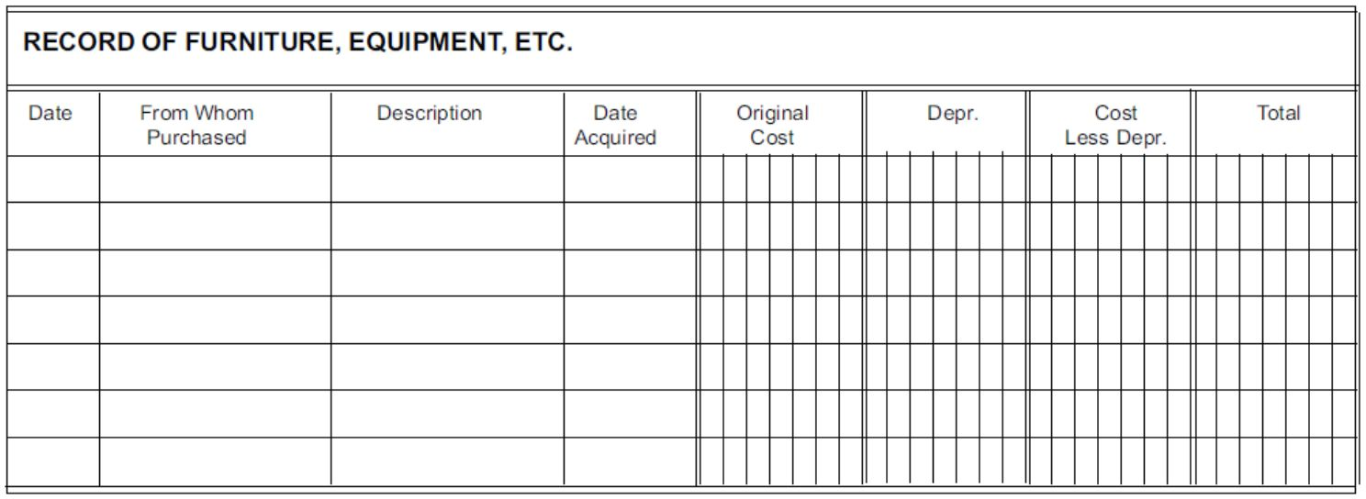
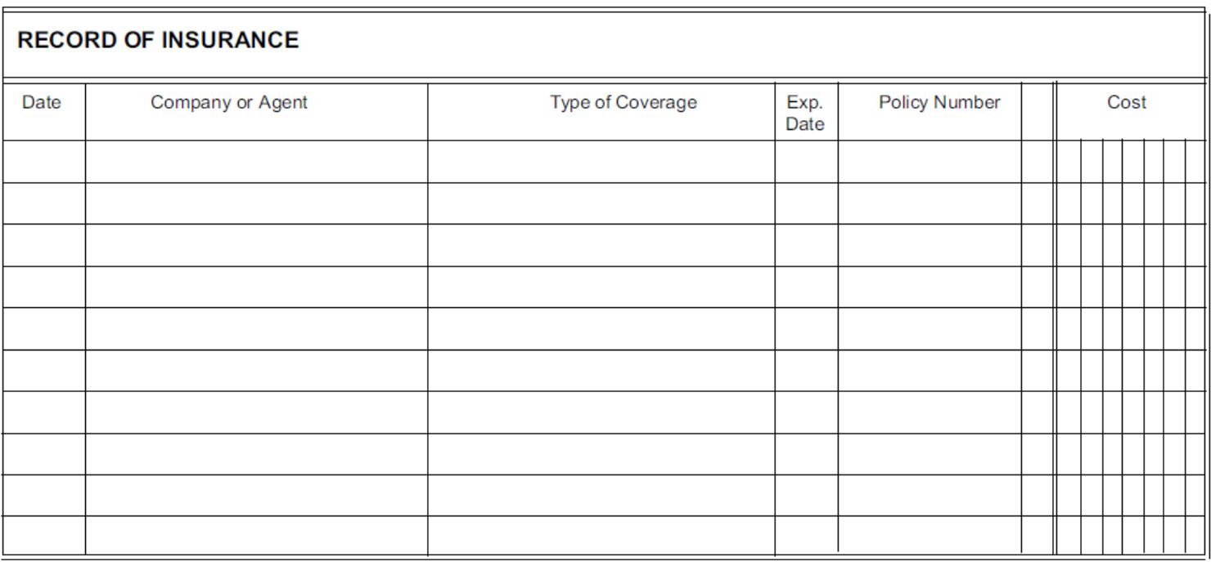

Sample Numbered Receipts
Use a pre-numbered two-copy, paper receipt book available at most office supplies stores.
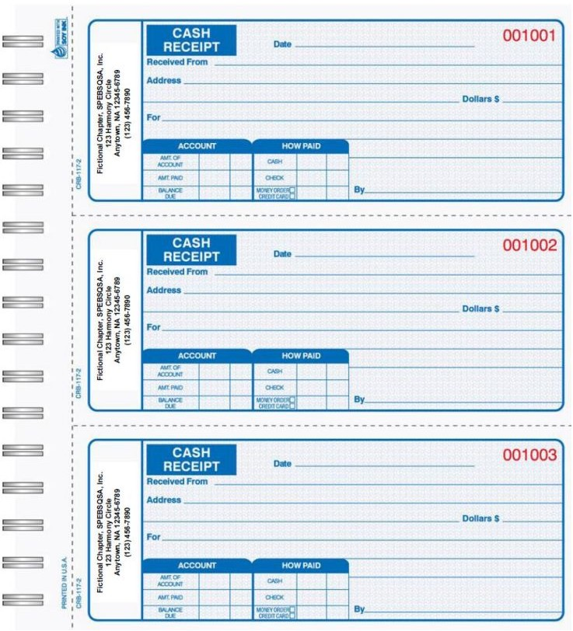

3.Sample Deposit Receipts
The treasurer should promptly deposit all monies, retain the receipted second copy in the chapter’s records, and record specific details on the second copy, such as accounts credited, purpose, check numbers, etc.
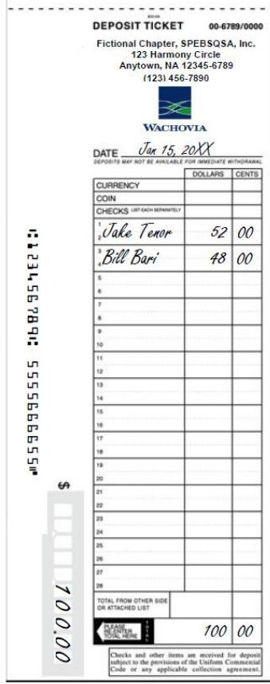

4.Sample Pre-Numbered Checks
When issuing checks or receipts, the treasurer should use only pre-numbered checks and always record the purpose on the stub or duplicate copy.
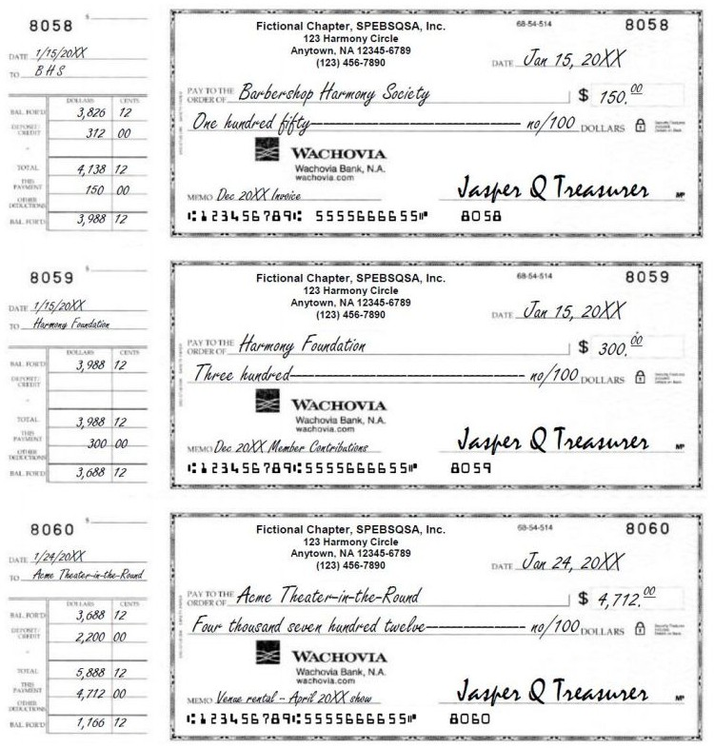

5.Sample Expense Voucher/Report
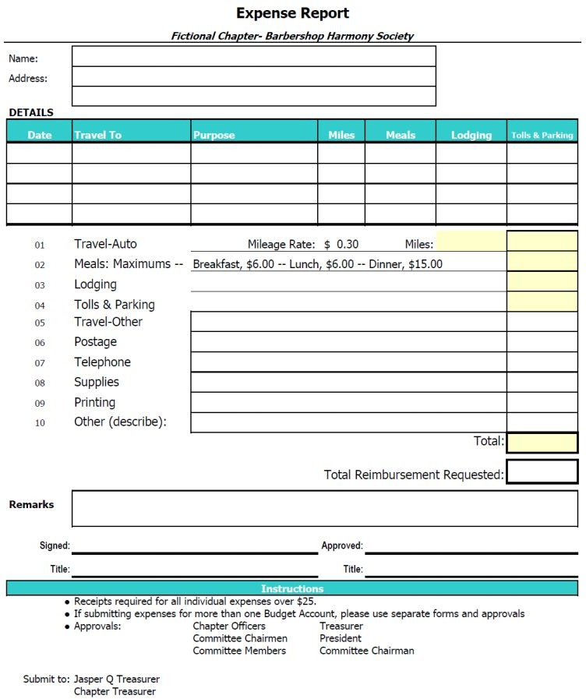
The chapter member attaches receipts and invoices to the chapter expense voucher when requesting reimbursement. If the member does not have a receipt or invoice, he must explain these items on the expense voucher. The treasurer records the check number and the date of the check on the expense voucher.

6.Sample BHS Chapter Statement

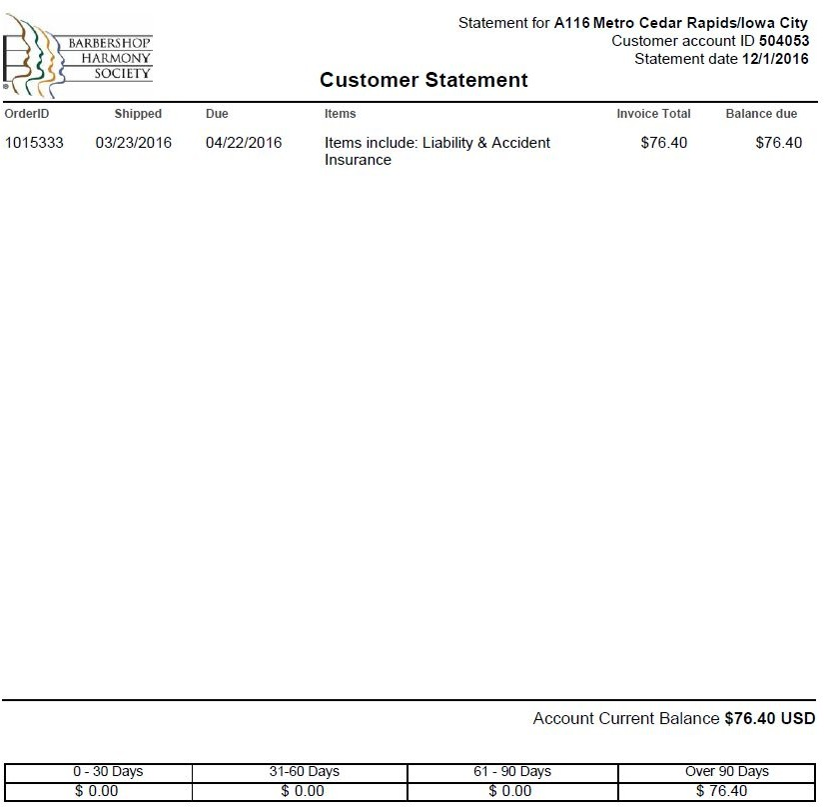

7.Sample Direct Dues Payout Report
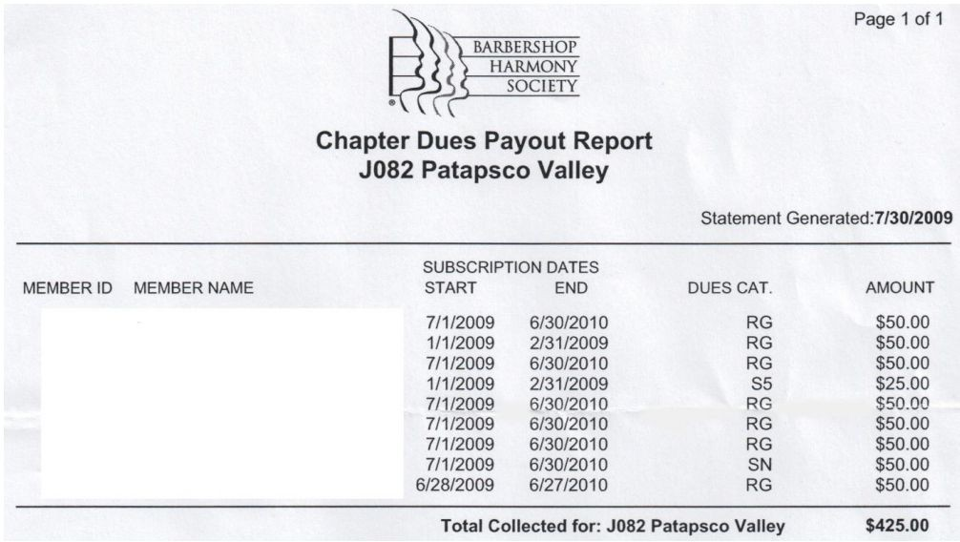

Appendix B. Example Chapter Accounting System & Reporting

Sample Chart of Accounts
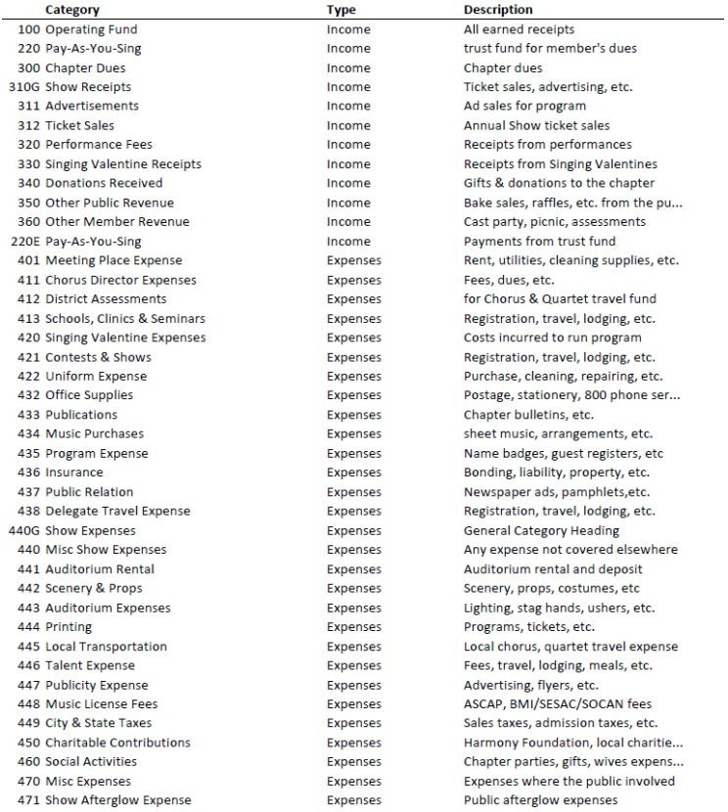

Sample Use of Chart of Accounts
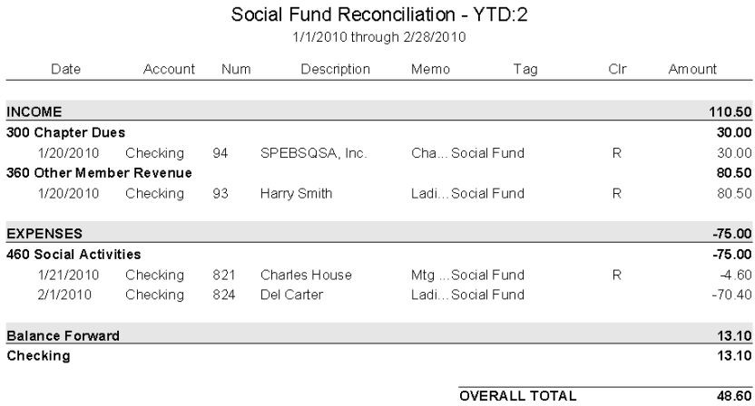

Sample “FORM 1” Report
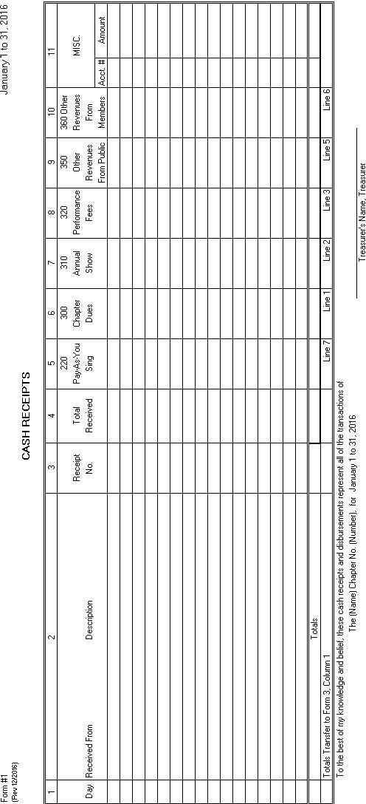

Sample “FORM 2” Report
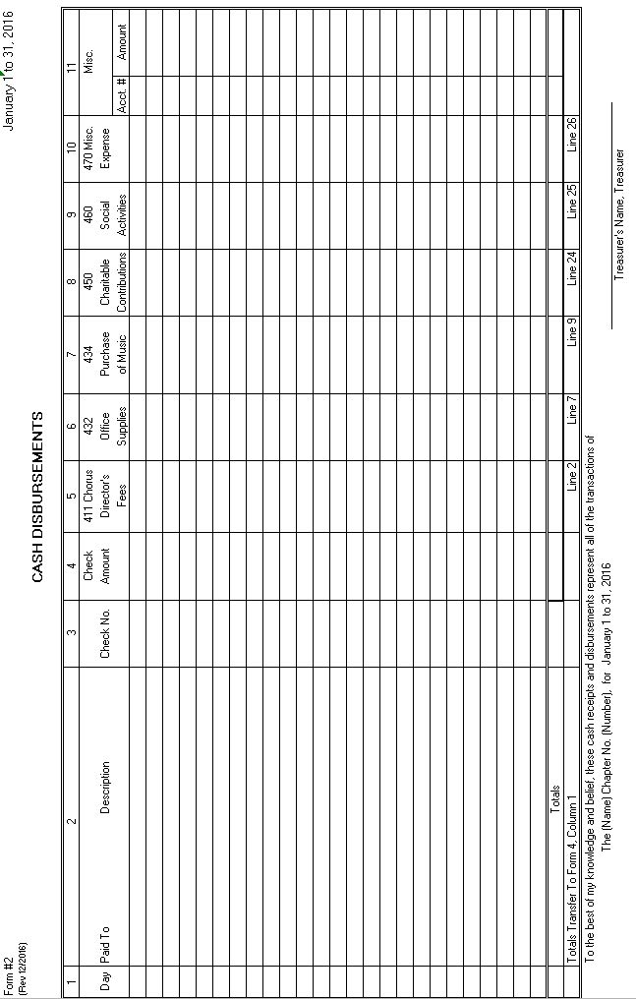

Sample “FORM 3” Report
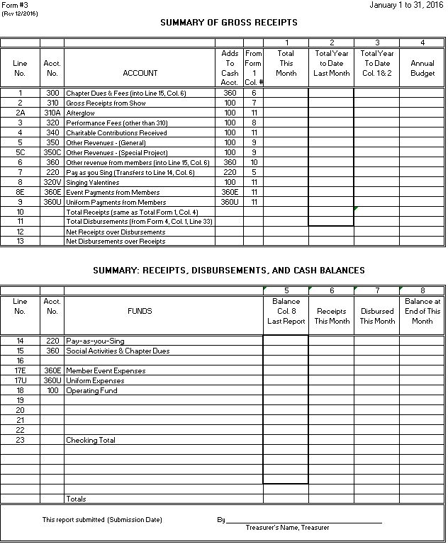

Sample “FORM 4” Report
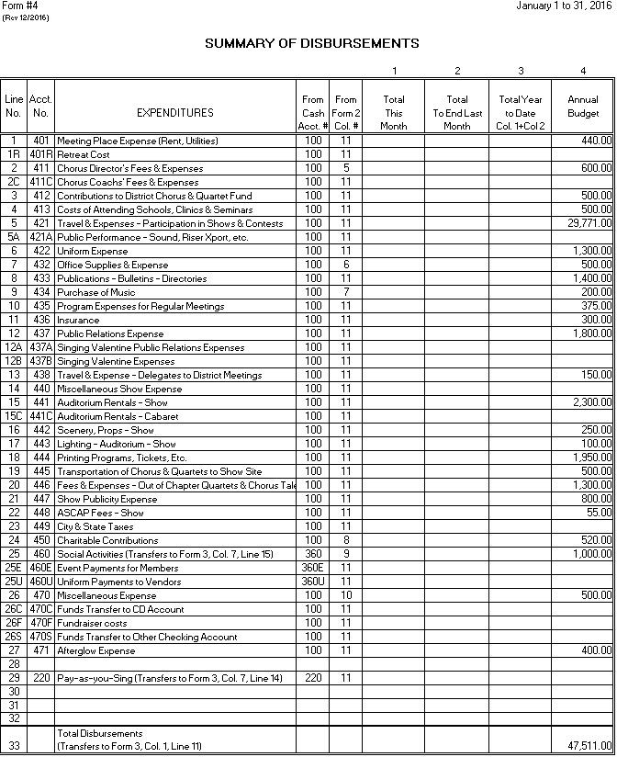

Sample “FORM 5” Report
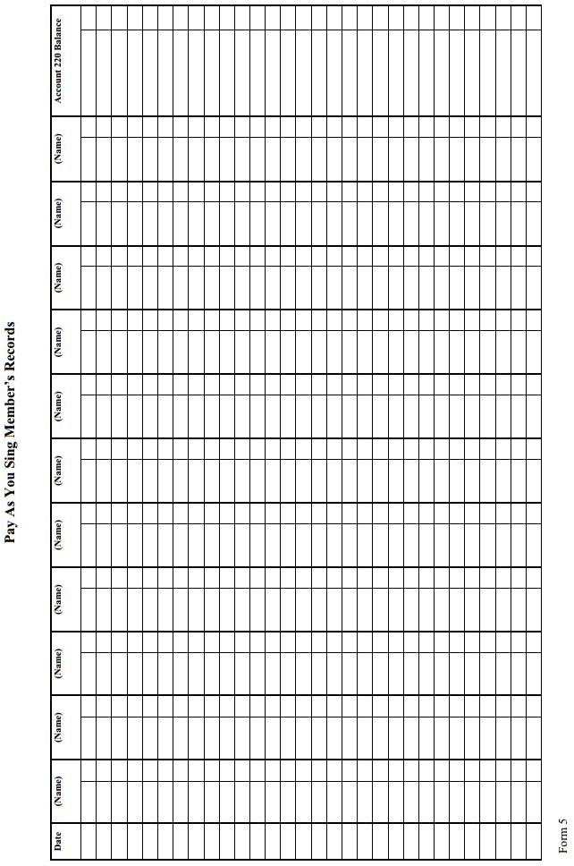

Sample “FORM 6” Report
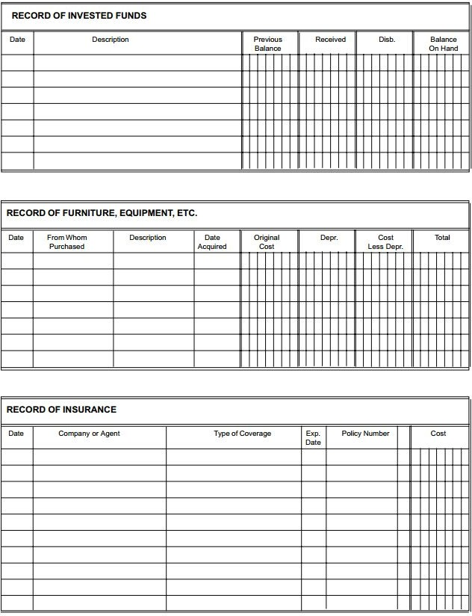

Sample Transaction Report
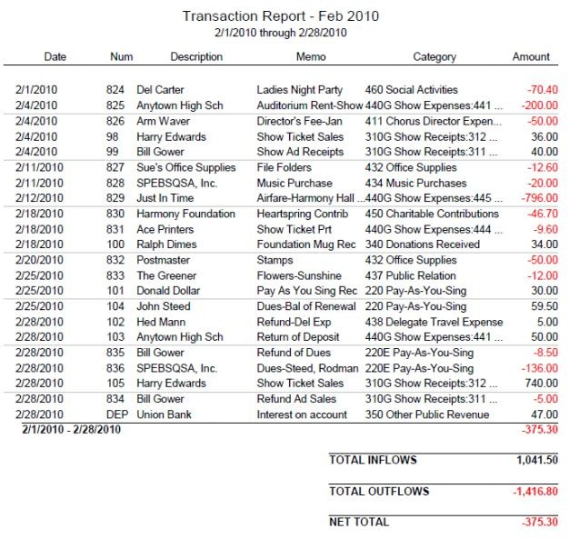

Sample General Event Comparison Report

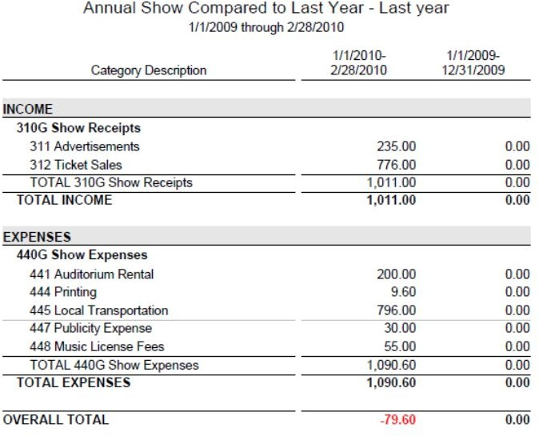

Sample Event to Event Comparison Report
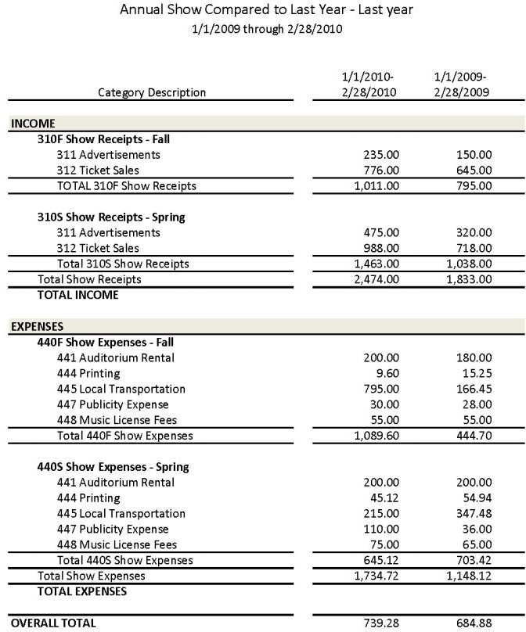

Appendix C. Fiscal Planning & Budget

Sample Budget
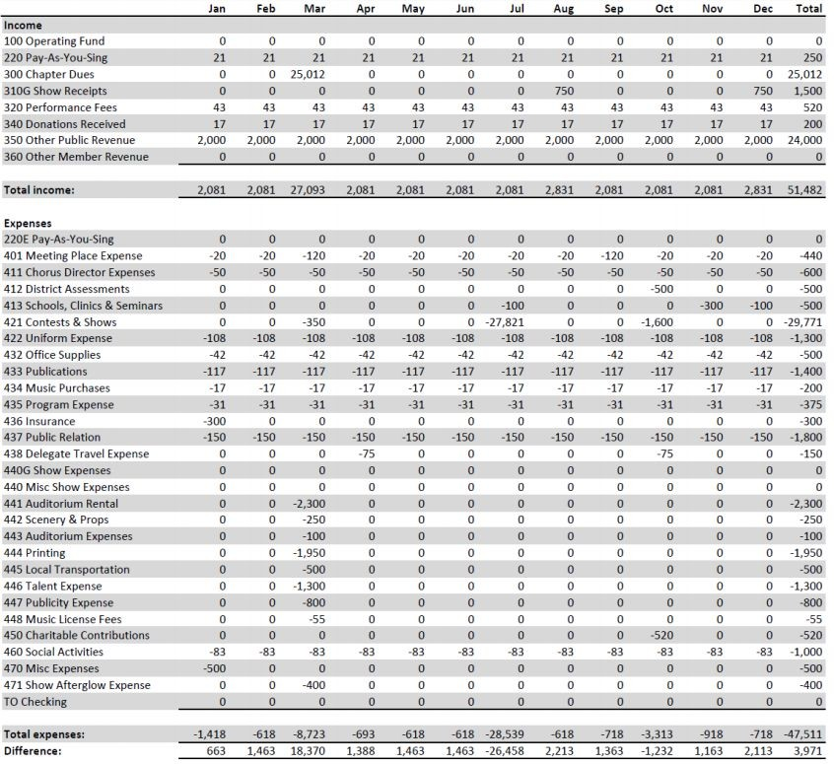

Records Retention Schedule
Chapter Treasurers should work with the Chapter Secretary to ensure the maintenance of the chapter Legal Files and various records below.

Type of Records | Records | Years
Annual Reports | Annual financial statements, journals, tax returns and worksheets, depreciation schedules, general ledgers, fixed asset purchases and financial reviews. | Permanent
 | Accounts Payable/receivable | 10 Years
 | Sales records, expense records, and loan schedules | 7 Years
Bank Records | Bank Statements and cancelled checks | 7 Years
 | Tax Payment Checks | Permanent
 | Loan Records | 7 Years from Last Payment
Computer Records | Backups of all records | Permanent
Corporate Records | Board minutes, incorporation documents, bylaws, licenses, contracts, leases, mortgages, insurance policies and other legal documents. | Permanent
Personnel Records | Employee and Independent Contractor, contracts and records, including performance reviews. | 7 Years after Termination
Real Property Records | Purchases, deeds, bill of sale, construction, appraisals, improvements, blueprints, and plans. | Permanent

Example Financial Review Report
The BHS Financial Review form can be found on the Society online Document Center. Below are example statements that can be included with the template form.

TO CHAPTER:

The Board of Directors of the Chapter of the Barbershop Harmony Society

We have reviewed the annual statement of receipts and disbursements and supporting documents, vouchers, invoices and bank reconciliations evidencing the recorded receipts and disbursements of the chapter for the year ended December 31, 20XX. The financial statements, reconciliations and summary of funds for the year ended 20XX, and the cash balances at December 31, 20XX, are fairly presented and documented.

Attached is the completed form to be submitted to the Barbershop Harmony Society.

Chairman Financial Review Committee Date

TO HEADQUARTERS THROUGH CHAPTER PROFILE IN EBIZ:

We have reviewed the annual statement of receipts and disbursements and supporting documents, vouchers, invoices and bank reconciliations evidencing the recorded receipts and disbursements of the
chapter for the year ended December 31, 20XX. The financial statements, reconciliations and summary of funds for the year ended 20XX, and the cash balances at December 31, 20XX, are fairly presented and documented.

Attached is the completed form.

Chairman Financial Review Committee Date

Appendix D. Charitable Donation Receipts

Sample Receipt for Donation less than $250

This type of receipt can be included at the bottom of the Show Program Ad form

RECEIPT: The Chapter of the Barbershop Harmony Society, gratefully acknowledges your donation of $ towards the program for our annual show. Your support of our non-profit, music education activities is vital in our efforts to “Keep the Whole World Singing.” Thank you very much!

Chapter Show Program Committee

Chapter Tax ID: xx-xxxxxxx Chapter Contact:
Phone:

Sample Receipt for Donation more than $250
If you want to give a formal receipt to support a charitable contribution greater than $250, you can use something like this:

Federal Tax ID Number: xx-xxxxxxxx

DATE: December 1, 2016
DONOR: Mary Giver
TYPE: Cash
AMOUNT: $500.00

The Chapter of the Barbershop Harmony Society gratefully acknowledges your kind gift [in support of our annual show, or other program in keeping with the chapter's mission]. No goods or services were received in exchange for this gift.

We appreciate your generosity. Signature of Chapter Treasurer

The Internal Revenue Service has indicated that the amount of a charitable contribution is limited to the excess of the amount of cash (and/or property) contributed by the donor, over the value of any goods or services received by the donor in connection with the contribution. The above information should serve as a receipt in accordance with Internal Revenue Service regulations regarding charitable contributions after 1993, and should be kept with your income tax records.

Appendix E. United States Chapters: Income Tax Exemptions & IRS Audits

Society IRS Determination Letter
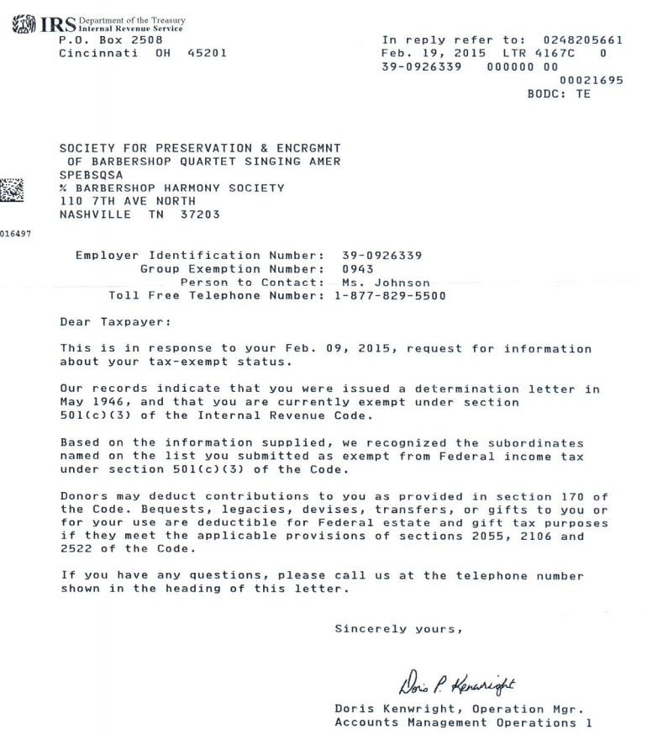

IRS is Conducting an Audit Article
By Gary Hatfield
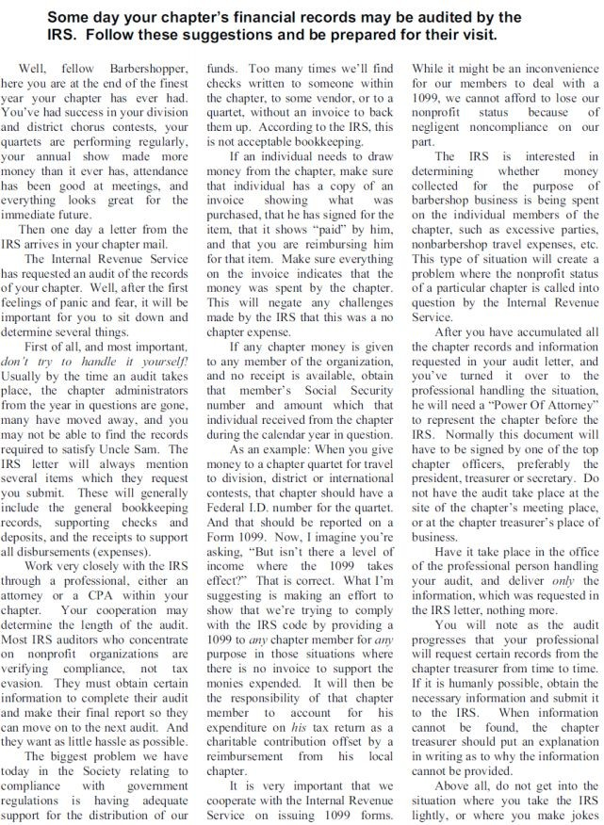

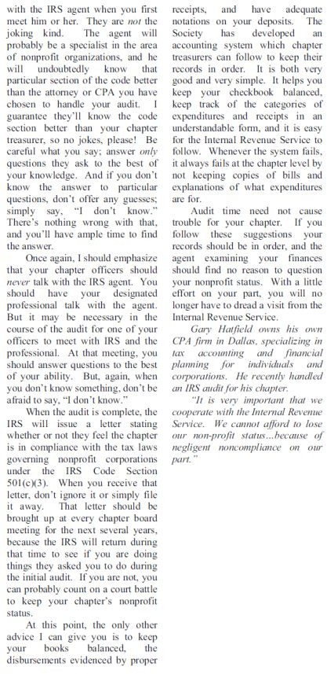

Quartet Fees and Expenses Memo
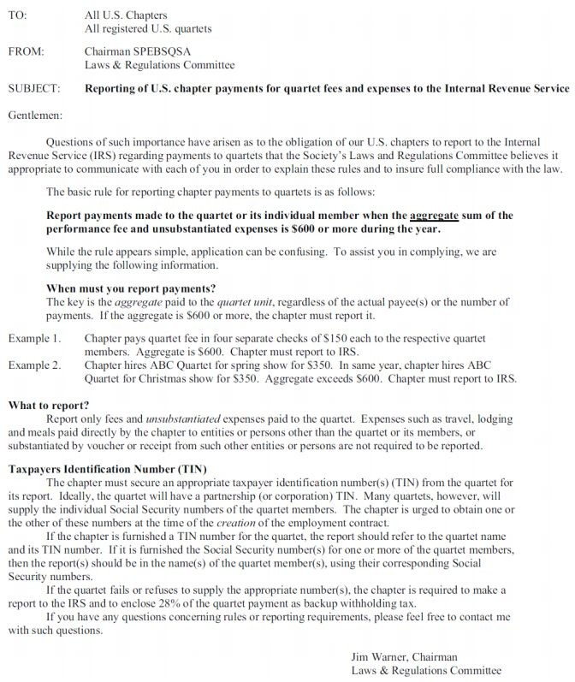

Appendix F. Canadian Chapters: Example Checklist for
Treasurers
To determine whether or not your chapter is considered a not-for-profit corporation or tax exempt, contact your local province and/or the Canadian Revenue Agency (CRA) It is crucial that Chapter Treasurers and Secretaries work collaboratively to keep the chapter fully compliant with all applicable laws, regulations, rules and guidelines. Below are some of the responsibilities required of Canadian Chapter Treasurers throughout each year.

Annually
  - BHS chapters incorporated in Canada are not-for-profit entities and are required to file an annual income tax return with the CRA. This must be done by June 30 each year. This filing consists of form T2 Short Return (including relevant schedules 100, 125 and possibly 141) along with form T1178 General Index of Financial Information – Short.
  - Ontario District chapters must also file an annual form T2SCH546 Corporations Information Act Annual Return for Ontario Corporations. Chapters incorporated in other provinces may have similar requirements for their province of incorporation.
  - For chapters who have not obtained a CRA charity registration number, no other federal income tax-related filing is required.
  - Chapters registered as charitable organizations must file form T3010 Registered Charity Information Return, T1235 Directors/Trustees and Like Officials Worksheet, T1236 Qualified Donees Worksheet and RC232 Ontario Corporations Information Act Annual Return (if based in Ontario). Other provinces and territories may have similar reporting requirements, which local treasurers and secretaries should determine. The required returns should be completed and sent to the CRA by June 30 or the extended deadline as appropriate.
  - If applicable, send form T4A Statement of Pension, Retirement Annuity, and other income to any person, quartet or unincorporated business who received $500 or more in the previous calendar year. This does not include reimbursement of expenses, such as travel expenses, for which valid receipts are provided.
  - If applicable, send copies of forms T4ASUM Summary of Pension, Retirement Annuity, and Other income and copies of forms T4A to the CRA by the applicable deadline.
  - Work with your Chapter Secretary to ensure continued compliance with provincial incorporation requirements, including payment of any applicable fees.
  - All chapters must report in the BHS Member Center when their filings are complete in their “Financial Filings” section under their chapter profile. Ontario District Chapters should reach out to their District Treasurer once filings are complete.
  - Work with your Chapter Secretary to ensure that any required payments for SOCAN/Entandem licensing are made on a timely basis.

As needed
  - Chapters registered as charitable organizations must comply with requests to disclose financial information, including information about fundraising activities, either as part of its normal public relations activity or in response to specific requests from a member of the public.
  - If your chapter has a Goods and Services Tax, or Harmonized Sales Tax, business registration, ensure that all appropriate and required information is sent in to qualify for, and maintain, the registration status.

Canadian and U.S. Exchange Rate
The Society will establish the exchange rate quarterly to reflect the U.S. dollar equivalent. Chapters will be appropriately notified of the rate. For the most up to date information, visit the Society Member Center website and refer to the “Documents” page.

EXAMPLE:

The current Canadian Exchange Rate for business is XXXXXX. This rate will remain in effect until the next quarterly rate change.
  - Canadian members have the option of writing a check and paying in Canadian dollars at a designated exchange rate or charging their credit card for the U.S. amount. Canadian members may pay their Society and District dues directly to Headquarters in Canadian funds. Chapter dues will be paid directly to the chapter.
  - If a member chooses to pay his dues on Member Center with his credit card, the Credit Card company's exchange will be used, NOT the current BHS Exchange rate.
  - The same rules apply on merchandise ordered from the Harmony Marketplace.

Rates are updated each February, May, August, and November.

