Guest Welcoming Process
Clipper City Chordsmen
Manitowoc, WI
The Clipper City Chordsmen Chorus is an ever-growing, well-respected brotherhood of men who love to perform a cappella music in the barbershop style, preserving the heritage of the barbershop quartet. The Chordsmen strive to improve the quality of life for our members and our communities through music education programs and family-friendly musical entertainment.
So we can be prepared to do a good job of welcoming guests, we ask/remind our members to inform us when we might expect a guest and encourage them to arrive at least by 6:45 .
On a guest’s first visit:
- When a guest arrives, he will be greeted and asked to fill out a Name Tag and a Guest Information Sheet which will help us track prospective members.
- They will be given a Guest Music Book on which they will find a Welcome Page.
- Since our Director, Dave Buss, leads Early Bird, we would then introduce him to our Assistant Director, Derek Luckow, to do a quick voice placement to determine what part he is interested in or suited for. If/When a guest arrives at or after 7:00 (when Derek is leading warm-ups) Dave would do this.
- Then a Singing Buddy from the chosen section will be identified to help him for the night.
- At the end of the rehearsal, someone will gather a quartet and invite him to sing a tag or two. Following that the Membership VP or other member of the Welcome Task Force will circle back to give him a Take Home Sheet, ask him about his experience, answer any questions, and make sure he gets a FREE beer or soft drink.
During the week following that first visit, the guest will receive a thanks for visiting email.
After a guest’s second visit – if it is deemed appropriate and not too pushy – a guest will be given a Membership FAQ Sheet, which describes the BHS membership process.
When he expresses the desire to join, the prospective member will receive the New Member Facts Sheet, and the Membership VP or designee, will go online with him to start the BHS application process. The Board will be informed of the prospective member’s application so they can officially vote to receive him.
What follows are the various components of the Manitowoc program:
- Guest Information Sheet
- Guest Information Tracking Form
- Welcome Page
- Take Home Sheet
- Membership FAQ Sheet
- New Member Facts Sheet
For further information or questions, contact Jim Rasmus pjras20@gmail.com; (920) 973-0010
For other approaches, you might also contact two other Chapters:
- Appleton Chapter > Paul Schreiner: dinerdude44@yahoo.com
- Fargo Chapter > Ken Frank: frankken@far.midco.net
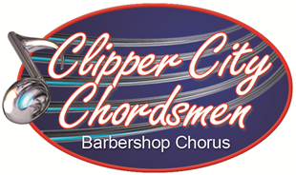
Guest Information Sheet
Date: ________________

Name: __________________________________________________Birthdate _____________________

Email: _______________________________________________________________________________

Phone: Cell > ____________________ Home > ____________________ Work > ____________________

Address ______________________________________________________________________________

Singing Buddy: _______________________________ Man Of Note: ______________________________

Voice Part: Tenor [ ] Lead [ ] Baritone [ ] Bass [ ] Read Music? Yes [ ] No [ ]

Music/Singing Background:

This is a compressed picture of the Excel file we use:

Guest Information Tracking
Name | Visit | Join? | Email | Cell Phone | Voice | Address | City | Zip | Singing Buddy | Man of Note | Birth  date | Reads Music

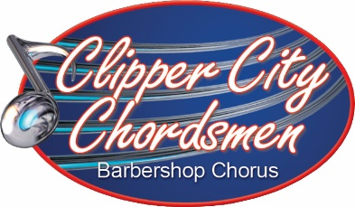
Welcome
to an evening of
Barbershop Harmony!!

We’re really glad you’re here! This book will provide you with the music you need to sing along tonight. It’s arranged in alphabetical order by title.

Our meetings serve up singing and musical insights in a fun side-by-side manner. Though each rehearsal is scripted differently, here is the basic outline of what to expect:
- Early Bird is from 6:30 to 7, led by our Director, Dave Buss.
- Vocal Warm-ups start at 7 pm, led by our Assistant Director, Derek Luckow.
- Around 7:15, we sing old and new repertoire songs, usually from the chairs.
- If there’s a performance coming up, we take to the risers to work on songs and choreography.
- Sectionals may be used and/or guys might volunteer to take the stage to sing in an octet.
- At 8:45 is our brief business meeting and we sing our theme song: “Keep the Whole World Singing!”
- At the afterglow you’ll get a free beer/soft drink, maybe sing some tags and get acquainted.
Tonight, you will experience how barbershop harmony is put together. The lead usually sings the melody in most barbershop songs. The bass sings the low notes that complement the melody. The tenor part is high, more like counter-tenor, and often sung in falsetto. Choir or glee club tenors usually make excellent leads or sing baritone in the barbershop style.
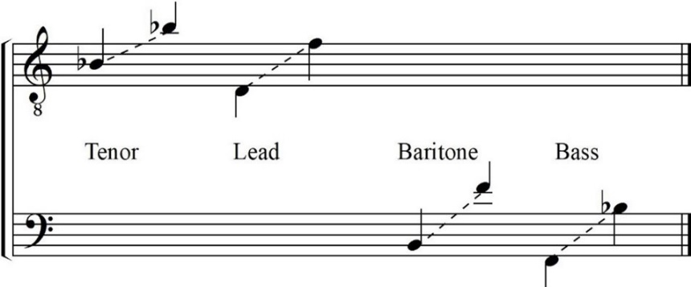
You’ll need to decide what part to sing.
If you read music, barbershop parts generally fall within these vocal ranges, but we’ll help you see where you might fit best. By the way, 30% of our members don’t know how to read music, and we all use learning tracks to help ourselves learn our part.
Once you’ve decided what part you want to try tonight, we’ll assign you a “Singing Buddy” to help guide you through our energetic rehearsal schedule.

The Clipper City Chordsmen is an a cappella membership organization whose mission is to preserve and encourage the barbershop style of music in our community and is made up of male singers who meet regularly to practice, perform, socialize, and have fun. You’ll find we are a great fellowship of guys who enjoy each other’s company.

Before you leave tonight, you will be given a Take Home Page that will give you some more information about the Chordsmen, what you’ve experienced this evening and serve to answer some of your questions.
We hope you’ll come back!
Take Home Sheet
https://clippercitychordsmen.org/
https://www.facebook.com/ClipperCityChordsmen
Primary Contacts for Questions:
Singing Buddy
Membership | Jim Rasmus | (920) 973-0010 | pjras20@gmail.com
Music Issues | Tim Steffen | (920) 980-5743 | mitneffets60@gmail.com
Director | Dave Buss | (920) 323-0523 | notabass@yahoo.com
Asst Director | Derek Luckow | (920) 973-1823 | derek.luckow@snc.edu
We hope you enjoyed your first experience singing with the Clipper City Chordsmen! Our focus is on enriching lives through singing – the lives of our audiences, of upcoming generations of singers, of our members…and your life too! We hope you will return to sing with many, many times!
We want to introduce you to some basic information about our group and the passion we share for singing barbershop harmony. Our Mission Statement reads:
The Clipper City Chordsmen Chorus is an ever-growing, well-respected brotherhood of men who love to perform a cappella music in the barbershop style, preserving the heritage of the barbershop quartet. The Chordsmen strive to improve the quality of life for our members and our communities through music education programs and family-friendly musical entertainment.
Barbershop harmony is four-part, unaccompanied, close harmony singing. Barbershoppers love to sing, have fun performing for others, and enjoy the camaraderie we share. The goal of our singing in a quartet or chorus is to ring chords in pursuit of the elusive overtone, which is produced when the four parts of a barbershop chord are sung in such perfect harmony that a fifth note becomes audible above the chord.
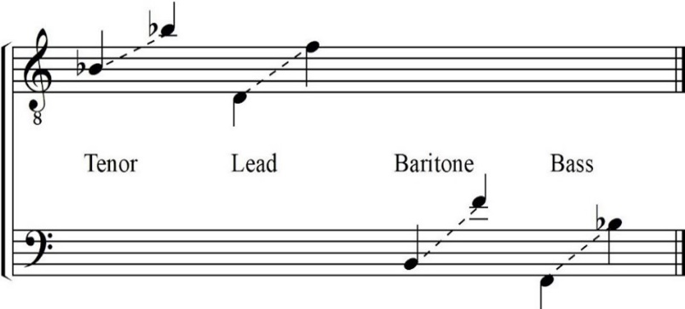
The four barbershop singing parts are:
- Lead usually carries melody in the second-highest voice.
- Bass sings the lowest notes and is sometime called the second melody.
- Tenor harmonizes above the melody and is often sung in falsetto.
- Baritone provides the left over-notes that form our unique barbershop chords.
Our chorus consists of men who live in and around Manitowoc County. We have members from as far north as Green Bay, south as Belgium and west as St. Nazianz. We rehearse almost every week on Tuesday nights for two hours, except when we are performing somewhere or taking some time off at Christmas. We enjoy performing in a variety of places and take pride in our affiliation with the world’s largest singing fraternity—the Barbershop Harmony Society.

We’ll give you membership details later, but only if you decide to come back.
Definitions of Some Unique Barbershop Terms You May Have Heard:
Afterglow | A time for barbershoppers to gather after a rehearsal or performance to socialize and sing informally
Barbershop Harmony | Four-part, unaccompanied, close-harmony style of singing
Board of Directors | The group of 9 elected members who oversee the business of the Chorus
Charts | The paper or electronic musical scores we use to learn our songs.
Early Bird | The half hour before rehearsal when members gather to work on learning notes and words of our songs
Flashbytes | The Chordsmen newsletter that is sent to members once or twice a month
Learning tracks | Specially recorded musical tracks, featuring one part louder and the other parts quieter, so one can learn the notes and words between rehearsals
Music Team | The group made up of our directors and two leaders from each section that makes the music and performance plans for the Chorus
Octet | A group of 8 singers, with two singing each part
Overtone | A sound produced when the four parts of a barbershop chord are sung in such perfect harmony that a fifth note becomes audible above the chord
Quartet | A group composed of a lead, tenor, baritone and bass
Repertoire | The songs approved by the Music Team for use by the chorus for shows and other performances
Reset | A physical movement used regularly to take tension out of the body while singing to promote better pitch
Ringing chords | The goal of all barbershoppers singing in a quartet or chorus is to ring chords in pursuit of the elusive overtone
Risers by Section | Standing on the risers arranged by the section of singers
Risers in Shotgun | Standing on the risers with members arranged by the similarities of the tone and timbre of their voices
Sectionals | A separate gathering of the members of a voice part to work on notes, words, and/or develop more unified sound within the section
Tag | A short passage from song’s ending taught and sung in sessions of informal chord-ringing. It allows four singers to quickly blend their voices in a few seconds of blissful harmony without the burden of learning an entire song.
VLQ | A "Very Large Quartet" is composed of 8 or more singers
Warm-ups | The first 10 minutes of rehearsal when we get our voices and bodies prepared for the work ahead
2022 Board of Directors:
Position | Member | Phone | Email
President
Secretary
Treasurer
VP Music/Performance
VP Marketing/PR
VP Chapter Development
At Large Members
Frequently Asked Questions (FAQ)
About Membership in the
Clipper City Chordsmen
Manitowoc, WI
Who is Involved?
At the beginning of 2022, chorus consisted of 28 active members residing in and around Manitowoc. We have members from as far north as Green Bay, as far south as Belgium and as far west as St. Nazianz.
What’s the nature of the commitment?
We rehearse almost every week on Tuesday nights from 7-9, except when we are performing somewhere or taking some time off at Christmas. We expect members to spend time learning our songs between rehearsals. There is a weekly “Early Bird” from 6:30-7, and 4-6 times a year we schedule a special rehearsal on Saturday mornings from 9–11 to provide additional help.
We expect members to participate in 75% or more of our performances. The three major local performances which provide us financial support are:
- Annual Spring Show – usually in late March or April at Endries Hall
- Cabaret – a dinner show, usually on Packer Bye Sunday
- Annual Christmas Show – usually in early December at Endries Hall
Each October we attend the Land o’ Lakes District Convention held in Minneapolis and compete in the annual chorus contest.
Other performances may include the following events in local venues:
- Quartets provide singing valentines as a fund-raiser each year on February 14th.
- Fallen Officer Memorial Ceremony in Manitowoc in May.
- Memorial Day
- 4th of July in Two Rivers
- Summer outdoor performances at Felician Village, Two Rivers and elsewhere by invitation
- Christmas caroling in nursing homes on Tuesdays after the Christmas Show
- Other business, fraternal, social, church and community organizations upon request
What is Involved in Becoming a Member of the Clipper City Chordsmen?
No earlier than your third meeting of participation you may ask to join the Chorus.
- If not done already, arrange a vocal placement with our Director and designate your “Man of Note” – the man who has been responsible for inviting you to be part of the Chorus
- The VP of Membership will assist you with completing the application paperwork. There are actually three groups you will be joining:
  - The Clipper City Chordsmen Chorus (also known as the Manitowoc County Chapter).
  - The Barbershop Harmony Society (BHS).
  - The Land O’ Lakes District (LOL) of the BHS.
- Applications for membership are voted on by the Chapter Board, but that is simply a formality.
What are the Benefits of Membership in the Clipper City Chordsmen?
Our Chorus offers many fun, exciting and enlightening opportunities as we join together in locking and ringing chords. As members we receive:
- All the sheet music and learning track recordings needed to learn the repertoire.
- Most of the costs for performance uniforms, which includes a polo shirt (Class R), burgundy shirt, tie and black pants (Class B with a $25 deposit), and tuxedo (Class A with a $50 deposit).
- Unlike many other chapters, we offer a 50% reimbursement of the registration expense when we compete at District.
- A “free voice lesson” – vocal and performance techniques – at every rehearsal!
- Periodic coaching from experienced coaches to help us improve our singing and performance.
- The chance to sing in a quartet or octet for fun, enjoyment, and performance opportunities.
- The promise of new friends and being part of the local and international barbershop family.
- Learn more on our website: www.clippercitychordsmen.org.
We enthusiastically support music education for youth locally by inviting local choruses to sing on our shows and provide annual donations to two schools in our area. We provide a significant discount for young men who want to join our chapter. We are the founding chapter of the Wisconsin Youth Harmony Festival, which identifies the top three high school barbershop and treble quartets in the State and provides a financial reward to their schools each May.
What are the Benefits of Membership in the Barbershop Harmony Society (BHS)?
We take pride in our affiliation with the world’s largest singing fraternity, the Barbershop Harmony Society. We are one of the 650 barbershop chapters, organized into 17 Districts, in North America and affiliated with 12 international barbershop organizations. As members of BHS we receive:
- Discounted pricing on barbershop merchandise, music and learning tracks.
- Early access and discounts to the annual International Convention the week of July 4th and the Midwinter Convention in January.
- Discounts to Harmony University, the premiere 8-day music education program in July.
- The latest news and trends in the world of barbershop harmony through the Harmonizer magazine (6 issues per year) and the Livewire (the weekly electronic newsletter).
- The opportunity to support music education around the country through donations to BHS and/or our affiliated Harmony Foundation International.
- Learn more on the BHS website: www.barbershop.org. and enjoy video recordings of choruses and quartets on the BHS YouTube Channel: www.youtube.com/c/BarbershopHarmony38.
What are the Benefits of Membership in the Land O’Lakes (LOL) District?
Our LOL barbershop family includes 46 barbershop chapters in WI, MN, ND, MI’s UP, as well as Manitoba, Saskatchewan and Western Ontario in Canada! As members of the LOL we receive:
- Access to the coaches who work with our chorus and quartets.
- The opportunity to join our barbershop brothers and sisters at the Annual District Convention held each October in Minneapolis where we compete as a chorus and in quartets to gain valuable input on how to improve our singing and performance.
- Access to a weekend at the Annual Leadership Training Academy in River Falls each January to enhance our individual music and leadership skills.
- News about choruses, quartets, and District events in the Pitch Piper published six times a year.
- Learn more on the LOL website: www.loldistrict.org.
How Much Does Membership Cost?
The current membership dues are: BHS $144, LOL $24, Chordsmen $5 for an annual total of $173 (about $16 per month – or $12 for seniors (ever 70)– if you decide to pay monthly).

We’re excited you’ve decided to join the Chordsmen!
The following describes what is involved in becoming a member and provides some helpful information as you begin making your way into the chorus.
What is the Process for Officially Joining the Clipper City Chordsmen?
To join the Chordsmen you will also becoming a member of the Barbershop Harmony Society (BHS) and the Land O’Lakes District (LOL). It is all handled online in two easy steps:
- Now that you’ve decided, the Membership VP will register you with the BHS as a new member, providing your name, phone number(s), email address and birthdate.
- You will then receive an email with a link to activate your membership in the Manitowoc Chapter of the BHS and the LOL. As part of that process, you will need to:
  - Decide if you want to pay for your membership total dues of $183 annually or $16 per month.
  - Designate your “Man of Note” (the man responsible for inviting you to join the Chapter).
  - Determine how much of your personal information you want publicly shared.
Once that is completed, you are officially a card carrying barbershopper. Congratulations!
What about Music?
As part of your membership, the Clipper City Chordsmen provide you with all the music you will need for singing with the Chorus. While our guest, you have used a Guest Book containing the charts in our current repertoire. Please work to replace that as soon as possible with your own copies of the charts. All of our music can be found online on our website (https://clippercitychordsmen.org/). If you have not done so already, ask Dave to grant you access to the “members only” section of our website where you will find all the music utilized by the Chorus.
You will need to decide if you want to continue using paper charts or store your music on a tablet.
- Paper Charts
If you choose to use paper, most guys download and print the music charts from the “Current Repertoire” folder on the website. Get a 2-inch three-ring binder, load them into plastic sleeves and organize them into your binder. Or talk to Tim Steffen, our music librarian, to request printed charts.
- Electronic Charts
Many members have found tablets to be a more compact method of working with their music. There are numerous .pdf readers available on the internet. Music reading apps for both Apple (Fourscore) and Android (Mobile Sheets) devices are also available at a minimal cost. They are very convenient and easy to use once you get the hang of it. Ask anyone using one to show you how they work. Then download the electronic charts onto your tablet, upload them into the app, and you are ready to go.
- Learning Tracks
We have learning tracks available for download from the “Learning Tracks” folder of the website. These are very helpful recordings of a quartet singing the song with lead, tenor, baritone, and bass parts highlighted and set apart to make it easier for you to learn your part. If you use paper charts, you will need to download the tracks onto your computer or cell phone to listen to them or upload them onto as CD or USB (flash) drive, so you can listen in your car stereo or other player. If you are using a tablet and music software, you can download tracks onto it, upload them into your app and play it directly from there while following the musical score.
Flashbytes
Once a month, members receive an electronic copy of the Flashbytes, the newsletter of the Clipper City Chordsmen. There you will find times and uniforms for upcoming performances, timely information from the Music Team and Board of Directors, music lists the Chorus is working on, and usually a little humor. If you would prefer, a hard copy can be sent or given you at rehearsal.
Uniforms
Once you have joined, you will be issued some uniform parts that are generally worn with black shoes and black socks when we perform. We refer to our uniforms as follows:
- Class A > Maroon, long sleeve shirt, tie, and black pants. (There is a $25 deposit required for this.)
- Class B > Blue polo shirt, with Chordsmen logo, usually worn with the black pants.
- Class R > Red polo shirt, with Chordsmen logo, usually worn with the black pants.
Caps and Fleece Jackets
There are two additional logo items guys often wear that to provide identification of our members as we go around our communities. You will be given a blue logo ballcap. Though not required, most guys also purchase a grey fleece jacket, which can be imprinted with your name for a small fee.
Octets and VLQ’s
Octets are commonly used within rehearsals to aid everyone in learning our music. Please feel free to volunteer to sing in these octets! It’s a great way for you to practice performing and hear how your voice fits into a smaller group. Octets and “very large quartets” (VLQ’s) are also utilized in our public performances. Please make your interest in performing in an octet or VLQ known to our directors!
Quartets
The BHS was originally called the “Society for The Preservation and Encouragement of Barber Shop Quartet Singing in America” (SPEBSQSA). Thus, we like to encourage the formation of chapter quartets. Some are simply “Step Out Quartets” who sing on our chapter shows. Others form with the purpose of singing for audiences within the community and/or competing at barbershop conventions. If you would like to be in a quartet, talk to some guys you think you’d like to sing with and give it a try. Our directors and other chorus members are available to help coach you along the way! The Land O’Lakes District (https://loldistrict.org/) and the BHS have lots of resources to assist you too.
Rehearsal and Riser Placement
As we sing from the chairs during rehearsals, you make the choice of where to sit within your section: baritones on the left, then basses, leads, and tenors on the right as you face forward.
When we sing on the risers, however, we are assigned positions by our directors. Sometimes we stand on the risers by sections, but most often we are positioned on the risers in what is called a shotgun formation. Our riser position is assigned by the director, so the parts are distributed in a varied quartet formation across the chorus in an effort to create to most effective ensemble sound.
Help Us Help You to Learn About Barbershop Singing
As your time with the Chorus grows, you will undoubtedly hear many barbershop terms that are new to you. Forgive us when we use words you don’t know and help us know when you don’t understand terms we are using. Never be bashful – always reme
The Clipper City Chordsmen is an ever-growing, well-respected brotherhood of men who love to perform a cappella music in the barbershop style, preserving the heritage of the barbershop quartet. The Chordsmen strive to improve the quality of life for our members and our communities through music education programs and family-friendly musical entertainment.

