

**Half Marathon Training – Simple advice**

**Fuelling**

1. **UP YOUR PROTEIN INTAKE.**

This helps you build muscle in your legs, recover quicker and avoid injury.

Runners need about 50 to 75 per cent more protein than non-runners = 200g of chicken a day.

Chicken helps protect muscles from free-radical damage during exercise and regulates fat burning while running. Decent protein bars work too.

2. **IT’S JUST AS IMPORTANT TO HYDRATE WHEN YOU AREN’T TRAINING**.

When running drink 3-4 sips of fluid for every 15–20 minutes you’re running. Don’t exceed 600ml (1pt) of water per hour running. Alternate with a good sports drink.

3. **30 MINUTE RULE**

Best time to eat before a training run is 30-60 minutes before you head out.

Smaller snacks - nice balance of proteins and carbohydrates – a whole wheat bagel topped with a scoop of peanut butter or sliced banana for example.

4. **PROCEED GINGERLY**

Stress on joints? Add ginger to your diet = relieves muscle soreness, minimise your risk of injury.

Add chopped ginger to stir fries, soups and smoothies. Ginger tea?

5. **PRACTICE FUELLING MID-RUN**

Fuelling every 30 to 45 minutes is required.

“Fuel early and often”, take on at least 30g of carbs per hour = stay *ahead* of any feelings of exhaustion, so keep topping up the tank, even if you don’t feel you need it. Once you feel your energy levels start to crash, it’s too late.

6. **RECOVER RIGHT**

30-45 minutes of finishing a long run, you need a recovery snack consisting of both carbs and protein. = body is very responsive to nutrition and will rebuild and repair muscles. Recovery shakes are best.

High-protein breakfast helps prevent body fat gain, increase weight loss, reduce cravings and hunger hormones.

Consuming 30 grams of protein first thing in the morning prevents a mid-morning blood sugar crash and keeps your metabolism humming all day. It also helps build lean muscle mass, which means the more muscle you have, the more calories you burn sitting at your desk.

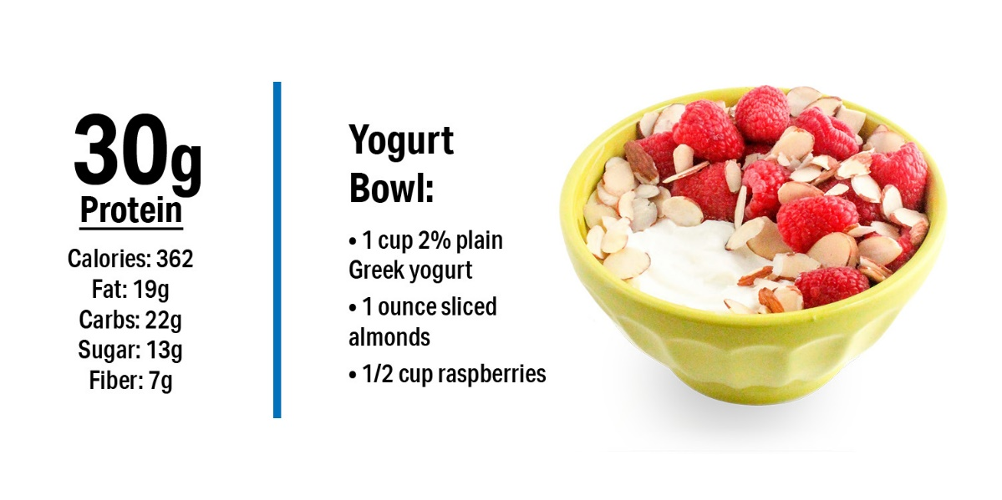

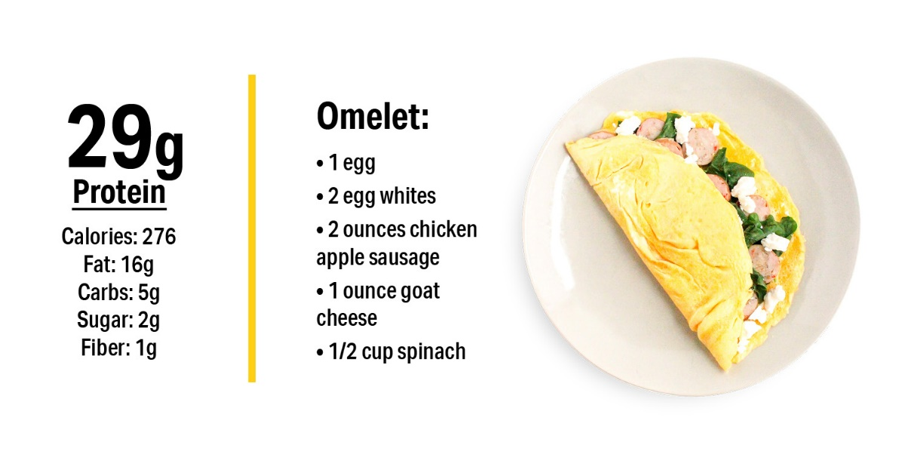

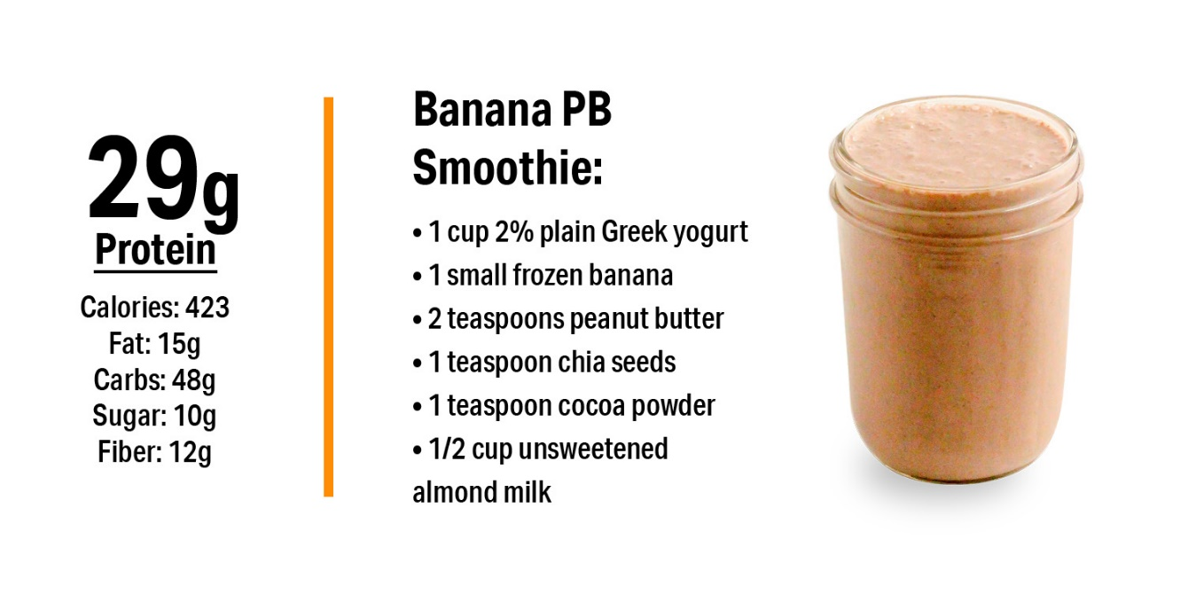

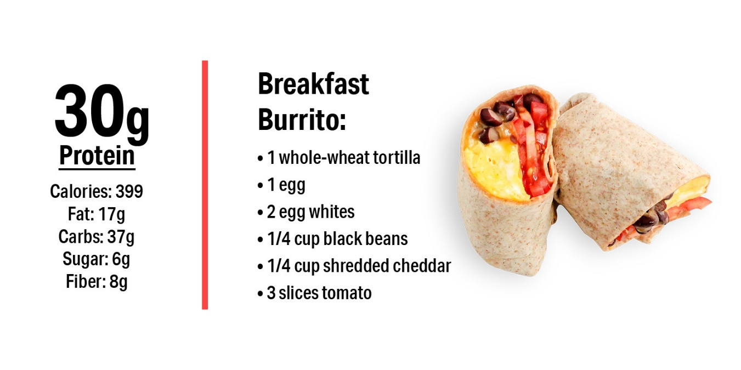

**

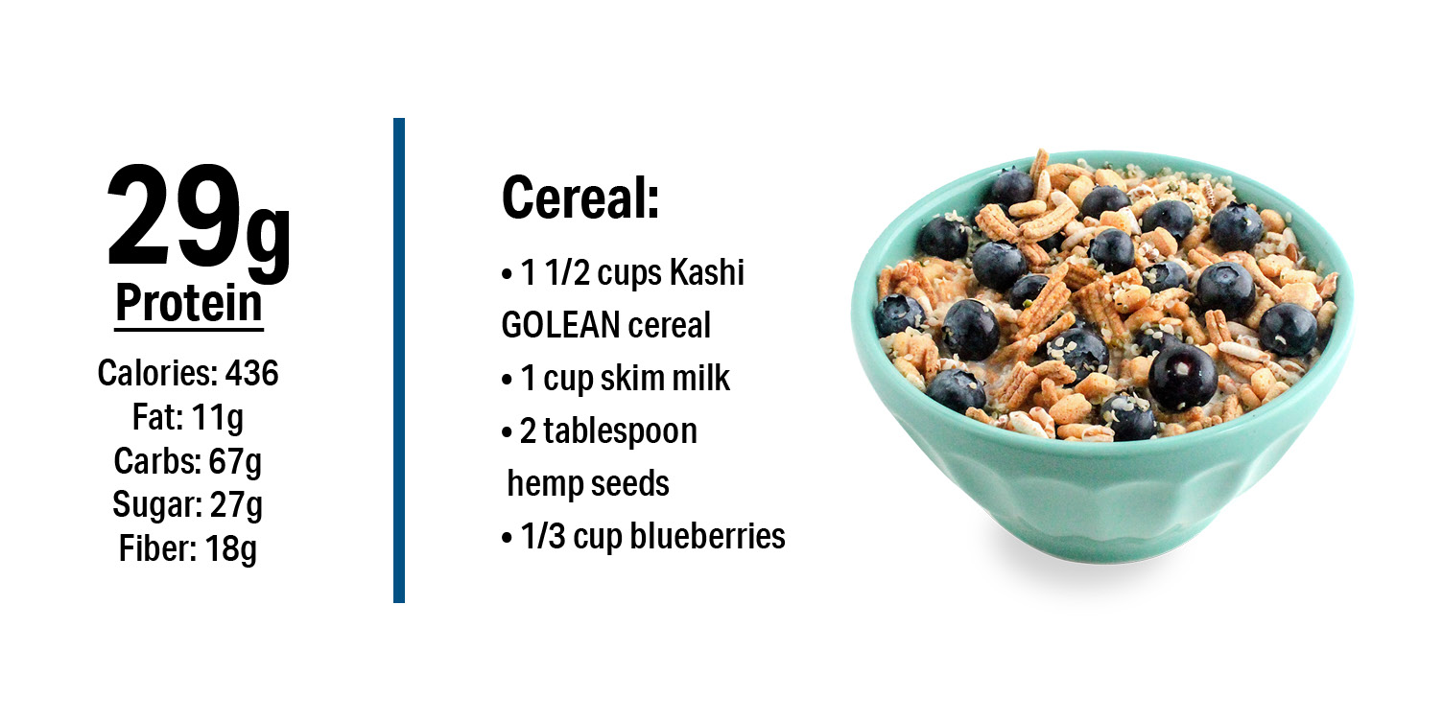



**11-WEEK HALF-MARATHON TRAINING PLAN**

**Schedule key**

Start all hill and speed sessions with 15 mins easy running and end with 5 mins easy

**GHMP:** Goal half-marathon pace

**Challenging:** A pace that’s on the edge of your comfort zone. An effort of 8 out of 10

**Negative split:** Running the second half of the distance quicker than you ran the first

**Strides:** Run 50-100m faster than your 5K pace, maintain good form. 100m jog recoveries

**Week 1 – 31/03/2025**

**Monday:** 30 – 40 mins easy Run

**Wednesday:** 4 x 5 mins challenging, with 3-min recovery jog in between each

**Friday:** Cross-train/easy run 30 mins(this can be done in your own time, rather than club)

**Weekend:** Long run 3-5 miles easy (depending on experience

**Week 2 – 07/04/2025**

**Monday:** 30 – 40 mins easy Run

**Wednesday:** 4 x 6 mins challenging, with 2-min recovery jog in between each

**Friday:** Cross-train/easy run 30 mins(this can be done in your own time, rather than club)

**Weekend:** Long run 4-6 miles easy (depending on experience

**WEEK 3 – 14/04/2025**

**Monday:** 4 miles easy

**Wednesday:** 5-6 x 3 minutes or 800m at 5K pace, with 2 mins rest (total 5K effort not to exceed 20 mins)

**Friday:** Progression run: 30 secs slower than GHMP, speeding up by 10 secs per mile for 5 miles in total (this can be done in your own time, rather than club)

**Weekend:** Long run 6 - 9 miles

**WEEK 4 – 21/04/2025**

**Monday:** 3 miles easy

**Wednesday:** 2 x 1.5 miles at 5K pace, followed by 4 easy miles

**Friday:** 5 miles easy, including 6 x 45-second hills (this can be done in your own time, rather than club)

**Weekend:** Long run: 8 - 10 miles with negative split (out-and-back course is ideal)

**WEEK 5 – 28/04**

**Monday:** 4 miles easy

**Wednesday:** 1 mile easy, 5 x 6 mins threshold intervals (approx. 5 secs slower than 10K pace per mile)

**Friday:** 1 mile easy, 4 miles GHMP, 1 mile easy plus 3 x 60m strides (this can be done in your own time, rather than club)

**Weekend:** 10K race. Use your time to refresh predicted half marathon and 10K paces

**WEEK 6 – 05/05**

**Monday:** 4 miles easy

**Wednesday:** 3 x 2 miles at GHMP, with 3 mins recovery jog between each

**Friday:** 5 miles easy, including 6 x 1-min hills (this can be done in your own time, rather than club)

**Weekend:** Long run 10 - 12 miles easy

**WEEK 7 – 12/05**

**Monday:** 4 miles

**Wednesday:** 2 x 18 mins tempo (approx. 10 secs slower than 10K pace per mile)

**Friday:** 5 miles steady plus 4 x 60m strides (this can be done in your own time, rather than club)

**Weekend:** Long run 10 - 12 miles, with miles 6-10 at goal GHMP

**WEEK 8 – 19/05**

**Monday:** 4 miles easy

**Wednesday:** 10 x 90 secs or 400m at 5K pace, with 1-min rest (Total 5K effort not to exceed 20 mins)

**Friday:** 1 mile easy, 2 x 3 miles at GHMP with 3 mins recovery jog between, 1 mile easy (this can be done in your own time, rather than club)

**Weekend:** Parkrun or 5 miles steady, inc. 8 x 1-min hills

**WEEK 9 – 26/05**

**Monday:** 4 miles easy

**Wednesday:** Progression run: 1 mile easy, 3 miles GHMP, then 2 miles tempo

**Friday:** 1 mile easy, 6 x 6-min threshold intervals, with 1-min recovery (this can be done in your own time, rather than club)

**Weekend:** Long run 11 - 14 miles easy

**WEEK 10 – 02/06**

**Monday:** 4 miles easy

**Wednesday:** 5 miles GHMP

**Friday:** 45 mins easy plus 4 x 60m strides (this can be done in your own time, rather than club)

**Weekend:** Long run 11 - 14 miles, with final 4 miles at GHMP

**WEEK 11 – 09/06**

**Monday:** 4 miles easy

**Wednesday:** 1 mile easy, 4 x 8 mins threshold intervals, with 90-sec recoveries

**Friday:** 4 miles GHMP (this can be done in your own time, rather than club)

**Weekend:** Long run 7 - 9 miles, with final 4 miles at GHMP

**WEEK 12 – 16/06**

**Monday:** 1 mile easy, 2 miles GHMP, 1 mile at 10K pace

**Wednesday:** 45 mins easy

**Friday:** Rest (this can be done in your own time, rather than club) !)

**Saturday:** 20 mins easy plus 3 x strides

**Sunday:** Race day!