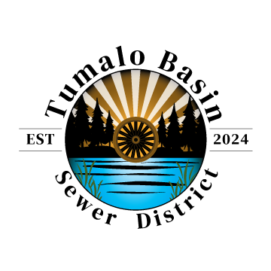**Tumalo Basin Sewer District**

64682 Cook Ave, Box 19, Bend OR 97703

[TumaloBasinSD@gmail.com](mailto:TumaloBasinSD@gmail.com)

TumaloBasinSD.org

541-239-3389

**Tumalo Basin Sewer District Board Meeting Agenda**

**Tuesday, February 11, 2025, at 4:30 p.m.**

**64670 Strickler Ave, Ste 100, (Tumalo) Bend OR**

1. Call to Order
2. Pledge of Allegiance
3. Public Comments
4. Consent Agenda
   1. January 14, 2025 Meeting Minutes (Exhibit A)
5. Discussion and Action Items
   1. Ordinance #2025-001, First Reading - An Ordinance Concerning the Tumalo Basin Sewer District Sewer System; Adopting Certain Rules, Regulations, Rates, and Charges Concerning the Sewer System. (Exhibit B)
   2. Membership in Oregon Association of Water Utilities (Exhibit C)
   3. Resolution #2025-003, SOS Registered Office and Registered Agent (Exhibit D)
   4. Financial Report and Funding Discussion
      1. IGA with Deschutes County Update
      2. Clean Water State Revolving Fund Updates
      3. Business Oregon Technical Assistance Program Update
   5. Authorize monetary reimbursement to Board members for budgeted items paid on behalf of Tumalo Basin Sewer District (Exhibit E)
   6. Treasurer Report
   7. Secretary Report
   8. Authorize Rob Fish to initiate procurement discussions on behalf of Tumalo Basin Sewer District, including vehicles and equipment.
6. Board Training: Recap from Special District Association of Oregon annual conference.
7. Other Items
8. Adjourn

The meeting location is accessible to persons with disabilities. A request for an interpreter for the hearing impaired or for other accommodations for persons with disabilities must be made to Linda Swearingen, 541-350-6012, [lllswear@aol.com](mailto:lllswear@aol.com) at least 48 hours in advance of the meeting.

This meeting will be conducted electronically, by phone, in person, and using Zoom. Members of the public may listen, view, and/or participate in this meeting in real time:

|  |  |
| --- | --- |
| Join Zoom Meeting <https://us06web.zoom.us/j/81467629302> Meeting ID: 814 6762 9302 | One tap mobile +12532050468,,81467629302# US +12532158782,,81467629302# US (Tacoma) |