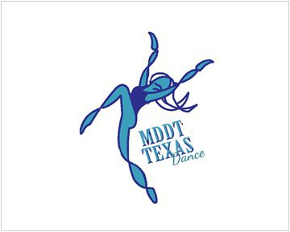
MDDTTEXAS COMPETITION SCORE SHEET 2020
Costume, grooming, appropriateness in music selection, projection, emotion
/10
PRESENTATION/SHOWMANSHIP 10 POINTS

CHOREOGRAPHY 25 POINTS
Originality, creativity, variety, musicality, accomplished difficulty , artistic development of routine (exhibiting interpretation of the material and ability to translate it to the audience)
/25

TECHNIQUE 25 POINTS
Method/completion of movement, body alignment, strength and execution of
movement, precision.

/25

PRESENTATION/STAGING 25 POINTS
Use of performance area, transitions, variety of movement Uniformity and timing, spacing, formation alignment and transitions (Solos- use of performance area, variety of movement, timing and transitions ) Use of prop/pom and/or staging
/25

Judge’s Signature
Effect of the total performance, audience appeal
/15
15 POINTS
OVERALL EFFECT

TOTAL

/100

