
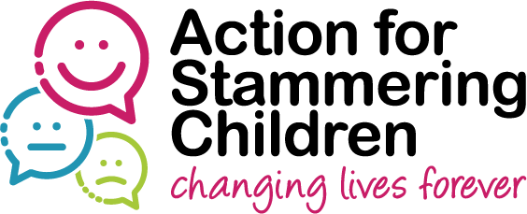


“Talking Out” Residential Course for young people who stammer

Referral Form
(to be completed by local Speech and Language Therapist)

Dates | Sunday 21st October – Friday 26nd October 2018
Venue | Bewerley Park for Outdoor Education, Pateley Bridge, Harrogate, North Yorkshire, HG3 5JB
Name |  |  |  |  | Dob
NHS No
Address
Contact Tel (home) |  |  | Contact Tel (Mobile)
Name of parent/guardian
Name and address of school
School Year
Area | North West England |  |  | Other  (please specify)

Criteria met | √ / X
- 12 – 16yrs of age on 21st October 2018 (12 Year olds to be in Yr 8)
- Significant identified difficulties about speaking & feelings towards stammering.
- Previous therapy has involved identification & fluency modification
- Has not attended a residential course in the past
- Any learning/ behavioural difficulties the child has would not prevent him / her or others from being able to work in a group of 10 children.
- A named person can collect their child during the week should any problems arise.
- Child and parent/ carer can attend a pre-group meeting in Stockport in early October (date to be confirmed shortly) to complete assessments & meet others involved in the course.
- Child and parent/ carer can attend a post-group meeting at the Stammering Support Centre 3 months and 6 months after the residential programme.

Please provide a brief description of child’s current strengths and needs in relation to their stammer
Please indicate why you feel the “Talking Out” course will benefit this child & how it will add to the SLT input already provided
Please detail any further information which you feel the panel should be aware of when considering this client for a place on the course.

Name of referring SLT: _______________________________________________

Address of referring SLT (in full):_______________________________________
______________________________________________________________________________________________________________________________________

E-mail address: _____________________________________________________

Telephone number: __________________________________________________

NHS Trust / Employer: _______________________________________________

Thank you for completing this form. Please return to us by e-mail at: Jennifer.Roche@nhs.net

Or by post to:
Jennifer Roche
Stockport NHS Foundation Trust
Children's Therapy Centre,
C/O Kingsgate House
Wellington Rd North
SK4 1EX

Forms to reach us by 17th September 2018

