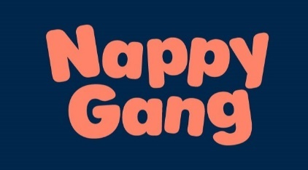
Nappy Gang Nursery
4 Coronation Square
Leyton
London
E10 5UN
24.04.2025

Nursery Fee Structure
Dear parents/carers,
I hope this letter finds you well. We would like to provide you with the fee structure for our nursery starting September 2024.
**Non-Funded Fees:**
- Ages 0-2: £330 per week
- Ages 3-4: £325 per week
**Funded Fees (0-2 years):**
- 11 hours free childcare: £260.86
- 22 hours free childcare: £191.71(as of September 2025) subject to change.
**Funded Fees (3-4 years):**
- 11 hours free childcare: £256.90
- 22 hours free childcare: £188.81
Please note that whilst the free early years entitlements are either 15 or 30 for term time only, we being a full time all year setting choose to stretch the entitlement for the full year. Meaning 15 becomes 11 and 30 becomes 22.
These fees cover a comprehensive package for 5 days, Monday to Friday, from 7:30 AM to 6:00 PM. It's important to note that our fees are subject to an annual review every April, and a small increase may occur.
For children aged 9 months and above, funding is available based on eligibility. Parents can benefit from funded hours, and the payable hours' details are outlined above.
Included in the fees are food, drink, and art supplies. Parents are kindly requested to provide milk for bottles, nappies, cream, and wipes when applicable. Please be informed that some optional trips may incur additional costs.
We would like to emphasize that all funding is contingent upon meeting the government's eligibility criteria.
If you have any questions or require further clarification, please do not hesitate to contact us. We appreciate your continued trust and support in providing a nurturing environment for your child.
Thank you for choosing Nappy gang.

